FOR IMMEDIATE RELEASE
DECEMBER 03, 2019

ANDERSON EAST AND FOY VANCE
ANNOUNCE 12 ROUNDS TOUR

TAKING THE STAGE TOGETHER, STRIPPED DOWN

TICKETS ON SALE THIS FRIDAY AT 10:00AM LOCAL

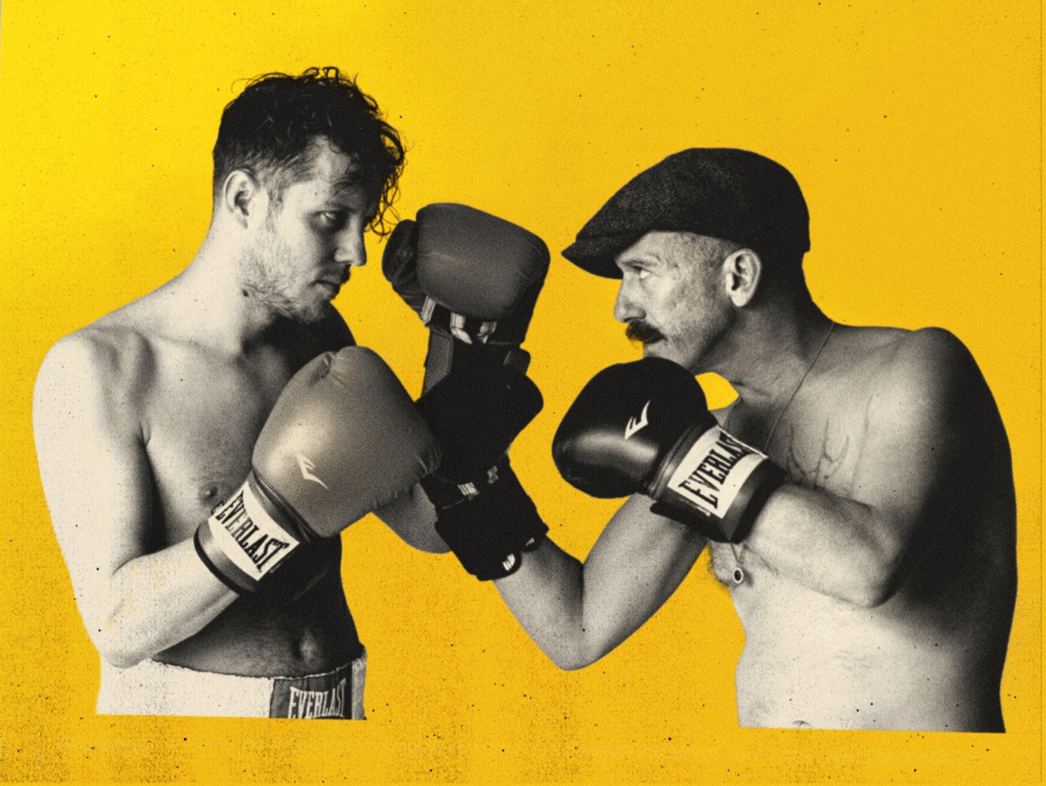

Equally brash, bold and entirely uncompromising in their respective artistry, Nashville-based singer/songwriter Anderson East and Northern Irish singer/songwriter Foy Vance have announced the stripped-down and double-billed “12 Rounds Tour”. The 19-date trek will see duo share the stage, swap songs, cover each other’s tunes, and likely hurl a friendly insult or two. “The 12 Rounds Tour” will kick off in Knoxville, TN on February 19, 2020, and wrap in Cincinnati, OH on March 15, 2020. Pre-sale tickets for the tour will be available starting tomorrow, December 4, and general tickets will go on sale this Friday, December 6, at 10:00am local time HERE.

Having made fast friends more than a decade ago when the pair met backstage at the Edmonton Folk Festival, and within minutes, East joined Vance onstage for his set, the two men have kept close tabs on one another ever since. “And I always thought, if I ever got a chance to do something with him I’d love to make it happen,” says Vance. Earlier this year, East floated the possibility of touring together, and Vance immediately signed on. “Man, I’d love to do something outside of my normal wheelhouse, be a bit more creative, strip it back a bit,” East recalls thinking upon bringing the idea to Vance.

Earlier this year, GRAMMY®-nominated Anderson East released his first-ever live album Alive In Tennessee, via Low Country Sound/Elektra. Recorded at Nashville’s famed Ryman Auditorium during his sold out Encore World Tour, Alive In Tennessee captures all the energy and excitement of East’s acclaimed live performances, highlighted by electrifying renditions of songs from his 2015 Low Country Sound/Elektra debut album, Delilah, as well as the complete tracklisting from last year’s breakthrough Encore, including “This Too Shall Last,” “Girlfriend,” “King For A Day”, and “All On My Mind,” which earned a GRAMMY® nomination for “Best American Roots Performance.”

The release of Encore was preceded by a series of breakout years for East following his widely praised debut album, Delilah. In addition to “Jimmy Kimmel Live!,” “Ellen,” and “The Late Show with Stephen Colbert,” East has also performed on “TODAY,” “Late Night with Seth Meyers,” “CBS This Morning Saturday” and Daryl Hall’s “Live from Daryl’s House” and has lent his talents to several notable projects. He’s been featured on Dave Cobb’s Southern Family compilation, contributed a song to Brandi Carlile’s Cover Stories LP and crafted the original song, “What Would It Take,” for the Fifty Shades Darker soundtrack.

Foy Vance just wrapped US and UK/IE tours in support of his two new companion albums From Muscle Shoals and To Memphis, released this summer via Ed Sheeran’s Gingerbread Man Records/Elektra. While digging through demo tracks, he came across a handful of songs he had labeled ‘Soul’ that provided the genesis for From Muscle Shoals, and ‘Americana’ that formed the basis of To Memphis. Foy recently shared stunning performance clips of songs including “You Love Are My Only” and “Pain Never Hurt Me Like Love” from FAME Studios in Muscle Shoals, AL, and “I Won’t Let You Fall” and “Malibu Jane” from Memphis TN’s Sun Studios.

Vance will release a new studio album in 2020, a more traditional follow-up to The Wild Swan, which contained the BBC Radio 2 playlisted singles “Coco”, “Upbeat Feelgood”, and “Noam Chomsky Is A Soft Revolution”, and saw Vance perform on “TODAY” and “The Late Late Show with James Corden”. Vance’s previous album, Joy Of Nothing, won the inaugural Northern Ireland Music Prize for best album in 2013.

12 Rounds Tour
February 19, 2020 - Knoxville, TN - Bijou Theatre
February 21, 2020 - Chattanooga, TN - Walker Theatre
February 22, 2020 - Charlotte, NC - McGlohon Theater at Spirit Square
February 24, 2020 - Charleston, SC - Charleston Music Hall
February 25, 2020 - Athens, GA - Georgia Theatre
February 26, 2020 - Florence, AL - Shoals Community Theatre
February 28, 2020 - Dallas, TX - Granada Theater
February 29, 2020 - Houston, TX - The Heights Theater
March 01, 2020 - Jackson, MS - Duling Hall
March 03. 2020 - Kansas City, MO - Madrid Theatre
March 04, 2020 - St. Louis, MO - The Sheldon Concert Hall
March 06, 2020 - Minneapolis, MN - The Cedar Cultural Center
March 07, 2020 - East Moline, IL - The Rust Belt
March 08, 2020 - Chicago, IL - Thalia Hall
March 10, 2020 - Indianapolis, IN - The Vogue
March 11, 2020 - Lexington, KY - Kentucky Theatre
March 13, 2020 - Louisville, KY - Old Forester’s Paristown Hall
March 14, 2020 - Columbus, OH - Newport Music Hall
March 15, 2020 - Cincinnati, OH - Bogart’s

12ROUNDSTOUR.COM

CONNECT WITH ANDERSON EAST
ANDERSONEAST.COM
TWITTER
FACEBOOK
YOUTUBE
INSTAGRAM

CONNECT WITH FOY VANCE
FOYVANCE.COM
TWITTER
FACEBOOK
YOUTUBE
INSTAGRAM

PRESS CONTACTS:

Glenn Fukushima (Anderson East)
GlennFukushima@elektra.com

Collin Citron (Foy Vance)
CollinCitron@Elektra.com

Sydney Worden (Tour)
SydneyWorden@Elektra.com

