FOR IMMEDIATE RELEASE
April 15, 2020

A DAY TO REMEMBER RETURN WITH NEW SINGLE & MUSIC VIDEO “MINDREADER”

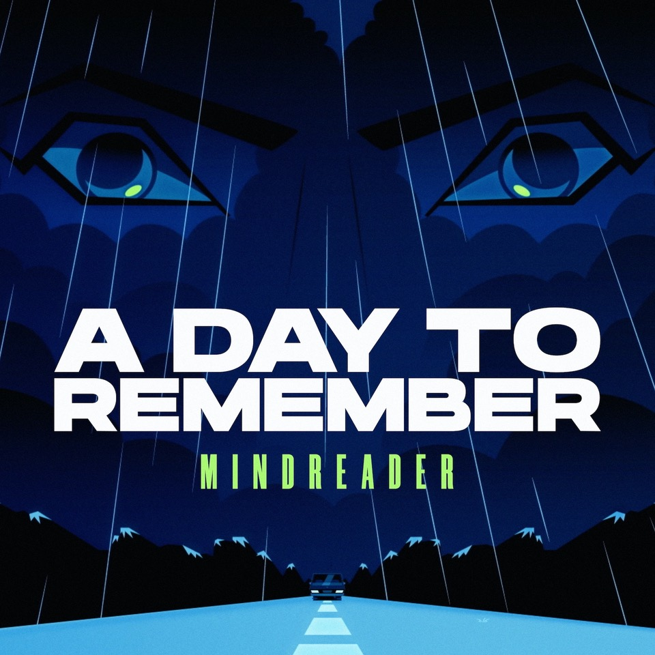
STREAM/DOWNLOAD/WATCH HERE

Ocala, FL rock band A Day To Remember have released their brand new single “Mindreader”. The song is available to stream and download now HERE. The platinum-certified band has also unveiled an official music video for the song, animated by Awesome, Inc. [Aqua Teen Hunger Force, Squidbillies]. Watch it HERE.

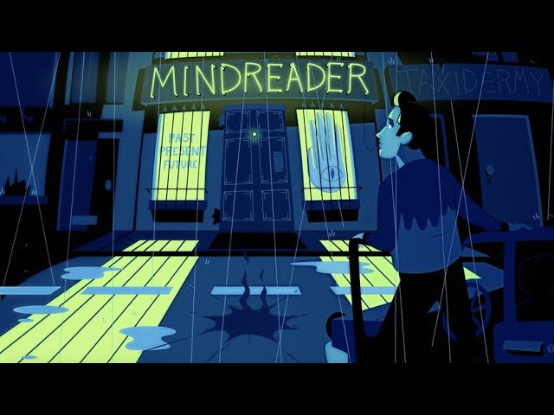
WATCH “MINDREADER” (OFFICIAL MUSIC VIDEO) HERE

Meeting an overwhelming demand from fans for new music, A Day To Remember has decided to reveal the track off their forthcoming full-length, You’re Welcome. About this move, frontman Jeremy McKinnon commented, “We’ve had this video done for some time now, and seeing as how our album isn’t out yet and the state of the world is keeping us off the road, we wanted to get some new material out there for our fans as soon as possible.”

“This song was one of my personal favorites off the new album from the day it was written. I wrote it with the incredibly talented Mike Green. Fun fact, it was the first song I’ve ever sent the guys in the band that was unanimously loved,” McKinnon elaborated. “This song was written to be a lighthearted take on people in relationships expecting their partners to read their minds.”

Anticipation for You’re Welcome has reached fever pitch, with early singles “Degenerates” and “Resentment” already amassing 30 million-plus streams and counting. Billboard praised “Degenerates” as “an anthemic hybrid of post-hardcore and pop,” while Kerrang! hailed, “‘Resentment’ offers a taste of the musical direction the band are heading, and will certainly tide us over until more news arrives.”

Last fall, A Day To Remember wrapped their massive Degenerates Tour, which saw them perform to sold-out crowds across North America, and culminated in four sold-out homecoming shows at House of Blues Orlando. Watch a recap video of the tour HERE.

Be on the lookout for more from A Day To Remember soon.

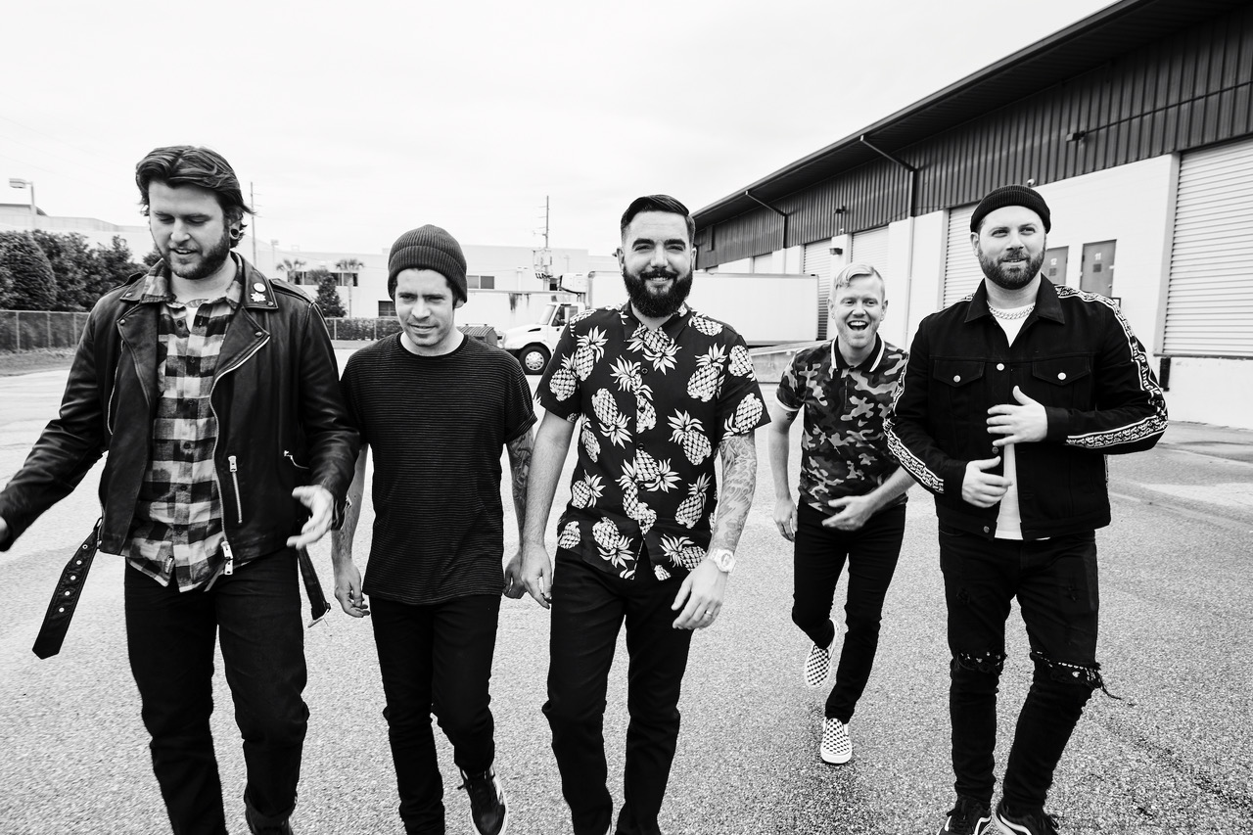
Photo credit: Jimmy Fontaine

ABOUT A DAY TO REMEMBER:
Since their formation in 2003, A Day To Remember quietly emerged as arguably the biggest underground band in the world. The Florida group affirmed this status by achieving four gold singles, two gold albums, and one platinum single. Not to mention, each full-length record ascended to #1 on the Billboard Rock, Indie, and/or Alternative Charts with 2016’s Bad Vibrations bowing at #2 on the Billboard Top 200. They’ve put up unprecedented numbers for a rock act in the 21st century, generating 400 million Spotify streams, 500 million YouTube views, and sales of one million-plus units. They’ve also packed arenas on continental tours and attracted a worldwide audience consisting of millions. Additionally, A Day To Remember successfully launched their own Self Help Festival in 2014, which continues going strong. Plus, everyone from Marshmello to Pierce The Veil has sought them out for collaborations. All of which explains why Rolling Stone called them “An Artist You Need To Know.”

A Day To Remember is: Jeremy McKinnon (vocals), Alex Shelnutt (drums), Kevin Skaff (guitar, vocals), Neil Westfall (guitar, vocals), and Joshua Woodard (bass).

http://adtr.com/
https://www.facebook.com/adtr
https://twitter.com/adtr
https://www.instagram.com/adtr/
https://www.youtube.com/adaytoremember

Press Contact:
Collin Citron / CollinCitron@Elektra.com

