FOR IMMEDIATE RELEASE

AUGUST 20, 2019

**A DAY TO REMEMBER RELEASE NEW SINGLE “DEGENERATES” THROUGH NEW LABEL PARTNER FUELED BY RAMEN**

**BAND TO PERFORM AT THIS WEEKEND’S READING AND LEEDS FESTIVALS IN UK**

**TICKETS FOR *THE DEGENERATES TOUR*AND SELF HELP FESTS ON SALE NOW**

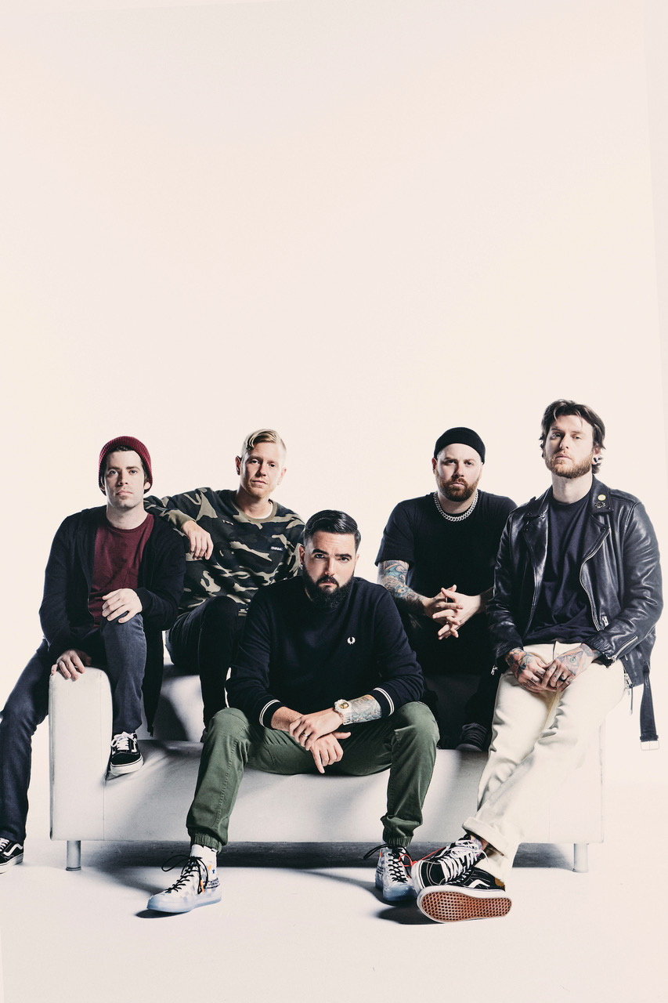

*Photo credit: Jimmy Fontaine*

Ahead of their main stage performances at this weekend’s Reading and Leeds Festivals in the UK, **A Day To Remember**have released their brand new single “Degenerates” through their new label Fueled By Ramen. The anthemic track is available to stream and download starting today [HERE](https://nam04.safelinks.protection.outlook.com/?url=https%3A%2F%2Ffbr.lnk.to%2FDegenerates&data=02%7C01%7CSydneyWorden%40elektra.com%7C1039d2a21a974aa130f408d7257866e6%7C8367939002ec4ba1ad3d69da3fdd637e%7C0%7C0%7C637019071374689965&sdata=zK2bbqBdfvyvZS5xHCEablF4lk7Vsi0mk2AwjEWeQ84%3D&reserved=0).

A Day To Remember will appear at numerous festivals in the coming weeks, including two massive installments of their own Self Help Fest. The first ever [Self Help Fest Massachusetts](https://nam04.safelinks.protection.outlook.com/?url=http%3A%2F%2Fwww.selfhelpfest.com%2Fworcester.html&data=02%7C01%7CSydneyWorden%40elektra.com%7C1039d2a21a974aa130f408d7257866e6%7C8367939002ec4ba1ad3d69da3fdd637e%7C0%7C0%7C637019071374699952&sdata=z1QjTYvCv409z%2Bmj800iNBD0dNlByODVcLUglFnTMLs%3D&reserved=0) will take place on September 7th in Worcester, MA and will see the band perform alongside Falling In Reverse, FEVER 333, Real Friends, Wage War, Whitechapel, This Wild Life, A Loss For Words, The Acacia Strain, and more. The fifth [Self Help Fest San Bernardino](https://nam04.safelinks.protection.outlook.com/?url=http%3A%2F%2Fwww.selfhelpfest.com%2Fsanbernardino.html&data=02%7C01%7CSydneyWorden%40elektra.com%7C1039d2a21a974aa130f408d7257866e6%7C8367939002ec4ba1ad3d69da3fdd637e%7C0%7C0%7C637019071374699952&sdata=jjfDwVTfg5NSqY%2FgIOwBGHXr1XHU%2BIcDgfGznxacE6U%3D&reserved=0) will take place on October 12th in San Bernardino, CA, and feature performances from A Day To Remember, I Prevail, Beartooth, Motionless In White, Animals as Leaders, Periphery, Real Friends, This Wild Life, Set Your Goals, Angel Du$t, Can’t Swim, Elder Brother, and more. Tickets for both Self Help Fests are on sale now [HERE](https://nam04.safelinks.protection.outlook.com/?url=http%3A%2F%2Fwww.selfhelpfest.com%2F&data=02%7C01%7CSydneyWorden%40elektra.com%7C1039d2a21a974aa130f408d7257866e6%7C8367939002ec4ba1ad3d69da3fdd637e%7C0%7C0%7C637019071374699952&sdata=T%2BD6gC1AzLi9X%2Bvr56apq2Gcc%2Fdf%2Beq16WaRH5AEZtU%3D&reserved=0).

In October, A Day To Remember will embark on their *The Degenerates Tour*for fall 2019. Produced by Live Nation, the massive North American trek will kick off with Self Help Fest San Bernardino on October 12th and wrap on November 23rd in Fayetville, NC. Special guests I Prevail and Beartooth will join on most dates. Tickets for all shows are available now [HERE](https://nam04.safelinks.protection.outlook.com/?url=http%3A%2F%2Fadtr.com%2F&data=02%7C01%7CSydneyWorden%40elektra.com%7C1039d2a21a974aa130f408d7257866e6%7C8367939002ec4ba1ad3d69da3fdd637e%7C0%7C0%7C637019071374709946&sdata=9U5uAMvXmkRWbcArfKUKFc3gpuVOXoGqDoBEigoRTDw%3D&reserved=0).

A Day To Remember recently surprised fans when they were featured on Marshmello’s single “Rescue Me”, marking their first new music since 2016’s acclaimed *Bad Vibrations.* Watch the song’s music video [HERE](https://nam04.safelinks.protection.outlook.com/?url=https%3A%2F%2Fwww.youtube.com%2Fwatch%3Fv%3DlPDw1QexVy4&data=02%7C01%7CSydneyWorden%40elektra.com%7C1039d2a21a974aa130f408d7257866e6%7C8367939002ec4ba1ad3d69da3fdd637e%7C0%7C0%7C637019071374709946&sdata=O%2BYADXXJ9Ff84AcYlrsif8ugrgLSOwRYZEjf%2BGGNKBk%3D&reserved=0).

Over the course of the past several years, each of A Day To Remember’s releases have hit No. 1 on Billboard’s Rock, Indie and/or Alternative Charts, they’ve sold more than a million units, racked up over 400 million Spotify streams and 500 million YouTube views, garnered two gold-selling albums and singles (and one silver album in the UK) and sold out entire continental tours, amassing a global fanbase whose members number in the millions. All of which explains why Rolling Stone called them “An Artist You Need To Know.” A Day To Remember is: Jeremy McKinnon (vocals), Alex Shelnutt (drums), Kevin Skaff (guitar, vocals), Neil Westfall (guitar, vocals), and Joshua Woodard (bass).

**A Day To Remember 2019 Tour Dates**

August 23, 2019 - Leeds, UK - Leeds Festival\*

August 25, 2019 - Reading, UK - Reading Festival\*

September 6, 2019 - Buffalo, NY - Buffalo Riverworks\*

September 7, 2019 - Worcester, MA - The Palladium ([Self Help Festival](https://nam04.safelinks.protection.outlook.com/?url=http%3A%2F%2Fwww.selfhelpfest.com%2Fworcester.html&data=02%7C01%7CSydneyWorden%40elektra.com%7C1039d2a21a974aa130f408d7257866e6%7C8367939002ec4ba1ad3d69da3fdd637e%7C0%7C0%7C637019071374719941&sdata=Bg2ih4U8fMpw0n1HYhkP%2FX74YsJ6hQujsVnTggbeQxE%3D&reserved=0))\*

September 8, 2019 - Concord, VA - Blue Ridge Rock Festival\*

September 27, 2019 - Louisville, KY - Louder Than Life Festival\*

September 28, 2019 - Simpsonville, SC - CCNB Amphitheatre at Heritage Park\*

October 12, 2019 - San Bernardino, CA - NOS Events Center ([Self Help Festival](https://nam04.safelinks.protection.outlook.com/?url=http%3A%2F%2Fwww.selfhelpfest.com%2Fsanbernardino.html&data=02%7C01%7CSydneyWorden%40elektra.com%7C1039d2a21a974aa130f408d7257866e6%7C8367939002ec4ba1ad3d69da3fdd637e%7C0%7C0%7C637019071374719941&sdata=EAIeugwm01G%2BZMZfjp5CFsdsaGxd2R3%2FShzyIysfTWQ%3D&reserved=0))

October 13, 2019 - Sacramento, CA - Aftershock Festival\*

October 15, 2019 - Boise, ID - CenturyLink Arena

October 16, 2019 - Salt Lake City, UT - USANA Amphitheatre

October 17, 2019 - Denver, CO - Fillmore Auditorium (Denver)

October 21, 2019 - Irving, TX - The Pavilion at Toyota Music Factory

October 22, 2019 - Houston, TX - NRG Arena

October 23, 2019 - Corpus Christi, TX - Concrete Street Amphitheater

October 25, 2019 - Saint Charles, MO - Family Arena

October 26, 2019 - Chicago, IL - Credit Union 1 Arena at UIC

October 27, 2019 - Minneapolis, MN - The Armory

October 29, 2019 - Fargo, ND - Scheels Arena

October 30, 2019 - Des Moines, IA - Wells Fargo Arena

October 31, 2019 - Independence, MO - Silverstein Eye Centers Arena (SECA)

November 2, 2019 - Pittsburgh, PA - Petersen Events Center

November 3, 2019 - Fairfax, VA - EagleBank Arena

November 5, 2019 - Laval, QC - Place Bell

November 7, 2019 - Reading, PA - The Santander Arena

November 9, 2019 - Glen Falls, NY - Cool Insuring Arena

November 10, 2019 - Trenton, NJ - CURE Insurance Arena

November 12, 2019 - Syracuse, NY - The Oncenter War Memorial Arena

November 14, 2019 - Fort Wayne, IN - Allen County War Memorial Expo Center

November 15, 2019 - Cleveland, OH - Wolstein Center at CSU

November 16, 2019 - Ypsilanti, MI - Eastern Michigan University Convocation Center

November 17, 2019 - Huntington, WV - Big Sandy Superstore Arena

November 19, 2019 - New York, NY - Terminal 5

November 21, 2019 - Duluth, GA - Infinite Energy Center

November 22, 2019 - Nashville, TN - Nashville Municipal Auditorium

November 23, 2019 - Fayetteville, NC - Crown Coliseum

\* without I Prevail and Beartooth

[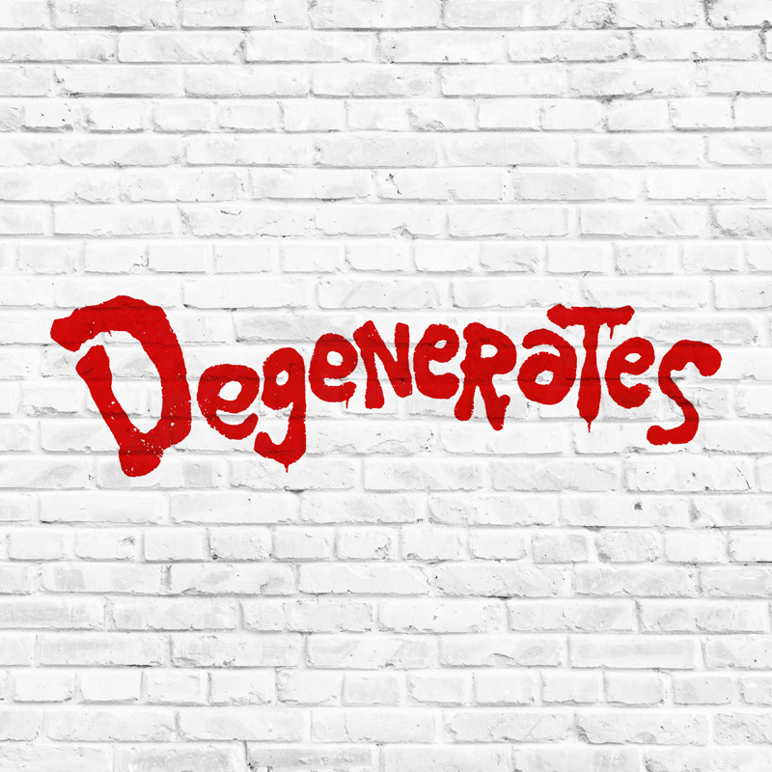](https://nam04.safelinks.protection.outlook.com/?url=https%3A%2F%2Ffbr.lnk.to%2FDegenerates&data=02%7C01%7CSydneyWorden%40elektra.com%7C1039d2a21a974aa130f408d7257866e6%7C8367939002ec4ba1ad3d69da3fdd637e%7C0%7C0%7C637019071374729937&sdata=agfQV98vISTE31R3Vk%2BVwmzP1AD3TryqD%2BUCyiCfOS8%3D&reserved=0)

[http://adtr.com/](https://nam04.safelinks.protection.outlook.com/?url=http%3A%2F%2Fadtr.com%2F&data=02%7C01%7CSydneyWorden%40elektra.com%7C1039d2a21a974aa130f408d7257866e6%7C8367939002ec4ba1ad3d69da3fdd637e%7C0%7C0%7C637019071374729937&sdata=ZYHC4YYffIy%2FocKT9xipkPLYwIlqsV04ab8DF0d4G%2B0%3D&reserved=0)

[https://www.facebook.com/adtr](https://nam04.safelinks.protection.outlook.com/?url=https%3A%2F%2Fwww.facebook.com%2Fadtr&data=02%7C01%7CSydneyWorden%40elektra.com%7C1039d2a21a974aa130f408d7257866e6%7C8367939002ec4ba1ad3d69da3fdd637e%7C0%7C0%7C637019071374729937&sdata=OCqoXcrOO%2FnDX0dOJ0HKReMkt1oEZPAWXf0ajofM6ic%3D&reserved=0)

[https://twitter.com/adtr](https://nam04.safelinks.protection.outlook.com/?url=https%3A%2F%2Ftwitter.com%2Fadtr&data=02%7C01%7CSydneyWorden%40elektra.com%7C1039d2a21a974aa130f408d7257866e6%7C8367939002ec4ba1ad3d69da3fdd637e%7C0%7C0%7C637019071374739927&sdata=ShgCKONi6LOFPi21NC41L9v1pAyi%2BNn%2B6pXCxGCdM2Y%3D&reserved=0)

[https://www.instagram.com/adtr/](https://nam04.safelinks.protection.outlook.com/?url=https%3A%2F%2Fwww.instagram.com%2Fadtr%2F&data=02%7C01%7CSydneyWorden%40elektra.com%7C1039d2a21a974aa130f408d7257866e6%7C8367939002ec4ba1ad3d69da3fdd637e%7C0%7C0%7C637019071374739927&sdata=vUhaQBst100kd4tCUeyRh%2B2fD%2Bpw%2BFhbQgyAbZ8Hp2k%3D&reserved=0)

[https://www.youtube.com/adaytoremember](https://nam04.safelinks.protection.outlook.com/?url=https%3A%2F%2Fwww.youtube.com%2Fadaytoremember&data=02%7C01%7CSydneyWorden%40elektra.com%7C1039d2a21a974aa130f408d7257866e6%7C8367939002ec4ba1ad3d69da3fdd637e%7C0%7C0%7C637019071374749925&sdata=cjcJ16N%2FqQrQUp%2BiK2XXggb8FfkKIG9UXFGXlKztfTg%3D&reserved=0)

pastedGraphic_2.png

**Press Contact:**Collin Citron

[CollinCitron@elektra.com](mailto:CollinCitron@elektra.com) / 818-238-6314