ANDERSON EAST PERFORMS “MADELYN” ON “LATE NIGHT WITH SETH MEYERS”
NEW ALBUM MAYBE WE NEVER DIE OUT AUGUST 20
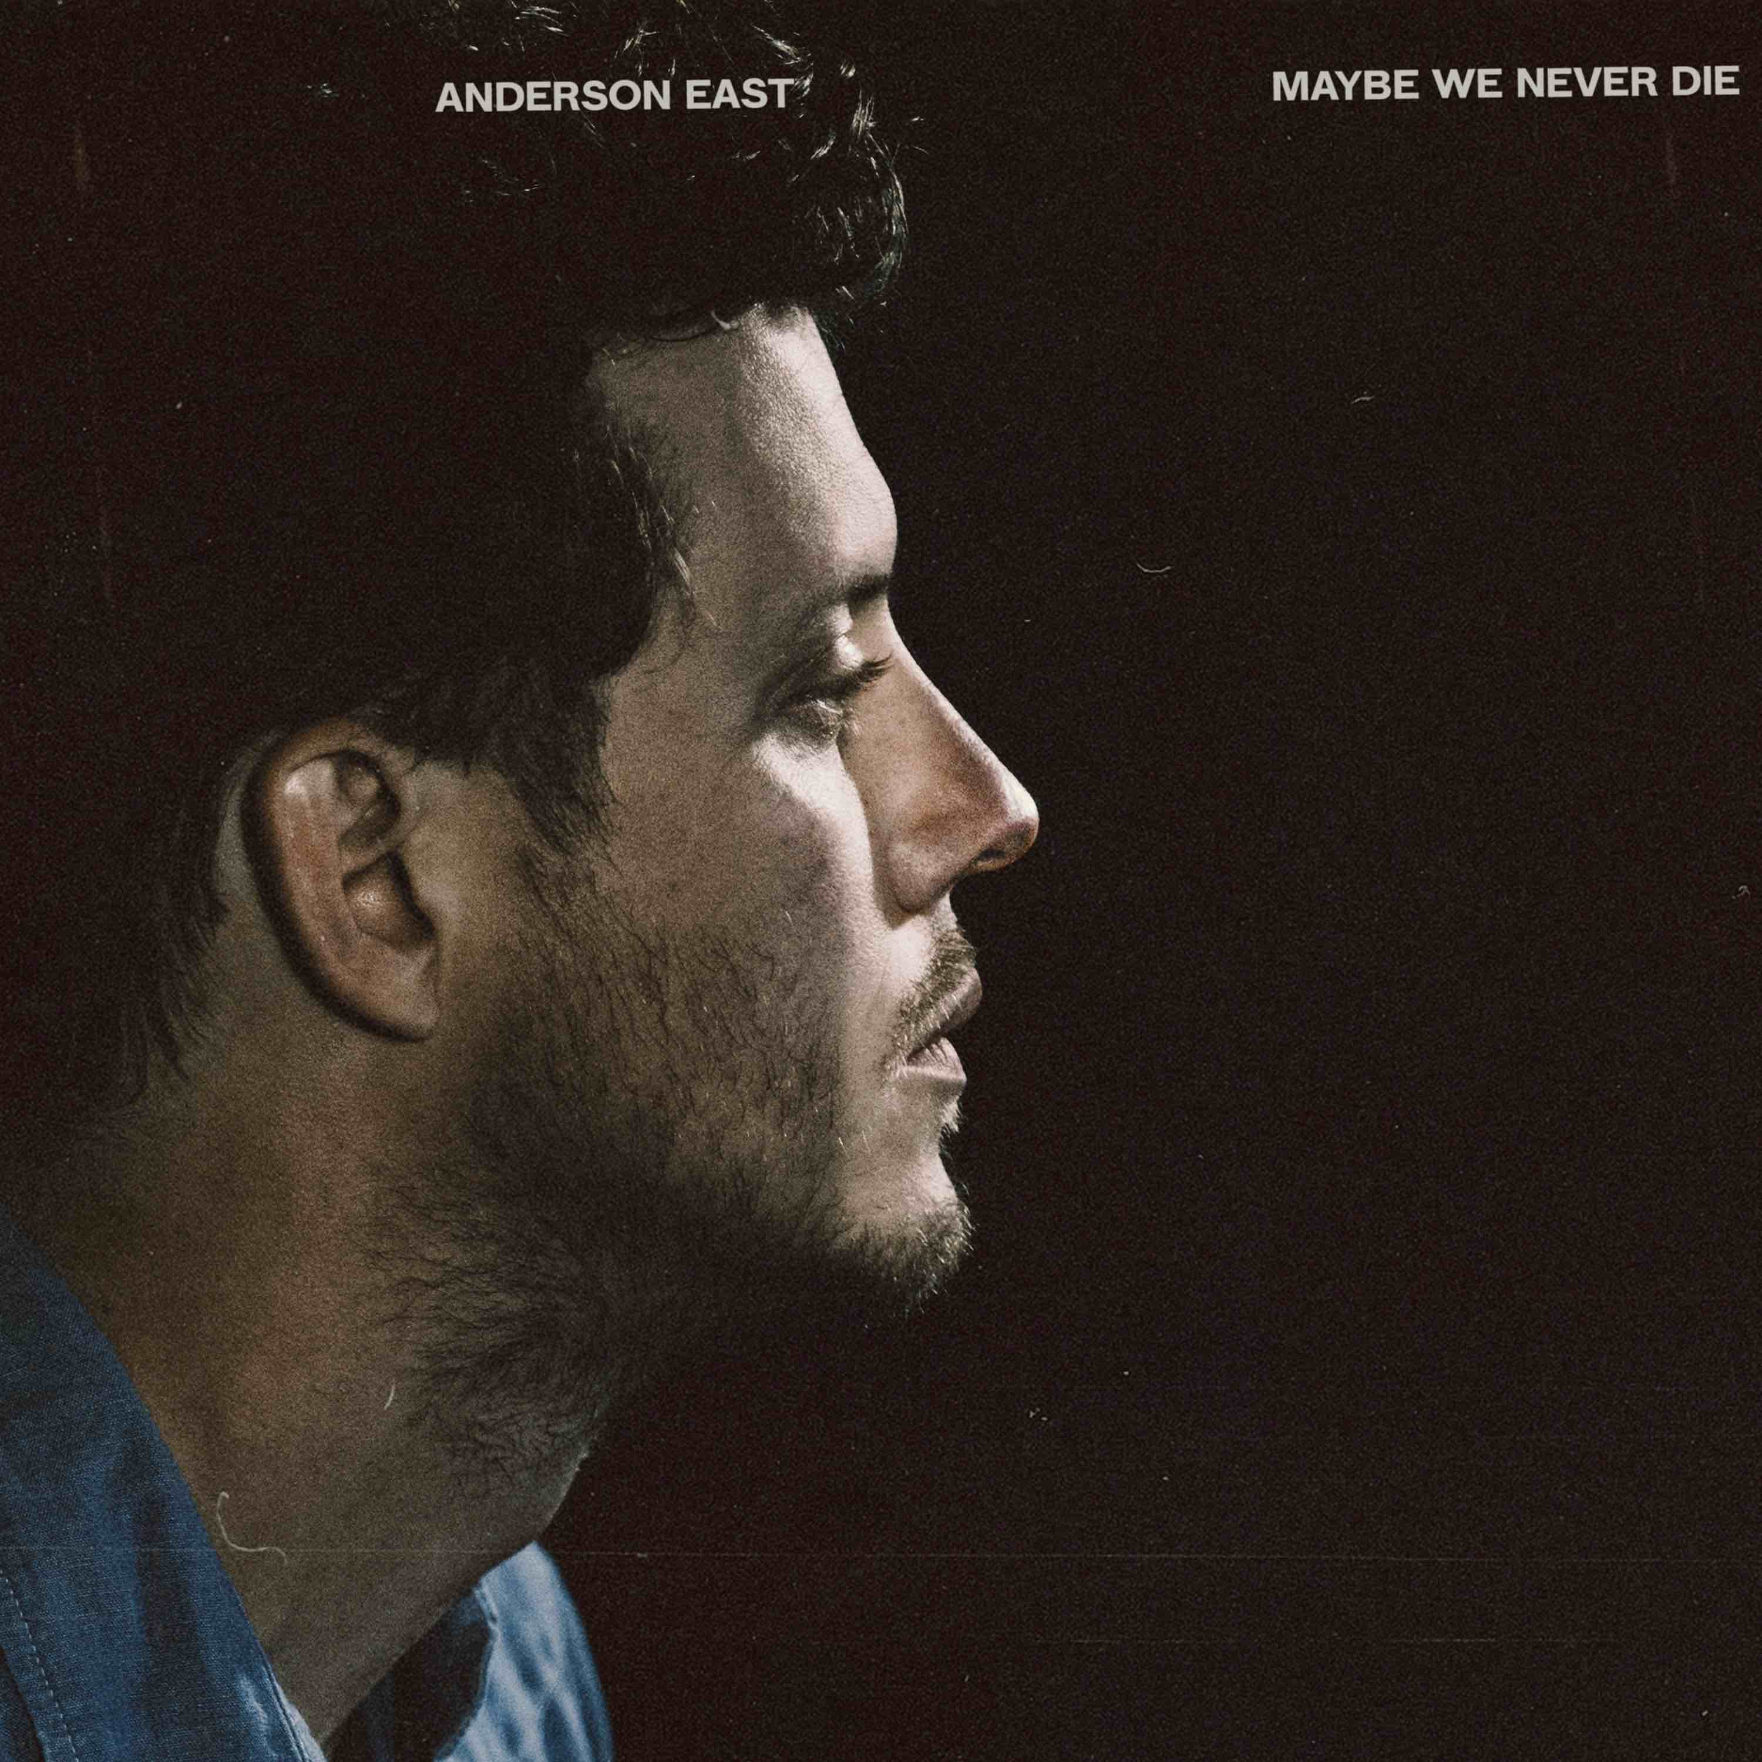
April 15, 2021—Anderson East returned to “Late Night with Seth Meyers” last night to perform his new single, “Madelyn.” Watch/share HERE.
“Madelyn” is the first track unveiled from East’s highly anticipated new album, Maybe We Never Die, which will be released August 20 and is now available for pre-order. Of the song, which debuted earlier this month, Rolling Stone praises, “mixes immersive, polished production with the easygoing soul of his voice,” while American Songwriter declares, “a peer into all the dystopian, curious, and uncertain lives permeating upcoming album Maybe We Never Die.”
East’s third release for Elektra/Low Country Sound, Maybe We Never Die takes the Alabama born, Nashville-based singer-songwriter’s seductively vintage voice in a decidedly fresh direction. Collaborating once again with Grammy Award-winning producer Dave Cobb along with longtime bandleader and now co-producer Philip Towns, the 12 tracks flow together with an overarching sense of urgency but maintain distinct musical boundaries. The energy toggles between a hunger for vulnerability in togetherness and a clinging to solitude as a romantic self-defense. There is consternation with the speed and volume at which the world operates and solace to be found in the simple act of getting up and going.
Of the album, East shares, “I wanted to create something unique with this record. A piece of music, that as a whole, knew where its footing was but yet still attempted to see what was behind the curtains. I’m very proud of what it took to make and its ultimate outcome. I am very grateful to the wonderfully talented humans that lent their gifts to make it what it is.”
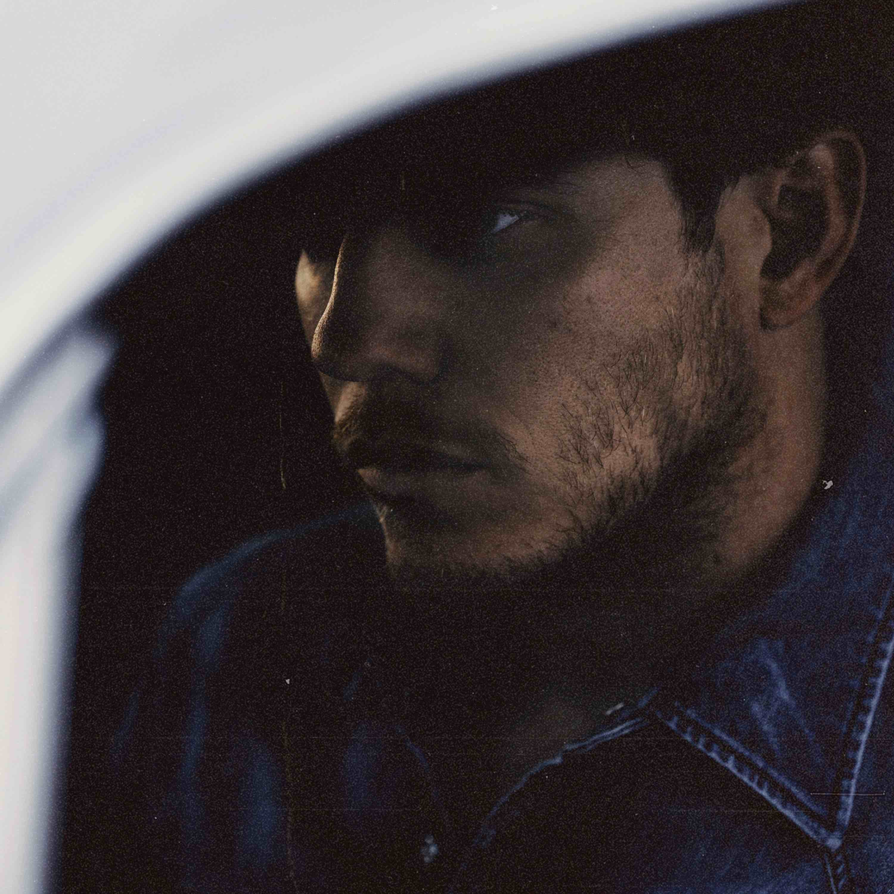
Photo credit: Kat Irlin
This is East’s first new music since 2018’s breakthrough album, Encore, which featured the Grammy-nominated #1 AAA radio single, “All On My Mind.” Heralded by critics, The New York Times praised Encore as, “…an often lustrous revisiting of raucous Southern soul, rousingly delivered and pinpoint precise. He has a voice full of extremely careful scrape and crunch, but his howls never feel unhinged,” while Rolling Stone declared, “On Encore, East’s influences meld seamlessly, stacking the album with Stax-worthy R&B grooves, gospel-blues ooohs and aaahs, surging keys and blasting brass.” Known for his magnetic live performances, East and his band have performed sold-out shows worldwide and have been featured on ABC’s “Jimmy Kimmel Live!,” CBS’ “The Late Show with Stephen Colbert” and “CBS This Morning Saturday,” NBC’s “TODAY” and “Late Night with Seth Meyers,” PBS’ “Austin City Limits” and more.
MAYBE WE NEVER DIE TRACKLIST
1. Maybe We Never Die
2. Lights On
3. Madelyn
4. Drugs
5. I Hate You
6. Hood Of My Car
7. Falling
8. Jet Black Pontiac
9. Like Nothing Ever Happened
10. If You Really Love Me
11. Just You & I
12. Interstellar Outer Space

