ANDERSON EAST’S NEW SONG “DRUGS” DEBUTS TODAY; WATCH THE OFFICIAL MUSIC VIDEO
NEW ALBUM MAYBE WE NEVER DIE OUT AUGUST 20
EXTENSIVE HEADLINE TOUR CONFIRMED, TICKETS ON-SALE THIS FRIDAY
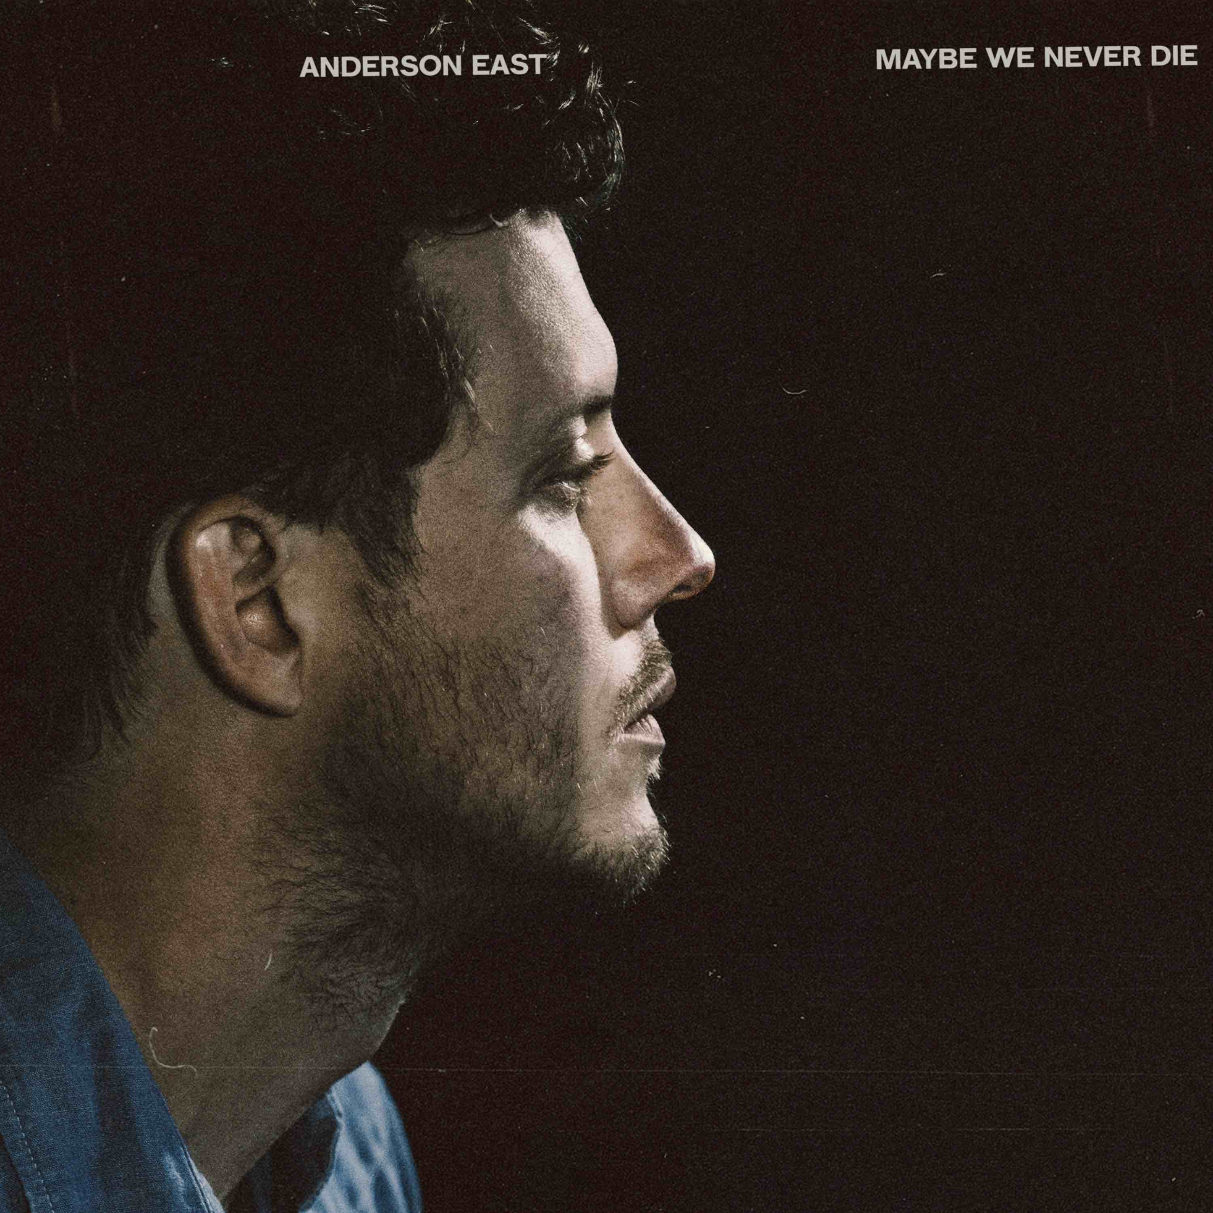
May 19, 2021—GRAMMY-nominated singer, songwriter and performer Anderson East’s new song, “Drugs,” is debuting today. Watch/share the official music video HERE.
Of the track, East shares, “I feel like that song, that was the hardest one to get right, because it’s definitely not a glorification of drugs. If anything, it’s a hardened look at yourself inward. Me and my buddy and co-writer Aaron Raitiere were in LA, and we’re cruising around, and you’re just like, what is going on here? Where are all these people going? It’s like everybody’s on drugs in this place…You just start calling a spade a spade about what drugs mean: Well, I’ve had coffee this morning. Some people go to the gym. Some people are going to church. Some people are on Twitter. I wouldn’t call it a protest song, but it’s just like a, ‘Is anybody else seeing what I’m seeing right now?’ It’s our inability to just interface with reality.”
“Drugs” is the second song unveiled from East’s highly anticipated new album, Maybe We Never Die, which will be released August 20 and is now available for pre-order. His third release for Elektra/Low Country Sound, Maybe We Never Die takes the Alabama born, Nashville-based singer-songwriter’s seductively vintage voice in a decidedly fresh direction. Collaborating once again with Grammy Award-winning producer Dave Cobb along with longtime bandleader and now co-producer Philip Towns, the 12 tracks flow together with an overarching sense of urgency but maintain distinct musical boundaries. The energy toggles between a hunger for vulnerability in togetherness and a clinging to solitude as a romantic self-defense. There is consternation with the speed and volume at which the world operates and solace to be found in the simple act of getting up and going.
Ahead of the release, East appeared on “Late Night with Seth Meyers” last month to perform the album’s lead single, “Madelyn,” of which Rolling Stone praises, “mixes immersive, polished production with the easygoing soul of his voice,” while American Songwriter declares, “a peer into all the dystopian, curious, and uncertain lives permeating upcoming album Maybe We Never Die.”
In celebration of the new music, East performed a special full-band livestream concert last night (watch HERE) and will return to the stage this fall with his newly confirmed “Maybe We Never Die” headline tour. Upcoming stops include Nashville’s historic Ryman Auditorium, Austin’s Mohawk, Los Angeles’ Troubadour, Seattle’s The Showbox, Chicago’s Vic Theatre, New York’s Webster Hall, Philadelphia’s Union Transfer and Boston’s Paradise among many others. See below for complete itinerary. Tickets for the tour go on-sale this Friday, May 21 at 10:00am local time, full details can be found at www.andersoneast.com.

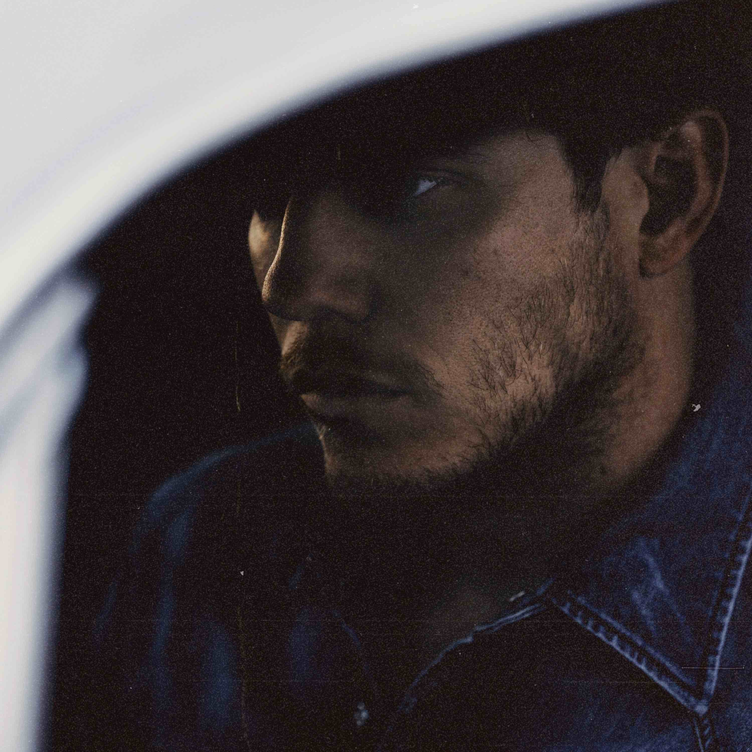
Photo credit: Kat Irlin
Reflecting on the new album, East shares, “I wanted to create something unique with this record. A piece of music, that as a whole, knew where its footing was but yet still attempted to see what was behind the curtains. I’m very proud of what it took to make and its ultimate outcome. I am very grateful to the wonderfully talented humans that lent their gifts to make it what it is.”
Maybe We Never Die is East’s first new music since 2018’s breakthrough album, Encore, which featured the Grammy-nominated #1 AAA radio single, “All On My Mind.” Heralded by critics, The New York Times praised Encore as, “…an often lustrous revisiting of raucous Southern soul, rousingly delivered and pinpoint precise. He has a voice full of extremely careful scrape and crunch, but his howls never feel unhinged,” while Rolling Stone declared, “On Encore, East’s influences meld seamlessly, stacking the album with Stax-worthy R&B grooves, gospel-blues ooohs and aaahs, surging keys and blasting brass.” Known for his magnetic live performances, East and his band have performed sold-out shows worldwide and have been featured on ABC’s “Jimmy Kimmel Live!,” CBS’ “The Late Show with Stephen Colbert” and “CBS This Morning Saturday,” NBC’s “TODAY” and “Late Night with Seth Meyers,” PBS’ “Austin City Limits” and more.
MAYBE WE NEVER DIE TRACKLIST
1. Maybe We Never Die
2. Lights On
3. Madelyn
4. Drugs
5. I Hate You
6. Hood Of My Car
7. Falling
8. Jet Black Pontiac
9. Like Nothing Ever Happened
10. If You Really Love Me
11. Just You & I
12. Interstellar Outer Space

ANDERSON EAST CONFIRMED TOUR DATES
October 13—Mobile, AL—Soul Kitchen
October 15—Dallas, TX—Venue TBA
October 16—Houston, TX—White Oak Music Hall
October 17—Austin, TX—Mohawk
October 22—Los Angeles, CA—Troubadour*
October 23—San Diego, CA—The Observatory*
October 24—San Francisco, CA—Filmore*
October 26—Crystal Bay, NV—Crystal Bay Club Crown Room*
October 28—Portland, OR—Roseland Theatre*
October 29—Eugene, OR—WOW Hall*
October 30—Seattle, WA—The Showbox*
October 31—Vancouver, Canada—Rickshaw Theatre*
November 2—Boise, ID—Knitting Factory*
November 3—Salt Lake City, UT—Commonwealth*
November 5—Englewood, CO—Gothic Theatre*
November 6—Fort Collins, CO—Venue TBA*
November 12—Nashville, TN—Ryman Auditorium†
November 30—Indianapolis, IN—The Vogue‡
December 1—Detroit, MI—St. Andrews Hall‡
December 3—Chicago, IL—Vic Theatre‡
December 4—Minneapolis, MN—First Avenue‡
December 5—Madison, WI—Majestic Theatre‡
December 7—Omaha, NE—Slowdown‡
December 8—Des Moines, IA—Wooly’s‡
December 10—Kansas City, MO—Madrid Theatre‡
December 11—St. Louis, MO—Delmar Hall‡
December 12—Chattanooga, TN—Walker Theatre‡
December 14—Asheville, NC—Orange Peel‡
December 15—Knoxville, TN—Bijou Theatre‡
December 17—Columbus, OH—Newport Music Hall‡
December 18—Cincinnati, OH—Bogart’s‡
January 13—Atlanta, GA—Variety Playhouse*
January 14—Charlotte, NC—Fillmore*
January 15—Raleigh, NC—Lincoln Theatre*
January 18—Washington, DC—9:30 Club*
January 21—New York, NY—Webster Hall*
January 22—Philadelphia, PA—Union Transfer*
January 23—Charlottesville, VA—Jefferson Theater*
January 25—Burlington, VT—Higher Ground Ballroom*
January 26—Portland, ME—State Theatre*
January 28—Boston, MA—Paradise*
February 1—Pittsburgh, PA—Mr. Smalls*
February 2—Toronto, Canada—Danforth Music Hall*
February 4—Louisville, KY—Mercury
*with special guest Bendigo Fletcher
†with special guest Foy Vance
‡with special guest Savannah Conley

