ANDERSON EAST’S NEW ALBUM MAYBE WE NEVER DIE OUT TODAY
EXTENSIVE FALL HEADLINE TOUR CONFIRMED
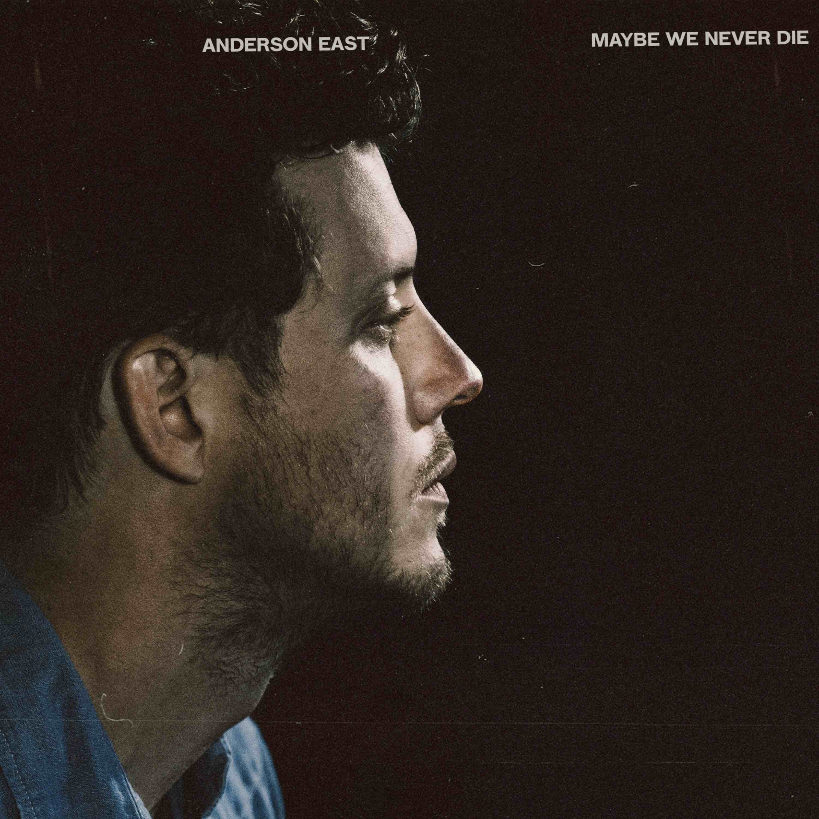
August 20, 2021—GRAMMY-nominated singer, songwriter and performer Anderson East’s highly anticipated new album, Maybe We Never Die, is out today. Stream/purchase HERE.
East’s third release for Elektra/Low Country Sound, Maybe We Never Die takes the Alabama born, Nashville-based artist’s seductively vintage voice in a decidedly fresh direction. Collaborating once again with Grammy Award-winning producer Dave Cobb along with longtime bandleader and now co-producer Philip Towns, the 12 tracks flow together with an overarching sense of urgency but maintain distinct musical boundaries. In conjunction with the release, a new video for the title track is debuting today—watch/share HERE.
Critical acclaim for Maybe We Never Die…
“‘80s pop-infused elixir…his hefty vocals seem only more urgent in this subdued setting, evoking the raw desire that accompanies new love”—NPR Music
“mixes immersive, polished production with the easygoing soul of his voice”—Rolling Stone
“East chooses to eschew the tried-and-true in favor of new textures and sonic influences that take him away from straightforward roots-based music and into the realm of ’80s and ’90s R&B…he pulls this shift off with aplomb.”—No Depression
“Mixing classic undertones and an energy rush, the Alabama native blends smoky R&B and soul with a sleek modernity, and a seductive strut”—Nashville Lifestyles
“a real-deal talent. And a legit threat (voice, looks, presence) to be a major star”—AL.com
“The heaviness of the synths crashing up against the more organic instrumentation, the crickets chirping into the night, and the rawness of East’s voice, makes the whole thing bigger and brighter…to take such an intimate and undefinable feeling and make it tangible, as if you were there, is magical.”—Atwood Magazine
In celebration of the new music, East will return to the stage this fall with his extensive “Maybe We Never Die” headline tour. Upcoming stops include Nashville’s historic Ryman Auditorium (two nights, one sold-out), Austin’s Mohawk, Los Angeles’ Troubadour (two nights, one sold-out), Seattle’s The Showbox, Chicago’s Vic Theatre, New York’s Webster Hall, Philadelphia’s Union Transfer and Boston’s Paradise among many others. See below for complete itinerary, full details can be found at www.andersoneast.com.
Reflecting on the album, East shares, “I wanted to create something unique with this record. A piece of music, that as a whole, knew where its footing was but yet still attempted to see what was behind the curtains. I’m very proud of what it took to make and its ultimate outcome. I am very grateful to the wonderfully talented humans that lent their gifts to make it what it is.”
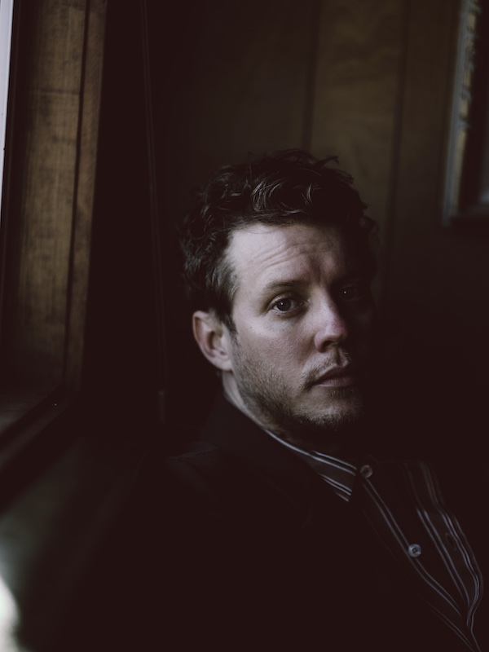
Photo credit: Kat Irlin
Maybe We Never Die is East’s first new music since 2018’s breakthrough album, Encore, which featured the Grammy-nominated #1 AAA radio single, “All On My Mind.” Heralded by critics, The New York Times praised Encore as, “…an often lustrous revisiting of raucous Southern soul, rousingly delivered and pinpoint precise. He has a voice full of extremely careful scrape and crunch, but his howls never feel unhinged,” while Rolling Stone declared, “On Encore, East’s influences meld seamlessly, stacking the album with Stax-worthy R&B grooves, gospel-blues ooohs and aaahs, surging keys and blasting brass.” Known for his magnetic live performances, East and his band have performed sold-out shows worldwide and have been featured on ABC’s “Jimmy Kimmel Live!,” CBS’ “The Late Show with Stephen Colbert” and “CBS This Morning Saturday,” NBC’s “TODAY” and “Late Night with Seth Meyers,” PBS’ “Austin City Limits” and more.
MAYBE WE NEVER DIE TRACKLIST
1. Maybe We Never Die
2. Lights On
3. Madelyn
4. Drugs
5. I Hate You
6. Hood Of My Car
7. Falling
8. Jet Black Pontiac
9. Like Nothing Ever Happened
10. If You Really Love Me
11. Just You & I
12. Interstellar Outer Space

ANDERSON EAST CONFIRMED TOUR DATES
August 29—Moorhead, MN—Sister Cities Smokeout
September 25—Portsmouth, NH—The Music Hall
October 13—Mobile, AL—Soul Kitchen
October 15—Dallas, TX—The HiFi Dallas
October 16—Houston, TX—White Oak Music Hall
October 17—Austin, TX—Mohawk
October 21—Los Angeles, CA*—Troubadour
October 22—Los Angeles, CA—Troubadour* (SOLD OUT)
October 23—San Diego, CA—The Observatory*
October 24—San Francisco, CA—Filmore*
October 26—Crystal Bay, NV—Crystal Bay Club Crown Room*
October 28—Portland, OR—Roseland Theatre*
October 29—Eugene, OR—WOW Hall*
October 30—Seattle, WA—The Showbox*
October 31—Vancouver, Canada—Rickshaw Theatre*
November 2—Boise, ID—Knitting Factory*
November 3—Salt Lake City, UT—Commonwealth*
November 5—Englewood, CO—Gothic Theatre*
November 6—Fort Collins, CO—Washington’s*
November 12—Nashville, TN—Ryman Auditorium† (SOLD OUT)
November 13—Nashville, TN—Ryman Auditorium†
November 30—Indianapolis, IN—The Vogue‡
December 1—Detroit, MI—St. Andrews Hall‡
December 3—Chicago, IL—Vic Theatre‡
December 4—Minneapolis, MN—First Avenue‡
December 5—Madison, WI—Majestic Theatre‡
December 7—Omaha, NE—Slowdown‡
December 8—Des Moines, IA—Wooly’s‡
December 10—Kansas City, MO—Madrid Theatre‡
December 11—St. Louis, MO—Delmar Hall‡
December 12—Chattanooga, TN—Walker Theatre‡
December 14—Asheville, NC—Orange Peel‡
December 15—Knoxville, TN—Bijou Theatre‡
December 17—Columbus, OH—Newport Music Hall‡
December 18—Cincinnati, OH—Bogart’s‡
December 31—Birmingham, AL—Alabama Theatre+
January 13—Atlanta, GA—Variety Playhouse*
January 14—Charlotte, NC—Fillmore*
January 15—Raleigh, NC—Lincoln Theatre*
January 18—Washington, DC—9:30 Club*
January 21—New York, NY—Webster Hall*
January 22—Philadelphia, PA—Union Transfer*
January 23—Charlottesville, VA—Jefferson Theater*
January 25—Burlington, VT—Higher Ground Ballroom*
January 26—Portland, ME—State Theatre*
January 28—Boston, MA—Paradise*
February 1—Pittsburgh, PA—Mr. Smalls*
February 2—Toronto, Canada—Danforth Music Hall*
February 4—Louisville, KY—Mercury
*with special guest Bendigo Fletcher
†with special guest Foy Vance
‡with special guest Savannah Conley
+with special guest Morgan Wade

