**ALL TIME LOW SCORE FIRST-EVER #1 AT RADIO AS “MONSTERS” (FEAT. BLACKBEAR) TOPS MODERN ROCK**



Photo Credit: Jimmy Fontaine

**September 14, 2020** - Fueled By Ramen band **All Time Low** have achieved their first-ever #1 at radio as their latest single [“Monsters” (feat. blackbear)](https://nam04.safelinks.protection.outlook.com/?url=https%3A%2F%2Fyoutu.be%2F6aIVwQFSnVc&data=02%7C01%7CSydneyWorden%40elektra.com%7C27360d80cd414491ca0a08d858b6c4d8%7C8367939002ec4ba1ad3d69da3fdd637e%7C0%7C0%7C637356889301851192&sdata=ePLukNDXJr6f3yc8sOwROpGixYTSTdcKktJmXq07LTY%3D&reserved=0) vaults to the top spot at Modern Rock this week. Marking a career first for the platinum-selling group, the song has completed a steady climb to #1. “Monsters” is the latest single off All Time Low’s critically acclaimed new album *Wake Up, Sunshine*, which is available now [HERE](https://nam04.safelinks.protection.outlook.com/?url=https%3A%2F%2Ffbr.lnk.to%2Fwakeupsunshine&data=02%7C01%7CSydneyWorden%40elektra.com%7C27360d80cd414491ca0a08d858b6c4d8%7C8367939002ec4ba1ad3d69da3fdd637e%7C0%7C0%7C637356889301851192&sdata=CCsSKXsoAgmSA17ZwIogyjjHuTEt64v5tBuYh%2FY33C8%3D&reserved=0).

Throughout a catalog streamed nearly half-a-billion times and highlighted by two gold albums, two gold singles, and a platinum single, All Time Low have continually raised the bar for both pop and punk. Since 2003, the group has notched five Top 10 entries on the *Billboard* Top 200, and canvased the world, headlining arenas on three continents. After nearly two decades together, the four musicians — Alex Gaskarth [vocals, guitar], Jack Barakat [guitar, vocals], Zack Merrick [bass, vocals], and Rian Dawson [drums] — have rekindled the spark they first ignited in a Baltimore basement on their latest album, [*Wake Up, Sunshine*](https://nam04.safelinks.protection.outlook.com/?url=https%3A%2F%2Ffbr.lnk.to%2Fwakeupsunshine&data=02%7C01%7CSydneyWorden%40elektra.com%7C27360d80cd414491ca0a08d858b6c4d8%7C8367939002ec4ba1ad3d69da3fdd637e%7C0%7C0%7C637356889301861178&sdata=3Xd6ZAv08Ckm%2FivmgpIfiG38qkhqiPk5F5M9jmgP6oo%3D&reserved=0).

*Wake Up, Sunshine*  was released in April and debuted at #1 on Billboard’s Top Rock Albums Chart. Upon its release, *Billboard* proclaimed “The album is All Time Low’s most vibrant set to date, combining the band’s rambunctious spirit with roaring guitars and anthemic melodies.” *Forbes* praised the collection as “an album that crackles with youthful exuberance and the energy of a live show,” while *Nylon* declared “All Time Low just wants their new album to make you feel good.”

All Time Low recently released an acoustic version of “Monsters”, which is available to stream and download now [HERE](https://nam04.safelinks.protection.outlook.com/?url=https%3A%2F%2Fatl.lnk.to%2Fmonstersacoustic&data=02%7C01%7CSydneyWorden%40elektra.com%7C27360d80cd414491ca0a08d858b6c4d8%7C8367939002ec4ba1ad3d69da3fdd637e%7C0%7C0%7C637356889301861178&sdata=gK6IWsKi3Gf%2BjMYYXwJyvQ5U0lSKa41MOZWnwMT%2FYPU%3D&reserved=0). The band also unveiled an official music video for the acoustic track. Watch it [HERE](https://nam04.safelinks.protection.outlook.com/?url=https%3A%2F%2Fyoutu.be%2F3Le4j-SP7sg&data=02%7C01%7CSydneyWorden%40elektra.com%7C27360d80cd414491ca0a08d858b6c4d8%7C8367939002ec4ba1ad3d69da3fdd637e%7C0%7C0%7C637356889301871182&sdata=vpqrd9uHwB2lkTfyv5ptWiRjJQkUNLkbLBOoVgW6wTI%3D&reserved=0).

Earlier this summer, All Time Low unveiledSummer Daze Rosé, their third wine release in partnership with [Wines That Rock](https://nam04.safelinks.protection.outlook.com/?url=http%3A%2F%2Fr20.rs6.net%2Ftn.jsp%3Ff%3D001vFjJA_BmKw5mlcIdDuUrkFaAhI3md-C4u0jAZVl043sFokBkAb7cpN38n0J9JBcQ66_ee7soiOLbrx-zP4-OYbA_1O3OKdzDmy5ck_qmgQ7AKW8LNJqxr_d0siqQmyWAQn9cNgOobSLKMlC_-XDuFA%3D%3D%26c%3DJYh4lf6hCq9FwniwvYaTyYQilO4GwFRaoghg_OIogkbbiyVgerB0PA%3D%3D%26ch%3Dth6UBg0DbpfIRqmolErwnD7A5iMKDodHtDKK2K5ViKdPzsN0OOnfUA%3D%3D&data=02%7C01%7CSydneyWorden%40elektra.com%7C27360d80cd414491ca0a08d858b6c4d8%7C8367939002ec4ba1ad3d69da3fdd637e%7C0%7C0%7C637356889301871182&sdata=zciekRUH8TndGJQrP2TfWiA%2BMPbbLtPHplbHmLp3GBA%3D&reserved=0). Summer Daze Rosé can be purchased exclusively from All Time Low’s Everything Is Wine webstore [HERE](https://nam04.safelinks.protection.outlook.com/?url=http%3A%2F%2Fr20.rs6.net%2Ftn.jsp%3Ff%3D001vFjJA_BmKw5mlcIdDuUrkFaAhI3md-C4u0jAZVl043sFokBkAb7cpN38n0J9JBcQ7nstwuQ0x34TkwMcyDJKoXwmi8Tfr-M2PX2SpYZaRZE18FkvbqfZPTxhU27jL7hH9rzvZzpn9U98tQMkgqKHoJ46VIHwIMRsIctjrq1Kum0%3D%26c%3DJYh4lf6hCq9FwniwvYaTyYQilO4GwFRaoghg_OIogkbbiyVgerB0PA%3D%3D%26ch%3Dth6UBg0DbpfIRqmolErwnD7A5iMKDodHtDKK2K5ViKdPzsN0OOnfUA%3D%3D&data=02%7C01%7CSydneyWorden%40elektra.com%7C27360d80cd414491ca0a08d858b6c4d8%7C8367939002ec4ba1ad3d69da3fdd637e%7C0%7C0%7C637356889301881172&sdata=Jlxo8Mq2ViJq3NHFulTuTJHeRLG%2BkqbMwIMprSEwVqQ%3D&reserved=0). Band members Alex Gaskarth and Jack Barakat also just ignited their multi-platform podcast Crash Test Live. Tailored to and recorded live for a streaming audience, the co-hosts provide the hottest and most hilarious takes on the *“Wonderful News”* of the week and possibly true, yet possibly not *“Fun Facts*.*”* Past episodes of Crash Test Live are available on [YouTube](https://nam04.safelinks.protection.outlook.com/?url=https%3A%2F%2Fwww.youtube.com%2Fchannel%2FUCB2Wr4MS5PZjiuhmaRGxk1w&data=02%7C01%7CSydneyWorden%40elektra.com%7C27360d80cd414491ca0a08d858b6c4d8%7C8367939002ec4ba1ad3d69da3fdd637e%7C0%7C0%7C637356889301881172&sdata=Un%2Bp3%2BL1I%2F4n37sK306az4peWPad5IKHbUV6LTr6thY%3D&reserved=0) now.

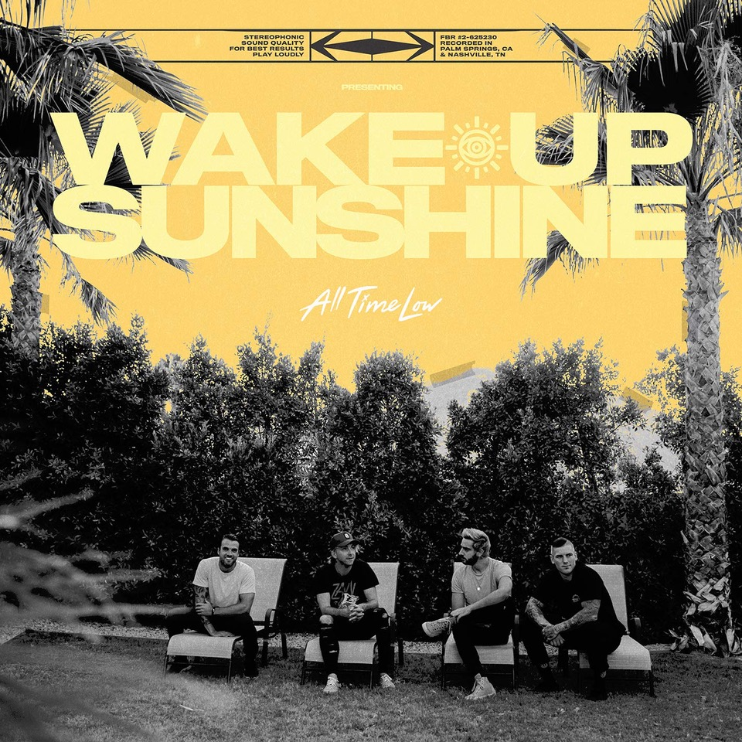

**CONNECT WITH ALL TIME LOW:**

[ALLTIMELOW.COM](https://nam04.safelinks.protection.outlook.com/?url=http%3A%2F%2Fwww.alltimelow.com%2F&data=02%7C01%7CSydneyWorden%40elektra.com%7C27360d80cd414491ca0a08d858b6c4d8%7C8367939002ec4ba1ad3d69da3fdd637e%7C0%7C0%7C637356889301891172&sdata=NChiUaSbVOPj9lIv4boMn88lv0vCqydjM7asvVCVaD8%3D&reserved=0)

[FACEBOOK](https://nam04.safelinks.protection.outlook.com/?url=https%3A%2F%2Ffacebook.com%2Falltimelow&data=02%7C01%7CSydneyWorden%40elektra.com%7C27360d80cd414491ca0a08d858b6c4d8%7C8367939002ec4ba1ad3d69da3fdd637e%7C0%7C0%7C637356889301891172&sdata=C6GbmdxWqs3S4%2Bmf3Cd8OWVKofJQqwJynUfwnAOFSVI%3D&reserved=0)

[TWITTER](https://nam04.safelinks.protection.outlook.com/?url=https%3A%2F%2Ftwitter.com%2Falltimelow&data=02%7C01%7CSydneyWorden%40elektra.com%7C27360d80cd414491ca0a08d858b6c4d8%7C8367939002ec4ba1ad3d69da3fdd637e%7C0%7C0%7C637356889301891172&sdata=YWjcb7GAGoY%2BUqqjgAWoijj9P%2Fe2mfHPBhQ0sSDIpu0%3D&reserved=0)

[YOUTUBE](https://nam04.safelinks.protection.outlook.com/?url=http%3A%2F%2Fyoutube.com%2Falltimelow&data=02%7C01%7CSydneyWorden%40elektra.com%7C27360d80cd414491ca0a08d858b6c4d8%7C8367939002ec4ba1ad3d69da3fdd637e%7C0%7C0%7C637356889301901164&sdata=zN1CmAHeDvyHZY4395%2Ba6mK2iQAn3Dr2egv5IbobgcM%3D&reserved=0)

[INSTAGRAM](https://nam04.safelinks.protection.outlook.com/?url=http%3A%2F%2Finstagram.com%2Falltimelow&data=02%7C01%7CSydneyWorden%40elektra.com%7C27360d80cd414491ca0a08d858b6c4d8%7C8367939002ec4ba1ad3d69da3fdd637e%7C0%7C0%7C637356889301901164&sdata=o95agjyqBpc7tYTfud9x4Kt%2Bgx4Zz%2BnoOvtk2XWCrt4%3D&reserved=0)

[FUELEDBYRAMEN.COM](https://nam04.safelinks.protection.outlook.com/?url=http%3A%2F%2Fwww.fueledbyramen.com%2F&data=02%7C01%7CSydneyWorden%40elektra.com%7C27360d80cd414491ca0a08d858b6c4d8%7C8367939002ec4ba1ad3d69da3fdd637e%7C0%7C0%7C637356889301911161&sdata=hhWr7J8dJ1eCC%2Fa6OhP%2BhTe%2FXrWxsuAQAr4M4r%2F4jHk%3D&reserved=0)

**PRESS CONTACTS:**

Ross Anderson / [RossAnderson@Elektra.com](mailto:RossAnderson@Elektra.com)

Collin Citron / [CollinCitron@Elektra.com](mailto:CollinCitron@Elektra.com)