FOR IMMEDIATE RELEASE

March 18, 2022

**ANDERSON EAST REIMAGINES ACCLAIMED ALBUM *MAYBE WE NEVER DIE* AS *M.W.N.D. / F.A.M.E.***

**RECORDED LIVE AT FAME STUDIOS WITH PRODUCER DAVE COBB**

**AVAILABLE MARCH 25 – PRE-ORDER** [**HERE**](https://nam04.safelinks.protection.outlook.com/?url=https%3A%2F%2Fandersoneast.lnk.to%2FMWNDFAME&data=04%7C01%7CDestinyDominguez%40elektra.com%7Cfbb318d90fca4da76f2608da08e586ec%7C8367939002ec4ba1ad3d69da3fdd637e%7C0%7C0%7C637832079163135371%7CUnknown%7CTWFpbGZsb3d8eyJWIjoiMC4wLjAwMDAiLCJQIjoiV2luMzIiLCJBTiI6Ik1haWwiLCJXVCI6Mn0%3D%7C3000&sdata=DVeFdtgVlXUf6a35aoIYy2NM9k4M4ZyfLHaR2hDy1Ew%3D&reserved=0)

**LEAD SINGLE “LIGHTS ON” AVAILABLE NOW – LISTEN** [**HERE**](https://nam04.safelinks.protection.outlook.com/?url=https%3A%2F%2Fyoutu.be%2FWrQM0Af6pGk&data=04%7C01%7CDestinyDominguez%40elektra.com%7Cfbb318d90fca4da76f2608da08e586ec%7C8367939002ec4ba1ad3d69da3fdd637e%7C0%7C0%7C637832079163135371%7CUnknown%7CTWFpbGZsb3d8eyJWIjoiMC4wLjAwMDAiLCJQIjoiV2luMzIiLCJBTiI6Ik1haWwiLCJXVCI6Mn0%3D%7C3000&sdata=sYbXnMfz%2B9SoORu%2BGbGdce4pAecEnwo41ex0OlZVgUo%3D&reserved=0)

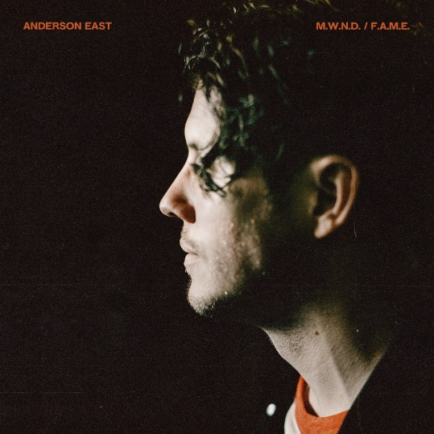

Elektra/Low Country Soundartist **Anderson East** has announced he will release his new album, ***M.W.N.D. / F.A.M.E.*** next Friday, March 25, 2022. The GRAMMY® Award-nominated Alabama-born and Nashville-based singer, songwriter, and performer reimagined, recut, and re-recorded his latest album, *Maybe We Never Die*, live in one day at the legendary FAME Studios in Muscle Shoals, AL. East was accompanied by his bandmates, GRAMMY® Award-winning producer Dave Cobb, and a handful of close friends including Natalie Hemby, Taylor Goldsmith of Dawes, and Foy Vance. *M.W.N.D. / F.A.M.E* is available for pre-order/pre-save starting today [HERE](https://nam04.safelinks.protection.outlook.com/?url=https%3A%2F%2Fandersoneast.lnk.to%2FMWNDFAME&data=04%7C01%7CDestinyDominguez%40elektra.com%7Cfbb318d90fca4da76f2608da08e586ec%7C8367939002ec4ba1ad3d69da3fdd637e%7C0%7C0%7C637832079163135371%7CUnknown%7CTWFpbGZsb3d8eyJWIjoiMC4wLjAwMDAiLCJQIjoiV2luMzIiLCJBTiI6Ik1haWwiLCJXVCI6Mn0%3D%7C3000&sdata=DVeFdtgVlXUf6a35aoIYy2NM9k4M4ZyfLHaR2hDy1Ew%3D&reserved=0).

East has also unveiled the album’s lead single **“Lights On”**. The track highlights the undeniable power and unpredictable magic of the lively session at FAME Studios. “Lights On”  is available to stream and download starting today [HERE](https://nam04.safelinks.protection.outlook.com/?url=https%3A%2F%2Fandersoneast.lnk.to%2FMWNDFAME&data=04%7C01%7CDestinyDominguez%40elektra.com%7Cfbb318d90fca4da76f2608da08e586ec%7C8367939002ec4ba1ad3d69da3fdd637e%7C0%7C0%7C637832079163135371%7CUnknown%7CTWFpbGZsb3d8eyJWIjoiMC4wLjAwMDAiLCJQIjoiV2luMzIiLCJBTiI6Ik1haWwiLCJXVCI6Mn0%3D%7C3000&sdata=DVeFdtgVlXUf6a35aoIYy2NM9k4M4ZyfLHaR2hDy1Ew%3D&reserved=0). Watch a visualizer for the song on East’s official YouTube channel [HERE](https://nam04.safelinks.protection.outlook.com/?url=https%3A%2F%2Fyoutu.be%2FWrQM0Af6pGk&data=04%7C01%7CDestinyDominguez%40elektra.com%7Cfbb318d90fca4da76f2608da08e586ec%7C8367939002ec4ba1ad3d69da3fdd637e%7C0%7C0%7C637832079163135371%7CUnknown%7CTWFpbGZsb3d8eyJWIjoiMC4wLjAwMDAiLCJQIjoiV2luMzIiLCJBTiI6Ik1haWwiLCJXVCI6Mn0%3D%7C3000&sdata=sYbXnMfz%2B9SoORu%2BGbGdce4pAecEnwo41ex0OlZVgUo%3D&reserved=0).

Regarding *M.W.N.D. / F.A.M.E.*, East shared, “It’s amazing how easy it is to make a record after you’ve already made it once. This was fun, and it’s a scrapbook of a moment. We’re used to making records with everyone in the same room. It was nice to revert back to that. I just wanted to be around people and go play something. We decided to go to FAME for a day, because it’s one of our favorite rooms and the people are incredible. It felt very natural to fully simplify *Maybe We Never Die* at a place we enjoy.”

[*Maybe We Never Die*](https://nam04.safelinks.protection.outlook.com/?url=https%3A%2F%2Fandersoneast.lnk.to%2Fmwnd&data=04%7C01%7CDestinyDominguez%40elektra.com%7Cfbb318d90fca4da76f2608da08e586ec%7C8367939002ec4ba1ad3d69da3fdd637e%7C0%7C0%7C637832079163135371%7CUnknown%7CTWFpbGZsb3d8eyJWIjoiMC4wLjAwMDAiLCJQIjoiV2luMzIiLCJBTiI6Ik1haWwiLCJXVCI6Mn0%3D%7C3000&sdata=OSvTsh5j7SdERoCREnSBcetY401KPRy6JVrSfQg2ud4%3D&reserved=0) initially captivated fans and critics last year. The album arrived to widespread acclaim from *Forbes*, *NPR Music*, *Rolling Stone*, *Southern Living*, *American Songwriter, and* more*.* East delivered unforgettable performances of the album’s lead single “[Madelyn](https://nam04.safelinks.protection.outlook.com/?url=https%3A%2F%2Fyoutu.be%2FbhL7A8k6kU8&data=04%7C01%7CDestinyDominguez%40elektra.com%7Cfbb318d90fca4da76f2608da08e586ec%7C8367939002ec4ba1ad3d69da3fdd637e%7C0%7C0%7C637832079163291622%7CUnknown%7CTWFpbGZsb3d8eyJWIjoiMC4wLjAwMDAiLCJQIjoiV2luMzIiLCJBTiI6Ik1haWwiLCJXVCI6Mn0%3D%7C3000&sdata=yYe9XhpPRhS1BR6XQwlw6zxOOFY%2ForehjaHDvN0EdYs%3D&reserved=0)”on *Late Night with Seth Meyers, CBS Saturday Morning*, and *The Ellen DeGeneres Show*, and celebrated the album’s release with his 49-city *Maybe We Never Die Tour* of North America, which wrapped earlier this month.

Now, *M.W.N.D. / F.A.M.E.* represents Anderson East at his most vulnerable, vibrant, and vital.

***M.W.N.D. / F.A.M.E.* TRACKLISTNG**

1. Maybe We Never Die

2. Lights On

3. Madelyn

4. Drugs

5. I Hate You

6. Hood Of My Car

7. Falling

8. Jet Black Pontiac

9. Like Nothing Ever Happened

10. If You Really Love Me

11. Just You & I

12. Interstellar Outer Space

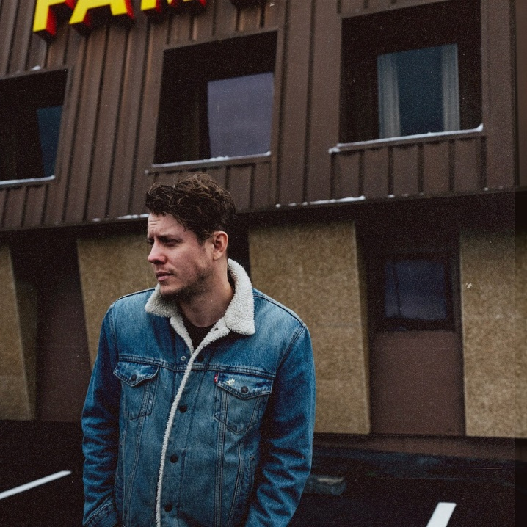

*Photo credit: Joshua Black Wilkins*

**ABOUT ANDERSON EAST:**

GRAMMY® Award-nominated Alabama-born and Nashville-based singer, songwriter, and performer Anderson East has always seamlessly trafficked between heritage soul, Americana, gospel, R&B, blues, roots, and rock. Following his independent debut *Flowers of the Broken Hearted* [2012], he continued to hone his voice and vision on *Delilah* [2015] and *Encore* [2018]. In addition to eclipsing 100 million streams, the latter yielded the single “All on My Mind,” which notably garnered a 2019 GRAMMY® Award nod in the category of *“Best American Roots Performance*.*”* In between sold out headline gigs in historic venues such as the Ryman, he delivered soaring and scorching performances on *Jimmy Kimmel LIVE!*, *The Late Show with Stephen Colbert*, *TODAY*, *Late Night with Seth Meyers*, PBS’ *Austin City Limits*, and more. *Maybe We Never Die* arrived to widespread tastemaker acclaim in 2021. *Forbes* raved, *“Maybe We Never Die is fit for dancing through the end of the world*,*”* *NPR* noted, *“his hefty vocals seem only more urgent in this subdued setting,”* and *American Songwriter* praised, “*characterized by his gentle, mesmerizing melodies* *and warm, twang-tinged vocal contributions, East sets the standard of continuously expanding artistry across the 12-track collection.*”Following the album’s release,he holed up in the world-renowned FAME Studios in Muscle Shoals, AL with his bandmates and longtime collaborator and producer Dave Cobb to cut a new version of the record entitled *M.W.N.D. / F.A.M.E.* [Low Country Sound/Elektra] for 2022. Performing face-to-face in this hallowed locale, they stripped the songs to their core only to give them another dimension altogether with every bit of soul, spark, and spirit intact.

[https://www.andersoneast.com/](https://nam04.safelinks.protection.outlook.com/?url=https%3A%2F%2Fwww.andersoneast.com%2F&data=04%7C01%7CDestinyDominguez%40elektra.com%7Cfbb318d90fca4da76f2608da08e586ec%7C8367939002ec4ba1ad3d69da3fdd637e%7C0%7C0%7C637832079163291622%7CUnknown%7CTWFpbGZsb3d8eyJWIjoiMC4wLjAwMDAiLCJQIjoiV2luMzIiLCJBTiI6Ik1haWwiLCJXVCI6Mn0%3D%7C3000&sdata=aKb8J1I9FlN8xlw6%2FdsCMASVQnweYqHk0EFrbsDVUWY%3D&reserved=0)

[Facebook](https://nam04.safelinks.protection.outlook.com/?url=https%3A%2F%2Fwww.facebook.com%2Fandersoneast&data=04%7C01%7CDestinyDominguez%40elektra.com%7Cfbb318d90fca4da76f2608da08e586ec%7C8367939002ec4ba1ad3d69da3fdd637e%7C0%7C0%7C637832079163291622%7CUnknown%7CTWFpbGZsb3d8eyJWIjoiMC4wLjAwMDAiLCJQIjoiV2luMzIiLCJBTiI6Ik1haWwiLCJXVCI6Mn0%3D%7C3000&sdata=rWbRNuSNPhE4hHEWfIGjaysCSeXjOUJscQU0itFpwe8%3D&reserved=0) | [Instagram](https://nam04.safelinks.protection.outlook.com/?url=https%3A%2F%2Fwww.instagram.com%2Fandersoneast%2F&data=04%7C01%7CDestinyDominguez%40elektra.com%7Cfbb318d90fca4da76f2608da08e586ec%7C8367939002ec4ba1ad3d69da3fdd637e%7C0%7C0%7C637832079163291622%7CUnknown%7CTWFpbGZsb3d8eyJWIjoiMC4wLjAwMDAiLCJQIjoiV2luMzIiLCJBTiI6Ik1haWwiLCJXVCI6Mn0%3D%7C3000&sdata=cwfSxSmRIpQgjKyK109QtsQr3VDCkNbA%2BYZJezFeLao%3D&reserved=0) | [Twitter](https://nam04.safelinks.protection.outlook.com/?url=https%3A%2F%2Ftwitter.com%2Fandersoneast&data=04%7C01%7CDestinyDominguez%40elektra.com%7Cfbb318d90fca4da76f2608da08e586ec%7C8367939002ec4ba1ad3d69da3fdd637e%7C0%7C0%7C637832079163291622%7CUnknown%7CTWFpbGZsb3d8eyJWIjoiMC4wLjAwMDAiLCJQIjoiV2luMzIiLCJBTiI6Ik1haWwiLCJXVCI6Mn0%3D%7C3000&sdata=berfh3qw8iNtdp5iftvaOVkSdHNckrD5nMAf6smXi2Y%3D&reserved=0) | [YouTube](https://nam04.safelinks.protection.outlook.com/?url=https%3A%2F%2Fwww.youtube.com%2Fuser%2Fandersoneast&data=04%7C01%7CDestinyDominguez%40elektra.com%7Cfbb318d90fca4da76f2608da08e586ec%7C8367939002ec4ba1ad3d69da3fdd637e%7C0%7C0%7C637832079163291622%7CUnknown%7CTWFpbGZsb3d8eyJWIjoiMC4wLjAwMDAiLCJQIjoiV2luMzIiLCJBTiI6Ik1haWwiLCJXVCI6Mn0%3D%7C3000&sdata=lcpjVsG3NVw44W%2BdVvd8tRE9I0U1ZXIgJsatDknuDbs%3D&reserved=0)

**Press contacts:**

Collin Citron | [CollinCitron@elektra.com](mailto:CollinCitron@elektra.com)

Glenn Fukushima | [GlennFukushima@elektra.com](mailto:GlennFukushima@elektra.com)