FOR IMMEDIATE RELEASE

MARCH 25, 2022

**ANDERSON EAST RELEASES NEW ALBUM *M.W.N.D. / F.A.M.E.***

**LISTEN**[**HERE**](https://nam04.safelinks.protection.outlook.com/?url=https%3A%2F%2Fandersoneast.lnk.to%2FMWNDFAME&data=04%7C01%7CDestinyDominguez%40elektra.com%7Cb1292d93d070435ac47908da0e67df31%7C8367939002ec4ba1ad3d69da3fdd637e%7C0%7C0%7C637838136533485193%7CUnknown%7CTWFpbGZsb3d8eyJWIjoiMC4wLjAwMDAiLCJQIjoiV2luMzIiLCJBTiI6Ik1haWwiLCJXVCI6Mn0%3D%7C3000&sdata=%2FnKOA9SdQKIhnYr1Hhzrtb%2FEKlhipKWJjsYxdti0JU4%3D&reserved=0)

**REIMAGINED VERSION OF ACCLAIMED ALBUM *MAYBE WE NEVER DIE*RECORDED LIVE AT FAME STUDIOS WITH PRODUCER DAVE COBB**

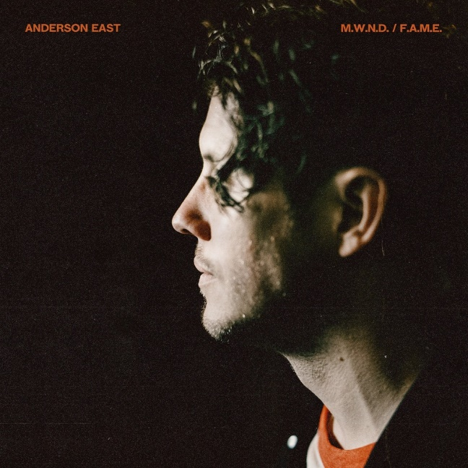

GRAMMY® Award-nominated Alabama-born and Nashville-based singer, songwriter, and performer **Anderson East**has released his new album [***M.W.N.D. / F.A.M.E.***](https://nam04.safelinks.protection.outlook.com/?url=https%3A%2F%2Fandersoneast.lnk.to%2FMWNDFAME&data=04%7C01%7CDestinyDominguez%40elektra.com%7Cb1292d93d070435ac47908da0e67df31%7C8367939002ec4ba1ad3d69da3fdd637e%7C0%7C0%7C637838136533485193%7CUnknown%7CTWFpbGZsb3d8eyJWIjoiMC4wLjAwMDAiLCJQIjoiV2luMzIiLCJBTiI6Ik1haWwiLCJXVCI6Mn0%3D%7C3000&sdata=%2FnKOA9SdQKIhnYr1Hhzrtb%2FEKlhipKWJjsYxdti0JU4%3D&reserved=0)The reimagined recording of his critically acclaimed studio album *Maybe We Never Die* is available to stream and download beginning today [HERE](https://nam04.safelinks.protection.outlook.com/?url=https%3A%2F%2Fandersoneast.lnk.to%2FMWNDFAME&data=04%7C01%7CDestinyDominguez%40elektra.com%7Cb1292d93d070435ac47908da0e67df31%7C8367939002ec4ba1ad3d69da3fdd637e%7C0%7C0%7C637838136533485193%7CUnknown%7CTWFpbGZsb3d8eyJWIjoiMC4wLjAwMDAiLCJQIjoiV2luMzIiLCJBTiI6Ik1haWwiLCJXVCI6Mn0%3D%7C3000&sdata=%2FnKOA9SdQKIhnYr1Hhzrtb%2FEKlhipKWJjsYxdti0JU4%3D&reserved=0) via Elektra/Low Country Sound.

Last year, East reimagined, recut, and re-recorded his fifth full-length offering, *Maybe We Never Die*, live in one day at the legendary FAME Studios in Muscle Shoals, AL as *M.W.N.D. / F.A.M.E.* He was accompanied by his bandmates, GRAMMY® Award-winning producer Dave Cobb, and a handful of close friends including Natalie Hemby, Taylor Goldsmith of Dawes, and Foy Vance.

Regarding *M.W.N.D. / F.A.M.E.*, East shared, “It’s amazing how easy it is to make a record after you’ve already made it once. This was fun, and it’s a scrapbook of a moment. We’re used to making records with everyone in the same room. It was nice to revert back to that. I just wanted to be around people and go play something. We decided to go to FAME for a day, because it’s one of our favorite rooms and the people are incredible. It felt very natural to fully simplify *Maybe We Never Die* at a place we enjoy.”

[*Maybe We Never Die*](https://nam04.safelinks.protection.outlook.com/?url=https%3A%2F%2Fandersoneast.lnk.to%2Fmwnd&data=04%7C01%7CDestinyDominguez%40elektra.com%7Cb1292d93d070435ac47908da0e67df31%7C8367939002ec4ba1ad3d69da3fdd637e%7C0%7C0%7C637838136533485193%7CUnknown%7CTWFpbGZsb3d8eyJWIjoiMC4wLjAwMDAiLCJQIjoiV2luMzIiLCJBTiI6Ik1haWwiLCJXVCI6Mn0%3D%7C3000&sdata=txQEmceqi7sbx79H0wShcmoq%2FdXnNHAkd3FMdYNGvvI%3D&reserved=0) initially captivated fans and critics last year. The album arrived to widespread acclaim from *Forbes*, *NPR Music*, *Rolling Stone*, *Southern Living*, *American Songwriter, and*more*.*East delivered unforgettable performances of the album’s lead single “[Madelyn](https://nam04.safelinks.protection.outlook.com/?url=https%3A%2F%2Fyoutu.be%2FbhL7A8k6kU8&data=04%7C01%7CDestinyDominguez%40elektra.com%7Cb1292d93d070435ac47908da0e67df31%7C8367939002ec4ba1ad3d69da3fdd637e%7C0%7C0%7C637838136533485193%7CUnknown%7CTWFpbGZsb3d8eyJWIjoiMC4wLjAwMDAiLCJQIjoiV2luMzIiLCJBTiI6Ik1haWwiLCJXVCI6Mn0%3D%7C3000&sdata=N33lbrMF2pVF3dme5Lsd5ZwxG49Bf8f5pHAW3g%2FAL78%3D&reserved=0)”on *Late Night with Seth Meyers, CBS Saturday Morning*, and *The Ellen DeGeneres Show*, and celebrated the album’s release with his 49-city *Maybe We Never Die Tour*of North America, which wrapped earlier this month.

Now, *M.W.N.D. / F.A.M.E.* represents Anderson East at his most vulnerable, vibrant, and vital.

***M.W.N.D. / F.A.M.E.* TRACKLISTNG**

1. Maybe We Never Die (feat. Foy Vance) [F.A.M.E.]

2. Lights On (F.A.M.E.)

3. Madelyn (F.A.M.E.)

4. Drugs (F.A.M.E.)

5. I Hate You (F.A.M.E.)

6. Hood Of My Car (feat. Taylor Goldsmith) [F.A.M.E.]

7. Falling (F.A.M.E.)

8. Jet Black Pontiac (F.A.M.E.)

9. Like Nothing Ever Happened (F.A.M.E.)

10. If You Really Love Me (feat. Natalie Hemby) [F.A.M.E.]

11. Just You & I (F.A.M.E.)

12. Interstellar Outer Space (F.A.M.E.)

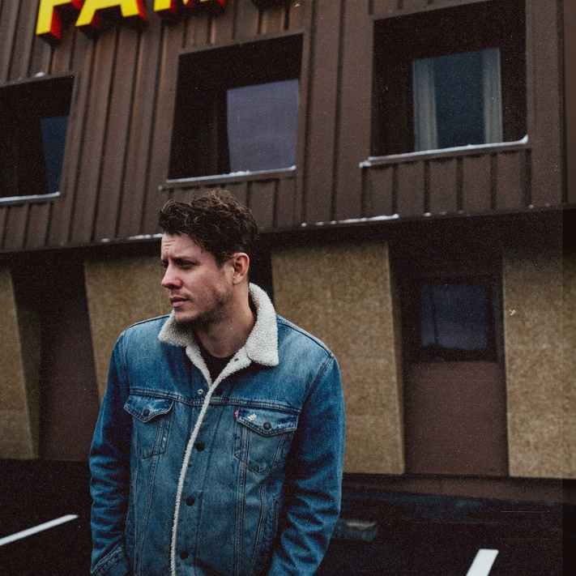

*Photo credit: Joshua Black Wilkins*

**ABOUT ANDERSON EAST:**

GRAMMY® Award-nominated Alabama-born and Nashville-based singer, songwriter, and performer Anderson East has always seamlessly trafficked between heritage soul, Americana, gospel, R&B, blues, roots, and rock. Following his independent debut *Flowers of the Broken Hearted* [2012], he continued to hone his voice and vision on *Delilah*[2015] and *Encore*[2018]. In addition to eclipsing 100 million streams, the latter yielded the single “All on My Mind,” which notably garnered a 2019 GRAMMY® Award nod in the category of *“Best American Roots Performance*.*”*In between sold out headline gigs in historic venues such as the Ryman, he delivered soaring and scorching performances on *Jimmy Kimmel LIVE!*, *The Late Show with Stephen Colbert*, *TODAY*, *Late Night with Seth Meyers*, PBS’ *Austin City Limits*, and more. *Maybe We Never Die* arrived to widespread tastemaker acclaim in 2021. *Forbes* raved, *“Maybe We Never Die is fit for dancing through the end of the world*,*”* *NPR*noted, *“his hefty vocals seem only more urgent in this subdued setting,”*and *American Songwriter*praised, “*characterized by his gentle, mesmerizing melodies* *and warm, twang-tinged vocal contributions, East sets the standard of continuously expanding artistry across the 12-track collection.*”Following the album’s release,he holed up in the world-renowned FAME Studios in Muscle Shoals, AL with his bandmates and longtime collaborator and producer Dave Cobb to cut a new version of the record entitled *M.W.N.D. / F.A.M.E.* [Low Country Sound/Elektra] for 2022. Performing face-to-face in this hallowed locale, they stripped the songs to their core only to give them another dimension altogether with every bit of soul, spark, and spirit intact.

[https://www.andersoneast.com/](https://nam04.safelinks.protection.outlook.com/?url=https%3A%2F%2Fwww.andersoneast.com%2F&data=04%7C01%7CDestinyDominguez%40elektra.com%7Cb1292d93d070435ac47908da0e67df31%7C8367939002ec4ba1ad3d69da3fdd637e%7C0%7C0%7C637838136533485193%7CUnknown%7CTWFpbGZsb3d8eyJWIjoiMC4wLjAwMDAiLCJQIjoiV2luMzIiLCJBTiI6Ik1haWwiLCJXVCI6Mn0%3D%7C3000&sdata=0GWbs1MROy6WYWr0RKjWhMMO9s41QIisaGogaYWR63I%3D&reserved=0)

[Facebook](https://nam04.safelinks.protection.outlook.com/?url=https%3A%2F%2Fwww.facebook.com%2Fandersoneast&data=04%7C01%7CDestinyDominguez%40elektra.com%7Cb1292d93d070435ac47908da0e67df31%7C8367939002ec4ba1ad3d69da3fdd637e%7C0%7C0%7C637838136533485193%7CUnknown%7CTWFpbGZsb3d8eyJWIjoiMC4wLjAwMDAiLCJQIjoiV2luMzIiLCJBTiI6Ik1haWwiLCJXVCI6Mn0%3D%7C3000&sdata=dLB62LsPa3Ez8mUekDsCy8mUdg3ydQ%2BpbLxe%2Bw7V%2FY0%3D&reserved=0) | [Instagram](https://nam04.safelinks.protection.outlook.com/?url=https%3A%2F%2Fwww.instagram.com%2Fandersoneast%2F&data=04%7C01%7CDestinyDominguez%40elektra.com%7Cb1292d93d070435ac47908da0e67df31%7C8367939002ec4ba1ad3d69da3fdd637e%7C0%7C0%7C637838136533485193%7CUnknown%7CTWFpbGZsb3d8eyJWIjoiMC4wLjAwMDAiLCJQIjoiV2luMzIiLCJBTiI6Ik1haWwiLCJXVCI6Mn0%3D%7C3000&sdata=bJ0nD6L5sFmnXlzO2DBidbSzbu%2Bhf1dnQb7JEBFRq3c%3D&reserved=0) | [Twitter](https://nam04.safelinks.protection.outlook.com/?url=https%3A%2F%2Ftwitter.com%2Fandersoneast&data=04%7C01%7CDestinyDominguez%40elektra.com%7Cb1292d93d070435ac47908da0e67df31%7C8367939002ec4ba1ad3d69da3fdd637e%7C0%7C0%7C637838136533485193%7CUnknown%7CTWFpbGZsb3d8eyJWIjoiMC4wLjAwMDAiLCJQIjoiV2luMzIiLCJBTiI6Ik1haWwiLCJXVCI6Mn0%3D%7C3000&sdata=sUfTvFy9IXaKNjkmvN1rxdjohwWwH1%2BnhWnt9l10rK8%3D&reserved=0) | [YouTube](https://nam04.safelinks.protection.outlook.com/?url=https%3A%2F%2Fwww.youtube.com%2Fuser%2Fandersoneast&data=04%7C01%7CDestinyDominguez%40elektra.com%7Cb1292d93d070435ac47908da0e67df31%7C8367939002ec4ba1ad3d69da3fdd637e%7C0%7C0%7C637838136533641426%7CUnknown%7CTWFpbGZsb3d8eyJWIjoiMC4wLjAwMDAiLCJQIjoiV2luMzIiLCJBTiI6Ik1haWwiLCJXVCI6Mn0%3D%7C3000&sdata=w1oBGehDzRRsnDtoe%2FPXKDKN2eTYh5uUfIY7Et7aGeo%3D&reserved=0)

**Press contacts:**

Collin Citron | [CollinCitron@elektra.com](mailto:CollinCitron@elektra.com)

Glenn Fukushima | [GlennFukushima@elektra.com](mailto:GlennFukushima@elektra.com)