FOR IMMEDIATE RELEASE
April 30, 2021

ALEC BENJAMIN RELEASES NEW SINGLE “THE WAY YOU FELT”
LISTEN HERE

NETWORK TELEVISION DEBUT PERFORMANCE OF THE TRACK ON CBS’S THE LATE LATE SHOW WITH JAMES CORDEN SET FOR MAY 6

Photo Credit: Matty Vogel

Multi-platinum singer-songwriter Alec Benjamin has today released his new single “The Way You Felt.” The song is now available to stream and download HERE via Elektra Records. Alec has also shared a lyric video for the song, which is viewable on his official YouTube channel HERE.

To accompany the release, Alec will deliver the song’s network television debut performance next Thursday, May 6 on CBS’s The Late Late Show With James Corden. Be sure to tune in.

For “The Way You Felt,” Alec reteamed with producers Sir Nolan and Aaron Z—who were behind his double-platinum breakout “Let Me Down Slowly”—and joined forces with co-writer RØMANS for the first time. On the track, neon keys wrap around a rousing beat as his voice dances over the hummable hook punctuated by flashes of his hypnotic high register. Lyrically, he delves into the pervasive isolation and deep sadness brought on by the COVID-19 pandemic.

“‘The Way You Felt’ was written in the darker part of my COVID experience,” Alec shared. “It was a period when we were experiencing a lot of physical isolation. I was just thinking about what it was like to be close to somebody and missing that.”

“The Way You Felt” follows Alec’s critically acclaimed 2020 debut studio album, These Two Windows. Generating nearly half-a-billion streams in under a year, it boasts the hit singles “Jesus In LA,” “Oh My God,” and “Mind Is A Prison.” Attracting widespread praise, People raved, “The album is a major milestone,” and Stereogum christened him “A fascinating voice in modern pop.” In addition to plugs from The New York Times, American Songwriter and more, Billboard noted, “The rising pop singer-songwriter succeeds in making the matter distinctive by how much his lyrics read like a heart-to-heart conversation.”

Stay tuned for more news from Alec Benjamin very soon.

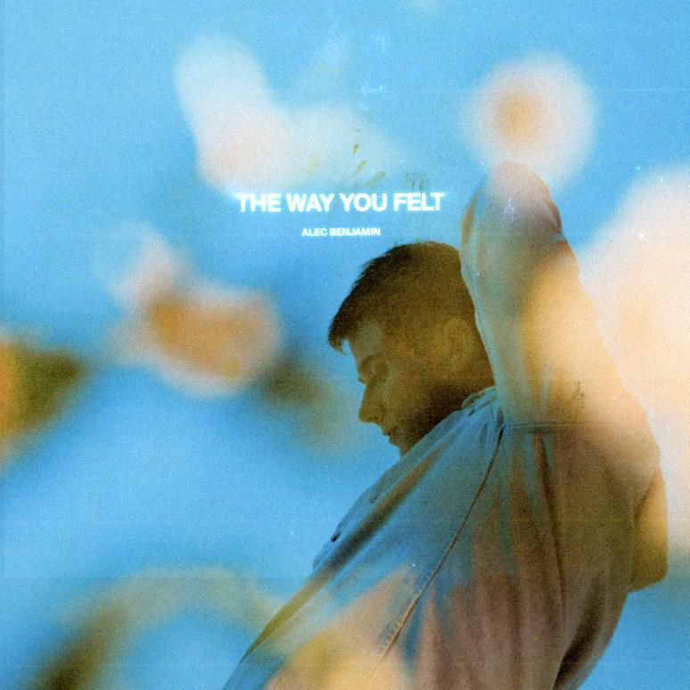

***
As popular music gets more and more “genre-less,” Alec Benjamin has only gotten more and more era-less. You can’t pin his candid storytelling, warm melodies, sticky hooks, and natural production to any age. That’s why he’s quietly become his generation’s own troubadour. Thus far, he has amassed nearly four billion streams, 820 million YouTube views, and multiple gold and platinum singles. He has sold out shows on three continents and counts Billie Eilish and John Mayer among his most vocal and ardent fans. Not to mention, he’s collaborated with everyone from Alessia Cara to Chinese superstar Zhao Lusi. His 2018 mixtape, Narrated For You, picked up a gold certification, while the 2020 debut album, These Two Windows, arrived to widespread critical acclaim from People, Stereogum, Billboard, and more. After a Global Pandemic, a year of soul-searching, and countless hours writing, he returns with his new single “The Way You Felt.”

CONNECT:
Facebook | Twitter | Instagram | YouTube

CONTACT:
Glenn Fukushima | GlennFukushima@elektra.com
Collin Citron | CollinCitron@elektra.com

