**ALL TIME LOW ANNOUNCE “BASEMENT NOISE CONCERT SERIES”**

**BAND TO STREAM PERFORMANCE OF *WAKE UP SUNSHINE* IN ITS ENTIRETY ON OCTOBER 9TH**

**FOUR ADDITIONAL CONCERT STREAMS TO FEATURE UNIQUE SET LISTS CURATED BY EACH BAND MEMBER**

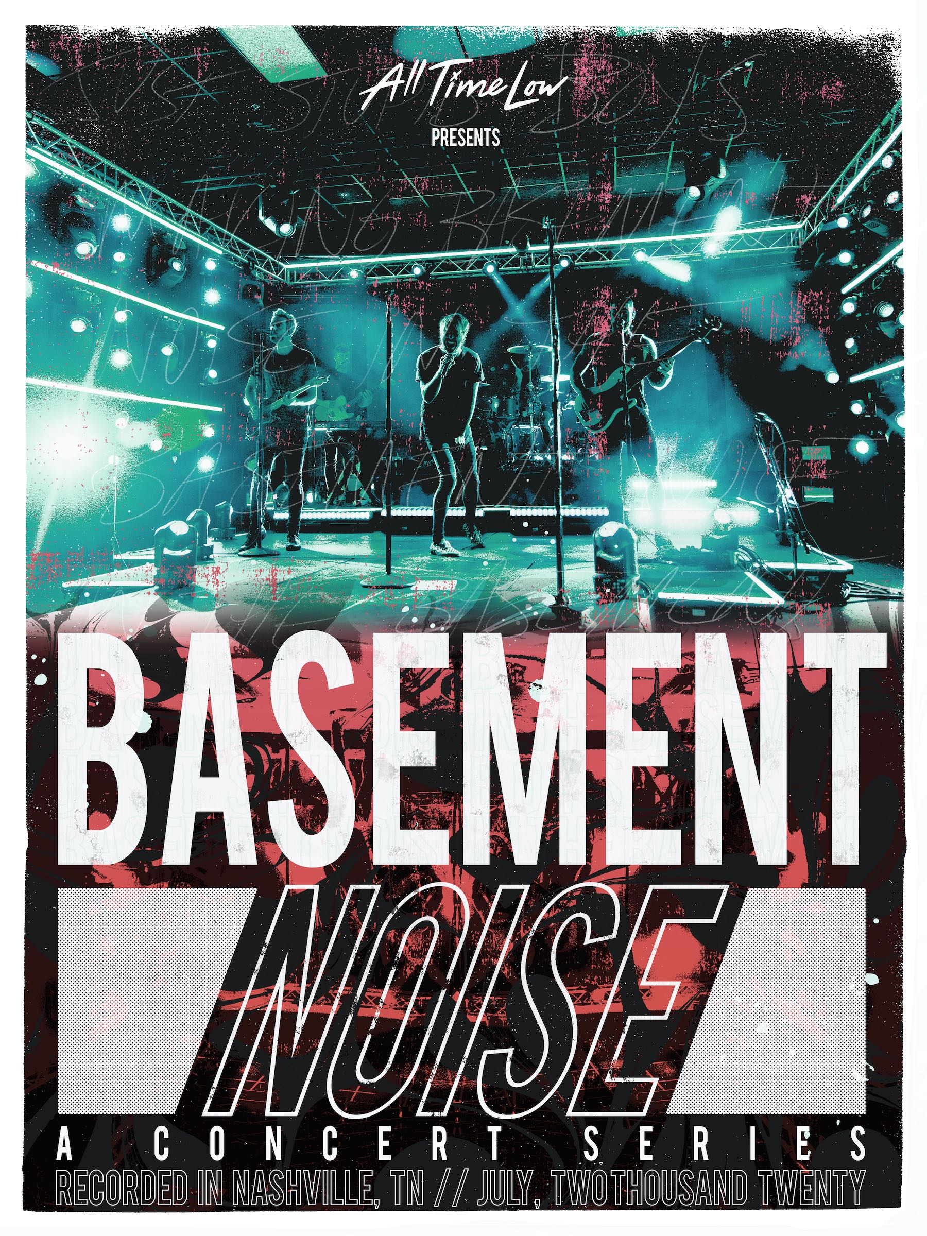

**September 28, 2020** - Platinum-selling Fueled By Ramen band **All Time Low** have announced their **Basement Noise Concert Series**. The five-night streaming event, which was filmed in Nashville, TN in July, will kick off on October 9, and see the band perform their new album *Wake Up, Sunshine* in its entirety for the very first time. Setlists for the remaining four shows in the series will be curated by each band member. Presale tickets for all five shows are available beginning today exclusively through All Time Low’s fan club. Spotify presale tickets will be available beginning tomorrow, and general tickets will go on sale this Wednesday, September 30 [HERE](https://nam04.safelinks.protection.outlook.com/?url=https%3A%2F%2Fshop.alltimelow.com%2F&data=02%7C01%7CSydneyWorden%40elektra.com%7Cc80bb9b885fa44e805a008d863d66689%7C8367939002ec4ba1ad3d69da3fdd637e%7C0%7C0%7C637369119799836638&sdata=947qx0kOaptMz6baXfoep4mY5E9oxL1T5xH5vjCvwlk%3D&reserved=0). Exclusive merch will be available to fans who purchase tickets to all five shows.

**BASEMENT NOISE CONCERT SERIES**

October 09, 2020 - *Wake Up, Sunshine* Full Album Show

October 23, 2020 - Rian’s Choice Set

November 13, 2020 - Zack’s Choice Set

December 04, 2020 - Alex’s Choice Set

December 18, 2020 - Jack’s Choice Set

All Time Low just achieved their first-ever #1 at radio as their latest single [“Monsters” (feat. blackbear)](https://nam04.safelinks.protection.outlook.com/?url=https%3A%2F%2Fyoutu.be%2F6aIVwQFSnVc&data=02%7C01%7CSydneyWorden%40elektra.com%7Cc80bb9b885fa44e805a008d863d66689%7C8367939002ec4ba1ad3d69da3fdd637e%7C0%7C0%7C637369119800066509&sdata=JM3KTgW5RCeyP64jvAMG6LwYL69G9RndWavhciw7dDI%3D&reserved=0) claimed top spot at Modern Rock. The band recently released an acoustic version of “Monsters”, which is available to stream and download now [HERE](https://nam04.safelinks.protection.outlook.com/?url=https%3A%2F%2Fatl.lnk.to%2Fmonstersacoustic&data=02%7C01%7CSydneyWorden%40elektra.com%7Cc80bb9b885fa44e805a008d863d66689%7C8367939002ec4ba1ad3d69da3fdd637e%7C0%7C0%7C637369119800076501&sdata=DgN9%2B4%2BSbkLRuBfP96Fg8g83XfMpCRqQzrzlvdKOmv8%3D&reserved=0). Watch an official music video for the acoustic track [HERE](https://nam04.safelinks.protection.outlook.com/?url=https%3A%2F%2Fyoutu.be%2F3Le4j-SP7sg&data=02%7C01%7CSydneyWorden%40elektra.com%7Cc80bb9b885fa44e805a008d863d66689%7C8367939002ec4ba1ad3d69da3fdd637e%7C0%7C0%7C637369119800076501&sdata=%2BrFgaJheduaBpWvVxmWsVi%2BqSpF4TCoMuL%2Byq%2BZbx8o%3D&reserved=0). “Monsters” is the latest single off All Time Low’s critically acclaimed new album *Wake Up, Sunshine*, which is available now [HERE](https://nam04.safelinks.protection.outlook.com/?url=https%3A%2F%2Ffbr.lnk.to%2Fwakeupsunshine&data=02%7C01%7CSydneyWorden%40elektra.com%7Cc80bb9b885fa44e805a008d863d66689%7C8367939002ec4ba1ad3d69da3fdd637e%7C0%7C0%7C637369119800086494&sdata=2Ic9SQipUyaR8N7nwexK9aYX%2FHDu1Qy24fmVf7cNmzI%3D&reserved=0).

*Wake Up, Sunshine*  was released in April and debuted at #1 on Billboard’s Top Rock Albums Chart. Upon its release, *Billboard* proclaimed “The album is All Time Low’s most vibrant set to date, combining the band’s rambunctious spirit with roaring guitars and anthemic melodies.” *Forbes* praised the collection as “an album that crackles with youthful exuberance and the energy of a live show,” while *Nylon* declared “All Time Low just wants their new album to make you feel good.”

Earlier this summer, All Time Low unveiledSummer Daze Rosé, their third wine release in partnership with [Wines That Rock](https://nam04.safelinks.protection.outlook.com/?url=http%3A%2F%2Fr20.rs6.net%2Ftn.jsp%3Ff%3D001vFjJA_BmKw5mlcIdDuUrkFaAhI3md-C4u0jAZVl043sFokBkAb7cpN38n0J9JBcQ66_ee7soiOLbrx-zP4-OYbA_1O3OKdzDmy5ck_qmgQ7AKW8LNJqxr_d0siqQmyWAQn9cNgOobSLKMlC_-XDuFA%3D%3D%26c%3DJYh4lf6hCq9FwniwvYaTyYQilO4GwFRaoghg_OIogkbbiyVgerB0PA%3D%3D%26ch%3Dth6UBg0DbpfIRqmolErwnD7A5iMKDodHtDKK2K5ViKdPzsN0OOnfUA%3D%3D&data=02%7C01%7CSydneyWorden%40elektra.com%7Cc80bb9b885fa44e805a008d863d66689%7C8367939002ec4ba1ad3d69da3fdd637e%7C0%7C0%7C637369119800086494&sdata=ejafIAPDXn70kq2X1PaItgi7rK2yGS%2FivY2%2BXWI%2B%2BA8%3D&reserved=0). Summer Daze Rosé can be purchased exclusively from All Time Low’s Everything Is Wine webstore [HERE](https://nam04.safelinks.protection.outlook.com/?url=http%3A%2F%2Fr20.rs6.net%2Ftn.jsp%3Ff%3D001vFjJA_BmKw5mlcIdDuUrkFaAhI3md-C4u0jAZVl043sFokBkAb7cpN38n0J9JBcQ7nstwuQ0x34TkwMcyDJKoXwmi8Tfr-M2PX2SpYZaRZE18FkvbqfZPTxhU27jL7hH9rzvZzpn9U98tQMkgqKHoJ46VIHwIMRsIctjrq1Kum0%3D%26c%3DJYh4lf6hCq9FwniwvYaTyYQilO4GwFRaoghg_OIogkbbiyVgerB0PA%3D%3D%26ch%3Dth6UBg0DbpfIRqmolErwnD7A5iMKDodHtDKK2K5ViKdPzsN0OOnfUA%3D%3D&data=02%7C01%7CSydneyWorden%40elektra.com%7Cc80bb9b885fa44e805a008d863d66689%7C8367939002ec4ba1ad3d69da3fdd637e%7C0%7C0%7C637369119800086494&sdata=r2JkrCdrRGovnlAR3K3fEkaux4%2BP8gMNh872WIWYp7g%3D&reserved=0). Band members Alex Gaskarth and Jack Barakat also just ignited their multi-platform podcast Crash Test Live. Tailored to and recorded live for a streaming audience, the co-hosts provide the hottest and most hilarious takes on the *“Wonderful News”* of the week and possibly true, yet possibly not *“Fun Facts*.*”* Past episodes of Crash Test Live are available on [YouTube](https://nam04.safelinks.protection.outlook.com/?url=https%3A%2F%2Fwww.youtube.com%2Fchannel%2FUCB2Wr4MS5PZjiuhmaRGxk1w&data=02%7C01%7CSydneyWorden%40elektra.com%7Cc80bb9b885fa44e805a008d863d66689%7C8367939002ec4ba1ad3d69da3fdd637e%7C0%7C0%7C637369119800096490&sdata=kPqqFKDKIFzrvmgtVma%2FcMYoygjUrjVvlKFkdUDKH0g%3D&reserved=0) now.

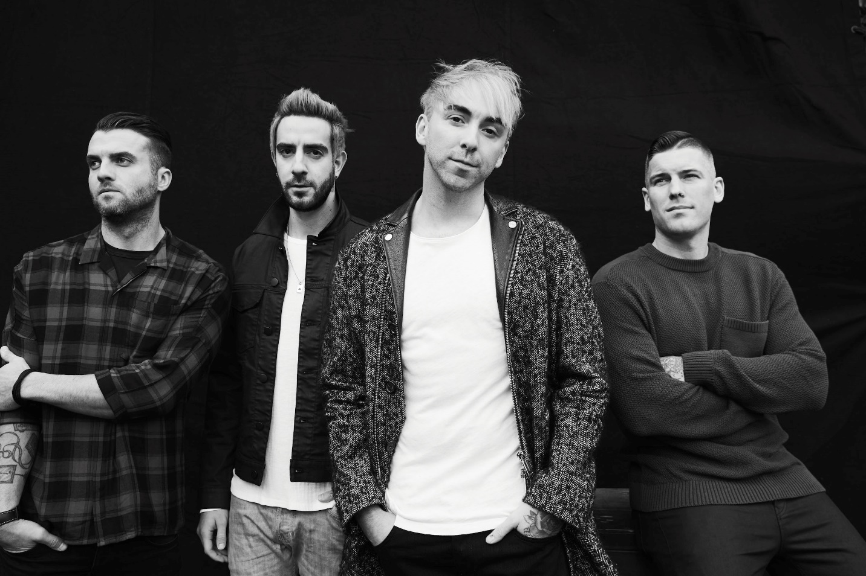

Photo Credit: Jimmy Fontaine

**ABOUT ALL TIME LOW**

Throughout a catalog streamed nearly half-a-billion times and highlighted by two gold albums, two gold singles, and a platinum single, All Time Low have continually raised the bar for both pop and punk. Since 2003, the group has notched five straight Top 10 entries on the *Billboard* Top 200, spanning the gold-certified *Nothing Personal* [2009], *Dirty Work* [2011], *Future Hearts* [2015], and *Last Young Renegade* [2017]. The latter attracted tastemaker acclaim from the likes of *Rolling Stone*, *Paste*, and more as the band canvased the world, headlining arenas on three continents. 2019 saw All Time Low celebrate *Nothing Personal* with a string of sold-out anniversary shows and a documentary following the band as they revisited the album at RedBull Studios. The record’s influence remains prevalent with *Rock Sound* citing its impact on Fall Out Boy, 5 Seconds of Summer, and more. After nearly two decades together, All Time Low have rekindled the spark they first ignited in a Baltimore basement on their 2020 full-length studio album, *Wake Up, Sunshine*. These four lifelong friends walked into a tiny room, plugged in, and turned up with the same spirit, but with more experience, and proficiency gained from performing to millions worldwide. As a result, they‘ve delivered *Wake Up, Sunshine*, a captivating body of work at the apex of pop punk prowess.

**CONNECT WITH ALL TIME LOW:**

[ALLTIMELOW.COM](https://nam04.safelinks.protection.outlook.com/?url=http%3A%2F%2Fwww.alltimelow.com%2F&data=02%7C01%7CSydneyWorden%40elektra.com%7Cc80bb9b885fa44e805a008d863d66689%7C8367939002ec4ba1ad3d69da3fdd637e%7C0%7C0%7C637369119800096490&sdata=zMqGSpUZQfR%2BVa3v%2F2amQCktgmCKrdzyOp2RktfKqhQ%3D&reserved=0)

[FACEBOOK](https://nam04.safelinks.protection.outlook.com/?url=https%3A%2F%2Ffacebook.com%2Falltimelow&data=02%7C01%7CSydneyWorden%40elektra.com%7Cc80bb9b885fa44e805a008d863d66689%7C8367939002ec4ba1ad3d69da3fdd637e%7C0%7C0%7C637369119800106481&sdata=aCXTy1ltJJO1RS2d71RYyyOpQN4of%2BYLDEH6JWtcEA8%3D&reserved=0)

[TWITTER](https://nam04.safelinks.protection.outlook.com/?url=https%3A%2F%2Ftwitter.com%2Falltimelow&data=02%7C01%7CSydneyWorden%40elektra.com%7Cc80bb9b885fa44e805a008d863d66689%7C8367939002ec4ba1ad3d69da3fdd637e%7C0%7C0%7C637369119800106481&sdata=%2BI6%2FGoLe5bZra9xH9vOoAM77lm%2FfblIp%2FIppLY6a2qk%3D&reserved=0)

[YOUTUBE](https://nam04.safelinks.protection.outlook.com/?url=http%3A%2F%2Fyoutube.com%2Falltimelow&data=02%7C01%7CSydneyWorden%40elektra.com%7Cc80bb9b885fa44e805a008d863d66689%7C8367939002ec4ba1ad3d69da3fdd637e%7C0%7C0%7C637369119800116479&sdata=ErQroSK9ZnEo0kuji6ImkFyLYVoV7xVkbIYs9lWJmiw%3D&reserved=0)

[INSTAGRAM](https://nam04.safelinks.protection.outlook.com/?url=http%3A%2F%2Finstagram.com%2Falltimelow&data=02%7C01%7CSydneyWorden%40elektra.com%7Cc80bb9b885fa44e805a008d863d66689%7C8367939002ec4ba1ad3d69da3fdd637e%7C0%7C0%7C637369119800116479&sdata=8mpRn8ySptuREl3HjFL2Vlaw6vTh7I9oTN6tdGCVhno%3D&reserved=0)

[FUELEDBYRAMEN.COM](https://nam04.safelinks.protection.outlook.com/?url=http%3A%2F%2Fwww.fueledbyramen.com%2F&data=02%7C01%7CSydneyWorden%40elektra.com%7Cc80bb9b885fa44e805a008d863d66689%7C8367939002ec4ba1ad3d69da3fdd637e%7C0%7C0%7C637369119800116479&sdata=TOp6%2F6VF86ozXzSYnXt8Rfcj4IKR1HZk%2FruPbX8gmug%3D&reserved=0)

**PRESS CONTACTS:**

Ross Anderson / [RossAnderson@Elektra.com](mailto:RossAnderson@Elektra.com)

Collin Citron / [CollinCitron@Elektra.com](mailto:CollinCitron@Elektra.com)