ALL TIME LOW SHARE NEW SINGLE “PMA” (FEAT. PALE WAVES)

LISTEN / WATCH THE OFFICIAL LYRIC VIDEO HERE

ON TOUR ACROSS THE WORLD THIS YEAR

TICKETS AVAILABLE HERE

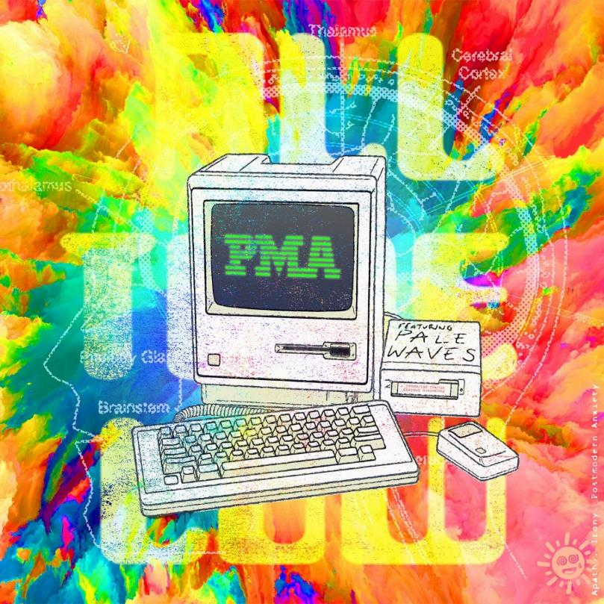
ALL TIME LOW – “PMA” (FEAT. PALE WAVES) – SINGLE ART

JULY 30, 2021 - Platinum-selling Fueled By Ramen band All Time Low have shared a brand new single entitled “PMA” (Feat. Pale Waves). The track is available today on all streaming platforms, while an accompanying lyric video for the song is streaming on All Time Low’s YouTube channel.

Upholding what has become an undeniable creative partnership in the studio, All Time Low worked with longtime collaborator and producer Zakk Cervini (Blink-182, MGK, Halsey) on the track. “PMA” hinges on effervescent electric hooks as All Time Low’s Alex Gaskarth and Pale Waves’ Heather Baron-Gracie trade-off melodies as they work through their anxiety.

Gaskarth elaborated on the collaboration, “‘PMA’ is a journey into isolation and overstimulation. It’s about the little mundane things we do to keep ourselves distracted when loneliness becomes a constant and leaves us feeling apathetic. It’s existential dread wrapped in nervous laughter kissed by the SoCal sun. Heather and Pale Waves joining us on this one quite literally brings the hopeful shine to the lyrics, the promise of safety in the shared experience, the understanding we’re all living it together.”

Baron-Gracie added, “I was really happy that Alex asked me to be on the track as I’ve always been a big fan of All Time Low and I loved the song when he sent it over. I really related to the themes, especially the exhausting worry that you’re never doing / being enough in life.”

It arrives on the heels of the band’s latest single “Once In A Lifetime.” It has already surpassed 20 million streams and counting in addition to reaching #5 at Alternative Radio and attracting critical acclaim. NME hailed it as “reflective” and “hopeful,” and KERRANG! dubbed it “dark but typically anthemic and infectious.” Produced by Cervini and Andrew Goldstein [Maroon 5, Katy Perry, blackbear], American Songwriter attested, “the new cut crashes the senses in bursts of color and sound,”

All Time Low will launch their first full-scale tour in two years in August. This Summer, the band will embark on a run of U.S. headline shows with support from The Maine and Grayscale. In the Fall, the band will return to the road for a North American headline trek with support from labelmates nothing,nowhere. and Meet Me @ The Altar. Tickets are available HERE.

All Time Low will also headline Sad Summer Fest 2021, which kicks off in August and visits US cities throughout the Summer. Additionally, the band is scheduled to appear at music festivals including Chicago, IL’s Lollapalooza and Las Vegas, NV’s Life Is Beautiful. A complete list of upcoming live dates can be found below.

All Time Low currently hold two spots in the Top 10 at Alternative Radio, with “Once In A Lifetime” and their smash hit “Monsters” (feat. blackbear). The band recently delivered the network television debut performance of “Once In A Lifetime” on The Late Late Show with James Corden. Watch the performance and interview HERE. Earlier this Summer, All Time Low also earned nominations for both Alternative Rock Song of the Year and Alternative Rock Artist of the Year at the 2021 iHeartRadio Music Awards. Additionally, the band received a nomination for Top Rock Song at the 2021 Billboard Music Awards.

“Monsters” (feat. blackbear) notably marked All Time Low’s first #1 at radio and remained in the top spot of the Billboard Alternative Airplay Chart for an unprecedented 18 weeks. The band delivered unforgettable network television performances of the song on Good Morning America, Jimmy Kimmel Live!, and The Ellen Degeneres Show. In December, All Time Low welcomed global superstar Demi Lovato to join them on a new version of the track. “Monsters” (feat. Demi Lovato and blackbear) marked All Time Low’s highest positions on the Billboard Hot 100 and Top 40 Radio Chart to date. Upon its release, the track received praise from The New York Times, Rolling Stone, People, and more.

All Time Low’s latest studio album Wake Up, Sunshine was released in April of 2020 and debuted at #1 on Billboard’s Top Rock Albums Chart. Billboard proclaimed, “The album is All Time Low’s most vibrant set to date, combining the band’s rambunctious spirit with roaring guitars and anthemic melodies.” Forbes praised the collection as “an album that crackles with youthful exuberance and the energy of a live show,” while Nylon declared “All Time Low just wants their new album to make you feel good.” Wake Up, Sunshine is available physically and digitally now HERE.

[TOUR ITINERARY / PRESS IMAGES BELOW]
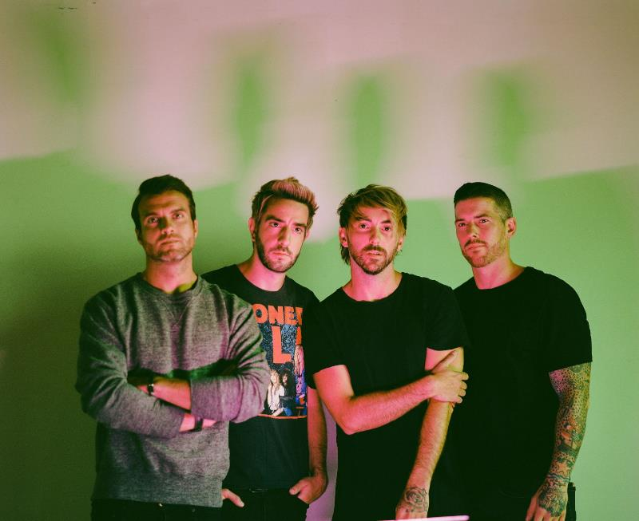
PHOTO CREDIT: NOLAN KNIGHT

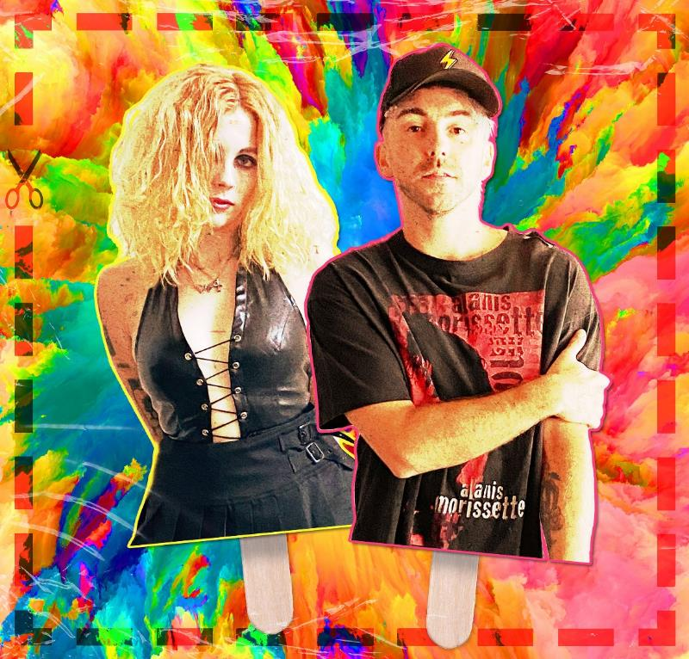
ALL TIME LOW X PALE WAVES – COMPOSITE PHOTO

ALL TIME LOW TOUR DATES
Festival Appearances
July 29-August 01, 2021 - Chicago, IL - Lollapalooza
September 18, 2021 - Las Vegas, NV - Life Is Beautiful
September 18, 2021 - Las Vegas, NV - Daytime Stage @ The iHeartRadio Music Festival

ALL TIME LOW TOUR DATES
Sad Summer Fest 2021
August 06, 2021 - Sacramento, CA - Papa Murphy’s
August 07, 2021 - Anaheim, CA - The Grove Outdoors
August 20, 2021 - Orlando FL - The Orlando Amphitheater
August 21, 2021 - Atlanta, GA - Masquerade
August 27, 2021 - New York, NY - The Rooftop at Pier 17 - SOLD OUT
August 28, 2021 - Baltimore, MD - MECU Pavilion
August 30, 2021 - Toronto, ON - RBC Echo Beach
August 31, 2021 - Columbus, OH - Express Live! Outdoor
September 03, 2021 - Asbury Park, NJ - Summer Stage - SOLD OUT
September 04, 2021 - Boston, MA - The Palladium Outdoors
September 05, 2021 - Philadelphia, PA - Skyline Stage @ The Mann
September 07, 2021 - Pittsburgh, PA - Stage AE Outdoors
September 10, 2021 - Milwaukee, WI - The Rave
September 11, 2021 - Pontiac, MI - Crofoot Festival Grounds

Headline Dates with The Maine and Grayscale
August 08, 2021 - Phoenix, AZ - Van Buren
August 10, 2021 - Denver, CO - Mission
August 13, 2021 - Kansas City, MO - KC Live!
August 14, 2021 - St. Louis, MO - Ballpark Village
August 15, 2021 - Tulsa, OK - Cain’s Ballroom
August 17, 2021 - Dallas, TX - South Side Ballroom
August 18, 2021 - Austin, TX - Stubb’s
August 22, 2021 - Nashville, TN - Marathon
August 24, 2021 - Norfolk, VA - NorVA
August 25, 2021 - Harrisburg, PA - XL Live
September 01, 2021 - Cleveland, OH - Agora
September 12, 2021 - Cincinnati, OH - The Andrew J Brady ICON Music Center
September 15, 2021 - Albuquerque, NM - Sunshine Theater*
September 16, 2021 - Tucson, AZ - Rialto Theatre*
*No Grayscale

UK Headline Dates
September 22, 2021 - London, UK - O2 Academy Brixton
September 23, 2021 - London, UK - O2 Academy Brixton - SOLD OUT
September 26, 2021 - Manchester, UK - O2 Apollo - SOLD OUT
September 27, 2021 - Glasgow, UK - Barrowland Ballroom - SOLD OUT
September 28, 2021 - Glasgow, UK - Barrowland Ballroom

Headline Dates with nothing,nowhere. and Meet Me @ The Altar
October 12, 2021 - New Orleans, LA - Orpheum Theater
October 13, 2021 - Birmingham, AL - Avondale Brewing Company
October 15, 2021 - Richmond, VA - The National
October 16, 2021 - Raleigh, NC - The Ritz
October 17, 2021 - Charlotte, NC - The Fillmore
October 19, 2021 - New Haven, CT - College Street Music Hall
October 20, 2021 - Buffalo, NY - Town Ballroom - SOLD OUT
October 22, 2021 - Toronto, Canada - History
October 23, 2021 - Grand Rapids, MI - 20 Monroe Live
October 24, 2021 - Louisville, KY - Paristown Hall
October 27, 2021 - Sioux Falls, SD - The District
October 28, 2021 - Des Moines, IA - Val Air Ballroom
October 30, 2021 - Minneapolis, MN - The Fillmore
October 31, 2021 - Winnipeg, MB - Burton Cummings Theatre
November 02, 2021 - Edmonton, AB - Union Hall
November 03, 2021 - Calgary, AB - MacEwan Hall
November 05, 2021 - Vancouver, BC - Vogue Theatre
November 06, 2021 - Portland, OR - Roseland - SOLD OUT
November 07, 2021 - Seattle, WA - Showbox SODO
November 10, 2021 - Oakland, CA - Fox Theater
November 11, 2021 - Los Angeles, CA - Hollywood Palladium
November 12, 2021 - San Diego, CA - Humphrey’s

About All Time Low:
Throughout a catalog streamed nearly half-a-billion times and highlighted by two gold albums, three gold singles, and a platinum single, All Time Low have continually raised the bar for both pop and punk. Since 2003, the group has notched five straight Top 10 entries on the Billboard Top 200, spanning the gold-certified Nothing Personal [2009], Dirty Work [2011], Future Hearts [2015], and Last Young Renegade [2017]. The latter attracted tastemaker acclaim from the likes of Rolling Stone, Paste, and more as the band canvassed the world, headlining arenas on three continents. 2019 saw All Time Low celebrate Nothing Personal with a string of sold-out anniversary shows and a documentary following the band as they revisited the album at RedBull Studios. The record’s influence remains prevalent with Rock Sound citing its impact on Fall Out Boy, 5 Seconds of Summer, and more. After nearly two decades together, All Time Low have rekindled the spark they first ignited in a Baltimore basement on their 2020 full-length studio album, Wake Up, Sunshine. These four lifelong friends walked into a tiny room, plugged in, and turned up with the same spirit, but with more experience, and proficiency gained from performing to millions worldwide. As a result, they‘ve delivered Wake Up, Sunshine, a captivating body of work featuring the hit single “Monsters” (feat. blackbear), which spent 17 weeks atop Billboard’s Alternative Airplay chart marking the group’s first #1 at radio. A brand-new version of “Monsters” was released at the end of 2020 featuring both blackbear and global super star Demi Lovato. In 2021, the band returned with their latest single “Once In A Lifetime”.

ALLTIMELOW.COM
FACEBOOK
TWITTER
YOUTUBE
INSTAGRAM
FUELEDBYRAMEN.COM

All Time Low Press Contacts:
Ross Anderson / RossAnderson@Elektra.com
Collin Citron / CollinCitron@Elektra.com

About Pale Waves:
Pale Waves - comprised of front woman Heather Baron-Gracie (she/her); drummer Ciara Doran (they/them); guitarist Huge Silvani (he/him) and bassist Charlie Wood (he/him) - made an immediate splash after hitting the music scene with their debut album My Mind Makes Noises which hit the Top 10 on the UK Album Chart, won the NME Under The Radar award, and saw the band tour with Dirty Hit label mates and mentors The 1975 as well as Muse and The Cure. Recently releasing their coming-of-age follow up to My Mind Makes Noises, sophomore album Who Am I? flipped the Pale Waves world upside down to draw strength from vulnerability and usher in a new, acoustic-guitar-laden pop rock energy. Featuring singles “Fall To Pieces,” “You Don’t Own Me,” “Easy,” “She’s My Religion,” and “Change,” and opening up a bold new chapter for Pale Waves, Who Am I? debuted at #3 on the UK Album Chart, was recorded primarily in Los Angeles and produced by Rich Costey (Muse, Foo Fighters, Sigur Rós) days before lockdown, and received major acclaim from NPR, Pitchfork, Wall Street Journal, Billboard, Buzzfeed, The FADER, AV Club, Vulture, Consequence, Stereogum, Alternative Press, NYLON, and many more. Confidently creating a safe space for people to be themselves, Heather’s songwriting holds the last few years of her life up to the light, reflecting on her own mental health and growing pains – depression, distraction, and feelings of darkness – but also her experience of falling in love and becoming more open about her sexuality, emerging with a newfound clarity and optimism.

Selling out their pre-sale in a matter of minutes, the band also recently announced their 2022 UK tour which will make a stop in London before culminating in a huge hometown show in Manchester. PRESS HERE for tickets, on general sale now.

PALEWAVES.CO.UK
FACEBOOK
TWITTER
YOUTUBE
INSTAGRAM

Pale Waves Press Contact:
Linda Carbone / linda@presshereproductions.com

