**ALL TIME LOW ANNOUNCE ADDITIONAL 2021 TOUR DATES**

**NEW SUMMER U.S. HEADLINE DATES**

**WITH THE MAINE & GRAYSCALE BEGIN AUGUST 8TH**

**FALL NORTH AMERICAN HEADLINE TOUR**

**WITH NOTHING,NOWHERE. & MEET ME @ THE ALTAR STARTS OCTOBER 12TH**

**TICKETS AVAILABLE TO THE PUBLIC THIS FRIDAY**[**HERE**](https://nam04.safelinks.protection.outlook.com/?url=https%3A%2F%2Fwww.alltimelow.com%2Ftour&data=04%7C01%7CSydneyWorden%40elektra.com%7C70626bcf3d8c417f037f08d925168bd4%7C8367939002ec4ba1ad3d69da3fdd637e%7C0%7C0%7C637581601059739376%7CUnknown%7CTWFpbGZsb3d8eyJWIjoiMC4wLjAwMDAiLCJQIjoiV2luMzIiLCJBTiI6Ik1haWwiLCJXVCI6Mn0%3D%7C1000&sdata=%2Fgmcmp3VogeAHSaqa%2BCh6GoJSAKHcDLw1rOb4HXN2sM%3D&reserved=0)

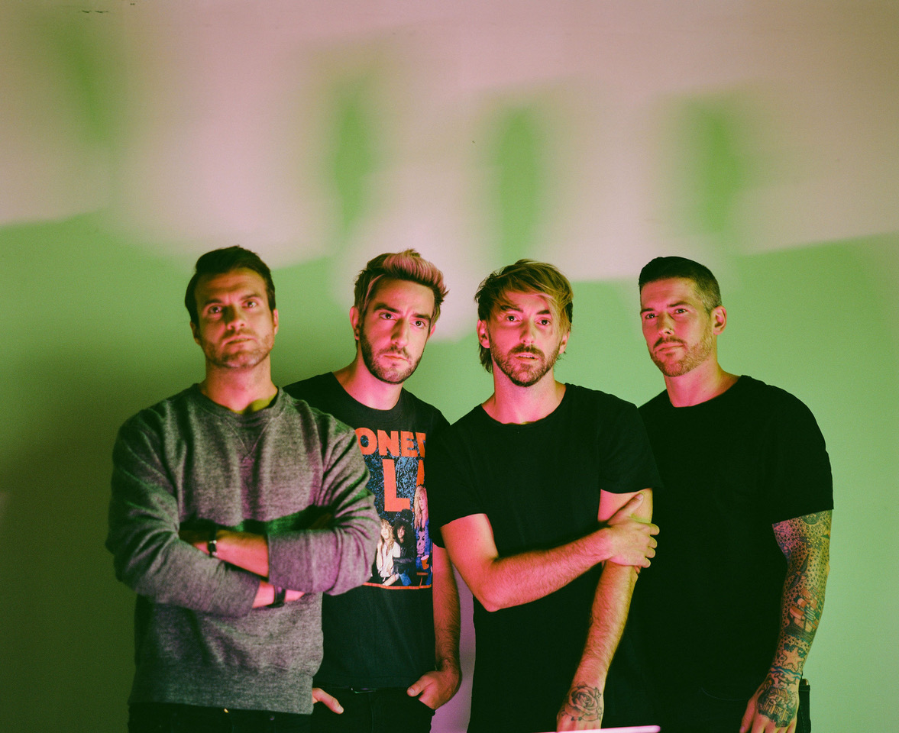

Photo credit: Nolan Knight

**June 1, 2021** - Platinum-selling Fueled By Ramen band **All Time Low** has announced additional 2021 tour dates. This Summer, the band will embark on a run of U.S. headline shows with support from The Maine and Grayscale. In the Fall, the band will return to the road for a North American headline trek with support from labelmates nothing,nowhere. and Meet Me @ The Altar. Pre-sale tickets will be available beginning today at 3:00pm ET, and general on sale begins this Friday, June 4 at 10:00am local time [HERE](https://nam04.safelinks.protection.outlook.com/?url=https%3A%2F%2Fwww.alltimelow.com%2Ftour&data=04%7C01%7CSydneyWorden%40elektra.com%7C70626bcf3d8c417f037f08d925168bd4%7C8367939002ec4ba1ad3d69da3fdd637e%7C0%7C0%7C637581601059739376%7CUnknown%7CTWFpbGZsb3d8eyJWIjoiMC4wLjAwMDAiLCJQIjoiV2luMzIiLCJBTiI6Ik1haWwiLCJXVCI6Mn0%3D%7C1000&sdata=%2Fgmcmp3VogeAHSaqa%2BCh6GoJSAKHcDLw1rOb4HXN2sM%3D&reserved=0).

All Time Low will also headline Sad Summer Fest 2021, which kicks off in August and visits US cities throughout the Summer. Additionally, the band is scheduled to appear at music festivals including Chicago, IL’s Lollapalooza and Las Vegas, NV’s Life Is Beautiful. A complete list of upcoming live dates can be found below.

All Time Low currently hold two spots in the Top 10 at Alternative Radio, as their latest single [“Once In A Lifetime”](https://nam04.safelinks.protection.outlook.com/?url=https%3A%2F%2Ffbr.lnk.to%2FOIAL&data=04%7C01%7CSydneyWorden%40elektra.com%7C70626bcf3d8c417f037f08d925168bd4%7C8367939002ec4ba1ad3d69da3fdd637e%7C0%7C0%7C637581601059749366%7CUnknown%7CTWFpbGZsb3d8eyJWIjoiMC4wLjAwMDAiLCJQIjoiV2luMzIiLCJBTiI6Ik1haWwiLCJXVCI6Mn0%3D%7C1000&sdata=%2FOOiD3egMSJZQV5tdN5o9SB%2FVVI9sK6Jjn%2F7PxojIUw%3D&reserved=0) ascends, and their smash hit [“Monsters” (feat. blackbear)](https://nam04.safelinks.protection.outlook.com/?url=https%3A%2F%2Ffbr.lnk.to%2Fatlmonsters&data=04%7C01%7CSydneyWorden%40elektra.com%7C70626bcf3d8c417f037f08d925168bd4%7C8367939002ec4ba1ad3d69da3fdd637e%7C0%7C0%7C637581601059749366%7CUnknown%7CTWFpbGZsb3d8eyJWIjoiMC4wLjAwMDAiLCJQIjoiV2luMzIiLCJBTiI6Ik1haWwiLCJXVCI6Mn0%3D%7C1000&sdata=3l7gnQx4O0BplWNGYxD%2Ff%2Fb9QgCIrGknacNbVVXi5f4%3D&reserved=0) holds strong. The band just delivered the network television debut performance of “Once In A Lifetime” on *The Late Late Show with James Corden*. Watch the performance and interview [HERE](https://nam04.safelinks.protection.outlook.com/?url=https%3A%2F%2Fyoutu.be%2FoRNJTFi1Wjo&data=04%7C01%7CSydneyWorden%40elektra.com%7C70626bcf3d8c417f037f08d925168bd4%7C8367939002ec4ba1ad3d69da3fdd637e%7C0%7C0%7C637581601059759364%7CUnknown%7CTWFpbGZsb3d8eyJWIjoiMC4wLjAwMDAiLCJQIjoiV2luMzIiLCJBTiI6Ik1haWwiLCJXVCI6Mn0%3D%7C1000&sdata=xP2y%2B8Y5nXjLDk2DFCu662KQlm3rQv6hg2XPqXir7aU%3D&reserved=0). Last week, All Time Low earned nominations for both Alternative Rock Song of the Year and Alternative Rock Artist of the Year at the 2021 iHeartRadio Music Awards. Additionally, the band received a nomination for Top Rock Song at the 2021 Billboard Music Awards.

“Monsters” (feat. blackbear) notably marked All Time Low’s first #1 at radio and remained in the top spot of the *Billboard* Alternative Airplay Chart for an unprecedented 18 weeks. The band delivered unforgettable network television performances of the song on *Good Morning America, Jimmy Kimmel Live!,*and *The Ellen Degeneres Show.* In December, All Time Low welcomed global superstar Demi Lovato to join them on a new version of the track. [“Monsters” (feat. Demi Lovato and blackbear)](https://nam04.safelinks.protection.outlook.com/?url=https%3A%2F%2Ffbr.lnk.to%2Fatlmonsters&data=04%7C01%7CSydneyWorden%40elektra.com%7C70626bcf3d8c417f037f08d925168bd4%7C8367939002ec4ba1ad3d69da3fdd637e%7C0%7C0%7C637581601059759364%7CUnknown%7CTWFpbGZsb3d8eyJWIjoiMC4wLjAwMDAiLCJQIjoiV2luMzIiLCJBTiI6Ik1haWwiLCJXVCI6Mn0%3D%7C1000&sdata=zX7Dqa1wT9SiiPeF0u2vqRt1%2BU2MazWgM5cFV4a55Bs%3D&reserved=0) marked All Time Low’s highest positions on the *Billboard*Hot 100 and Top 40 Radio Chart to date. Upon its release, the track received praise from *The New York Times*, *Rolling Stone*, *People,*and more.

All Time Low’s latest studio album *Wake Up, Sunshine* was released in April of 2020 and debuted at #1 on Billboard’s Top Rock Albums Chart. *Billboard* proclaimed, “The album is All Time Low’s most vibrant set to date, combining the band’s rambunctious spirit with roaring guitars and anthemic melodies.” *Forbes* praised the collection as “an album that crackles with youthful exuberance and the energy of a live show,” while *Nylon* declared “All Time Low just wants their new album to make you feel good.” *Wake Up, Sunshine*is available physically and digitally now[HERE](https://nam04.safelinks.protection.outlook.com/?url=https%3A%2F%2Ffbr.lnk.to%2Fwakeupsunshine&data=04%7C01%7CSydneyWorden%40elektra.com%7C70626bcf3d8c417f037f08d925168bd4%7C8367939002ec4ba1ad3d69da3fdd637e%7C0%7C0%7C637581601059769359%7CUnknown%7CTWFpbGZsb3d8eyJWIjoiMC4wLjAwMDAiLCJQIjoiV2luMzIiLCJBTiI6Ik1haWwiLCJXVCI6Mn0%3D%7C1000&sdata=a04UsTKkBqj6mB9wj1dpvh%2FD1LTpWC68okbD%2FLvHLtA%3D&reserved=0).

**ALL TIME LOW TOUR DATES**

**Festival Appearances**

July 29-August 01, 2021 - Chicago, IL - Lollapalooza

September 18, 2021 - Las Vegas, NV - Life Is Beautiful

**Sad Summer Fest 2021**

August 06, 2021 - Sacramento, CA - Papa Murphy’s

August 07, 2021 - Anaheim, CA - The Grove Outdoors

August 20, 2021 - Orlando FL - The Orlando Amphitheater

August 21, 2021 - Atlanta, GA - Masquerade

August 27, 2021 - New York, NY - The Rooftop at Pier 17

August 28, 2021 - Baltimore, MD - MECU Pavilion

August 30, 2021 - Toronto, ON - RBC Echo Beach

August 31, 2021 - Columbus, OH - Express Live! Outdoor

September 03, 2021 - Asbury Park, NJ - Summer Stage

September 04, 2021 - Boston, MA - The Palladium Outdoors

September 05, 2021 - Philadelphia, PA - Skyline Stage @ The Mann

September 07, 2021 - Pittsburgh, PA - Stage AE Outdoors

September 10, 2021 - Milwaukee, WI - The Rave

September 11, 2021 - Pontiac, MI - Crofoot Festival Grounds

**Headline Dates with The Maine and Grayscale - *JUST ANNOUNCED***

August 08, 2021 - Phoenix, AZ - Van Buren

August 10, 2021 - Denver, CO - Mission

August 13, 2021 - Kansas City, MO - KC Live!

August 14, 2021 - St. Louis, MO - Ballpark Village

August 15, 2021 - Tulsa, OK - Cain’s Ballroom

August 17, 2021 - Dallas, TX - South Side Ballroom

August 18, 2021 - Austin, TX - Stubb’s

August 22, 2021 - Nashville, TN - Marathon

August 24, 2021 - Norfolk, VA - NorVA

August 25, 2021 - Harrisburg, PA - XL Live

September 01, 2021 - Cleveland, OH - Agora

**UK Headline Dates**

September 22, 2021 - London, UK - O2 Academy Brixton

September 23, 2021 - London, UK - O2 Academy Brixton - SOLD OUT

September 26, 2021 - Manchester, UK - O2 Apollo - SOLD OUT

September 27, 2021 - Glasgow, UK - Barrowland Ballroom - SOLD OUT

September 28, 2021 - Glasgow, UK - Barrowland Ballroom - SOLD OUT

**Headline Dates with nothing,nowhere. and Meet Me @ The Altar*- JUST ANNOUNCED***

October 12, 2021 - New Orleans, LA - Orpheum Theater

October 13, 2021 - Birmingham, AL - Avondale Brewing Company

October 15, 2021 - Richmond, VA - The National

October 16, 2021 - Raleigh, NC - The Ritz

October 17, 2021 - Charlotte, NC - The Fillmore

October 19, 2021 - New Haven, CT - College Street Music Hall

October 20, 2021 - Buffalo, NY - Town Ballroom

October 23, 2021 - Grand Rapids, MI  - 20 Monroe Live

October 24, 2021 - Louisville, KY - Paristown Hall

October 27, 2021 - Sioux Falls, SD - The District

October 28, 2021 - Des Moines, IA - Val Air Ballroom

October 30, 2021 - Minneapolis, MN - The Fillmore

October 31, 2021 - Winnipeg, MB - Burton Cummings Theatre

November 02, 2021 - Edmonton, AB - Union Hall

November 03, 2021 - Calgary, AB - MacEwan Hall

November 05, 2021 - Vancouver, BC - Vogue Theatre

November 06, 2021 - Portland, OR - Roseland

November 07, 2021 - Seattle, WA - Showbox SODO

November 10, 2021 - Oakland, CA - Fox Theater

November 11, 2021 - Los Angeles, CA - Hollywood Palladium

November 12, 2021 - San Diego, CA - Humphrey’s

**About All Time Low:**

Throughout a catalog streamed nearly half-a-billion times and highlighted by two gold albums, three gold singles, and a platinum single, All Time Low have continually raised the bar for both pop and punk. Since 2003, the group has notched five straight Top 10 entries on the *Billboard* Top 200, spanning the gold-certified *Nothing Personal*[2009], *Dirty Work*[2011], *Future Hearts* [2015], and *Last Young Renegade* [2017]. The latter attracted tastemaker acclaim from the likes of *Rolling Stone*, *Paste*, and more as the band canvassed the world, headlining arenas on three continents. 2019 saw All Time Low celebrate *Nothing Personal* with a string of sold-out anniversary shows and a documentary following the band as they revisited the album at RedBull Studios. The record’s influence remains prevalent with *Rock Sound* citing its impact on Fall Out Boy, 5 Seconds of Summer, and more. After nearly two decades together, All Time Low have rekindled the spark they first ignited in a Baltimore basement on their 2020 full-length studio album, *Wake Up, Sunshine*. These four lifelong friends walked into a tiny room, plugged in, and turned up with the same spirit, but with more experience, and proficiency gained from performing to millions worldwide. As a result, they‘ve delivered *Wake Up, Sunshine*, a captivating body of work featuring the hit single “Monsters” (feat. blackbear), which spent 17 weeks atop Billboard’s *Alternative Airplay* chart marking the group’s first #1 at radio. A brand-new version of “Monsters” was released at the end of 2020 featuring both blackbear and global super star Demi Lovato. In 2021, the band returned with their latest single “Once In A Lifetime”.

[ALLTIMELOW.COM](https://nam04.safelinks.protection.outlook.com/?url=http%3A%2F%2Fwww.alltimelow.com%2F&data=04%7C01%7CSydneyWorden%40elektra.com%7C70626bcf3d8c417f037f08d925168bd4%7C8367939002ec4ba1ad3d69da3fdd637e%7C0%7C0%7C637581601059769359%7CUnknown%7CTWFpbGZsb3d8eyJWIjoiMC4wLjAwMDAiLCJQIjoiV2luMzIiLCJBTiI6Ik1haWwiLCJXVCI6Mn0%3D%7C1000&sdata=nu6kE3GazQq%2F%2BBZ3ZoJKHrU9hY8aZ%2BblHeu6l8hwAd4%3D&reserved=0)

[FACEBOOK](https://nam04.safelinks.protection.outlook.com/?url=https%3A%2F%2Ffacebook.com%2Falltimelow&data=04%7C01%7CSydneyWorden%40elektra.com%7C70626bcf3d8c417f037f08d925168bd4%7C8367939002ec4ba1ad3d69da3fdd637e%7C0%7C0%7C637581601059779349%7CUnknown%7CTWFpbGZsb3d8eyJWIjoiMC4wLjAwMDAiLCJQIjoiV2luMzIiLCJBTiI6Ik1haWwiLCJXVCI6Mn0%3D%7C1000&sdata=Uz8z3X0E5lBmhnlSa9OSq0VoR0LNWCvowYEe2ZV6bmw%3D&reserved=0)

[TWITTER](https://nam04.safelinks.protection.outlook.com/?url=https%3A%2F%2Ftwitter.com%2Falltimelow&data=04%7C01%7CSydneyWorden%40elektra.com%7C70626bcf3d8c417f037f08d925168bd4%7C8367939002ec4ba1ad3d69da3fdd637e%7C0%7C0%7C637581601059779349%7CUnknown%7CTWFpbGZsb3d8eyJWIjoiMC4wLjAwMDAiLCJQIjoiV2luMzIiLCJBTiI6Ik1haWwiLCJXVCI6Mn0%3D%7C1000&sdata=fzMtzzTsGFi6Ngay%2BCGKmsh2Y56xc7h9tnV6fKxvpkw%3D&reserved=0)

[YOUTUBE](https://nam04.safelinks.protection.outlook.com/?url=http%3A%2F%2Fyoutube.com%2Falltimelow&data=04%7C01%7CSydneyWorden%40elektra.com%7C70626bcf3d8c417f037f08d925168bd4%7C8367939002ec4ba1ad3d69da3fdd637e%7C0%7C0%7C637581601059789344%7CUnknown%7CTWFpbGZsb3d8eyJWIjoiMC4wLjAwMDAiLCJQIjoiV2luMzIiLCJBTiI6Ik1haWwiLCJXVCI6Mn0%3D%7C1000&sdata=pgb2RFjjmfeAPyBDPRWlU3KZoWpoZ0DF4lQfHNmTHhk%3D&reserved=0)

[INSTAGRAM](https://nam04.safelinks.protection.outlook.com/?url=http%3A%2F%2Finstagram.com%2Falltimelow&data=04%7C01%7CSydneyWorden%40elektra.com%7C70626bcf3d8c417f037f08d925168bd4%7C8367939002ec4ba1ad3d69da3fdd637e%7C0%7C0%7C637581601059789344%7CUnknown%7CTWFpbGZsb3d8eyJWIjoiMC4wLjAwMDAiLCJQIjoiV2luMzIiLCJBTiI6Ik1haWwiLCJXVCI6Mn0%3D%7C1000&sdata=KG1cHpUdHg9o5yHGTWzC666zUy7e7ZJhBd8JaDhkGVA%3D&reserved=0)

[FUELEDBYRAMEN.COM](https://nam04.safelinks.protection.outlook.com/?url=http%3A%2F%2Fwww.fueledbyramen.com%2F&data=04%7C01%7CSydneyWorden%40elektra.com%7C70626bcf3d8c417f037f08d925168bd4%7C8367939002ec4ba1ad3d69da3fdd637e%7C0%7C0%7C637581601059799340%7CUnknown%7CTWFpbGZsb3d8eyJWIjoiMC4wLjAwMDAiLCJQIjoiV2luMzIiLCJBTiI6Ik1haWwiLCJXVCI6Mn0%3D%7C1000&sdata=RjH8dyiiYDPyJueTS2F5%2BVRReBv99mOZy2g%2Fv1khSfM%3D&reserved=0)

**All Time Low Press Contacts:**

Ross Anderson / [RossAnderson@Elektra.com](mailto:RossAnderson@Elektra.com)

Collin Citron / [CollinCitron@Elektra.com](mailto:CollinCitron@Elektra.com)