FOR IMMEDIATE RELEASE

AUGUST 11, 2021

**FOY VANCE ANNOUNCES*AN EVENING WITH FOY VANCE***

**CONCERT LIVESTREAM CELEBRATING NEW ALBUM *SIGNS OF LIFE*ON FRIDAY SEPTEMBER 10 @ 9PM EST/PST VIA**[**DICE**](https://nam04.safelinks.protection.outlook.com/?url=https%3A%2F%2Flink.dice.fm%2Ffoyvance&data=04%7C01%7CSydneyWorden%40elektra.com%7C7361564bb47c4659f45108d95ce14930%7C8367939002ec4ba1ad3d69da3fdd637e%7C0%7C0%7C637642944945394014%7CUnknown%7CTWFpbGZsb3d8eyJWIjoiMC4wLjAwMDAiLCJQIjoiV2luMzIiLCJBTiI6Ik1haWwiLCJXVCI6Mn0%3D%7C1000&sdata=N0%2BYXD0Zzsz2eTtfVSt%2BOfVXLKn5w1NwzaqOAe%2FRnFg%3D&reserved=0)

***SIGNS OF LIFE*AVAILABLE SEPTEMBER 10 - PRE-ORDER**[**HERE**](https://nam04.safelinks.protection.outlook.com/?url=https%3A%2F%2Flnk.to%2FSigns-of-Life&data=04%7C01%7CSydneyWorden%40elektra.com%7C7361564bb47c4659f45108d95ce14930%7C8367939002ec4ba1ad3d69da3fdd637e%7C0%7C0%7C637642944945404010%7CUnknown%7CTWFpbGZsb3d8eyJWIjoiMC4wLjAwMDAiLCJQIjoiV2luMzIiLCJBTiI6Ik1haWwiLCJXVCI6Mn0%3D%7C1000&sdata=EHSe%2BQYMrdyJTyP82Ga8FHtGzCBHWTvGpKmFzYGQL%2B8%3D&reserved=0)

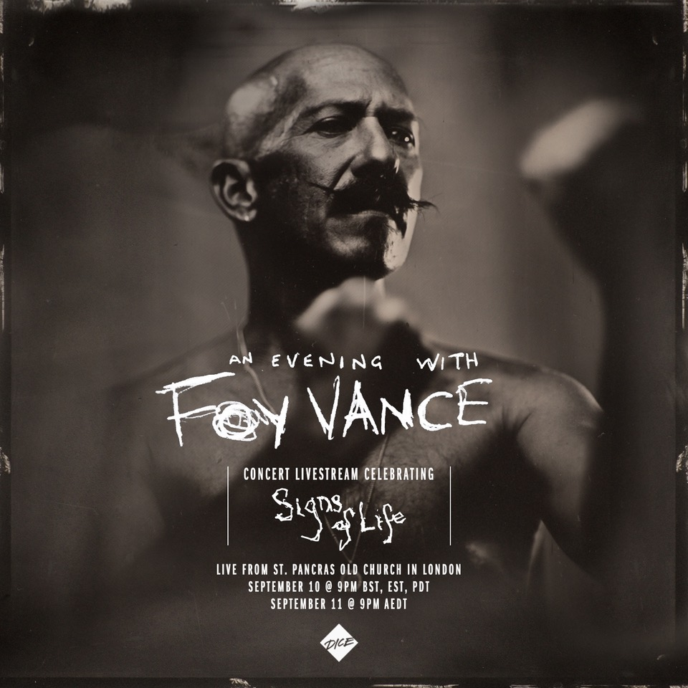

*“(Sapling) harks back to Van Morrison’s better days, grainy and impassioned”*

**The New York Times**

“…*simply beautiful, all about (Vance’s) wonderfully characterful voice*

*and the gorgeous melody it enfolds.”*

**Americana UK**

Award-winning Northern Irish singer/songwriter **Foy Vance** has announced a very special concert livestream to celebrate the release of his new studio album [*Signs Of Life*](https://nam04.safelinks.protection.outlook.com/?url=https%3A%2F%2Flnk.to%2FSigns-of-Life&data=04%7C01%7CSydneyWorden%40elektra.com%7C7361564bb47c4659f45108d95ce14930%7C8367939002ec4ba1ad3d69da3fdd637e%7C0%7C0%7C637642944945404010%7CUnknown%7CTWFpbGZsb3d8eyJWIjoiMC4wLjAwMDAiLCJQIjoiV2luMzIiLCJBTiI6Ik1haWwiLCJXVCI6Mn0%3D%7C1000&sdata=EHSe%2BQYMrdyJTyP82Ga8FHtGzCBHWTvGpKmFzYGQL%2B8%3D&reserved=0)on September 10. Vance’s sold-out show that evening at London’s St Pancras Old Church will be streaming live via Dice at 9:00pm BST, and will be available to US audiences at 9:00pm EST/PST. Tickets are available now from[Dice](https://nam04.safelinks.protection.outlook.com/?url=https%3A%2F%2Flink.dice.fm%2Ffoyvance&data=04%7C01%7CSydneyWorden%40elektra.com%7C7361564bb47c4659f45108d95ce14930%7C8367939002ec4ba1ad3d69da3fdd637e%7C0%7C0%7C637642944945414002%7CUnknown%7CTWFpbGZsb3d8eyJWIjoiMC4wLjAwMDAiLCJQIjoiV2luMzIiLCJBTiI6Ik1haWwiLCJXVCI6Mn0%3D%7C1000&sdata=HTbXm%2FRLx9UFEW8%2Fe649zhhBZhnIv1E5mmeXLHkMmyU%3D&reserved=0) for $13.20. The livestream will be produced and directed by award-winning production company Spiritland Productions, who have worked on recent livestreams with artists including Hot Chip, Nitin Sawney, Tom Grennan, and Anne-Marie.

Vance’s St Pancras Old Church show is part of an intimate UK & US tour around the release of *Signs of Life*. Remaining tickets for the largely sold-out run of shows are available now [HERE](https://nam04.safelinks.protection.outlook.com/?url=https%3A%2F%2Fwww.foyvance.com%2Ftour%2F&data=04%7C01%7CSydneyWorden%40elektra.com%7C7361564bb47c4659f45108d95ce14930%7C8367939002ec4ba1ad3d69da3fdd637e%7C0%7C0%7C637642944945414002%7CUnknown%7CTWFpbGZsb3d8eyJWIjoiMC4wLjAwMDAiLCJQIjoiV2luMzIiLCJBTiI6Ik1haWwiLCJXVCI6Mn0%3D%7C1000&sdata=cfzVHKyX5npKBZ%2F%2FLTDvVBckYAAiYqYF9HVC5aweGOg%3D&reserved=0).

Foy Vance’s fourth studio album and the follow-up to 2016’s acclaimed *The Wild Swan*, *Signs Of Life* is the sound of a beloved singer-songwriter at the peak of his powers. Created out of the grimness of 2020, *Signs of Life* is an album about dawn after darkness, hope after despair, engagement after isolation, uplift after lockdown.

Vance previewed the album with the release of tracks [“Sapling”](https://nam04.safelinks.protection.outlook.com/?url=https%3A%2F%2Fyoutu.be%2Fz18IKb3bcRs&data=04%7C01%7CSydneyWorden%40elektra.com%7C7361564bb47c4659f45108d95ce14930%7C8367939002ec4ba1ad3d69da3fdd637e%7C0%7C0%7C637642944945423997%7CUnknown%7CTWFpbGZsb3d8eyJWIjoiMC4wLjAwMDAiLCJQIjoiV2luMzIiLCJBTiI6Ik1haWwiLCJXVCI6Mn0%3D%7C1000&sdata=xmF%2BI3VGlkVCizzhlnLLlkv4TnpD1y33TvgIrp4upT8%3D&reserved=0), [“Signs Of Life”](https://nam04.safelinks.protection.outlook.com/?url=https%3A%2F%2Fyoutu.be%2FAF9gdUsGefk&data=04%7C01%7CSydneyWorden%40elektra.com%7C7361564bb47c4659f45108d95ce14930%7C8367939002ec4ba1ad3d69da3fdd637e%7C0%7C0%7C637642944945423997%7CUnknown%7CTWFpbGZsb3d8eyJWIjoiMC4wLjAwMDAiLCJQIjoiV2luMzIiLCJBTiI6Ik1haWwiLCJXVCI6Mn0%3D%7C1000&sdata=Cy2oFYeNCj2VrIfu%2F7c4KrxtMZM2TCYqIhRWqAt1iBY%3D&reserved=0), [“Time Stand Still”](https://nam04.safelinks.protection.outlook.com/?url=https%3A%2F%2Flnk.to%2FTime-Stand-Still&data=04%7C01%7CSydneyWorden%40elektra.com%7C7361564bb47c4659f45108d95ce14930%7C8367939002ec4ba1ad3d69da3fdd637e%7C0%7C0%7C637642944945433993%7CUnknown%7CTWFpbGZsb3d8eyJWIjoiMC4wLjAwMDAiLCJQIjoiV2luMzIiLCJBTiI6Ik1haWwiLCJXVCI6Mn0%3D%7C1000&sdata=yplYkTLqzAwlMPeKAt99vcNKoIvgG%2FGGwpTygHosUzY%3D&reserved=0), [“If Christopher Calls”](https://nam04.safelinks.protection.outlook.com/?url=https%3A%2F%2Flnk.to%2FIf-Christopher-Calls&data=04%7C01%7CSydneyWorden%40elektra.com%7C7361564bb47c4659f45108d95ce14930%7C8367939002ec4ba1ad3d69da3fdd637e%7C0%7C0%7C637642944945433993%7CUnknown%7CTWFpbGZsb3d8eyJWIjoiMC4wLjAwMDAiLCJQIjoiV2luMzIiLCJBTiI6Ik1haWwiLCJXVCI6Mn0%3D%7C1000&sdata=FCsopZ6BdmZv8vp4VXgwj7JWJc%2B3%2BAZO20tZf91f0fE%3D&reserved=0), and [“Hair Of The Dog”](https://nam04.safelinks.protection.outlook.com/?url=https%3A%2F%2Flnk.to%2FHair-Of-The-Dog&data=04%7C01%7CSydneyWorden%40elektra.com%7C7361564bb47c4659f45108d95ce14930%7C8367939002ec4ba1ad3d69da3fdd637e%7C0%7C0%7C637642944945443988%7CUnknown%7CTWFpbGZsb3d8eyJWIjoiMC4wLjAwMDAiLCJQIjoiV2luMzIiLCJBTiI6Ik1haWwiLCJXVCI6Mn0%3D%7C1000&sdata=Sx0Xjnhv0dLoA8N%2FIbVe6x%2BHS4pier9xuGHGlkCKwJ0%3D&reserved=0). Upon its release, *The New York Times* featured “Sapling” in *The Playlist* and *Clash Music*applauded the song as “An instant fan favorite… a song about renewal and survival.” The album’s early tracks have received additional praise from *Entertainment Tonight*, *Americana UK*, and more.

*Signs Of Life* was recorded in three locations: Vance’s Pilgrim studio at home on the shores of Loch Tay in Highland Perthshire, another recording set-up in a nearby Dunvarlich House, and at Plan B’s Kings X studio in London. The album was written and played more or less entirely by Vance, with assistance from young Northern Irish producer Gareth Dunlop. Serendipitously, Dunlop had been inspired on his career path by a chance encounter with Vance in a coffee shop 18 years ago.

Commenting on the album’s timely subject matter, Vance shared, “*Signs of Life* is about re-emergence – me in my own soft revolution, the world re-emerging in what we’re about to see as we hopefully go back to some semblance of normality. But just life in general – flowers growing through the cracks in Chernobyl. Life finds a way, doesn’t it?”

**An Evening With Foy Vance Tour 2021**

September 06, 2021 -  Glasgow, UK - King Tuts - **SOLD OUT**

September 07, 2021 - Leeds, UK -  Brudenell Social Club

September 09, 2021 - London, UK - Oslo - **SOLD OUT**

September 10, 2021 - London, UK - St. Pancras Old Church - **SOLD OUT**

September 12, 2021 - Belfast, UK - Empire - **SOLD OUT**

September 13, 2021 - Dublin, IE - Whelans - **SOLD OUT**

November 10, 2021 - Los Angeles, CA - Masonic Lodge at Hollywood Forever - **SOLD OUT**

November 12, 2021 - Nashville, TN - Ryman Auditorium **\*** - **SOLD OUT**

November 13, 2021 - Nashville, TN - Ryman Auditorium **\***

November 16, 2021 - New York, NY - Rockwood Music Hall Stage 2 - **SOLD OUT**

**\*** supporting Anderson East

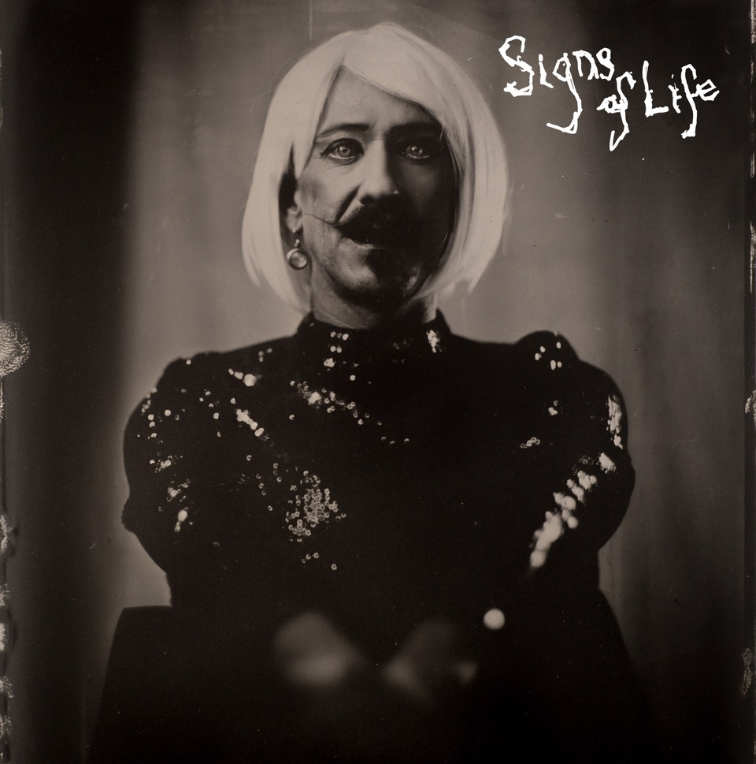

**About Foy Vance**

Hailing from Bangor in Northern Ireland, Vance independently released his debut album *Hope*in 2007, quickly garnering acclaim from fans and fellow musicians alike. His second full-length album, *Joy of Nothing*, released in 2013 on Glassnote Records, won the inaugural Northern Ireland Music Prize and saw Vance tour the globe with Ed Sheeran, Bonnie Raitt, Marcus Foster, Snow Patrol and Sir Elton John, as well as his own solo headline tours.

In 2015 Vance was became the second signing to Gingerbread Man Records, Ed Sheeran’s label division within Atlantic Records. His debut recording for the label, *The Wild Swan -* Executive Produced by Sir Elton John - contained the BBC Radio 2 playlisted singles “Coco”, “Upbeat Feelgood”, and “Noam Chomsky Is A Soft Revolution”, and saw Vance perform on NBC’s Today and CBS’s The Late Late Show with James Corden.

As a songwriter, Vance’s collaborations include co-writing four cuts including “Galway Girl” on Ed Sheeran’s 2017 album *Divide*. He has also worked with Alicia Keys, Rag N Bone Man, Keith Urban, Kacey Musgraves, Miranda Lambert, Plan B and Rudimental among many others, effortlessly switching between genres.

Last year, Vance launched the podcast series *The Vinyl Supper* in which he talks music, food and life stories with special guests and friends from the world of music, poetry and film. Recorded remotely during the global pandemic, series one featured Anderson East, Atticus, Benny Blanco, Blake Mills, Bruce Cockburn, Chrissy Metz, Courteney Cox, Devin Dawson, Josh Groban, Keith Urban and Passenger.

Foy Vance has headlined globally to sell-out crowds and splits his time between London and the Scottish Highlands with his family.

[FoyVance.com](https://nam04.safelinks.protection.outlook.com/?url=https%3A%2F%2Ffoyvance.com%2F&data=04%7C01%7CSydneyWorden%40elektra.com%7C7361564bb47c4659f45108d95ce14930%7C8367939002ec4ba1ad3d69da3fdd637e%7C0%7C0%7C637642944945443988%7CUnknown%7CTWFpbGZsb3d8eyJWIjoiMC4wLjAwMDAiLCJQIjoiV2luMzIiLCJBTiI6Ik1haWwiLCJXVCI6Mn0%3D%7C1000&sdata=RKMOObZQfgxyA9neow7si8Uq2MupjqxXNVZbdsZzz%2FQ%3D&reserved=0)

[Facebook](https://nam04.safelinks.protection.outlook.com/?url=https%3A%2F%2Fwww.facebook.com%2Ffoyvancemusic&data=04%7C01%7CSydneyWorden%40elektra.com%7C7361564bb47c4659f45108d95ce14930%7C8367939002ec4ba1ad3d69da3fdd637e%7C0%7C0%7C637642944945453981%7CUnknown%7CTWFpbGZsb3d8eyJWIjoiMC4wLjAwMDAiLCJQIjoiV2luMzIiLCJBTiI6Ik1haWwiLCJXVCI6Mn0%3D%7C1000&sdata=44abuZSRFZ0IQZw%2FyJPmqI%2FbOGETkdjlFfRWIFjQHgc%3D&reserved=0) | [Twitter](https://nam04.safelinks.protection.outlook.com/?url=https%3A%2F%2Ftwitter.com%2Ffoyvance&data=04%7C01%7CSydneyWorden%40elektra.com%7C7361564bb47c4659f45108d95ce14930%7C8367939002ec4ba1ad3d69da3fdd637e%7C0%7C0%7C637642944945453981%7CUnknown%7CTWFpbGZsb3d8eyJWIjoiMC4wLjAwMDAiLCJQIjoiV2luMzIiLCJBTiI6Ik1haWwiLCJXVCI6Mn0%3D%7C1000&sdata=%2FEPxcX4j0PnqCxw8q20UJ%2BVTZieb6FlkM%2FhezxrQNYo%3D&reserved=0) | [Instagram](https://nam04.safelinks.protection.outlook.com/?url=https%3A%2F%2Fwww.instagram.com%2Ffoyvance%2F&data=04%7C01%7CSydneyWorden%40elektra.com%7C7361564bb47c4659f45108d95ce14930%7C8367939002ec4ba1ad3d69da3fdd637e%7C0%7C0%7C637642944945463978%7CUnknown%7CTWFpbGZsb3d8eyJWIjoiMC4wLjAwMDAiLCJQIjoiV2luMzIiLCJBTiI6Ik1haWwiLCJXVCI6Mn0%3D%7C1000&sdata=jQuRsTmuRdDQhM1ZGtO2Jh8SlI6wxo6JemgAs8eVJTM%3D&reserved=0) | [YouTube](https://nam04.safelinks.protection.outlook.com/?url=https%3A%2F%2Fwww.youtube.com%2Fuser%2Ffoyvancemusic%2Ffeatured&data=04%7C01%7CSydneyWorden%40elektra.com%7C7361564bb47c4659f45108d95ce14930%7C8367939002ec4ba1ad3d69da3fdd637e%7C0%7C0%7C637642944945463978%7CUnknown%7CTWFpbGZsb3d8eyJWIjoiMC4wLjAwMDAiLCJQIjoiV2luMzIiLCJBTiI6Ik1haWwiLCJXVCI6Mn0%3D%7C1000&sdata=RLUL3c2oEcpfGSTaHavmdEOtdhANJGMScXLo2jb0wPA%3D&reserved=0)

**Press contact:**

Collin Citron | [CollinCitron@elektra.com](mailto:CollinCitron@elektra.com)