ANGEL DU$T RELEASE NEW ALBUM YAK: A COLLECTION OF TRUCK SONGS

ON TOUR NOW WITH MANNEQUIN PUSSY

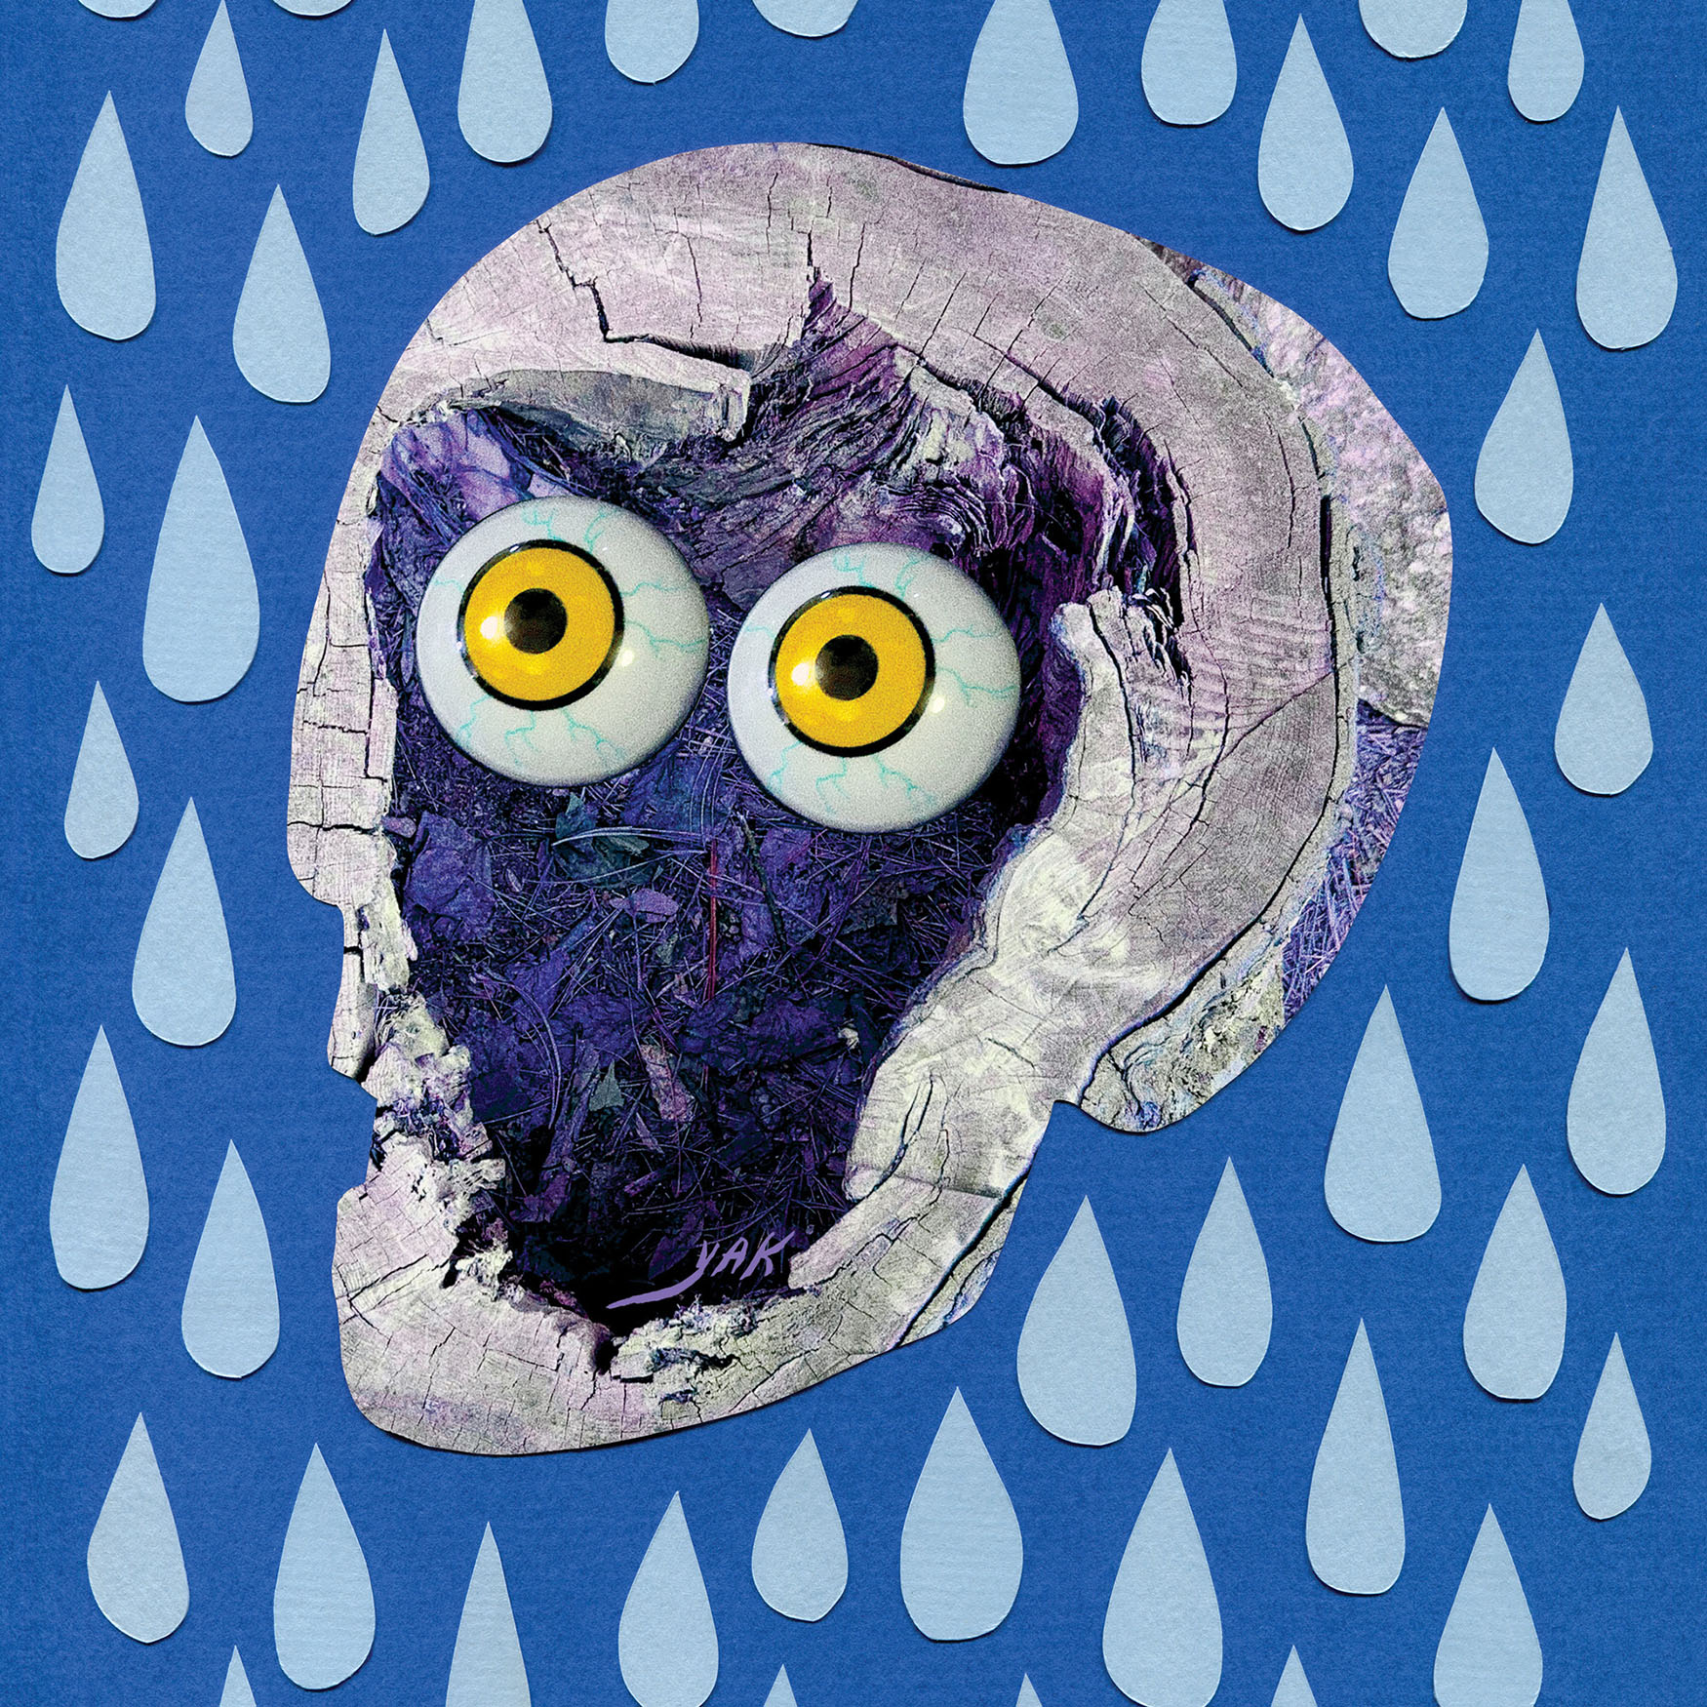
ANGEL DU$T – YAK: A COLLECTION OF TRUCK SONGS

OCTOBER 22, 2021 – Baltimore, Maryland’s Angel Du$t have released their widely-anticipated new album YAK: A Collection of Truck Songs, which available today on all streaming platforms.

Produced by Rob Schnapf (Kurt Vile, Elliott Smith), YAK: A Collection of Truck Songs sees Angel Du$t channeling an anything-goes philosophy into their tightest, most forward-thinking material yet. Recorded over a two-month period in Los Angeles last year, the album is a rotating smorgasbord of percussion, guitar tones, effects, genres, and influences, fashioned in the spirit of a playlist as opposed to a capital-R ‘Record.’ The album’s 12 tracks span jangle-rock gems (“Big Bite”), piano-spiked power pop (“No Fun”), and a breezy duet with Rancid’s Tim Armstrong (“Dancing On The Radio”). Put simply, Angel Du$t are the guys who do whatever you don't expect. YAK: A Collection of Truck Songs also features the singles “Truck Songs” and “Big Bite,” the latter of which is joined by an Ian Shelton directed music video. The new album also includes “Love Is The Greatest,” “All The Way Dumb,” “Turn Off The Guitar,” and “Never Ending Game,” all of which appeared on Angel Du$t’s 2021 EP Bigger House, an expansion on the foundation of their 2020 EP Lil House.

“YAK: A Collection of Truck Songs, is all about the punkest value of all: Thinking outside the box,” declared GRAMMY.com, with UPROXX attesting, “It’s a really cool look at the full spectrum of what this band is capable of.” The FADER praised “Big Bite” as “a cheerful and peppy song soaked in alt-rock and underground punk traditions,” and REVOLVER hailed Angel Du$t “Violent Femmes for a new generation.” CONSEQUENCE affirmed “Angel Du$t aren’t rehashing ideas,” with FLOOD celebrating “Truck Songs” as the “middle ground between bluesy, rockabilly guitars and hardcore smash mode,” and PASTE declaring “It’s a country-tinged jangle-pop gem with ripping guitars.”

Angel Du$t are currently on a U.S. tour with Mannequin Pussy which continues tomorrow, October 23rd in Rochester, NY with official record release shows slated for October 31st in Baltimore, MD and November 1st in Brooklyn, NY. Next month Angel Du$t will embark on a run of west coast headline dates featuring special guests Militarie Gun, which will get underway with a west coast record release show on November 17th at The Roxy is Los Angeles, CA (tour itinerary below). For more information on tickets and tour dates, visit www.angeldustmoney.com/tour.

Breezy but determined as they imbue their laid-back acoustics with sharpness, Angel Du$t continue to prove they are band averse to boundaries. The band’s Roadrunner Records debut LP, Pretty Buff, was produced by Will Yip and earned the band critical acclaim with UPROXX attesting “they somehow managed to pull off a 180-degree sonic overhaul with Pretty Buff, stripping back the raw aggression of their previous releases in favor of melodies and strong choruses.” GQ declared, “It’s impossible not to smile and bounce around hearing it, the perfect album for defeating your seasonal depression,” while HIGHSNOBIETY confirmed, “punk has never been more alive with Angel Du$t tearing up the hardcore scene and continuing to push all of the boundaries.” THE FADER praised Angel Du$t for their “Fast-paced acoustic guitar chords, speedy vocals, and sunny melodies,” and STEREOGUM asserted “Angel Du$t’s ripping hardcore seems to have emerged even more melodic… hurling forward with layers of percussion and a chunking acoustic guitar.”

ANGEL DU$T
2021 TOUR DATES
All Dates With Mannequin Pussy Except:
11/1: Angel Du$t NYC Record Release Show With Support TBA
11/17 – 11/21: Angel Du$t Headline Shows With Support From Militarie Gun

OCT 23 - BUG JAR - ROCHESTER, NY
OCT 24 - THE SPACE - HAMDEN, CT
OCT 26 - UPSTATE CONCERT HALL - CLIFTON PARK, NY
OCT 27 - THE SINCLAIR - CAMBRIDGE, MA
OCT 28 - MUSIC HALL OF WILLIAMSBURG - BROOKLYN, NY
OCT 29 - UNION TRANSFER - PHILADELPHIA, PA
OCT 30 - BOWERY BALLROOM - NEW YORK, NY
OCT 31 - OTTOBAR - BALTIMORE, MD (Official Record Release Show)
NOV 1 – BROOKLYN MADE – BROOKLYN, NY (Official Record Release Show)
NOV 17 - THE ROXY - LOS ANGELES, CA* (Official Record Release Show)
NOV 18 - SODA BAR - SAN DIEGO, CA*
NOV 19 - SUPPLY & DEMAND - LONG BEACH, CA *
NOV 20 - STRUMMER’S - FRESNO, CA*
NOV 21 - RICKSHAW STOP - SAN FRANCISCO, CA*

For more information on Angel Du$t:
WEBSITE
TWITTER
INSTAGRAM
FACEBOOK
YOUTUBE
SPOTIFY
APPLE MUSIC

