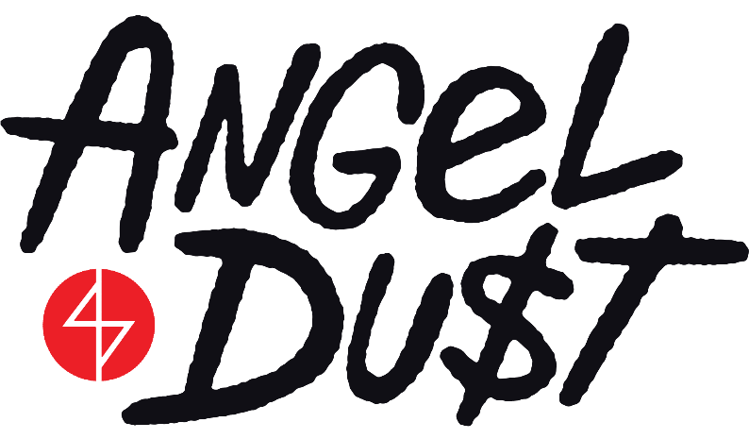

DEBUT “ON MY WAY” ANIMATED VIDEO ON ADULT SWIM

NEW ALBUM PRETTY BUFF OUT NOW

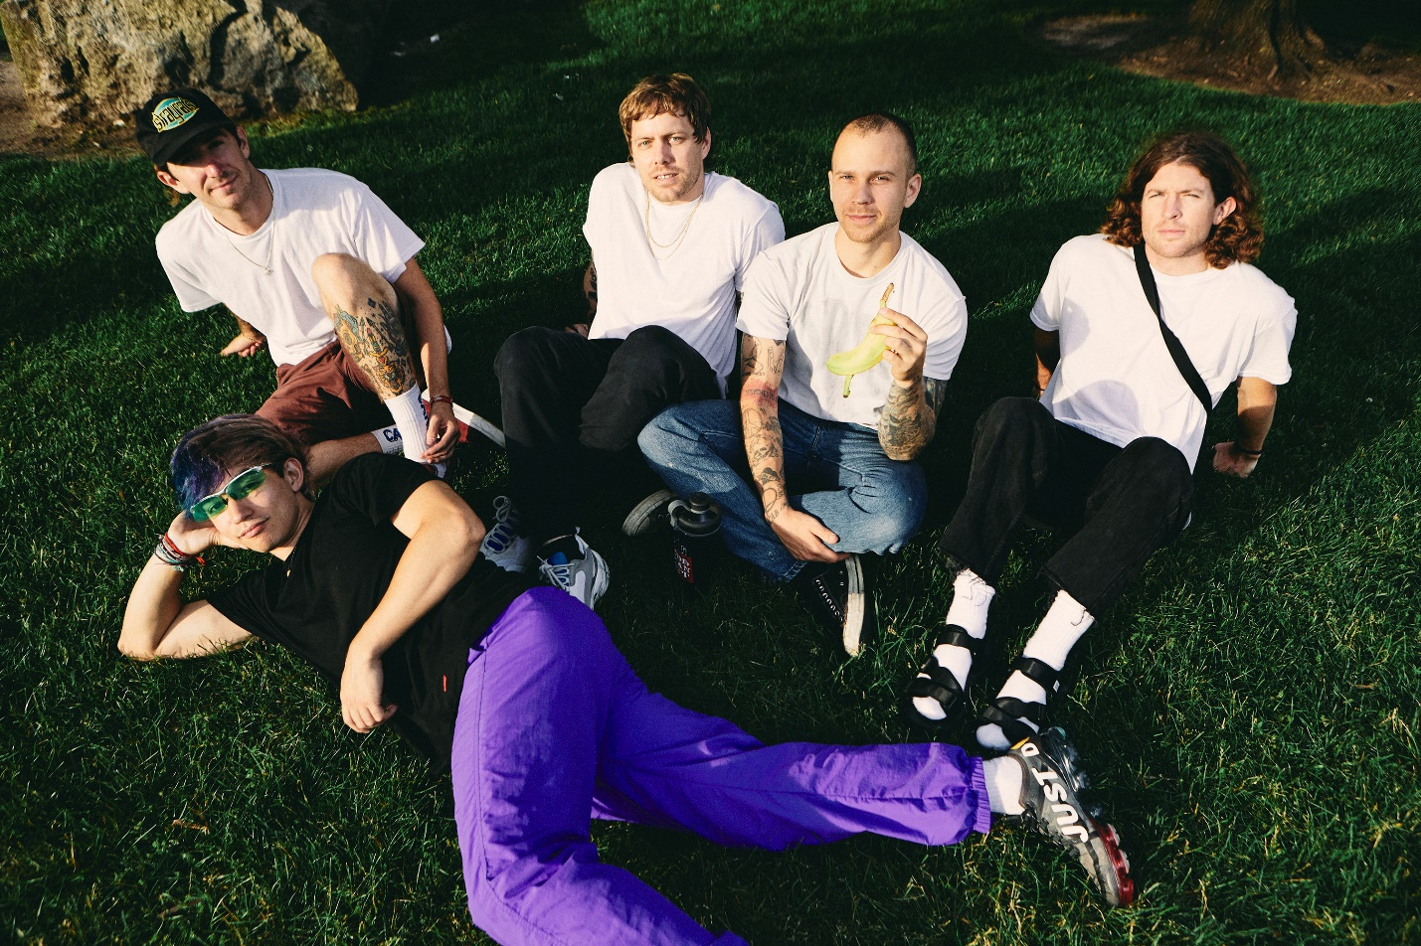

ANGEL DU$T – “ON MY WAY” [OFFICIAL VIDEO]

YOUTUBE: https://youtu.be/tbOg1K3NOQY
EMBED: <iframe width="560" height="315" src="https://www.youtube.com/embed/tbOg1K3NOQY" frameborder="0" allow="accelerometer; autoplay; encrypted-media; gyroscope; picture-in-picture" allowfullscreen></iframe>

OCTOBER 28, 2019 – Angel Du$t have shared their official music video for “On My Way,” which debuted during Adult Swim’s Toonami broadcast this past Saturday, October 26th. The animated video, which was directed / animated by Dani David-Spickermann, features over 1,750 hand painted frames and is streaming now on the band’s YouTube Channel as well as Adult Swim’s website.

“On My Way” is featured on Angel Du$t’s widely celebrated Roadrunner Records debut LP, PRETTY BUFF. Recorded with producer Will Yip at Studio 4 in Conshohocken, PA, PRETTY BUFF has earned the band critical applause with UPROXX naming the album to their “Best Indie Albums of 2019 So Far” round-up, while GQ named album standout “Park” to their “45 Best Songs of 2019 So Far” recap. “Punk has never been more alive with Angel Du$t tearing up the hardcore scene and continuing to push all of the boundaries,” declared HIGHSNOBIETY. PRETTY BUFF is highlighted by singles “Big Ass Love,” “Take Away The Pain,” “Bang My Drum,” and “On My Way,” and follows Angel Du$t’s 2016 breakthrough LP, ROCK THE FUCK ON FOREVER.

Named an “Artist To Watch: 17 Alternative & Indie Breakouts for 2019” by Billboard, Angel Du$t’s “Big Ass Love” was named one of “The 20 Best Rock Songs Right Now” by The FADER who praised the track for its “Fast-paced acoustic guitar chords, speedy vocals, and sunny melodies.” STEREOGUM asserted “Angel Du$t’s ripping hardcore seems to have emerged even more melodic… hurling forward with layers of percussion and a chunking acoustic guitar,” while REVOLVER named Angel Du$t one of “5 Artists You Need To Know: January 2019.”

Comprised of Justice Tripp (Vocals), Daniel Fang (Drums), Pat McCrory (Guitars/Vocals), Brendan Yates (Guitars/Vocals), and Jeff Caffey (Bass), Angel Du$t is a band averse to boundaries. Stacking hooks and harmonies over unorthodox acoustic guitars, beds of hand percussion, and the occasional saxophone, Angel Du$t are leaders for the shifting zeitgeist into punk circles. That is their rebellion.

(Album Art / Track Listing)

ANGEL DU$T
PRETTY BUFF

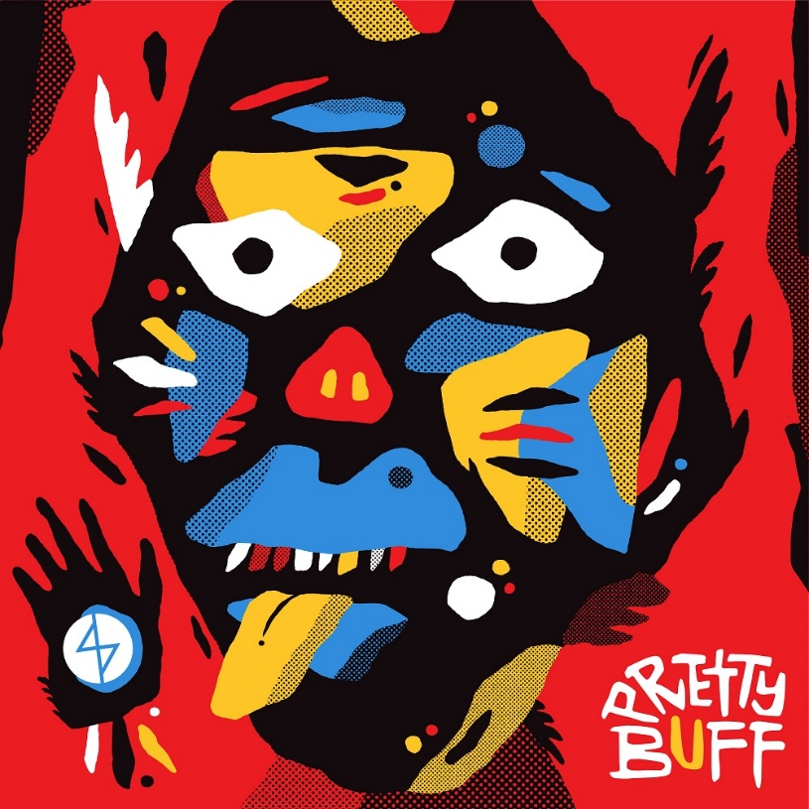

01. No Fair
02. Big Ass Love
03. On My Way
04. Light Blue
05. Biggest Girl
06. Push
07. Bang My Drum
08. Let Me Know
09. Want It All
10. Where I Am
11. Park
12. Take Away The Pain
13. Five

For more information on Angel Du$t:

www.angeldustmoney.com
www.twitter.com/angeldustmoney
www.instagram.com/angeldustmoney
www.facebook.com/angeldustmoney

Contact:
Ross Anderson
RossAnderson@elektra.com
212-707-3066

Sarah Goldstein
SarahGoldstein@elektra.com
212-707-2146

