ANGEL DU$T SHARE NEW SONG “TRUCK SONGS”

NEW ALBUM YAK: A COLLECTION OF TRUCK SONGS ARRIVES OCTOBER 22ND

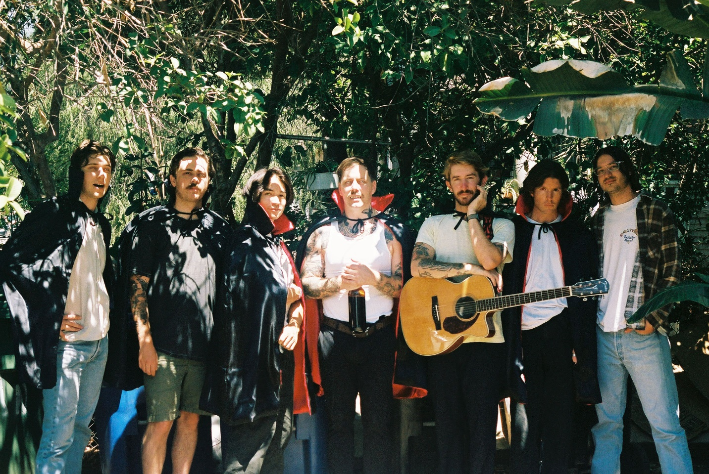
PHOTO CREDIT: KAT NIJMEDDIN

SEPTEMBER 29, 2021 – Baltimore, Maryland’s Angel Du$t have shared “Truck Songs,” the latest single to be released from their forthcoming new album YAK: A Collection of Truck Songs – due out October 22nd on Roadrunner Records. YAK: A Collection of Truck Songs is available for pre-order today (album art / track listing below) with “Truck Songs” available on all streaming platforms.

Vocalist / guitarist Justice Tripp elaborated on the new single sharing, “This is one of my favorite recordings of a song that I’ve written. Plus, all my best homies got all up in this track’s ass and sent it home. Was listening to Tom Petty a grip. If you don’t know who that is check him out, I guess.”

“Truck Songs” follow Angel Du$t’s recent single “Big Bite,” which arrived earlier this month alongside an official music video directed by Ian Shelton – watch it HERE. UPROXX included “Big Bite” in their weekly Best New Indie Music round-up, while The FADER praised the track as “a cheerful and peppy song soaked in alt-rock and underground punk traditions.” REVOLVER highlighted “Big Bite” in their Best New Songs Right Now column describing Angel Du$t as “Violent Femmes for a new generation,” with CONSEQUENCE confirming “Angel Du$t aren’t rehashing ideas.”

Produced by Rob Schnapf (Kurt Vile, Elliott Smith), YAK: A Collection of Truck Songs follows Angel Du$t’s 2019’s LP Pretty Buff, and sees the group channeling an anything-goes philosophy into their tightest, most forward-thinking material yet. Recorded over a two-month period in Los Angeles last year, the album is a rotating smorgasbord of percussion, guitar tones, effects, genres, and influences, fashioned in the spirit of a playlist as opposed to a capital-R ‘Record.’ The album’s 12 tracks span jangle-rock gems (“Big Bite”), piano-spiked power pop (“No Fun”), and a breezy duet with Rancid’s Tim Armstrong (“Dancing On The Radio”). Put simply, Angel Du$t are the guys who do whatever you don't expect.

YAK: A Collection of Truck Songs also features; “Love Is The Greatest,” “All The Way Dumb,” “Turn Off The Guitar,” and “Never Ending Game,” all of which appeared on Angel Du$t’s 2021 EP Bigger House, an expansion on the foundation of their 2020 EP Lil House.

This week Angel Du$t will rejoin Mannequin Pussy on their U.S. tour which continues tomorrow, September 30th, at Teragram Ballroom in Los Angeles, CA. Later this fall Angel Du$t are set for a run of west coast headline dates featuring special guests Militarie Gun, which will get underway on November 17th at The Roxy is Los Angeles, CA (tour itinerary below). For more information on tickets and tour dates, visit www.angeldustmoney.com/tour.

Breezy but determined as they imbue their laid-back acoustics with sharpness, Angel Du$t continue to prove they are band averse to boundaries. The band’s Roadrunner Records debut LP, Pretty Buff, was produced by Will Yip and earned the band critical acclaim with UPROXX attesting “they somehow managed to pull off a 180-degree sonic overhaul with Pretty Buff, stripping back the raw aggression of their previous releases in favor of melodies and strong choruses.” GQ declared, “It’s impossible not to smile and bounce around hearing it, the perfect album for defeating your seasonal depression,” while HIGHSNOBIETY confirmed, “punk has never been more alive with Angel Du$t tearing up the hardcore scene and continuing to push all of the boundaries.” THE FADER praised Angel Du$t for their “Fast-paced acoustic guitar chords, speedy vocals, and sunny melodies,” and STEREOGUM asserted “Angel Du$t’s ripping hardcore seems to have emerged even more melodic… hurling forward with layers of percussion and a chunking acoustic guitar.”

ANGEL DU$T
YAK: A COLLECTION OF TRUCK SONGS
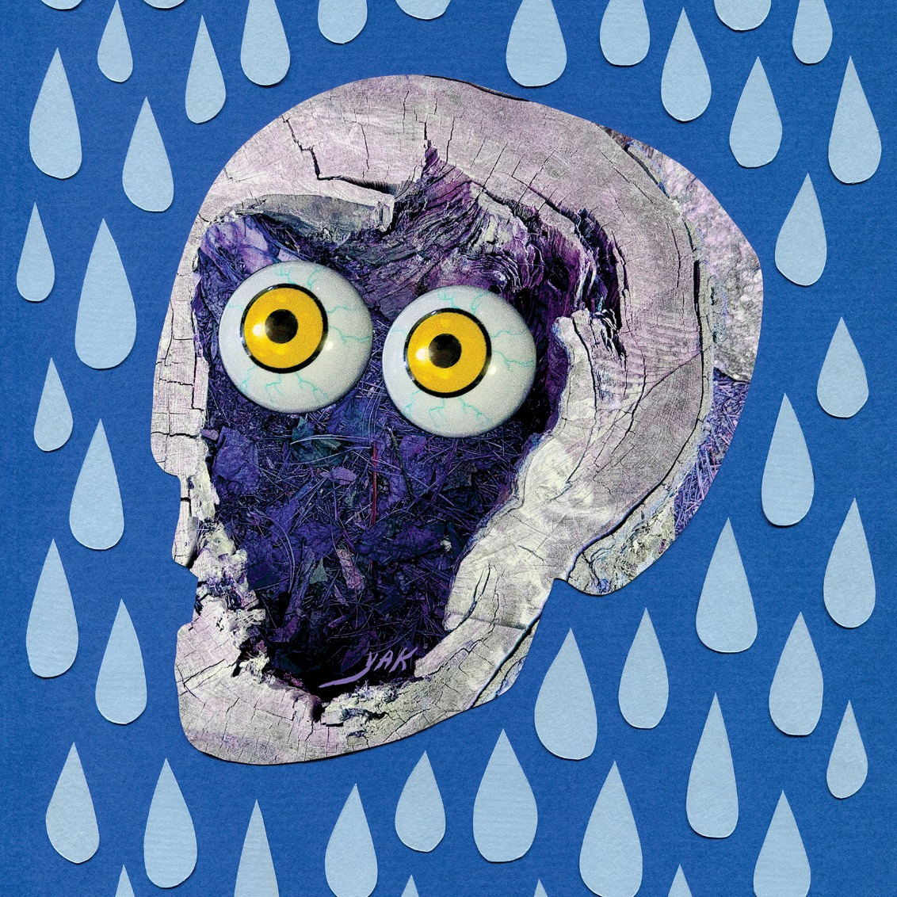

01. Big Bite
02. No Vacancy
03. All The Way Dumb
04. Dancing On The Radio feat. Tim Armstrong
05. Fear Some
06. Yak
07. Love Is The Greatest
08. Cool Faith
09. Never Ending Game
10. No Fun
11. Truck Songs
12. Turn Off The Guitar

ANGEL DU$T
2021 TOUR DATES
All Dates With Mannequin Pussy Except:
10/8 – 10/11: Angel Du$t Headline Shows
11/17 – 11/21: Angel Du$t Headline Shows With Support From Militarie Gun

SEP 30 - TERAGRAM BALLROOM - LOS ANGELES, CA
OCT 08 - THE UNDERGROUND - MESA, AZ**
OCT 09 - CLUB CONGRESS - TUCSON, AZ**
OCT 11 - PAPER TIGER - SAN ANTONIO, TX**
OCT 12 - THE PARISH - AUSTIN, TX
OCT 13 - CLUB DADA - DALLAS, TX
OCT 14 - THE SECRET GROUP - HOUSTON, TX
OCT 16 - SATURN - BIRMINGHAM, AL
OCT 17 - MOTORCO MUSIC HALL - DURHAM, NC
OCT 19 - AISLE 5 - ATLANTA, GA
OCT 20 - THE HIGH WATT - NASHVILLE, TN
OCT 21 - WOODWARD THEATER - CINCINNATI, OH
OCT 23 - BUG JAR - ROCHESTER, NY
OCT 24 - THE SPACE - HAMDEN, CT
OCT 26 - UPSTATE CONCERT HALL - CLIFTON PARK, NY
OCT 27 - THE SINCLAIR - CAMBRIDGE, MA
OCT 28 - MUSIC HALL OF WILLIAMSBURG - BROOKLYN, NY
OCT 29 - UNION TRANSFER - PHILADELPHIA, PA
OCT 30 - BOWERY BALLROOM - NEW YORK, NY
OCT 31 - OTTOBAR - BALTIMORE, MD
NOV 17 - THE ROXY - LOS ANGELES, CA*
NOV 18 - SODA BAR - SAN DIEGO, CA*
NOV 19 - SUPPLY & DEMAND - LONG BEACH, CA *
NOV 20 - STRUMMER’S - FRESNO, CA*
NOV 21 - RICKSHAW STOP - SAN FRANCISCO, CA*

For more information on Angel Du$t:
WEBSITE
TWITTER
INSTAGRAM
FACEBOOK
YOUTUBE
SPOTIFY
APPLE MUSIC

