ANGEL DU$T ANNOUNCE NEW ALBUM YAK: A COLLECTION OF TRUCK SONGS

SHARE NEW SONG & MUSIC VIDEO - “BIG BITE”

YAK: A COLLECTION OF TRUCK SONGS ARRIVES OCTOBER 22ND

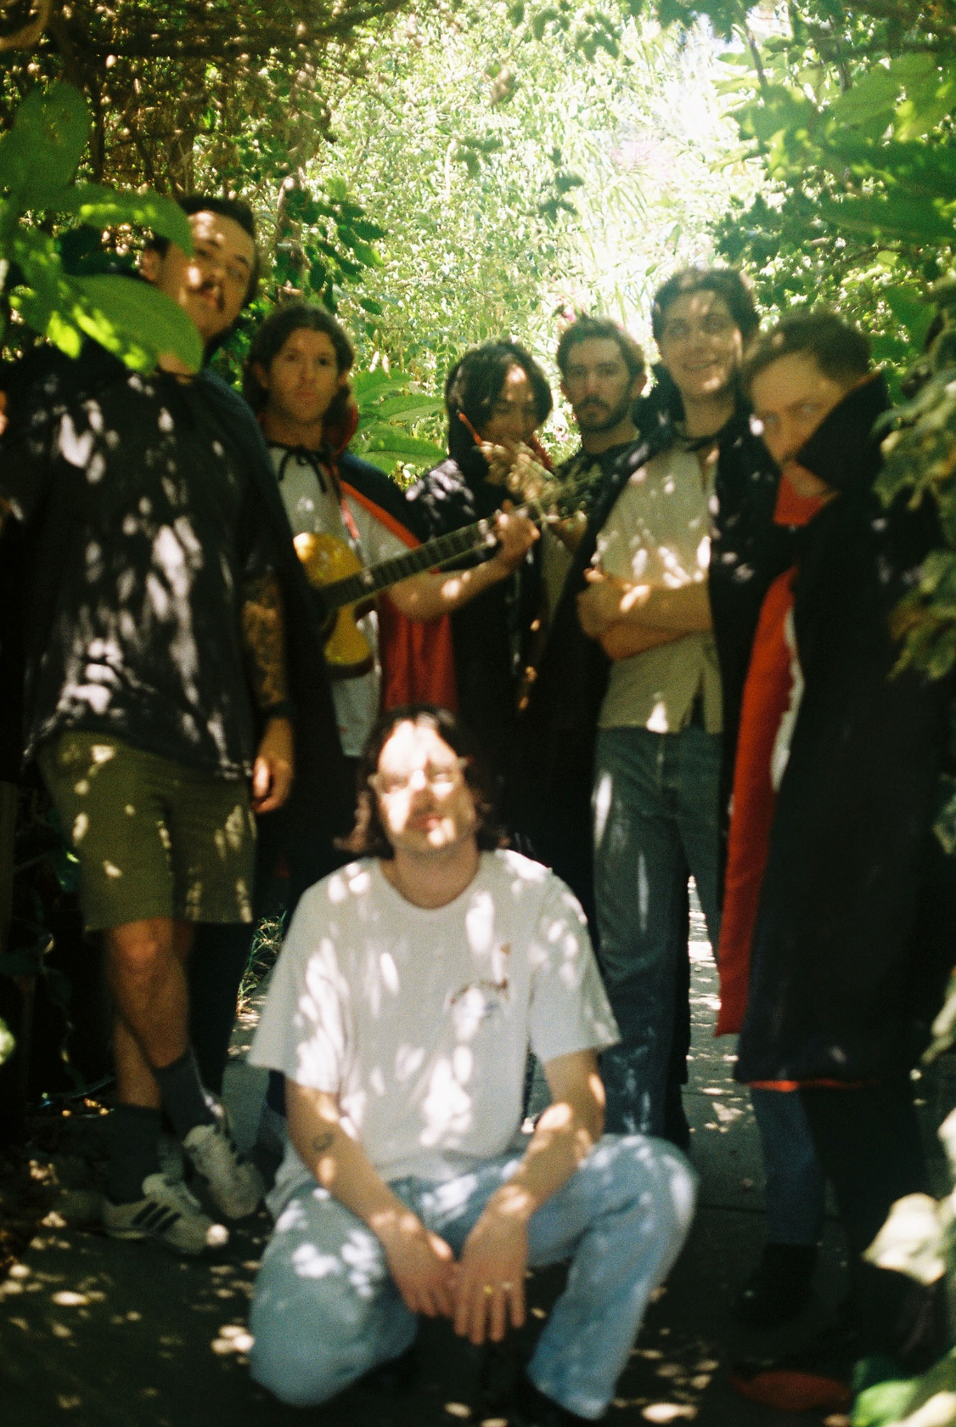
PHOTO CREDIT: KAT NIJMEDDIN

SEPTEMBER 8, 2021 – Baltimore, Maryland’s Angel Du$t have announced details of their new album YAK: A Collection of Truck Songs, which will be released October 22nd on Roadrunner Records and is available for pre-order today (album art / track listing below). The band have also shared the new song, “Big Bite” which is available today on all streaming platforms and joined by a music video directed by Ian Shelton – watch it HERE.

Vocalist / guitarist Justice Tripp remarked on the forthcoming album sharing, “People get really married to the idea of making a record that sounds like the same band. If one song to the next doesn’t sound like it’s coming from the same band, I’m ok with that.”

Put simply, Angel Du$t are the guys who do whatever you don't expect.

Produced by Rob Schnapf (Kurt Vile, Elliott Smith), YAK: A Collection of Truck Songs follows Angel Du$t’s 2019’s LP Pretty Buff, and sees the group channeling an anything-goes philosophy into their tightest, most forward-thinking material yet. Recorded over a two-month period in Los Angeles last year, the album is a rotating smorgasbord of percussion, guitar tones, effects, genres, and influences, fashioned in the spirit of a playlist as opposed to a capital-R ‘Record.’ The album’s 12 tracks span jangle-rock gems (“Big Bite”), piano-spiked power pop (“No Fun”), and a breezy duet with Rancid’s Tim Armstrong (“Dancing On The Radio”).

YAK: A Collection of Truck Songs also features; “Love Is The Greatest,” “All The Way Dumb,” “Turn Off The Guitar,” and “Never Ending Game,” all of which appeared on Angel Du$t’s 2021 EP Bigger House, an expansion on the foundation of their 2020 EP Lil House.

Next week Angel Du$t will kick off a coast-to-coast tour alongside Mannequin Pussy which will begin on September 14th in Chicago, IL. Today the band has also announced a series of west coast headline dates featuring special guests Militarie Gun, which will get underway on November 17th at The Roxy is Los Angeles, CA. Tickets for the west coast performances will be available this Friday, September 10th, at 10:00AM local time (see tour itinerary below). For more information on tickets and tour dates, visit www.angeldustmoney.com/tour.

Breezy but determined as they imbue their laid-back acoustics with sharpness, Angel Du$t continue to prove they are band averse to boundaries. The band’s Roadrunner Records debut LP, Pretty Buff, was produced by Will Yip and earned the band critical acclaim with UPROXX attesting “they somehow managed to pull off a 180-degree sonic overhaul with Pretty Buff, stripping back the raw aggression of their previous releases in favor of melodies and strong choruses.” GQ declared, “It’s impossible not to smile and bounce around hearing it, the perfect album for defeating your seasonal depression,” while HIGHSNOBIETY confirmed, “punk has never been more alive with Angel Du$t tearing up the hardcore scene and continuing to push all of the boundaries.” THE FADER praised Angel Du$t for their “Fast-paced acoustic guitar chords, speedy vocals, and sunny melodies,” and STEREOGUM asserted “Angel Du$t’s ripping hardcore seems to have emerged even more melodic… hurling forward with layers of percussion and a chunking acoustic guitar.”

[ALBUM ART / TRACKLISTING / TOUR ITINERARY BELOW]

ANGEL DU$T
YAK: A COLLECTION OF TRUCK SONGS
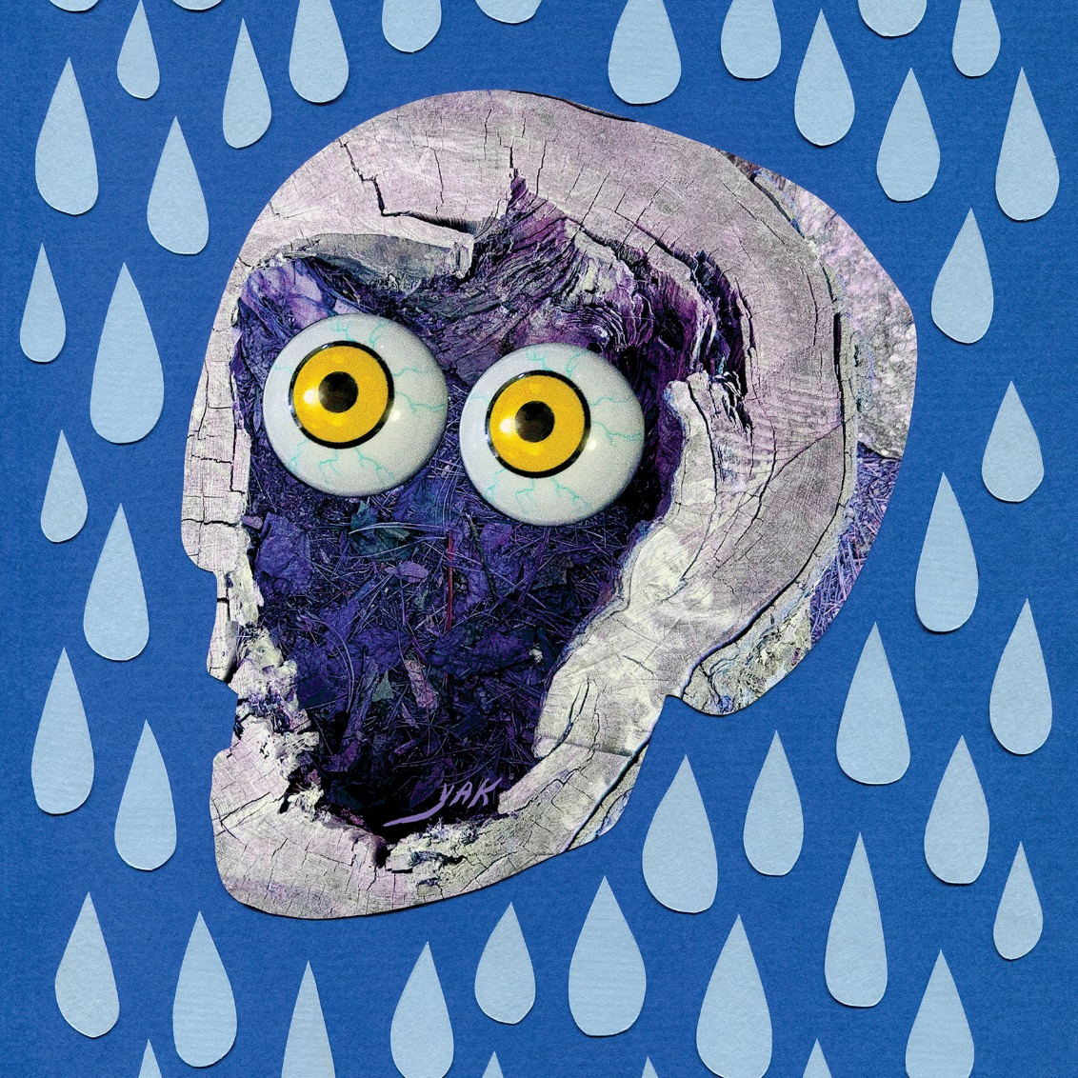

01. Big Bite
02. No Vacancy
03. All The Way Dumb
04. Dancing On The Radio feat. Tim Armstrong
05. Fear Some
06. Yak
07. Love Is The Greatest
08. Cool Faith
09. Never Ending Game
10. No Fun
11. Truck Songs
12. Turn Off The Guitar

ANGEL DU$T
2021 TOUR DATES
All Dates With Mannequin Pussy Except:
*Angel Du$t Headline Shows With Support From Militaire Gun

SEP 14 - SCHUBAS TAVERN - CHICAGO, IL
SEP 15 - LINCOLN HALL - CHICAGO, IL
SEP 16 - 7TH ST ENTRY - MINNEAPOLIS, MN
SEP 17 - SLOWDOWN - OMAHA, NE
SEP 18 - THE RIOT ROOM - KANSAS CITY, MO
SEP 20 - BLUEBIRD THEATER - DENVER, CO
SEP 21 - KILBY COURT - SALT LAKE CITY, UT
SEP 23 - THE CROCODILE - SEATTLE, WA
SEP 24 - LUCKY YOU LOUNGE - SPOKANE, WA
SEP 25 – HOLOCENE - PORTLAND, OR
SEP 26 - TREEFORT MUSIC FESTIVAL - BOISE, ID
SEP 28 - THE NEW PARISH - OAKLAND, CA
SEP 29 - THE CATALYST ATRIUM - SANTA CRUZ, CA
SEP 30 - TERAGRAM BALLROOM - LOS ANGELES, CA
OCT 08 - THE UNDERGROUND - MESA, AZ*
OCT 09 - CLUB CONGRESS - TUCSON, AZ*
OCT 11 - PAPER TIGER - SAN ANTONIO, TX*
OCT 12 - THE PARISH - AUSTIN, TX
OCT 13 - CLUB DADA - DALLAS, TX
OCT 14 - THE SECRET GROUP - HOUSTON, TX
OCT 16 - SATURN - BIRMINGHAM, AL
OCT 17 - MOTORCO MUSIC HALL - DURHAM, NC
OCT 19 - AISLE 5 - ATLANTA, GA
OCT 20 - THE HIGH WATT - NASHVILLE, TN
OCT 21 - WOODWARD THEATER - CINCINNATI, OH
OCT 23 - BUG JAR - ROCHESTER, NY
OCT 24 - THE SPACE - HAMDEN, CT
OCT 26 - UPSTATE CONCERT HALL - CLIFTON PARK, NY
OCT 27 - THE SINCLAIR - CAMBRIDGE, MA
OCT 28 - MUSIC HALL OF WILLIAMSBURG - BROOKLYN, NY
OCT 29 - UNION TRANSFER - PHILADELPHIA, PA
OCT 30 - BOWERY BALLROOM - NEW YORK, NY
OCT 31 - OTTOBAR - BALTIMORE, MD
NOV 17 - THE ROXY - LOS ANGELES, CA*
NOV 18 - SODA BAR - SAN DIEGO, CA*
NOV 19 - SUPPLY & DEMAND - LONG BEACH, CA *
NOV 20 - STRUMMER’S - FRESNO, CA*
NOV 21 - RICKSHAW STOP - SAN FRANCISCO, CA*

For more information on Angel Du$t:
WEBSITE
TWITTER
INSTAGRAM
FACEBOOK
YOUTUBE
SPOTIFY
APPLE MUSIC

