BRANDI CARLILE’S NEW ALBUM
IN THESE SILENT DAYS OUT OCTOBER 1, FIRST SINGLE “RIGHT ON TIME” OUT TODAY
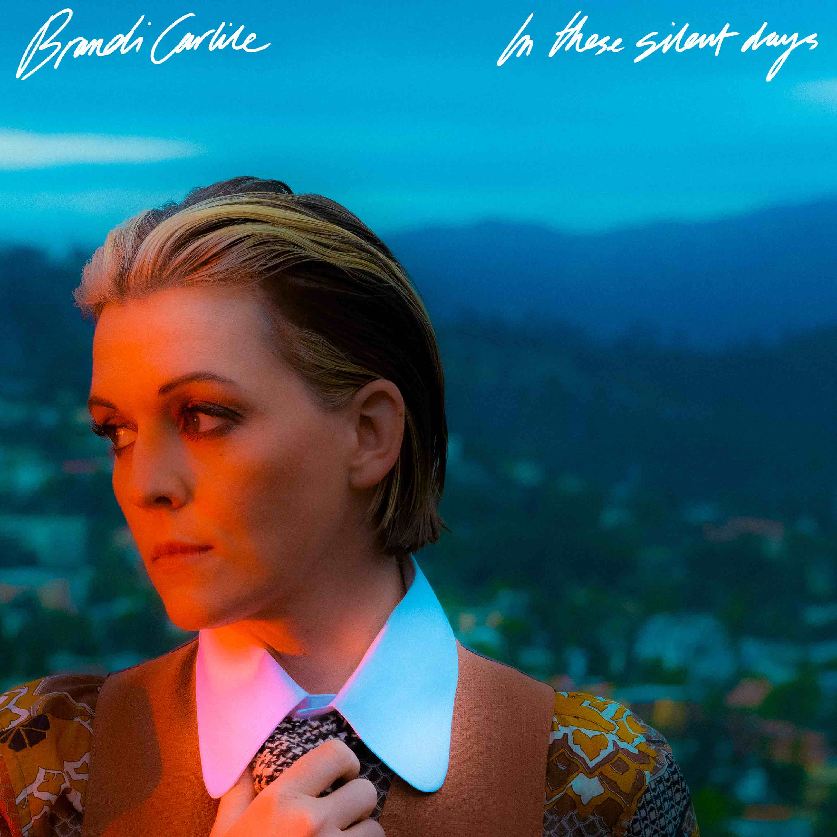
album artwork
July 21, 2021—In These Silent Days, the highly anticipated new studio album from six-time Grammy Award-winning singer, songwriter, performer, producer and New York Times Best Selling author Brandi Carlile, will be released October 1 on Low Country Sound/Elektra Records (pre-order/pre-save). Ahead of the release, the album’s first single, “Right On Time,” featuring a music video directed by Courteney Cox, is premiering today. Watch/share HERE.
Of the album, Carlile shares,
“Never before have the twins and I written an album during a time of such uncertainty and quiet solitude. I never imagined that I’d feel so exposed and weird as an artist without the armor of a costume, the thrill of an applause and the platform of the sacred stage.
Despite all this, the songs flowed through—pure and unperformed, loud and proud, joyful and mournful. Written in my barn during a time of deep and personal reckoning.
There’s plenty reflection…but mostly it’s a celebration.
This album is what drama mixed with joy sounds like. It’s resistance and gratitude, righteous anger and radical forgiveness.
It’s the sound of these silent days.”
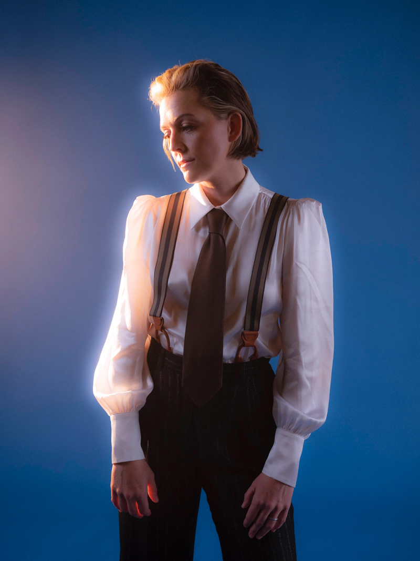
Inspired by the mining of her own history while writing this year’s #1 New York Times Best Selling memoir Broken Horses (Crown), In These Silent Days was conceived of while Carlile was quarantined at home with longtime collaborators and bandmates Tim and Phil Hanseroth. The ten songs chronicle acceptance, faith, loss and love and channel icons like David Bowie, Freddie Mercury, Elton John and Joni Mitchell—the latter two who, by some sort of cosmic alignment of the stars, have turned out to be close friends in addition to being her biggest heroes and inspirations.
Recorded once again at Nashville’s historic RCA Studio A with producers Dave Cobb and Shooter Jennings, the album features Carlile (vocals, guitar, piano), Tim Hanseroth (vocals, bass), Phil Hanseroth (vocals, guitar), Cobb (guitar, percussion) and Jennings (piano, organ, synth) as well as Chris Powell (drums, percussion), Josh Neumann (strings) and special guests Jess Wolfe and Holly Laessig of Lucius on backing vocals on the track “You And Me On The Rock.”
Carlile will perform select headline shows this year including an upcoming concert at NYC’s Forest Hills Stadium this Friday as well as landmark summer shows at Washington’s Gorge Amphitheatre on August 14 and Colorado’s Red Rocks Amphitheatre with the Colorado Symphony on September 11 and 12. Additionally, her “Girls Just Wanna Weekend” festival will return to the Hard Rock Hotel in Riviera Maya, Mexico February 1-5, 2022. The sold-out vacation destination event will once again feature an all-female-fronted lineup including performances by Carlile, Sheryl Crow, Tanya Tucker, Indigo Girls, Lucius, Margo Price, Yola, KT Tunstall, Allison Russell, Amythyst Kiah and Katie Pruitt as well as special guests. See below for complete tour itinerary. Additional dates to be announced.
photo credit: Neil Krug

In These Silent Days follows Carlile’s 2018 breakthrough GRAMMY Award-winning album, By The Way, I Forgive You, which Rolling Stone declared, “…an Adele-meets Joni Mitchell tour de force.” In the years since—in addition to collaborative projects with The Highwomen, Tanya Tucker, Soundgarden, Alicia Keys, Dolly Parton, Barry Gibb, Leslie Jordan, Brandy Clark and more—she has earned six Grammy Awards recognizing her work as a performer, songwriter and producer, was awarded Billboard’s Women In Music “Trailblazer Award,” CMT’s Next Women of Country “Impact Award” and received multiple recognitions from the Americana Music Association Honors & Awards including 2020’s Album of the Year (Highwomen), Group of the Year (The Highwomen) and Song of the Year (“Crowded Table”) and 2019’s Artist of the Year. Carlile is also once again nominated for Artist of the Year and Group of the Year (The Highwomen) at the 2021 ceremony, to be held in September.
In addition to their work as a band, Carlile and the Hanseroth twins remain committed to social activism and advocacy. Together they are founders of the Looking Out Foundation, which amplifies the impact of music by empowering those without a voice with varied initiatives including campaigns focused on Children in Conflict/War Child, The IF Project, Fund Racial Justice and more. To date, they have raised over $2 million for grassroots causes.
IN THESE SILENT DAYS TRACKLIST
1. Right On Time
2. You And Me On The Rock
3. This Time Tomorrow
4. Broken Horses
5. Letter To The Past
6. Mama Werewolf
7. When You’re Wrong
8. Stay Gentle
9. Sinners Saints And Fools
10.Throwing Good After Bad
BRANDI CARLILE CONFIRMED TOUR DATES
July 23—Forest Hills, NY—Forest Hills Stadium
July 24—Canandaigua, NY—CMAC
August 14—Quincy, WA—Gorge Amphitheatre
August 20—Portland, ME—Thompson’s Point
August 21—Lenox, MA—Koussevitzky Music Shed
August 28—Vienna, VA—Wolf Trap Center for Performing Arts
September 3—Napa County, CA—BottleRock Napa Valley 2021
September 4—Bend, OR—Les Schwab Amphitheater
September 5—Bend, OR—Les Schwab Amphitheater
September 11—Morrison, CO—Red Rocks Amphitheatre with the Colorado Symphony
September 12—Morrison, CO—Red Rocks Amphitheatre with the Colorado Symphony
September 25—Columbia, MO—Roots N Blues Festival
September 26—Dana Point, CA—Ohana Fest 2021
October 2—Dana Point, CA—Ohana Fest 2021
October 8—New Orleans, LA—New Orleans Jazz & Heritage Festival
October 21—Miramar Beach, FL—Moon Crush
February 1-5, 2022—Riviera Maya, Mexico—Girls Just Wanna Weekend (SOLD OUT)
April 29, 2022—Indio, CA—Stagecoach Music Festival
www.brandicarlile.com

