BRANDI CARLILE’S NEW ALBUM IN THESE SILENT DAYS OUT TODAY
FEATURED ON “CBS THIS MORNING”
“SATURDAY NIGHT LIVE” DEBUT CONFIRMED FOR OCTOBER 23
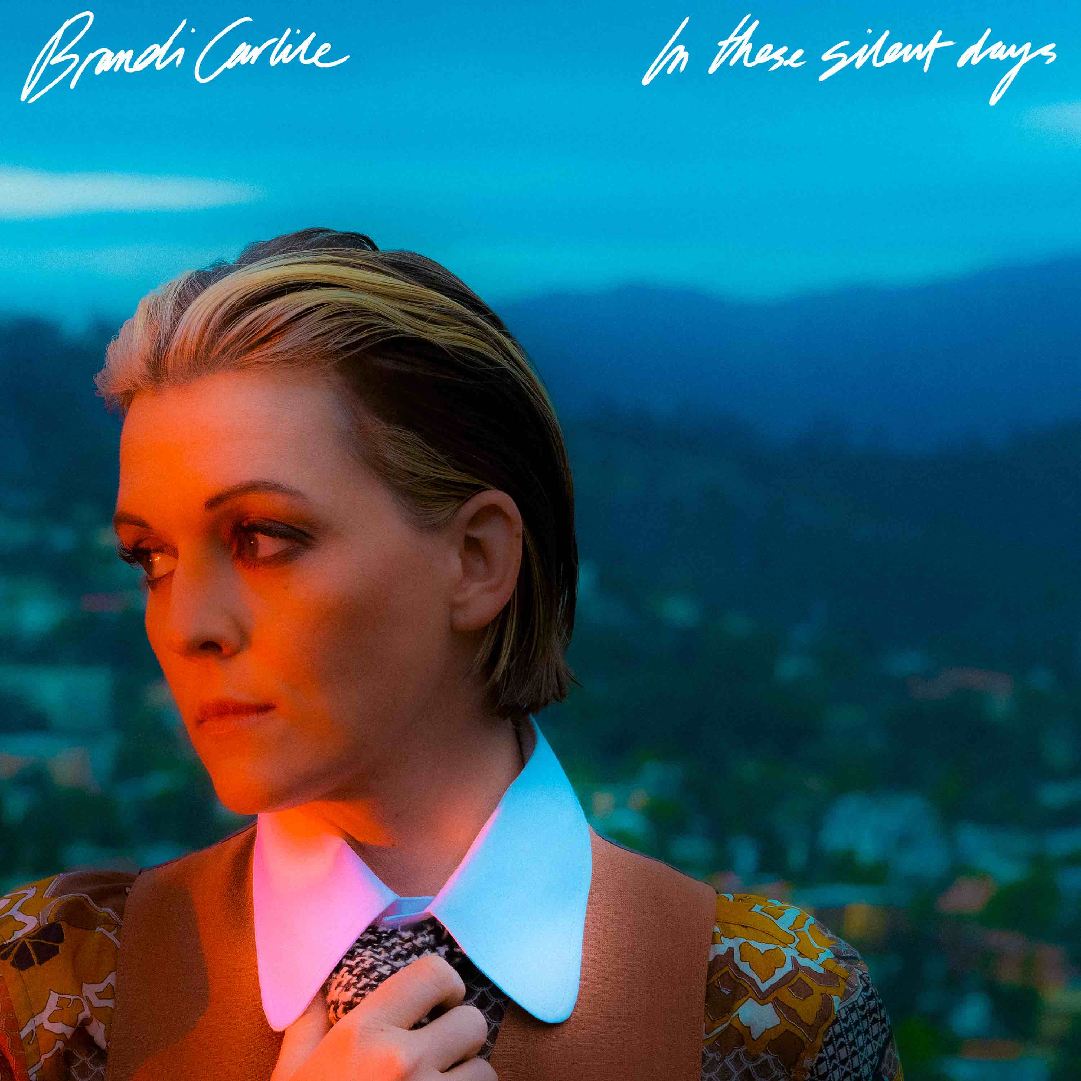
album artwork
October 1, 2021—In These Silent Days, the highly anticipated new album from six-time Grammy Award-winning singer, songwriter, performer, producer and New York Times Best Selling author Brandi Carlile, is out today on Low Country Sound/Elektra Records. Stream/purchase HERE.
In celebration of the release, Carlile was featured on “CBS This Morning” earlier today speaking with Anthony Mason and will make her debut as the musical guest on NBC’s “Saturday Night Live” October 23 with host Jason Sudeikis.
Inspired by the mining of her own history while writing this year’s #1 New York Times Best Selling memoir, Broken Horses (Crown), In These Silent Days was conceived of while Carlile was quarantined at home with longtime collaborators and bandmates Tim and Phil Hanseroth. The ten songs chronicle acceptance, faith, loss and love and channel icons like David Bowie, Freddie Mercury, Elton John and Joni Mitchell—the latter two who, by some sort of cosmic alignment of the stars, have turned out to be close friends in addition to being her biggest heroes and inspirations.
Critical acclaim for In These Silent Days…
“Expectations are high for her next album, but the searing In These Silent Days rises to the occasion. It’s a confidently composed testament to Carlile’s eclecticism”—The New York Times
“absolutely breathtaking, across the whole album Brandi Carlile pulls out all the stops. It’s just extraordinary…she’s just claiming rock god status”—NPR Music
“Brandi Carlile is a portrait of grace and acceptance on In These Silent Days”
—Entertainment Weekly
“For fans of the classic singer-songwriter form, there’s no more anticipated album this
year”—Variety
“one of the biggest voices in the genre”—Vulture
“she has built a remarkable reputation for writing sweeping roots-rock ballads that defy genre categorization and bring comfort to fans who might also feel out of step with heteronormative culture.”—Stereogum
“gorgeous”—Billboard
“cements her as one of music’s biggest superstars”—Spin
“The album is filled with sweeping instrumental compositions and emotional crescendos…it’s Brandi Carlile’s signature, genre-bending sound, just turned all the way up.”—Bustle
“it’s the most dynamic and unflinching collection of her career…she sings with beautiful precision”—The Seattle Times
“a lyric poet and storyteller in the truest sense”—The Advocate
“a set of honest, pure new originals that now sit proudly in the Brandi Carlile songbook.”—Relix
“Rejoice, Americana faithful…Carlile spins cinematic piano rock worthy of her hero-friend Elton John, matched by introspective storytelling and a booming vocal
performance.”—The Tennessean
“It’s classic Carlile, taking some of the most profound experiences in life and being able to capture them perfectly in a three-minute song…she once again proves why she’s one of the best songwriters and performers in music”—OUT
“yet another triumph for this singular artist, a preeminent voice of our times whose command of vocal and musical dynamics is the perfect complement for both her straightforward and oft ambiguous lyrics.”—Glide
“an eclectic, beautifully produced collection of songs with both wisdoms and melodies that will get stuck in your head.”—Sojourners
“The six-time Grammy winner sounds even more lustrous and evocative…her alto shimmers and her Nashville production team shines in every note.”—Music Row
“This is a stone-cold, instant classic – one that should cement Carlile and her collaborators at the forefront of the warm embrace of mainstream Americana.”—Holler
“It is, as usual, Carlile’s voice that’s the instrument that shines brightest – from delicate to forceful, emotional cracks to an outright howl”—Americana Highways
“shows just how skillful a singer Carlile has become: She shifts effortlessly between wavery murmur, fluttery falsetto and stratospheric roar.”—RIFF Magazine
Recorded once again at Nashville’s historic RCA Studio A with producers Dave Cobb and Shooter Jennings, the album features Carlile (vocals, guitar, piano), Tim Hanseroth (vocals, bass), Phil Hanseroth (vocals, guitar), Cobb (guitar, percussion) and Jennings (piano, organ, synth) as well as Chris Powell (drums, percussion), Josh Neumann (strings) and special guests Jess Wolfe and Holly Laessig of Lucius on backing vocals on the track “You And Me On The Rock.”
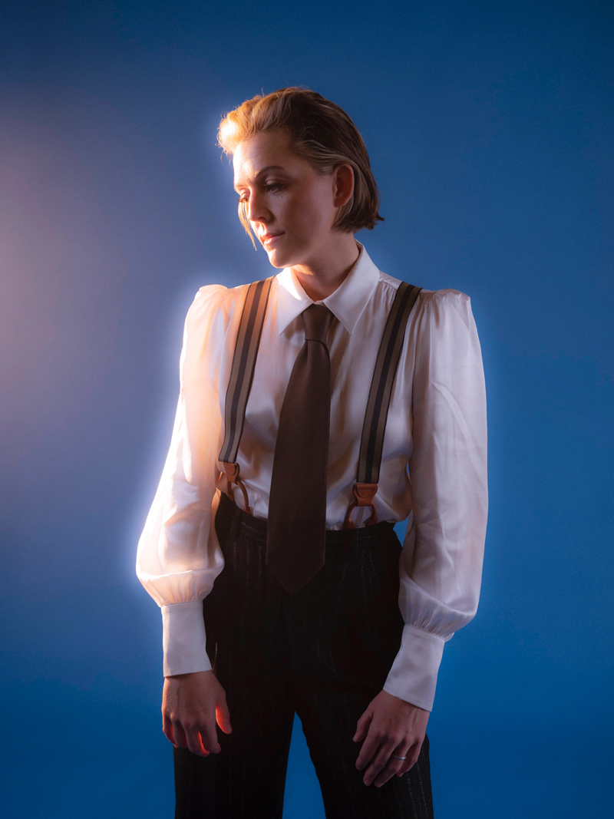
Reflecting on the album, Carlile shares, “Never before have the twins and I written an album during a time of such uncertainty and quiet solitude. I never imagined that I’d feel so exposed and weird as an artist without the armor of a costume, the thrill of an applause and the platform of the sacred stage. Despite all this, the songs flowed through—pure and unperformed, loud and proud, joyful and mournful. Written in my barn during a time of deep and personal reckoning. There’s plenty reflection…but mostly it’s a celebration. This album is what drama mixed with joy sounds like. It’s resistance and gratitude, righteous anger and radical forgiveness. It’s the sound of these silent days.”
Adding to yet another monumental year, Carlile will once again perform Joni Mitchell’s legendary album Blue in full at Carnegie Hall on November 6. Additionally, her wildly successful “Girls Just Wanna Weekend” will return February 1-5, 2022. The sold-out vacation destination event held at Mexico’s Hard Rock Hotel Riviera Maya will once again feature an all-female-fronted lineup including performances by Carlile, Sheryl Crow, Tanya Tucker, Indigo Girls, Lucius, Margo Price, Yola, KT Tunstall, Allison Russell, Amythyst Kiah and Katie Pruitt as well as special guests. See below for complete tour itinerary.
photo credit: Neil Krug

In These Silent Days follows Carlile’s 2018 breakthrough GRAMMY Award-winning album, By The Way, I Forgive You, which Rolling Stone declared, “…an Adele-meets Joni Mitchell tour de force.” In the years since—in addition to collaborative projects with The Highwomen, Tanya Tucker, Soundgarden, Alicia Keys, Dolly Parton, Barry Gibb, Leslie Jordan, Brandy Clark and more—she has earned six Grammy Awards recognizing her work as a performer, songwriter and producer, was awarded Billboard’s Women In Music “Trailblazer Award,” CMT’s Next Women of Country “Impact Award” and received multiple recognitions from the Americana Music Association Honors & Awards including 2021’s Artist of the Year, 2020’s Album of the Year (Highwomen), Group of the Year (The Highwomen) and Song of the Year (“Crowded Table”) and 2019’s Artist of the Year.
In addition to their work as a band, Carlile and the Hanseroth twins remain committed to social activism and advocacy. Together they are founders of the Looking Out Foundation, which amplifies the impact of music by empowering those without a voice with varied initiatives including campaigns focused on Children in Conflict/War Child, The IF Project, Fund Racial Justice and more. To date, they have raised over $2 million for grassroots causes.
IN THESE SILENT DAYS TRACKLIST
1. Right On Time
2. You And Me On The Rock
3. This Time Tomorrow
4. Broken Horses
5. Letter To The Past
6. Mama Werewolf
7. When You’re Wrong
8. Stay Gentle
9. Sinners Saints And Fools
10.Throwing Good After Bad
BRANDI CARLILE CONFIRMED TOUR DATES
October 1—Stanford, CA—Frost Amphitheater
October 2—Dana Point, CA—Ohana Encore 2021
November 6—New York, NY—Carnegie Hall (SOLD OUT)
February 1-5, 2022—Riviera Maya, Mexico—Girls Just Wanna Weekend (SOLD OUT)
April 29, 2022—Indio, CA—Stagecoach Music Festival
May 12-15—Miramir Beach, FL—Moon Crush
www.brandicarlile.com

