BRANDI CARLILE DEBUTS “THIS TIME TOMORROW” ON “THE LATE SHOW WITH STEPHEN COLBERT,” JOINS HOST FOR INTERVIEW

PERFORMS JONI MITCHELL’S “BLUE” AS BONUS WEB EXCLUSIVE

2022 HEADLINE TOUR DATES CONFIRMED

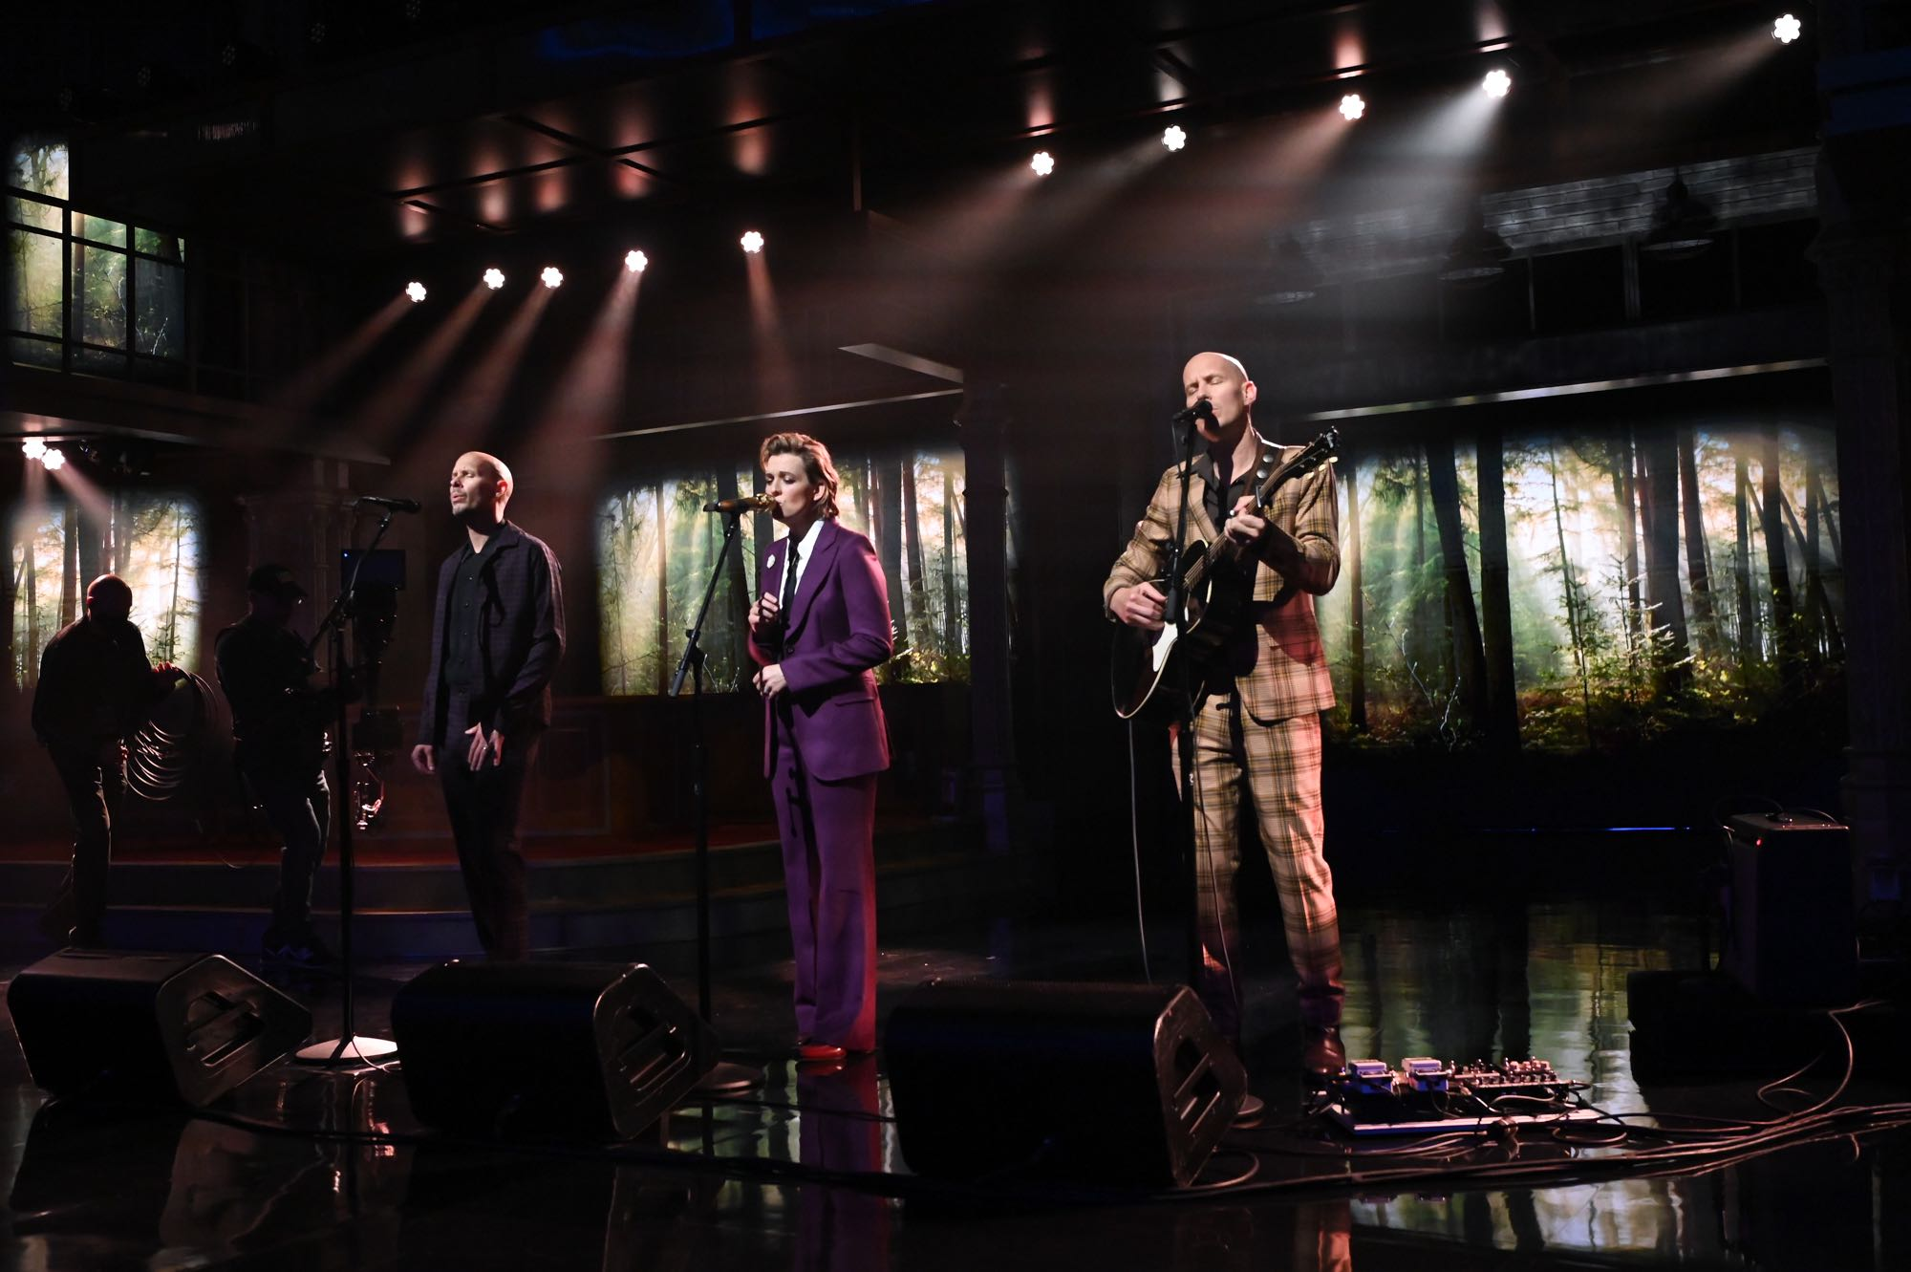
Photo credit: Scott Kowalchyk
November 9, 2021—Six-time Grammy Award-winning singer, songwriter, performer, producer and New York Times Best Selling author Brandi Carlile returned to “The Late Show with Stephen Colbert” last night to debut her new song, “This Time Tomorrow,” and speak with the host. Watch the performance HERE and the full interview HERE. Carlile also performed a version of Joni Mitchell’s “Blue” as a bonus web exclusive—watch HERE.
The appearance adds to a monumental month for Carlile following the release of her acclaimed #1 new album, In These Silent Days. In the weeks since, Carlile made her debut as the musical guest on NBC’s “Saturday Night Live” with host Jason Sudeikis performing “Broken Horses” and “Right On Time and returned to “The Ellen DeGeneres Show” to debut “You And Me On The Rock.” Most recently, Carlile performed Mitchell’s legendary album Blue in its entirety at Carnegie Hall. Of the sold-out performance, Billboard proclaims, “an extraordinary concert…who better to take on this homage but Carlile, who has taken up Mitchell’s still brightly burning torch, as one of the finest songwriters and singers of this era.”
In celebration of the new album, Carlile will perform a series of landmark shows next year as part of her newly confirmed “Beyond These Silent Days Tour” including Washington’s Gorge Amphitheatre on June 11, Los Angeles’ The Greek Theatre on June 24 and 25, Nashville’s Ascend Amphitheatre on July 8 and 9, St. Paul’s Xcel Energy Center on July 30, Chicago’s Huntington Bank Pavilion at Northerly Island on August 6, D.C.’s Merriweather Post Pavilion on August 18, Colorado’s Red Rocks Amphitheatre on September 9 and 10, Boston’s TD Garden on October 21 and New York’s Madison Square Garden on October 22. Special guests featured on the tour include (in alphabetical order): Allison Russell, Ani DiFranco, Brittany Howard, Celisse, Indigo Girls, Lake Street Dive, Lucius and Sarah McLachlan. See below for complete itinerary. Full details can be found at www.brandicarlile.com.
Released on Low Country Sound/Elektra Records, In These Silent Days debuted at #1 on Billboard’s Americana/Folk Albums chart, Top Rock Albums chart and Tastemaker Albums chart (stream/purchase here). Produced by Dave Cobb and Shooter Jennings, the record was inspired by the mining of Carlile’s own history while writing this year’s #1 New York Times Best Selling memoir, Broken Horses (Crown), and conceived of while she was quarantined at home with longtime collaborators and bandmates Tim and Phil Hanseroth. The ten songs chronicle acceptance, faith, loss and love and channel icons like David Bowie, Freddie Mercury, Elton John and Joni Mitchell—the latter two who, by some sort of cosmic alignment of the stars, have turned out to be close friends in addition to being her biggest heroes and inspirations.
Critical acclaim for In These Silent Days…
“Larger than life and achingly human…she empathizes, apologizes and lays out accusations. She’s righteous and she’s self-doubting. She proffers fond lullabies and she unleashes full-throated screams.”—The New York Times
“absolutely breathtaking, across the whole album Brandi Carlile pulls out all the stops. It’s just extraordinary…she’s just claiming rock god status”—NPR Music
“a huge vocal range. She does these songs that start off soft and vulnerable and then they just knock you down.”—NPR Morning Edition
“Carlile effortlessly glides between octaves while, somehow, still sounding completely conversational—the everyday diva we didn’t know we needed until she showed up at our door…a vocal tour de force”—Variety
“Heartfelt and intimate even when Carlile is aiming her songs toward the rafters, In These Silent Days is sure to please the longtime fans”—Los Angeles Times
“Brandi Carlile is a portrait of grace and acceptance on In These Silent Days”
—Entertainment Weekly
“the emotion that Carlile projects is unbridled, unfettered joy in the face of hard times—and it’s the exact boost of positivity that will make you want to listen again and again.”—Billboard
“it’s the kind of vulnerable, complicated statement that has made her such a relatable artist”
—Rolling Stone
“one of the biggest voices in the genre”—Vulture
“she has built a remarkable reputation for writing sweeping roots-rock ballads that defy genre categorization and bring comfort to fans who might also feel out of step with heteronormative culture.”—Stereogum
“cements her as one of music’s biggest superstars”—Spin
“This is, in every way, a crowning affair, one that’s destined to be considered a high point in Carlile’s ever-expansive career…In These Silent Days consistently speaks volumes.”
—American Songwriter
“The album is filled with sweeping instrumental compositions and emotional crescendos…it’s Brandi Carlile’s signature, genre-bending sound, just turned all the way up.”—Bustle
“With her talent and charisma, and this group around her, it’s no wonder Carlile is the star she was always meant to be”—Paste
“it’s the most dynamic and unflinching collection of her career…she sings with beautiful precision”—The Seattle Times
“a lyric poet and storyteller in the truest sense”—The Advocate
“a set of honest, pure new originals that now sit proudly in the Brandi Carlile songbook.”—Relix
“Rejoice, Americana faithful…Carlile spins cinematic piano rock worthy of her hero-friend Elton John, matched by introspective storytelling and a booming vocal
performance.”—The Tennessean
“It’s classic Carlile, taking some of the most profound experiences in life and being able to capture them perfectly in a three-minute song…she once again proves why she’s one of the best songwriters and performers in music”—OUT
“yet another triumph for this singular artist, a preeminent voice of our times whose command of vocal and musical dynamics is the perfect complement for both her straightforward and oft ambiguous lyrics.”—Glide
“an eclectic, beautifully produced collection of songs with both wisdoms and melodies that will get stuck in your head.”—Sojourners
“The six-time Grammy winner sounds even more lustrous and evocative…her alto shimmers and her Nashville production team shines in every note.”—Music Row
“This is a stone-cold, instant classic – one that should cement Carlile and her collaborators at the forefront of the warm embrace of mainstream Americana.”—Holler
“It is, as usual, Carlile’s voice that’s the instrument that shines brightest – from delicate to forceful, emotional cracks to an outright howl”—Americana Highways
“shows just how skillful a singer Carlile has become: She shifts effortlessly between wavery murmur, fluttery falsetto and stratospheric roar.”—RIFF Magazine
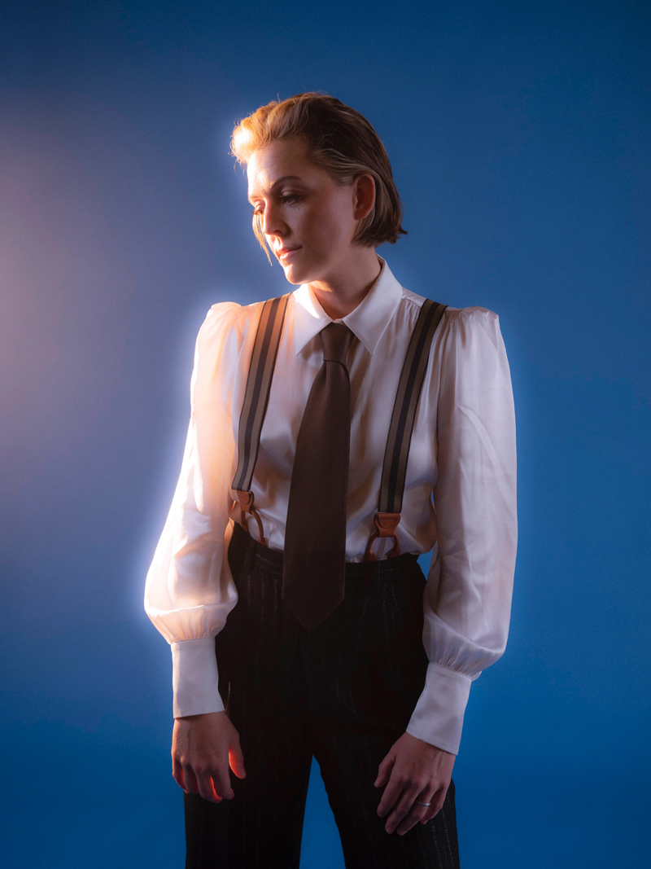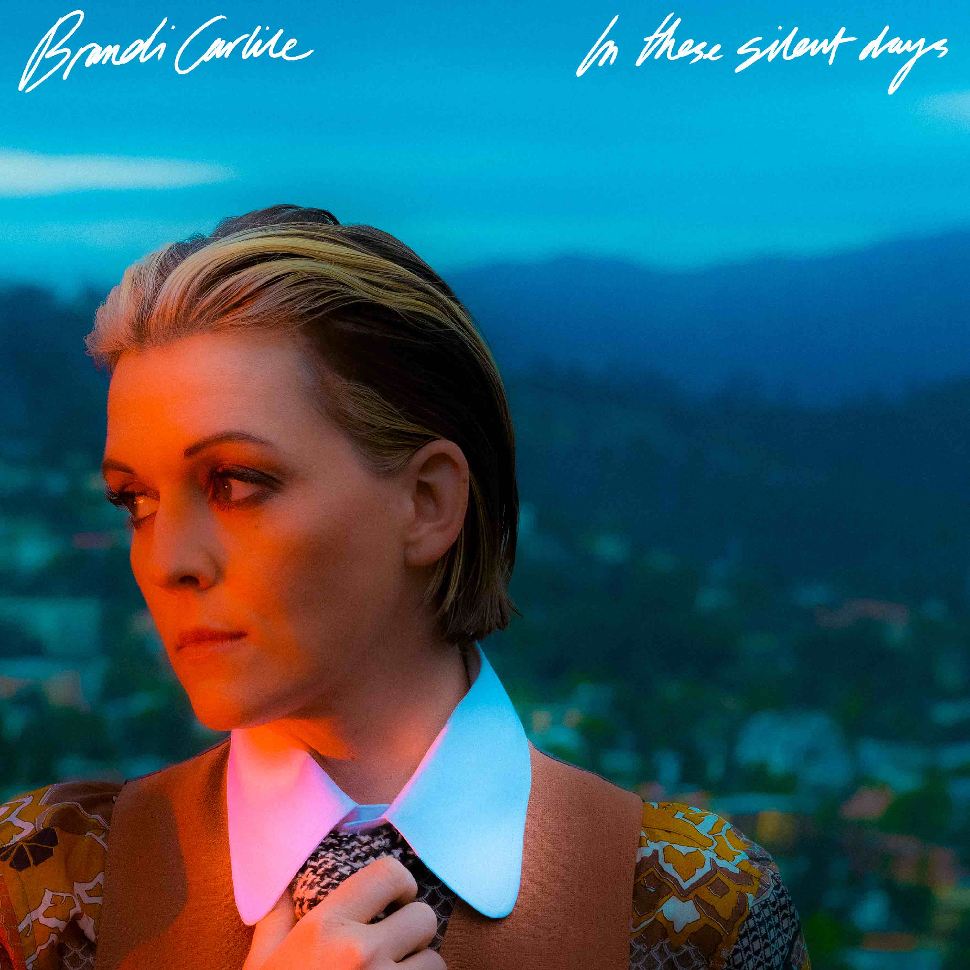
photo credit: Neil Krug // album artwork
In These Silent Days follows Carlile’s 2018 breakthrough GRAMMY Award-winning album, By The Way, I Forgive You, which Rolling Stone declared, “…an Adele-meets Joni Mitchell tour de force.” In the years since—in addition to collaborative projects with Elton John, The Highwomen, Tanya Tucker, Soundgarden, Alicia Keys, Dolly Parton, Barry Gibb, Leslie Jordan, Brandy Clark and more—she has earned six Grammy Awards recognizing her work as a performer, songwriter and producer, was awarded Billboard’s Women In Music “Trailblazer Award,” CMT’s Next Women of Country “Impact Award” and received multiple recognitions from the Americana Music Association Honors & Awards including 2021’s Artist of the Year, 2020’s Album of the Year (Highwomen), Group of the Year (The Highwomen) and Song of the Year (“Crowded Table”) and 2019’s Artist of the Year. Moreover, the audiobook version of Carlile’s memoir was recently highlighted as one of Libro.fm’s top 10 bestselling audiobooks of 2021.
In addition to their work as a band, Carlile and the Hanseroth twins remain committed to social activism and advocacy. Together they are founders of the Looking Out Foundation, which amplifies the impact of music by empowering those without a voice with varied initiatives including campaigns focused on Children in Conflict/War Child, The IF Project, Fund Racial Justice and more. To date, they have raised over $2 million for grassroots causes.
IN THESE SILENT DAYS TRACKLIST
1. Right On Time
2. You And Me On The Rock
3. This Time Tomorrow
4. Broken Horses
5. Letter To The Past
6. Mama Werewolf
7. When You’re Wrong
8. Stay Gentle
9. Sinners Saints And Fools
10.Throwing Good After Bad
BRANDI CARLILE CONFIRMED TOUR DATES
February 1-5—Riviera Maya, Mexico—Girls Just Wanna Weekend (SOLD OUT)
April 22—Miramar Beach, FL—Moon Crush 2022
April 29—Indio, CA—Stagecoach Music Festival
June 11—George, WA—Gorge Amphitheatre*
June 24—Los Angeles, CA—The Greek Theatre†
June 25—Los Angeles, CA—The Greek Theatre
July 8—Nashville, TN—Ascend Amphitheatre‡
July 9—Nashville, TN—Ascend Amphitheatre‡
July 30—St. Paul, MN—Xcel Energy Center+
August 6—Chicago, IL—Huntington Bank Pavilion at Northerly Island#
August 18—Columbia, MD—Merriweather Post Pavilion§
September 9—Morrison, CO—Red Rocks Amphitheatre~
September 10—Morrison, CO—Red Rocks Amphitheatre§
October 21—Boston, MA—TD Garden^
October 22—New York, NY—Madison Square Garden^
*with special guests Sarah McLachlan and Lucius and featuring Celisse
†with special guest Lucius
‡with special guests Indigo Girls and Celisse and featuring Lucius
+with special guests Lake Street Dive and Celisse
#with special guests Ani DiFranco and Celisse
§with special guests Indigo Girls and Allison Russell
~with special guests Lucius and Allison Russell
^with special guest Brittany Howard
www.brandicarlile.com

