BRANDI CARLILE CONFIRMS FOREST HILLS STADIUM SHOW FOR JULY 23
NEW MEMOIR BROKEN HORSES DEBUTS AT #1 ON THE NEW YORK TIMES BEST SELLERS LIST
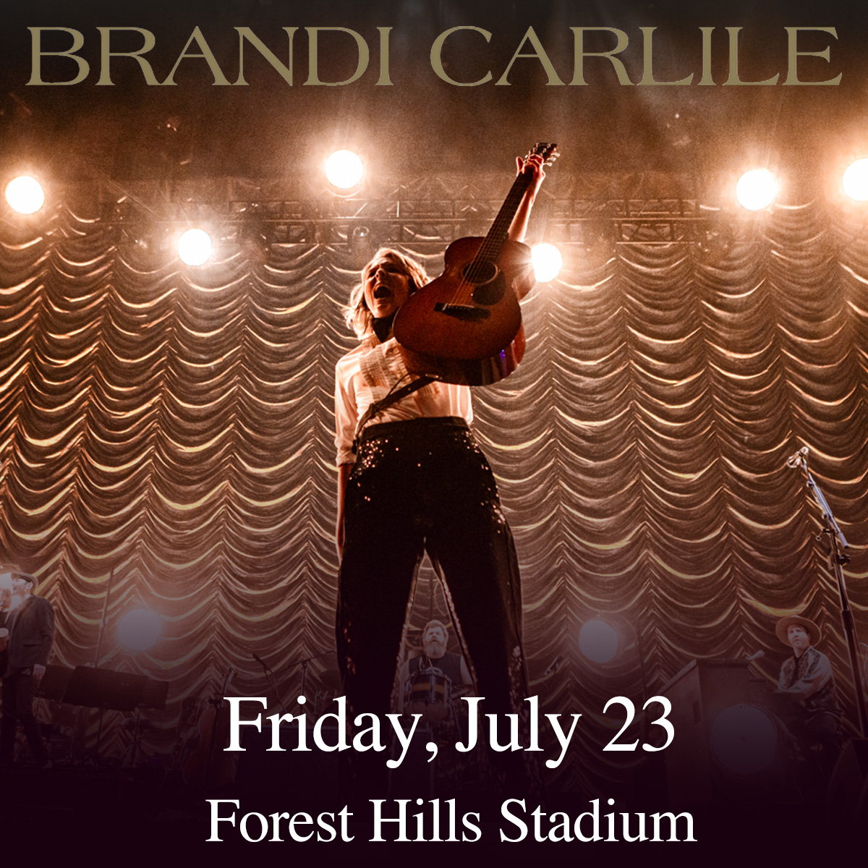
May 17, 2021—Six-time GRAMMY Award-winning singer, songwriter, performer, producer and activist Brandi Carlile will perform a special show at New York’s Forest Hills Stadium on July 23. Tickets for the show go on-sale this Friday, May 21 at 11:00am ET, full details can be found at www.brandicarlile.com.
The performance adds to a monumental year for Carlile, who won Best Country Song at the 63rd GRAMMY Awards (“Crowded Table” performed by The Highwomen) and whose acclaimed new memoir, Broken Horses, recently debuted at #1 on The New York Times Best Sellers list (Print Hardcover Nonfiction and Combined Print & E-Book Nonfiction).
Published by Crown—an imprint of the Random House Publishing Group, a division of Penguin Random House LLC—Broken Horses continues to receive overwhelming critical praise: The New York Times Book Review heralds, “If you’re already a Brandi Carlile fan…there’s an excellent chance you’ll find ‘Broken Horses’ charming, funny, illuminating and poignant. If you’re not a fan, ‘Broken Horses’ might well make you into one, especially now, because the book feels like the antithesis of social distancing,” while Variety declares, “Carlile is that rare pop or rock star gifted with complete self-consciousness and confidence but also the soulful clairvoyance to read a room…even a really, really big, global room,” and the Associated Press asserts, “’Broken Horses,’ shines…It’s clear that through writing the full arc of her story, not only does the reader get to better know the Americana singer, but she begins to better understand herself…She’s perceptive, vulnerable, humble, funny and above all else, a good story teller. She’d already proven her storytelling chops as a lyricist and she proves them once again in these pages. She knows how to use a few words to make a big impact.”
In addition to the hardback, a very special audiobook edition of the memoir, narrated by Carlile herself, debuted at #6 on The New York Times Audio Nonfiction Best Sellers list and is available now on Random House Audio. In the book, Carlile opens up about a life shaped by music, including songs that inspired her and the true stories behind many of her lyrics, woven throughout the book at the end of each chapter. Exclusively for the audiobook, Carlile recorded new stripped-down, solo renditions of more than 30 of these songs, including her own and songs from other artists, from Dolly Parton to Elton John, Leonard Cohen, Joni Mitchell and more.
On top of her work as a musician and writer, Carlile is also a founder of the Looking Out Foundation. Created in 2008 with longtime bandmates Tim and Phil Hanseroth, Looking Out amplifies the impact of music by empowering those without a voice with varied initiatives including campaigns focused on Children in Conflict/War Child, The IF Project, Fund Racial Justice and more. To date, they have raised over $2 million for grassroots causes.
BRANDI CARLILE CONFIRMED TOUR DATES
July 2—Bonner, MT—KettleHouse Amphitheater
July 3—Bonner, MT—KettleHouse Amphitheater
July 4—Bonner, MT—KettleHouse Amphitheater
July 23—Forest Hills, NY—Forest Hills Stadium
July 27—Lenox, MA—Koussevitzky Music Shed
August 14—Quincy, WA—Gorge Amphitheatre
September 11—Morrison, CO—Red Rocks Amphitheatre
September 12—Morrison, CO—Red Rocks Amphitheatre
September 25—Columbia, MO—Roots N Blues Festival
September 26—Dana Point, CA—Ohana Fest 2021

