ACCLAIMED SINGER-SONGWRITER BRYNN CARTELLI RETURNS WITH DREAMY NEW SINGLE, “GEMINI”

JUST IN TIME FOR GEMINI SEASON, THE SONG IS AVAILABLE HERE
WATCH THE OFFICIAL MUSIC VIDEO HERE

BRYNN IS CURRENTLY WORKING ON MORE NEW ORIGINAL MUSIC TO BE RELEASED LATER THIS YEAR
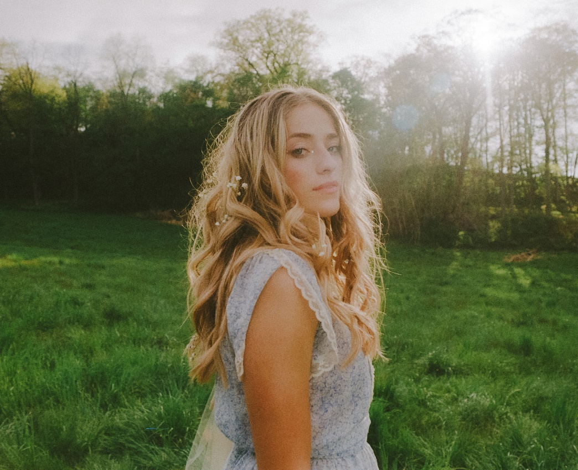
(CREDIT: ELINOR KRY)
DOWNLOAD HI-RES HERE | PRESS ASSETS HERE

“…with a maturity far beyond her years” – PEOPLE

“…marvelous debut” – AMERICAN SONGWRITER
“Cartelli’s voice is wildly impressive” – THE WASHINGTON POST

(May 20, 2022) – LOS ANGELES, CA – Acclaimed 19-year-old singer-songwriter Brynn Cartelli today returned with the release of her ethereal new single, “Gemini,” which arrives just in time for Gemini Season. Sonically inspired by Stevie Nicks and Florence Welch, the dreamy pop song explores the dual-natured personality associated with the astrological sign. Listen to it HERE on all streaming platforms. The accompanying music video is also out today, which marks Brynn’s directorial debut. Captured in upstate New York, the visual plays into the Gemini Twins Zodiac sign. Watch it HERE.

Of the new release, Cartelli said, “The song ‘Gemini’ started off as a joke. I thought it would be funny to play into the dual-natured stereotype in a song; then I went to London and finished it.” She elaborated, “I wanted to lean into inspirations of women that inspired me since I was young, like Stevie Nicks and Florence Welch, but in my own pop sphere. I am so excited about how different ‘Gemini’ is than any of the songs on my first project [Based on a True Story]. I’m leaning into the witchy energy of the East Coast and am scaring Geminis everywhere, which you can also see in the music video that I directed myself.”

Flaunting a skyscraping range, undeniable presence, and eloquent songcraft, Cartelli tells relatable stories without filter, but with a whole lot of finesse and fire, as evidenced on her stellar 2021 debut EP, Based on a True Story. The EP was introduced with “Long Way Home,” which was co-written by Cartelli and Nathan Chapman (Taylor Swift, Kylie Minogue) and attracted praise as People named Brynn among its “Emerging Artists to Watch.” Cartelli also delivered an emotional performance of the fan-favorite track “If I Could” – co-penned with Ben Abraham (Demi Lovato, Sara Bareilles) – on The Kelly Clarkson Show. The song has amassed over 15M+ global streams to date.

At age 15, Cartelli’s vocals captivated viewers nationwide when she won Season 14 of NBC’s The Voice (on Team Kelly) and emerged as the youngest champion in the show’s history. She introduced her signature style on standout single “Last Night’s Mascara,” which has racked up 16M+ total streams worldwide. Hitting the road, she supported Kelly Clarkson and Maroon 5 on tour. Along the way, she garnered a nomination at the People’s Choice Awards and captivated audiences with stunning performances on the TODAY Show, Macy’s Thanksgiving Day Parade, and more.

Cartelli is currently in the studio working on new original music, slated for release later this year on Elektra Records. She will also be the special guest at labelmates New Rules’ sold out headline show at Mercury Lounge in New York, NY on Thursday, June 2, and headline Rockwood Music Hall in the city on Saturday, June 11. Tickets are available HERE. Stay tuned for more to come from this exciting artist on the ascent.

BRYNN CARTELLI
“GEMINI”
AVAILABLE HERE
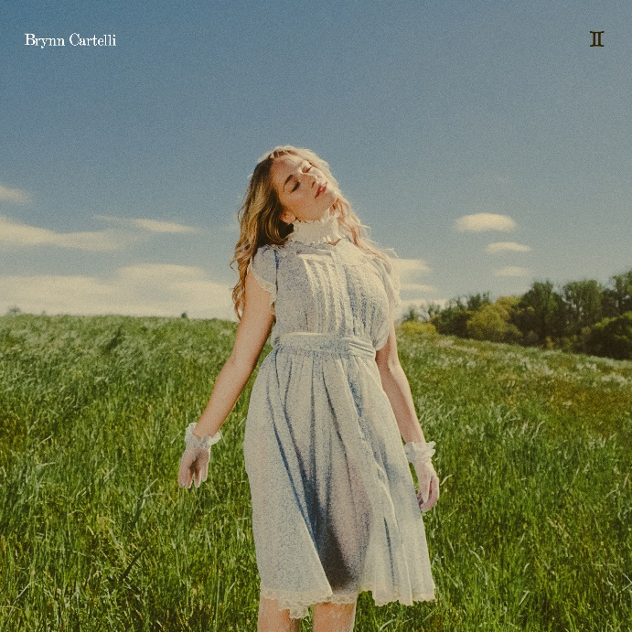
DOWNLOAD HI-RES ARTWORK HERE

ABOUT BRYNN CARTELLI:
At just five-years-old, Cartelli took regular piano lessons, soon learning guitar and developing her chops by performing in talent shows, at coffeehouses, and anywhere else with a stage in her hometown of Longmeadow, Massachusetts. Following her win on The Voice and being crowned the youngest champion in the history of the show, Cartelli returned to her hometown after the surreal experience and became hyperaware of returning to a ‘normal’ life as a teenager. After two years of writing, recording, and honing her craft as a songwriter, Brynn released her much-anticipated 2021 debut EP Based on a True Story via Elektra Records. Based On A True Story is a snapshot of the time she spent reconnecting with old friends, being observant, and illustrating what youth is about. Across her discography, Cartelli takes seemingly small moments from typical experiences and turns them into candid, anthemic pop ballads that people of all ages can relate to.

# # #

CONNECT WITH BRYNN CARTELLI:
Website | Facebook | Twitter | Instagram | YouTube

MEDIA CONTACTS:
Glenn Fukushima | GlennFukushima@elektra.com
Nathalie Rubin | NathalieRubin@elektra.com
Sydney Worden | SydneyWorden@elektra.com

