FOR IMMEDIATE RELEASE
MARCH 17, 2021

BENDIGO FLETCHER SIGNS TO ELEKTRA RECORDS

BAND PREVIEWS FORTHCOMING DEBUT ALBUM WITH NEW SINGLE “EVERGREEN”

LISTEN HERE / WATCH HERE

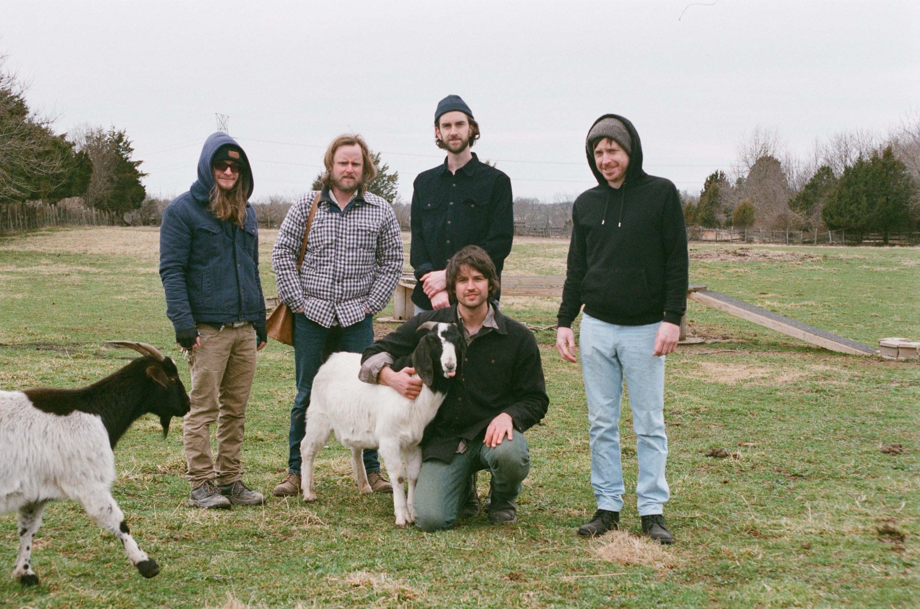
Photo credit: Richie Wireman

Louisville, KY band Bendigo Fletcher has signed with Elektra Records and released their major label debut single “Evergreen”. The song is available to stream and download now HERE. Watch an accompanying visualizer for the track HERE. “Evergreen” was produced by original Wilco and Uncle Tupelo drummer Ken Coomer, and previews Bendigo Fletcher’s forthcoming debut album, expected later this year.

“Evergreen” cycles through a series of spellbinding tonal schisms, cresting at a chorus that speaks to the urgency of self-preservation. “I wrote ‘Evergreen’ in the early stages of admitting to myself that medical school was a path that looked way more obscured than working to make records,” shares frontman Ryan Anderson. “I was also getting into self-care methods for the first time in my life, and realizing that you have to take time for yourself in order to be the best and truest version of yourself for everyone else—so in a way, that’s a form of service.”

Anderson crafts the patchwork poetry of his lyrics by serenely observing the world around him, often while working his grocery-store day job or walking aimlessly in nature (a practice partly borrowed from the late poet Mary Oliver). When matched with Bendigo Fletcher’s gorgeously jangly collision of country and folk-rock and dreamy psychedelia, the result is story-songs graced with raw humanity, wildly offbeat humor, and a transcendent sense of wonder.

Bendigo Fletcher’s forthcoming studio album will follow a trio of independent EPs that quietly amassed millions of streams and earned praise from American Songwriter, Pop Matters, Atwood Magazine, and more. Converting audiences to fans on the road, Bendigo Fletcher has supported Mt. Joy, Nathaniel Rateliff, Rayland Baxter, Caamp, and Hiss Golden Messenger on tour.

Bendigo Fletcher is: Ryan Anderson (lead vocals, guitar, banjo) - Andrew Shupert (backing vocals, lead guitar) - Evan Wagner (backing vocals, keys, guitar, auxiliary percussion) - Conner Powell (bass) - Chris Weis (drums).

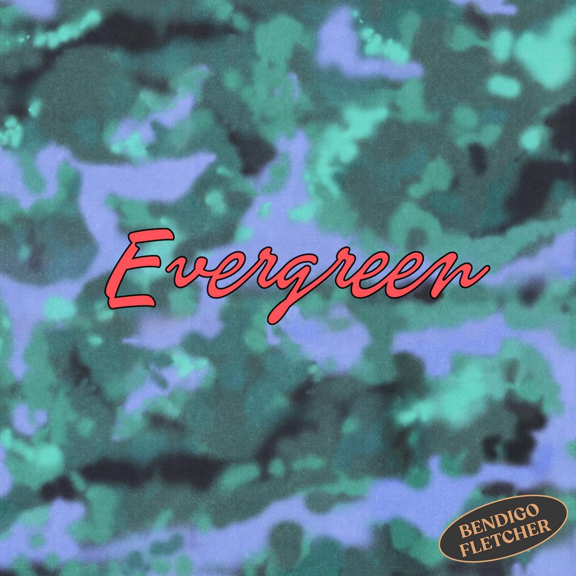

BendigoFletcher.com
Facebook
Instagram
Twitter
YouTube

Press contact:
Collin Citron / CollinCitron@elektra.com

