FOR IMMEDIATE RELEASE
OCTOBER 8, 2021

SINGER-SONGWRITER BRYNN CARTELLI UNVEILS
“IF I COULD (LIVE FROM BABE STUDIOS)” ALONGSIDE NEW VIDEO
LISTEN HERE | WATCH HERE

DEBUT EP BASED ON A TRUE STORY OUT NOW
LISTEN HERE

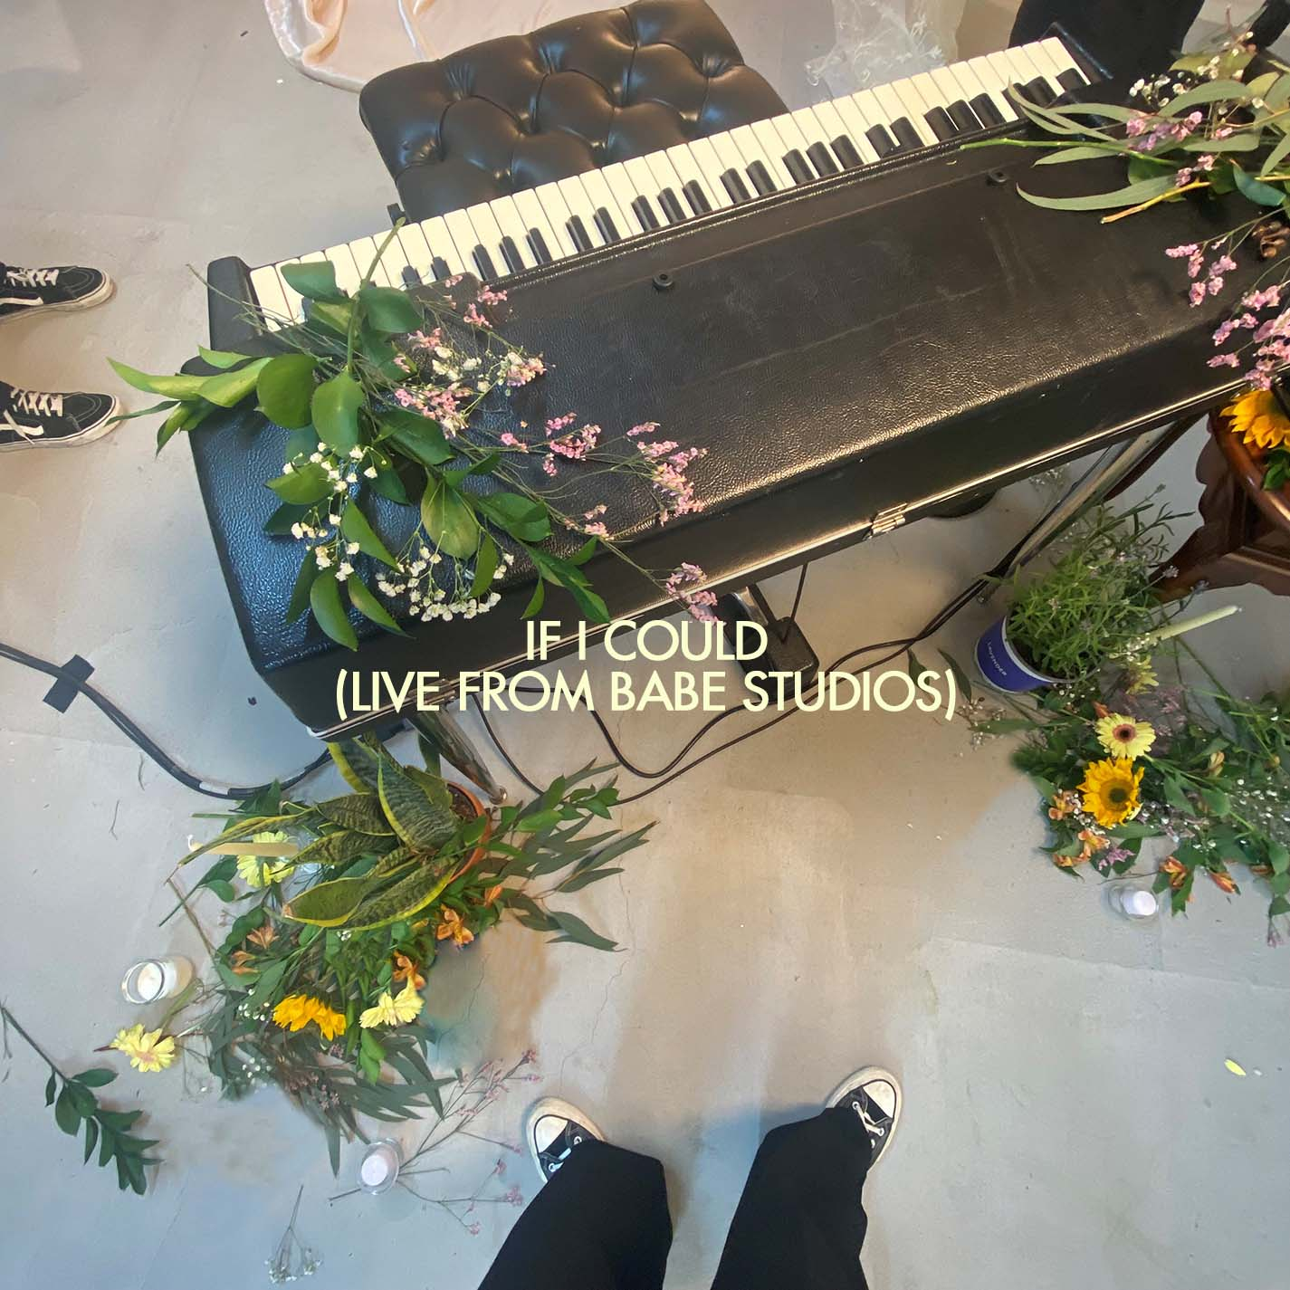
PRESS ASSETS HERE

Singer Songwriter Brynn Cartelli has unveiled a live version of fan-favorite track “If I Could” off her debut EP Based On A True Story. “If I Could (Live From Babe Studios)” is available now at all DSPs. The track arrives alongside a new video, streaming now on Brynn’s official YouTube channel. Both were recorded and filmed at the female owned and run Babe Studios in Brooklyn.

Cartelli commented, “I loved diving back into this song and creating a dreamy visual world only I saw while writing If I Could, now brought to life at Babe Studios.”

Earlier this Summer, Brynn released her debut EP Based On A True Story, available now at all DSPS and streaming services . Returning to her hometown of Longmeadow, MA after the surreal experience of winning NBC’s season 14 of The Voice and touring with Kelly Clarkson, Brynn became hyperaware of getting back to her normal life as a teen. Based On A True Story is a snapshot of the time she spent reconnecting with friends, being observant, and really honing into what being young is about.

Brynn takes seemingly small moments from typical suburban experiences and turns them into candid, anthemic pop ballads that people of all ages can relate to. “Imaginary Stranger” fulfills a wish she held for years, vividly detailing her connection to her grandfather who passed away from lung cancer six years before her birth. Then, there’s the piano-driven “Love You In My Mind,” which is based off a collection of stories from fans who were obsessing over crushes. Blossoming from an acoustic intro into a bouncy refrain, the buoyant “We Belong” captures an idyllic moment of teen freedom and friendship in lines like, “We didn’t get invited to the party it’s fine, so we’ll sit around the fire and we’ll talk about life.” As the final addition to the EP, “Jane” pairs a powerhouse vocal performance with lullaby-style instrumentation that sees Brynn imagining what it would be like if she was someone else – specifically choosing the name Jane because that’s almost what her mom had named her.

Co-written by Brynn and Ben Abraham (Demi Lovato, Sara Bareilles, and Kesha), “If I Could”, which has seen over 11 million streams, is Brynn’s message to a friend in a one-sided relationship, “If I could do it for you, then I would say, ‘Goodbye’.” She originally shared a snippet of the song through a post on Tik Tok that has amassed over 9 million views and performed the track on The Kelly Clarkson Show.

“Long Way Home,” co-written by Brynn and Nathan Chapman (Taylor Swift, Kylie Minogue and Colbie Caillat), was the first track released off the EP and her first new music since 2019, attracting praise as People named Brynn among its “Emerging Artists to Watch.” Directed by Blythe Thomas (Julia Michaels, Hozier, Grace Vanderwall), the official video for the track sees Brynn and her real-life friends driving around New York City, singing and dancing through the streets of Greenwich Village and Times Square, and even celebrating her friend Piper's 18th birthday with a surprise cake.

Keep an eye out for more to come from Brynn Cartelli.

ABOUT BRYNN CARTELLI
Flaunting a skyscraping range, undeniable presence, and eloquent songcraft, Brynn Cartelli tells relatable stories without filter, but with a whole lot of finesse and fire. Long before amassing 20 million-plus streams and receiving acclaim from People, Billboard, and more, she grew up in Longmeadow, MA where she embraced music as a kid. At just five-years-old, she took regular piano lessons. She eventually learned guitar and developed her chops by performing in talent shows, at coffeehouses, and anywhere else with a stage. Her vocals captivated viewers everywhere when she won Season 14 of NBC’s “The Voice” and emerged as “the youngest champion in the show’s history.” However, she hunkered down and focused on writing original material in the aftermath. Introducing her signature style, “Last Night’s Mascara” amassed over 10 million streams globally. Meanwhile, her 2019 follow-up and original composition “Grow Young (Version 1)” cracked over 1 million total streams. Hitting the road coast-to-coast, she supported Kelly Clarkson on the Meaning Of Life Tour and opened for Maroon 5. Along the way, she also garnered a nomination at the “People’s Choice Awards” and captivated audiences on the NBC’s “TODAY” and “Macy’s Thanksgiving Day Parade,” “Radio Disney Music Awards,” and on Boston’s most hallowed ground, Fenway Park. Brynn released her fan favorite, holiday cover of “Have Yourself A Merry Little Christmas” and gave an unforgettable performance of the staple on The Kelly Clarkson Show to cap off 2019. After two years of writing and recording, she’s back in 2021 with her debut EP Based On A True Story.

CONNECT:
Facebook | Twitter | Instagram | YouTube

CONTACT:
Glenn Fukushima | GlennFukushima@elektra.com
Sydney Worden | SydneyWorden@elektra.com

