COHEED AND CAMBRIA
SHARE OFFICIAL MUSIC VIDEO FOR NEW SINGLE “SHOULDERS”

“SHOULDERS” IMPACTING ACTIVE ROCK RADIO NOW

2021 SUMMER CO-HEADLINE TOUR WITH THE USED STARTS AUGUST 27TH

WATCH THE “SHOULDERS” OFFICIAL MUSIC VIDEO HERE

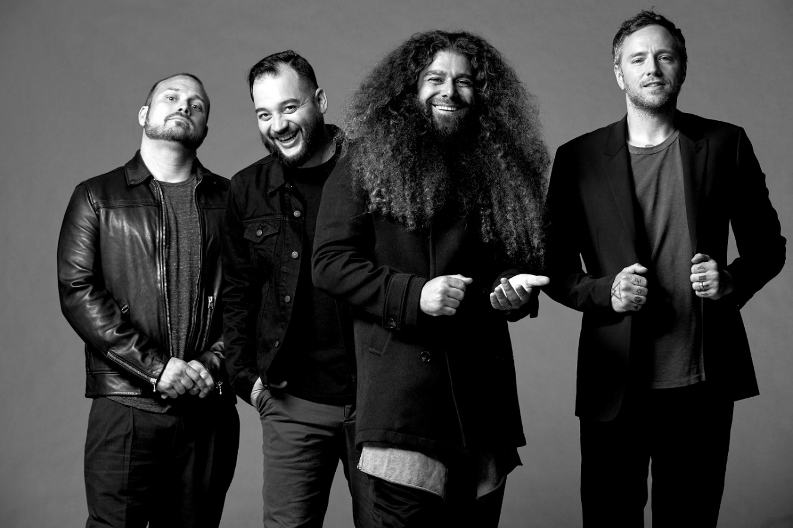
PHOTO CREDIT: JIMMY FONTAINE

AUGUST 9, 2021 - Coheed and Cambria have shared the official music video for “Shoulders,” their first proper studio recording in almost three years. Streaming now on the band’s YouTube channel, the Max Moore directed video captures the band delivering a powerful performance of the track set within a cavernous industrial space – Watch it HERE.

“As a band, we’ve always been a little outside of the mainstream and that’s helped keep us true to ourselves. As people, it’s important to focus on your strengths and who you are, and not try too hard for acceptance. Everyone is special and has their own unique contributions and that’s what the video represents,” remarked the band.

The song “Shoulders" was officially released on July 21st and has since amassed over 1,000,000 streams and become the first song inside the top 40 at Active Rock radio in the band’s history, currently sitting at #31 with a bullet.

“A total banger… as explosive and catchy as anything they've ever released,” declared REVOLVER who placed “Shoulders” in their weekly Best New Songs Right Now round-up. “Coheed and Cambria are back, and they’re heavy as ever,” asserted Billboard, with Guitar World attesting “Coheed and Cambria have come out swinging.” Brooklyn Vegan observed, “It finds the band embracing their love of classic heavy metal riffage, before exploding into the kind of soaring chorus that Coheed have been churning out since day one… they sound pretty damn inspired.”

For the last 20 years, Coheed and Cambria have continuously broken the mold of what a rock band can be, forging their own path and building a universe around their music unlike any other. Whether it is in the way their genre-spanning approach to songwriting has allowed them to bridge worlds without being contained to one, or the multifaceted story arc of their albums and comic book series which mark the longest running concept story in music, Coheed and Cambria have consistently shaped new standards, never conformed.

“Shoulders” touches on the highs and lows of this journey, and how at times it can be frustrating to be an outsider to trendy circles, but in the end, doing it your own way has the biggest rewards.

Coheed and Cambria vocalist / guitarist Claudio Sanchez commented on “Shoulders” noting, “In art, in your career, in relationships… No matter how much you give of yourself or try, you have to accept that not everything in life can be a perfect fit.”

Ironically, “Shoulders” might be the band’s most accessible material of their career, built with ferocious riffs and a towering chorus - maybe it’s time for the best of both worlds.

Later this summer Coheed and Cambria will embark on a outdoor co-headlining amphitheater tour with The Used. The 18-city U.S. tour, produced by Live Nation, will begin on Friday, Aug 27th in Irvine, CA and make stops in Phoenix, Dallas, Cleveland, New Jersey, Worcester, and more. The late summer journey will feature special guests Meet Me @ The Altar and carolesdaughter on select dates and will culminate with performance at Daily’s Place in Jacksonville, FL on Sept 24th. A full listing of dates can be found below along with additional information on www.CoheedAndCambria.com.

It’s been almost three years since Coheed and Cambria’s 2018 album, “Vaxis I: The Unheavenly Creatures,” was released as the band’s “return to concept" album. After stepping away with a more introspective album in 2015, frontman Claudio Sanchez and the band returned to the sci-fi universe of “The Amory Wars” in what was said to be the first of a 5-part series of albums. With the release of “Shoulders,” and a major summer tour now announced, the volume of fans’ chatter for “Vaxis 2” are loading up the band’s social media pages.

[SINGLE ARTWORK / TOUR ITINERARY BELOW]

COHEED AND CAMBRIA
“SHOULDERS” – SINGLE ARTWORK

COHEED AND CAMBRIA ON TOUR
8/27 – 9/24: Co-headlining Dates with The Used

Fri Aug 27 – Los Angeles, CA – FivePoint Amphitheatre*
Sat Aug 28 – Phoenix, AZ – Mesa Amphitheatre*
Mon Aug 30 – Salt Lake City, UT – The Complex - Outdoors*
Tue Aug 31 – Denver, CO – Levitt Pavilion Denver*
Thu Sep 02 – Irving, TX – The Pavilion at Toyota Music Factory*
Sat Sep 04 – Austin, TX – Germania Insurance Amphitheater*
Sun Sep 05 – Houston, TX – The Cynthia Woods Mitchell Pavilion*
Tue Sep 07 – Wichita, KS – WAVE - Outdoors*
Wed Sep 08 – St. Louis, MO – Saint Louis Music Park*
Thu Sep 09 - Milwaukee, WI – Summerfest^^
Sat Sep 11 – Columbus, OH – Express Live! - Outdoors*
Sun Sep 12 – Cleveland, OH – Jacobs Pavilion at Nautica*
Tue Sep 14 – Cincinnati, OH – The ICON Festival Stage at Smale Park*
Wed Sep 15 – Indianapolis, IN – TCU Amphitheater at White River State Park*
Sat Sep 18 – Worcester, MA – The Palladium - Outdoors*
Sun Sep 19 – Holmdel, NJ – PNC Bank Arts Center*
Tue Sep 21 – Baltimore, MD – MECU Pavilion^
Wed Sep 22 – Raleigh, NC – Red Hat Amphitheater^
Fri Sep 24 – Jacksonville, FL – Daily's Place^
Sun Sep 26 – Miami, FL – S.S. Neverender Cruise

* with special guest Meet Me @ The Altar
^ with special guest carolesdaughter
^^ Festival Date

CONNECT WITH COHEED AND CAMBRIA:
Facebook // Twitter // Instagram // YouTube // Website

