CAFUNÉ SIGN TO ELEKTRA RECORDS

SHARE OFFICIAL MUSIC VIDEO FOR BREAKOUT HIT “TEK IT”

TOURING WITH CHVRCHES THIS SUMMER / FALL

DEBUT ALBUM RUNNING OUT NOW

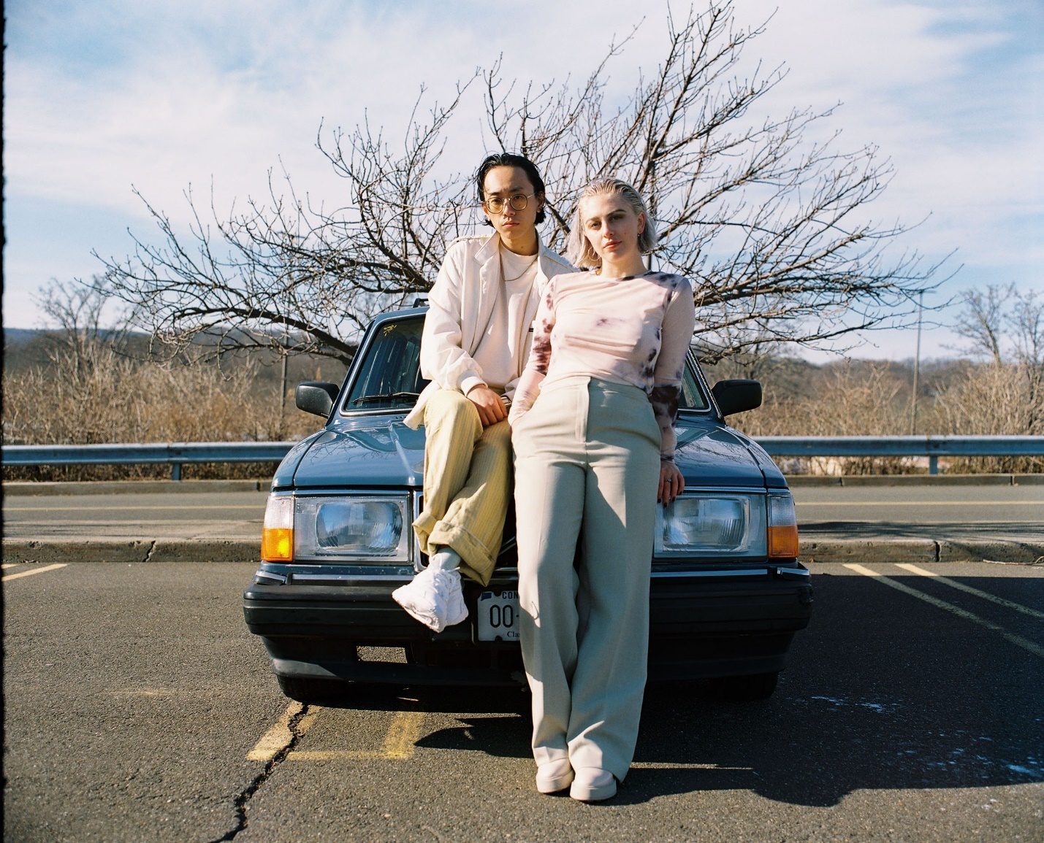
PHOTO CREDIT: NOAH FALGE

“Delicate, dazed indie-pop” - THE FADER
“Blonde-esque minimalist guitar swoon” - STEREOGUM
“Infectious and bittersweet” - BILLBOARD
“Dreamy new sophisti-pop” - GORILLA VS. BEAR

JUNE 2, 2022 – Cafuné - the NYC-based duo of singer/songwriter Sedona Schat and writer/producer Noah Yoo - have announced their signing to Elektra Records and shared an official music video for their breakout hit “Tek It.” Produced by Natia Sopromadze and directed by Frederick Venet of Crux Animation Studio, the anime music video for “Tek It” is streaming now on the band’s YouTube Channel.

Having amassed 45 million global streams to date, “Tek It” is featured on Cafuné’s debut album Running, which was released last July via their own Aurelians Club label. “Tek It” currently sits in the Top 5 on Billboard’s “Bubbling Under Hot 100” chart, and recently debuted on the UK’s “Official Singles Chart Top 100.” Furthermore, “Tek It” continues to grow at both Alternative and AAA radio formats, entering the Top 10 this week on Billboard’s “Hot Rock & Alternative Songs” chart while also debuting on Mediabase’s “Alternative Chart” this week at #38.

In other recent news, Cafuné have been announced as direct support to CHVRCHES on their upcoming North American headline tour. The coast-to-coast run is set to kick off on July 26th at the Orpheum Theater in New Orleans, LA and extend into the fall, concluding with a performance on October 3rd at the Knitting Factory in Boise, ID. For tickets and more information on Cafuné’s upcoming tour dates, visit www.wearecafune.xyz.

Sedona Schat and Noah Yoo have been recording alternative pop songs together as Cafuné since their days as NYU students in the mid-2010s. Self-produced and almost entirely recorded by the duo at their homes, mostly during the pandemic, their debut album Running is a record born in isolation. It peers out at a world that feels like it’s on the precipice of disaster, considering what it means to get older, to carve out a future for yourself. It’s a labor of the duo’s friendship, of doing the work and trying to figure out what the way forward is, even when it seems like there’s no end in sight. It’s a record of growing old and growing up, of making something you can move to—whether you’re alone in a room, in a sweaty club with all of your friends, or driving away to someplace better.

CAFUNÉ 2022 TOUR DATES
7/26 – 10/03 – WITH CHVRCHES

07/26 — New Orleans, LA @ Orpheum Theater
07/27 — Birmingham, AL @ Iron City
07/29 — Atlanta, GA @ The Roxy
07/30 — Asheville, NC @ The Orange Peel
07/31 — Richmond, VA @ The National
08/01 — Norfolk, VA @ The Norva
08/03 — Brooklyn, NY @ Brooklyn Mirage
08/04 — Boston, MA @ Roadrunner
08/05 — North Adams, MA @ Mass Moca
09/20 — Denver, CO @ Mission
09/22 — Salt Lake City, UT @ Twilight
09/24 — Phoenix, AZ @ Marquee Theatre
09/26 — Sacramento, CA @ Ace of Spades
09/28 — Vancouver, BC @ Queen Elizabeth Theatre
09/30 — Seattle, WA @ Paramount Theatre
10/01 — Portland, OR @ Roseland Theater
10/02 — Spokane, WA @ Knitting Factory
10/03 — Boise, ID @ Knitting Factory

CONNECT WITH CAFUNÉ:
Website | Instagram | Twitter | TikTok | Facebook | YouTube | Spotify | Apple Music

CAFUNÉ PRESS CONTACT:
Ross Anderson | RossAnderson@Elektra.com

