CHLOE MORIONDO DEBUTS LONG-AWAITED SINGLE AND VIDEO
“HELL HOUNDS”

BLOOD BUNNY DELUXE ALBUM AVAILABLE NOW
INCLUDES alternate and acoustic versions of album tracks, ORIGINAL voice MEMOS

NORTH AMERICAN FALL HEADLINE TOUR DATES KICK OFF IN OCTOBER

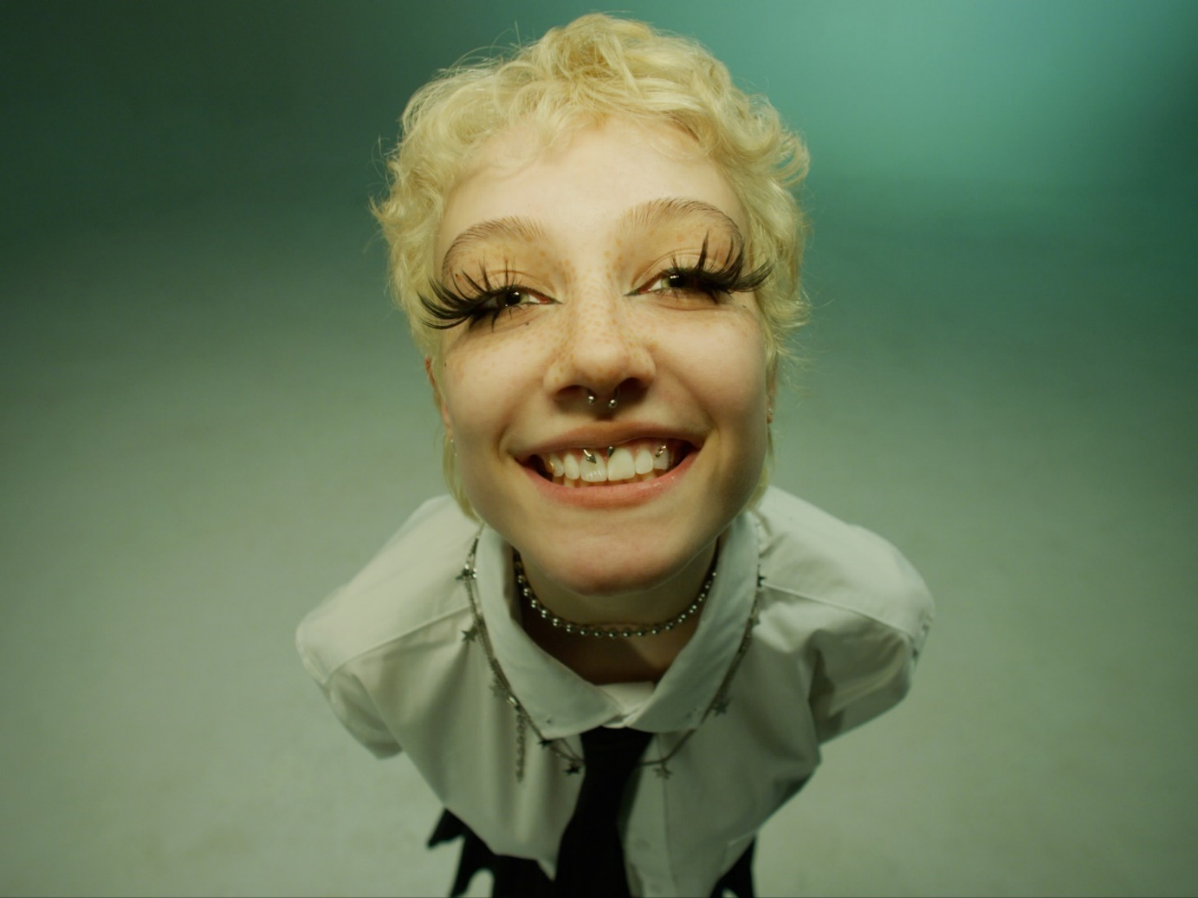
DOWNLOAD PRESS ASSETS HERE
JUNE 10, 2022 – Rising star Chloe Moriondo has debuted long-awaited single and video “Hell Hounds.” The track arrives in tandem with a deluxe version of Chloe’s critically acclaimed album, Blood Bunny, which is available now via Public Consumption/Fueled By Ramen. In addition to “Hell Hounds,” Blood Bunny Deluxe features alternate and acoustic versions of album tracks – including a rendition of “I Eat Boys” featuring dodie – original voice memos, and a studio version of Chloe’s early pandemic ballad, “Living Virtually.”
“I’ve been waiting SO FUCKING LONG to release this and am so excited for everyone to hear it,” Chloe shared on “Hell Hounds.” “This is the beginning of a shiny new era and i hope everyone loves it!! <3”
Earlier this week, Chloe announced a U.S. fall headline tour featuring support from Dreamer Isioma. The five-week trek kicks off October 12th in Columbus, OH, making stops at The Regent in Los Angeles on October 26th and Irving Plaza in New York City on November 10th before wrapping up with a hometown performance at The Majestic in Detroit, MI on November 19th. Tickets for all dates are available today beginning at 12pm local time. Chloe is currently wrapping up dates supporting mxmtoon’s North American headline tour and will also be hitting the festival circuit with upcoming performances at Seattle, WA’s Capitol Hill Block Party and this year’s Firefly Festival (tour itinerary below). For up-to-date ticketing information, please visit www.chloemoriondo.com.
The Blood Bunny Deluxe release continues a banner year for the artist, who was included in Billboard’s prestigious “21 Under 21” list last month. In April, Chloe shared the puppy luv EP, a collection of canine-themed songs. The release was accompanied by an official video for “nice pup,” which features over fifty fan-submitted dogs. The five-track collection was heralded by the charming, breezy single “sammy,” and accompanied by an official music video starring Moriondo’s own pet dog (the titular Sammy). UPROXX praised the “wholesome” track, while Billboard hailed it as “a pure bump of joy.” Consequence attested “sammy” is “adorable and heartwarming.” The puppy luv EP is available now via Public Consumption/Fueled By Ramen.
About Chloe Moriondo:
Chloe Moriondo professes to be an “internet kid,” yet they tackle overwhelming infatuation, listless daydreams, and first love with keen empathy that’s unsearchable online. With relatable, confessional lyrics and idiosyncratic humor, the singer-songwriter has built a devoted fanbase of millions, sharing their authentic self to create a genuine connection with their listeners. Last May, Moriondo shared her critically acclaimed major-label debut album Blood Bunny via Public Consumption/Fueled By Ramen, which landed on “Best Albums of 2021” lists from The New York Times and Billboard. The release was also crowned a “Critic’s Pick” by The New York Times, who exclaimed, “On the robust and vividly plain-spoken ‘Blood Bunny,’ Moriondo…is a pop-punk whiz, deftly hopping between musical approaches from spare to lushly produced, and emphasizing intimate, cut-to-the-bone lyrics.” Chloe has also racked up praise from Billboard, Pitchfork, The FADER, PAPER, UPROXX, Refinery29, them., and more. Following Blood Bunny’s release, Moriondo made her television debut performing “Bodybag” on Jimmy Kimmel LIVE!, and appeared soon after on The Late Late Show With James Corden, where they played a dynamic rendition of “I Want To Be With You.”
[Tour Itinerary / Album Art below]
###

CHLOE MORIONDO
2022 HEADLINE TOUR DATES
^ supporting mxmtoon
*festival date

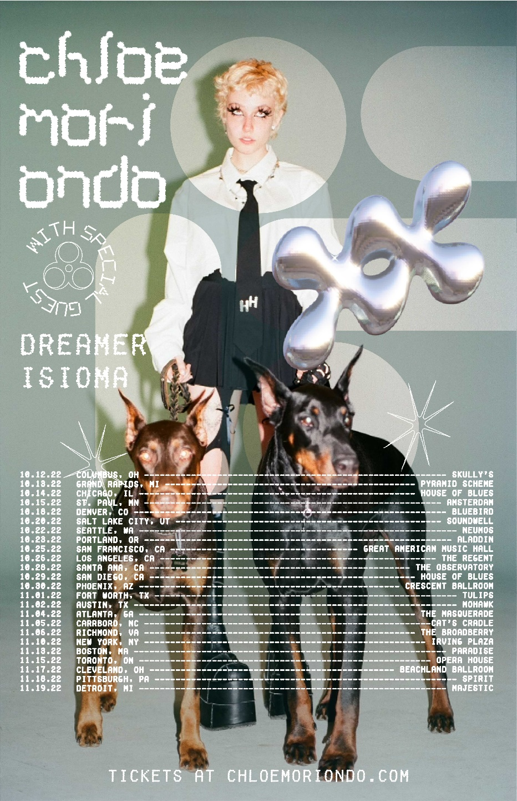

JUNE
11 Boston, MA Royale^

JULY
22-24 Seattle, WA Capitol Hill Block Party*

SEPTEMBER
22-25 Dover, DE Firefly Music Festival*

OCTOBER
12 Columbus, OH Skully's
13 Grand Rapids, MI Pyramid Scheme
14 Chicago, IL House Of Blues
15 St. Paul, MN Amsterdam
18 Denver, CO Bluebird
20 Salt Lake City, UT Soundwell
22 Seattle, WA Neumos
23 Portland, OR Aladdin
25 San Francisco, CA Great American Music Hall
26 Los Angeles, CA The Regent
28 Santa Ana, CA The Observatory
29 San Diego, CA House of Blues
30 Phoenix , AZ Crescent Ballroom

NOVEMBER
1 Fort Worth, TX Tulips
2 Austin, TX Mohawk
4 Atlanta, GA The Masquerade
5 Carrboro, NC Cat's Cradle
6 Richmond, VA The Broadberry
10 New York, NY Irving Plaza
13 Boston, MA Paradise
15 Toronto, ON Opera House
17 Cleveland, OH Beachland Ballroom
18 Pittsburgh, PA Spirit
19 Detroit, MI Majestic

Chloe Moriondo
Blood Bunny Deluxe
AVAILABLE NOW
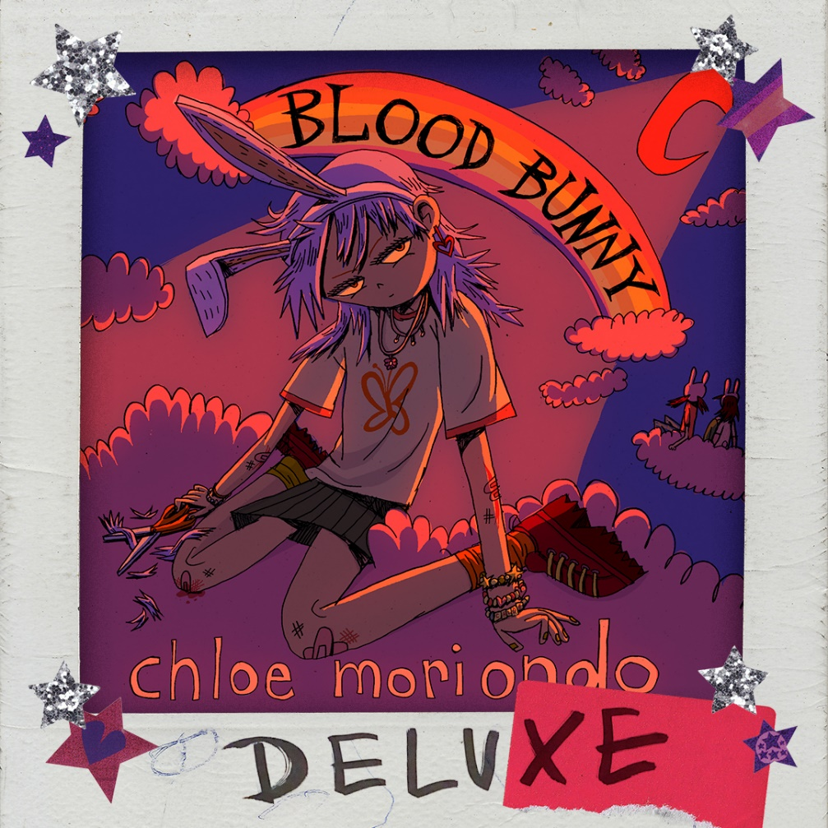

Tracklisting:
1. Rly Don’t Care
2. I Eat Boys
3. Manta Rays
4. GIRL ON TV
5. I Want To Be With You
6. Slacker
7. Take Your Time
8. Bodybag
9. Favorite Band
10. Samantha
11. Strawberry Blonde
12. Vapor
13. What If It Doesn’t End Well
14. I Eat Boys (feat. dodie)
15. Living Virtually
16. Slacker (Cavetown Version)
17. GIRL ON TV (Voice Memo)
18. Favorite Band (Voice Memo)
19. Strawberry Blonde (Voice Memo)
20. i want to be with you (acoustic)
21. manta rays (acoustic)
22. girl on tv (acoustic)
23. take your time (acoustic)
24. Hell Hounds

CONNECT WITH Chloe Moriondo
www.chloemoriondo.com
YOUTUBE
INSTAGRAM
TWITTER
FACEBOOK

CONTACT:
Sarah Goldstein
SarahGoldstein@elektra.com

