CHLOE MORIONDO ANNOUNCES NEW EP puppy luv
ARRIVING APRIL 8TH

NEW TRACK AND VIDEO “SAMMY” STREAMING NOW
WATCH HERE

NORTH AMERICAN TOUR DATES WITH MXMTOON KICK OFF MAY 2ND

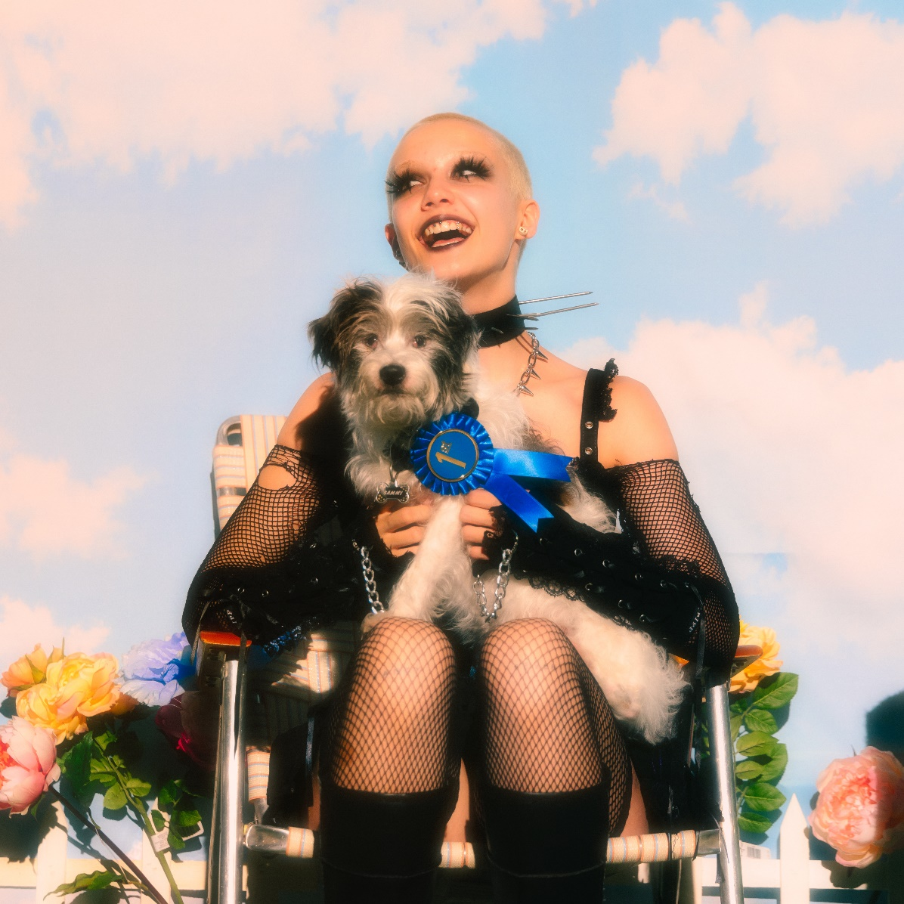
MARCH 7, 2022 – Rising star Chloe Moriondo has announced the puppy luv EP, a collection of canine-themed songs arriving April 8th. The announcement is heralded by the charming, breezy new single “sammy,” and accompanied by an official music video starring Moriondo’s own pet dog (the titular Sammy). puppy luv is available for presave now via Public Consumption/Fueled By Ramen.
Expanding on the EP, Moriondo shared, “‘puppy luv’ is a collection of canine songs that i coincidentally wrote over the past couple years. to me it feels like a playful bite from a tiny puppy that kinda stings a little later. i dedicate it to Sammy my dog!”
This spring, Moriondo will head out on tour in support of mxmtoon’s North American headline dates. The trek kicks off May 2nd in Montreal, Quebec and includes two nights at The Fonda in Los Angeles and New York City’s Webster Hall. Chloe will also be hitting the festival circuit with upcoming performances at Seattle, WA’s Capitol Hill Block Party and this year’s Firefly Festival (tour itinerary below). For a full list of tour dates and ticketing information, please visit www.chloemoriondo.com.
Following the release of their critically acclaimed album Blood Bunny last May, Moriondo’s momentum only continued throughout the fall, releasing “Dizzy feat. Thomas Headon and Alfie Templeman,” and supporting Ashnikko’s sold out headline tour between her own headline dates.

About Chloe Moriondo:
Chloe Moriondo professes to be an “internet kid,” yet they tackle overwhelming infatuation, listless daydreams, and first love with keen empathy that’s unsearchable online. With relatable, confessional lyrics and idiosyncratic humor, the singer-songwriter has built a devoted fanbase of millions, sharing their authentic self to create a genuine connection with their listeners. Last May, Moriondo shared her critically acclaimed major-label debut album Blood Bunny via Public Consumption/Fueled By Ramen, which landed on “Best Albums of 2021” lists from The New York Times and Billboard. The release was also crowned a “Critic’s Pick” by The New York Times, who exclaimed, “On the robust and vividly plain-spoken ‘Blood Bunny,’ Moriondo…is a pop-punk whiz, deftly hopping between musical approaches from spare to lushly produced, and emphasizing intimate, cut-to-the-bone lyrics.” Chloe has also racked up praise from Billboard, Pitchfork, The FADER, PAPER, UPROXX, Refinery29, them., and more. Following Blood Bunny’s release, Moriondo made her television debut performing “Bodybag” on Jimmy Kimmel LIVE!, and appeared soon after on The Late Late Show With James Corden, where they played a dynamic rendition of “I Want To Be With You.”
[Tour Itinerary / EP Art below]
###

CHLOE MORIONDO
2022 TOUR DATES
supporting mxmtoon
*festival date

MAY
2 Montreal QC Theatre Fairmount
4 Toronto ON The Danforth Music Hall
5 Detroit MI The Majestic Theatre
7 Chicago IL House of Blues Chicago
8 Minneapolis MN Varsity Theater
10 Englewood CO Gothic Theatre
11 Salt Lake City UT The Complex
13 Vancouver BC Vogue Theatre
14 Portland OR Wonder Ballroom
15 Seattle WA Showbox Market
17 San Francisco CA The Regency Ballroom
18 San Francisco CA The Regency Ballroom
20 Santa Ana CA The Observatory
21 Los Angeles CA The Fonda Theatre
22 Los Angeles CA The Fonda Theatre
24 San Diego CA House of Blues San Diego
25 Phoenix AZ The Van Buren
27 Dallas TX Southside Music Hall
28 Austin TX Scoot Inn (Outdoors)
29 Houston TX White Oak Downstairs
31 Orlando FL The Beacham

JUNE
1 Atlanta GA Variety Playhouse
3 Washington DC 9:30 Club
5 Philadelphia PA Theatre of Living Arts
7 New York NY Webster Hall
8 New York NY Webster Hall
10 Boston MA Royale
11 Boston MA Royale

JULY
22-24 Seattle WA Capitol Hill Block Party*

SEPTEMBER
22-25 Dover DE Firefly Music Festival*

Chloe Moriondo
puppy luv EP – available April 8th
PRESAVE NOW
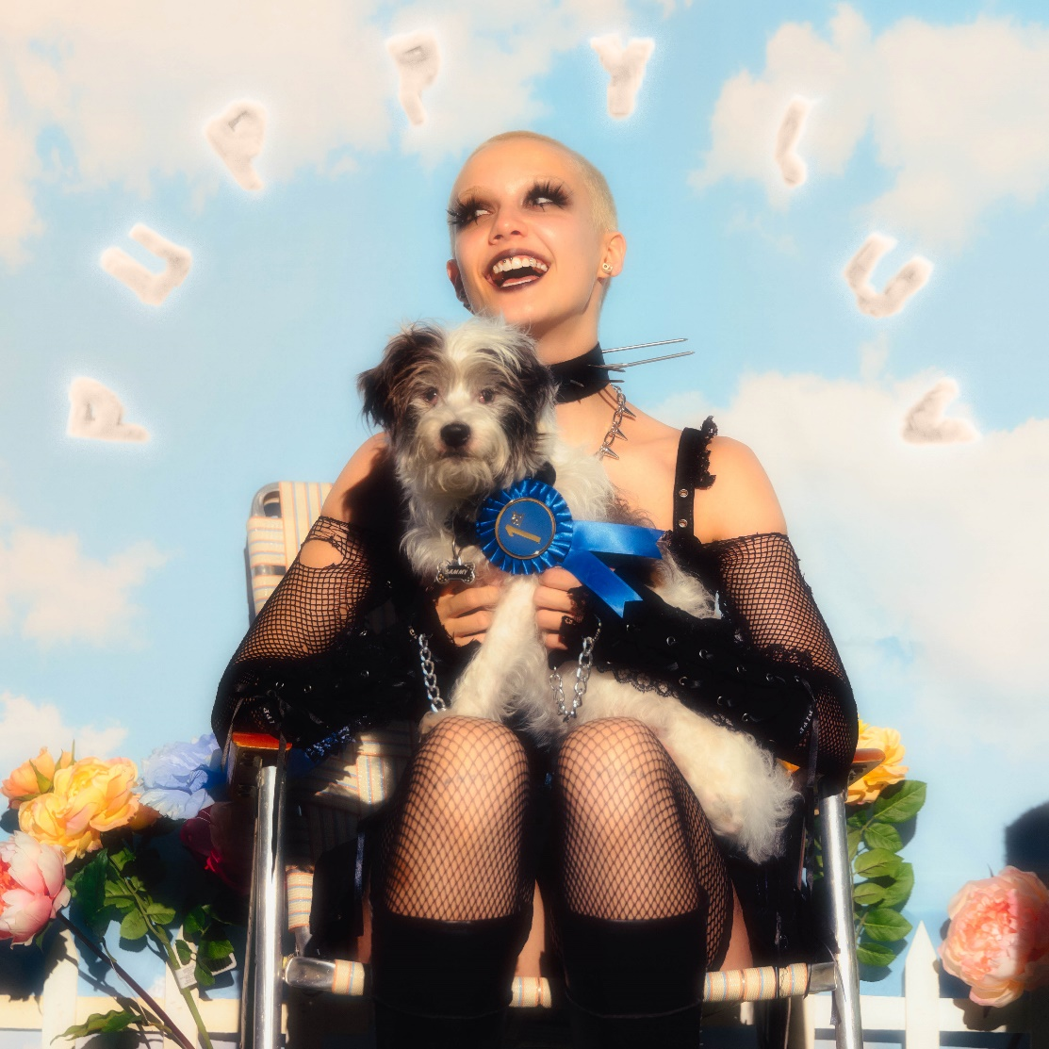

Tracklisting:
- sammy
- nice pup
- my dog won’t miss you (dead 2 me)
- dog days are over
- werewolf

CONNECT WITH Chloe Moriondo
www.chloemoriondo.com
YOUTUBE
INSTAGRAM
TWITTER
FACEBOOK

CONTACT:
Sarah Goldstein
SarahGoldstein@elektra.com

