FOR IMMEDIATE RELEASE
JULY 3, 2020

CHRISTINA PERRI RELEASES
“jar of hearts (10th anniversary acoustic)”

MULTI-PLATINUM SINGER-SONGWRITER CELEBRATES WITH A SPECIAL RE-IMAGINING OF HER BREAKOUT DEBUT SINGLE AVAILABLE NOW

STREAM/DOWNLOAD HERE

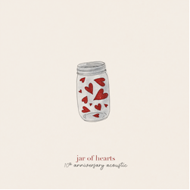

PRESS ASSETS HERE

Elektra recording artist Christina Perri has today released “jar of hearts (10th anniversary acoustic).” The special re-imagining of her 2010 breakout hit single is available at all DSPs and streaming services now.

On June 30, 2010, the original “Jar of Hearts” was featured in a choreographed dance routine on the popular, national television show “So You Think You Can Dance.” At the time, Perri was still a struggling, unsigned musician working as a waitress in Hollywood at the time, but, after that night, her life would be forever be changed. Within weeks, she had signed a major record label deal and officially re-released “Jar of Hearts,” which is now RIAA certified 5x-Platinum with more than 720 million streams globally, and kicked off a career highlighted by multi-platinum success, countless television appearances, and sold out shows around the world. To celebrate, Perri posted a companion visual for “jar of hearts (10th anniversary acoustic)” this past Tuesday, ten years to the day when it all started for her. Watch HERE.

Perri shared this note with her fans: “happy 10 year anniversary to my baby jar of hearts!!! what a wild ride it has been. in honor of this special day, here is an acoustic version of the song that i recorded at home. i'm so grateful for all the love and support i have received from day one ! most special thanks to my team of fairy godmothers on this fateful day: keltie knight, stacey tookey, tom gates, ryan chisholm, philly brenthall, steven schillaci, jordan davidoff, kathryn mccormick, and billy bell. without all of you i wouldn't be here. i was catapulted into the stars on that day and i have never come down since! thank you for this life! i wonder what the next decade will bring 💕”

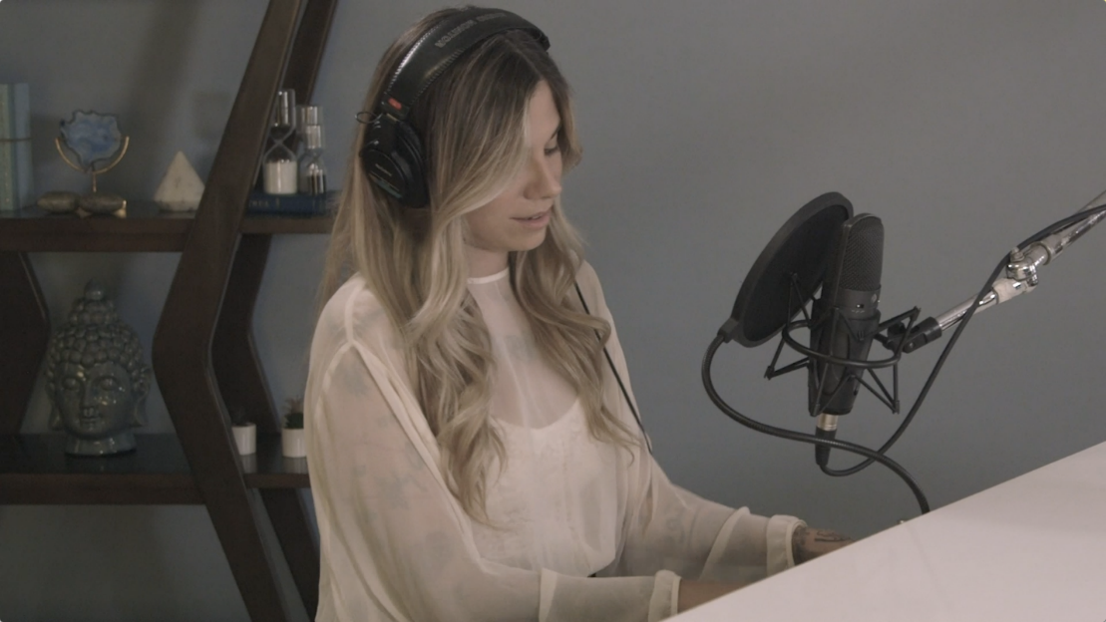

***

Multi-platinum singer-songwriter Christina Perri has earned critical applause and an increasingly fervent fan following since the arrival of her extraordinary, platinum-certified, 2011 debut, lovestrong, which featured the 5x-platinum certified smash, “Jar of Hearts” and gold-certified “arms.” Perri followed lovestrong. with the worldwide hit single, “A Thousand Years,” exclusively featured on THE TWILIGHT SAGA: BREAKING DAWN – PART 1 & 2– ORIGINAL MOTION PICTURE SOUNDTRACKS. The 7x-Platinum certified track was a multi-format radio favorite, and accompanied by an equally popular companion video, now boasting over 1.3 billion individual views via YouTube alone HERE. HEAD OR HEART, Perri’s acclaimed gold-certified, second album, arrived in 2014, highlighted by the RIAA 2X platinum certified single, “Human.” Perri kicked off 2019 with songs for carmella: lullabies & sing-a-longs, a collection of songs the acclaimed singer-songwriter sang to her daughter everyday, released on Carmella’s first birthday. More recently, Perri released the poignant single “Tiny Victories,” a track she wrote for the HBO documentary FOSTER, which made its premiere in Spring 2019, and is currently working on her much anticipated, third full length album.

CONTACT:

Glenn Fukushima
Elektra Music Group
GlennFukushima@elektra.com

