COHEED AND CAMBRIA
ANNOUNCE “THE GREAT DESTROYER TOUR" WITH SPECIAL GUESTS SHEER MAG

NEW DATES BEGIN FEBRUARY 16TH AT PAPPY & HARRIET’S IN PIONEERTOWN, CA

PRE-SALES BEGIN DECEMBER 15TH AT 10:00AM LOCAL
TICKETS ON SALE DECEMBER 17TH AT 10:00AM LOCAL

NEW SINGLES “SHOULDERS” & “RISE, NAIANASHA (CUT THE CORD)” STREAMING NOW

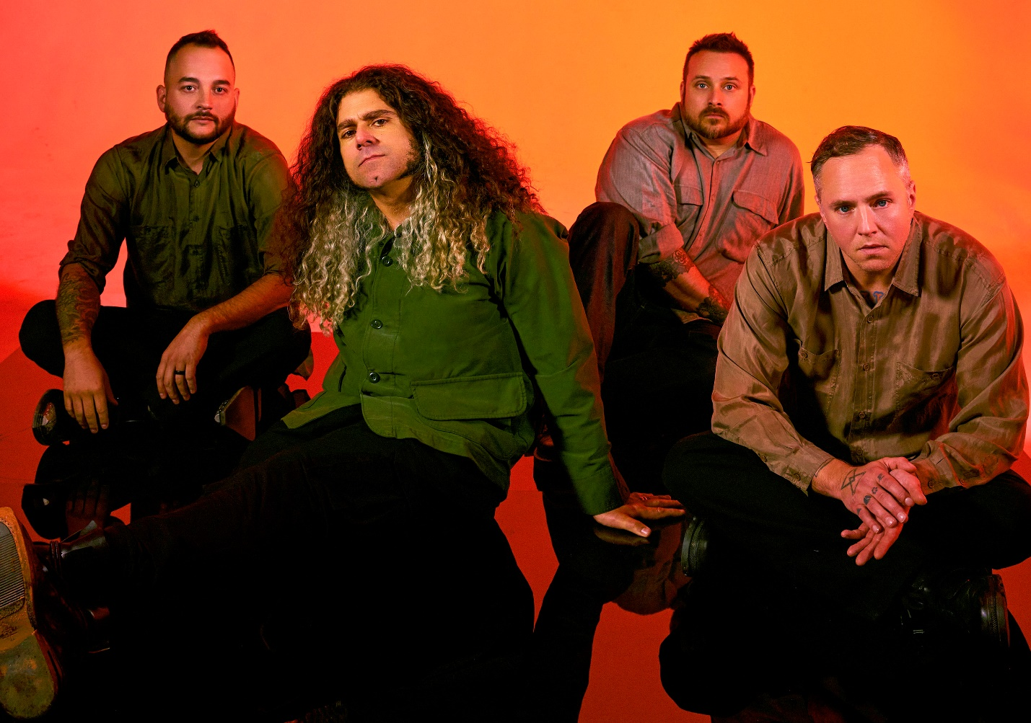
PHOTO CREDIT: ALEXANDRA GAVILLET

DECEMBER 14, 2021 – Coheed and Cambria have announced details of “The Great Destroyer Tour,” a U.S. headline run which will feature support from special guests Sheer Mag. The coast-to-coast trek is set to get underway on February 16th at the legendary Pappy & Harriet’s in Pioneertown, CA and will continue through mid-March giving audiences an opportunity to see the band live in intimate clubs across the U.S. Pre-sales for tickets to “The Great Destroyer Tour” will begin tomorrow, December 15th at 10:00AM local time with general on sale starting Friday, December 17th at 10:00AM local time. For tickets and more information on the “The Great Destroyer Tour,” visit www.coheedandcambria.com.

The upcoming winter dates will see Coheed and Cambria performing their 2021 singles “Rise, Naianasha (Cut The Cord)” and “Shoulders,” the latter of which is currently Top 10 at Active Rock Radio, marking the group’s career highest radio chart position to date. “A total banger… as explosive and catchy as anything they've ever released,” declared REVOLVER who placed “Shoulders” in their weekly Best New Songs Right Now round-up. “Coheed and Cambria are back, and they’re heavy as ever,” asserted Billboard, with Guitar World attesting “Coheed and Cambria have come out swinging.” Brooklyn Vegan observed, “It finds the band embracing their love of classic heavy metal riffage, before exploding into the kind of soaring chorus that Coheed have been churning out since day one… they sound pretty damn inspired.”

Furthermore, Coheed and Cambria vocalist / guitarist Claudio Sanchez sat down with GRAMMY.com earlier this year for an in-depth interview discussing details of the band’s imminent new album while also examining Vaxis - an emerging central figure in the sci-fi universe of “The Amory Wars” - previewing his origin story and expanding the mythos.

For the last 20 years, Coheed and Cambria have continuously broken the mold of what a rock band can be, forging their own path and building a universe around their music unlike any other. Whether it is in the way their genre-spanning approach to songwriting has allowed them to bridge worlds without being contained to one, or the multifaceted story arc of their albums and comic book series which mark the longest running concept story in music, Coheed and Cambria have consistently shaped new standards, never conformed. Comprised of Claudio Sanchez (Vocals / Guitar), Travis Stever (Guitar), Josh Eppard (Drums) and Zach Cooper (Bass) the band has gripped listeners and press around the globe with their visionary compositions and conceptual mastery. In 2018, Coheed and Cambria made a stunning debut with their album Vaxis I: The Unheavenly Creatures, which debuted at #1 on Billboard’s “Hard Rock Albums” chart, #6 current sales and Top 15 on the “Billboard 200” chart.

[TOUR ITINERARY / ADMAT BELOW]

COHEED AND CAMBRIA
“THE GREAT DESTROYER TOUR”
WITH SPECIAL GUESTS SHEER MAG

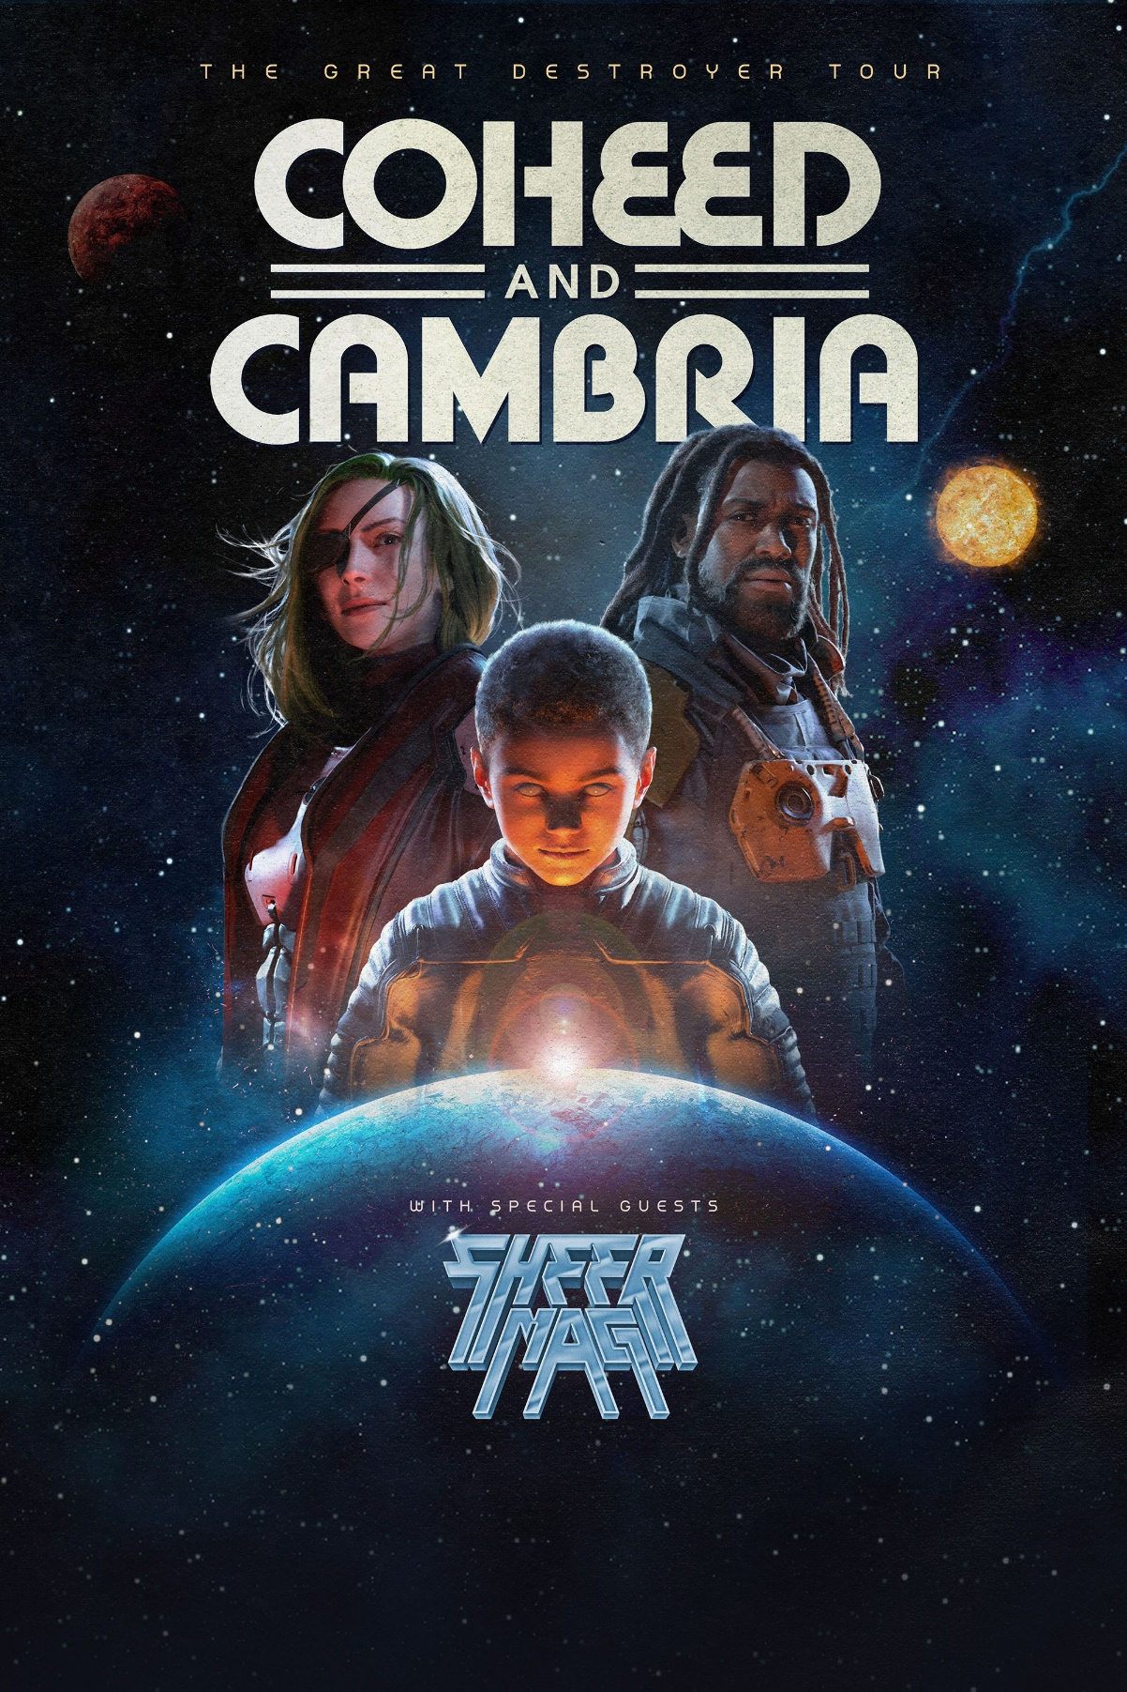

Feb 16 - Pappy and Harriet’s - Pioneertown, CA
Feb 17 - Brooklyn Bowl - Las Vegas, NV
Feb 19 - El Rey Theatre - Albuquerque, NM
Feb 20 - Rialto Theatre - Tucson, AZ
Feb 22 - Diamond Ballroom - Oklahoma City
Feb 23 - The Soundstage at Graceland - Memphis, TN
Feb 25 - Mars Music Hall - Huntsville, AL
Feb 26 - The Fillmore - New Orleans, LA
Feb 28 - The Mill & Mine - Knoxville, TN
Mar 01 - The Signal - Chattanooga, TN
Mar 02 - The Orange Peel - Asheville, NC
Mar 04 - The NorVa - Norfolk, VA
Mar 05 - The National - Richmond, VA
Mar 06 - PromoWest Pavilion at OVATION - Newport, KY
Mar 08 - Uptown Theater - Kansas City, MO
Mar 09 - The Sylvee - Madison, WI
Mar 11 - Clyde Theatre - Fort Wayne, IN
Mar 13 - GLC Live at 20 Monroe - Grand Rapids, M
Mar 14 - Main Street Armory - Rochester, NY
Mar 15 - Empire Live - Albany, NY
Mar 17 - Fete Music Hall - Providence, RI
Mar 18 - College Street Music Hall - New Haven, CT
Mar 19 - XL Live - Harrisburg, PA

CONNECT WITH COHEED AND CAMBRIA:
Facebook / Twitter / Instagram / YouTube / Website

