COREY TAYLOR
CELEBRATES ANOTHER TRIP AROUND THE SUN WITH
“EVERYBODY DIES ON MY BIRTHDAY” LYRIC VIDEO

NEW LIMITED-EDITION COFFEE COLLABORATION & BIRTHDAY MERCH AVAILABLE HERE

FIRST ARTIST EVER TO TOP THE ACTIVE ROCK RADIO FORMAT WITH THREE SEPARATE PROJECTS

DEBUT SOLO ALBUM CMFT AVAILABLE NOW ON ALL STREAMING PLATFORMS

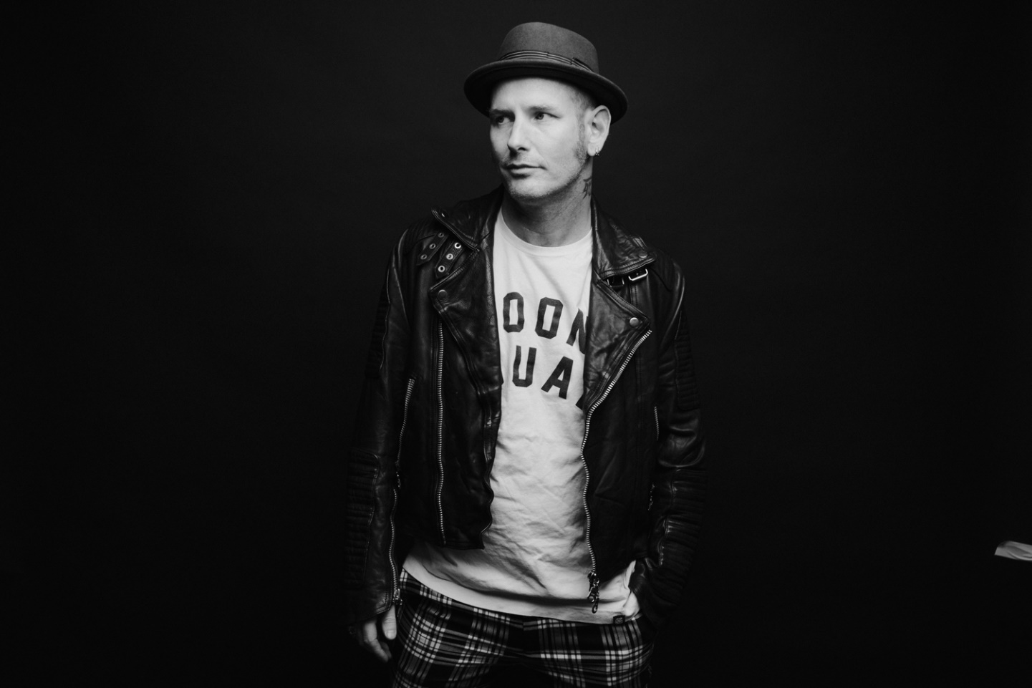

DECEMBER 8, 2020 – GRAMMY® Award-winning singer / songwriter, actor, and New York Times Best-Selling Author, Corey Taylor is celebrating another year around the sun today with the release of a new animated lyric video for his single, “Everybody Dies On My Birthday.” Speaking to Metal Hammer earlier this year, Taylor elaborated on the song’s significance stating, “We’re all born, and we all die. It’s those two things we all have in common; it’s everything in between that can be changed.” “Everybody Dies On My Birthday” is featured on Taylor’s acclaimed first-ever solo album, CMFT, which is available on all streaming platforms.

Furthermore, in celebration of his birthday, Taylor has launched a new limited-edition coffee collaboration: CMFT Private Blend. Taylor collaborated with Menotti’s Coffee in Venice, CA on this unique blend for friends that love darkish roast flavor, with just a hint of excitement peeking around the corner ready to ride a Rainbow in the Dark. Fans can order a 12oz bag now at http://store.thecoreytaylor.com/.

Taylor commented, “We wanted to create something that gave you that same comfortable and cozy feeling you get from a really good cup of diner coffee after you’ve been riding on HWY 666.”

Fans can also visit http://store.thecoreytaylor.com/ for a brand new “Everybody Dies On My Birthday” t-shirt design released today. The coffee and merch launch follows a recent appearance on Bert Kreischer’s “Bertcast” where Taylor discussed his approach to building one of the most dynamic and thrilling careers in modern music.

Earlier this year Taylor made history as he reached #1 at Active Rock Radio with his powerful single “Black Eyes Blue.” The achievement put Taylor in a class all his own, making him the first artist in the history of the format to reach #1 with three separate projects, following chart-topping efforts from his band’s Slipknot and Stone Sour.

CMFT made impressive debuts on charts around the world this month entering at #1 on Billboard’s “Current Hard Rock Albums” chart, while claiming #2 on “Current Rock Albums,” #6 on “Vinyl Albums,” and #9 on the “Top Albums” charts. Furthermore, CMFT landed Top 10 on the official album charts in Australia, Germany, Switzerland and Austria, with Top 20 debuts in the United Kingdom, Finland and Japan (international chart).

Names one of Loudwire’s “Best Rock +Metal Albums of 2020,” CMFT has been garnering widespread critical applause with FORBES affirming, “Corey Taylor’s singing is undeniably the best it’s ever been. From Slipknot’s last album to his new solo material, Taylor is easily among the best sounding rock singers alive.” Kerrang! raved, “Corey Taylor certainly couldn’t have predicted how important a sense of uninhibited joy would be on his debut solo effort, it’s just what 2020 needs – and, even more importantly, exactly what he delivers.” The Daily Beast attested, “CMFT finds the singer broadening his horizons and showing off his considerable versatility,” while Stereogum noted, “Corey Taylor’s lived several lives in the span that it takes most of us to push through just one, and it’s clear that he cherishes every experience he’s had so far.” New York Magazine added that CMFT “bridges his vast tastes and influences, dabbling in punk rock, metal, reflective acoustic tunes, plaintive piano ballads, and hip-hop, with Taylor’s power-house vocals and introspective lyrics acting as a guide”

Taylor celebrated the release of his debut solo album in spectacular style, when he and his band took to the stage of iconic Los Angeles venue, The Forum to put on an epic, globally streamed rock n roll show for the ages. Originally broadcasted on October 2nd, Forum Or Against ‘Em, saw Taylor and crew blaze through a 23 song setlist including every song on his debut solo album CMFT, songs from the Slipknot and Stone Sour catalogues, and several covers. Fans can watch a full performance of “Samantha’s Gone” and "Halfway Down," from the evening as well as the official pre-show on Taylor’s official YouTube channel.

CMFT is highlighted by the singles “Culture Head,” “HWY 666,” “CMFT Must Be Stopped” [feat. Tech N9ne & Kid Bookie],” and the Active Rock radio hit “Black Eyes Blue.” Taylor also hit #1 on Billboard’s “Hard Rock Songwriters” chart following the unprecedented debut of “Black Eyes Blue” and “CMFT Must Be Stopped” [feat. Tech N9ne & Kid Bookie],” the latter of which has racked up over four million YouTube views for its star-studded music video. Furthermore, Taylor debuted the pummeling “Culture Head” during WWE’s NXT broadcast on the USA Network, illuminating yet another facet of CMFT and showcasing the broad spectrum of this fiery and fearless rock ‘n’ roll opus, as Taylor touches on lifelong influences ranging from hard rock to classic rock, punk rock to hip-hop. 14-Time World Champion and EVP of Global Talent Strategy & Development at WWE, Triple H, also shared a WWE exclusive performance of Taylor and his band tearing through the Motorhead classic “Ace of Spades” – Watch it HERE.

CMFT has been a long time coming for Taylor, with newly written tracks alongside some dating back to his teens. Recorded at Hideout Studio in Las Vegas, with producer Jay Ruston and his band—Christian Martucci [guitar], Zach Throne [guitar], Jason Christopher [bass], and Dustin Robert [drums]— the album traces a wild and exhilarating roadmap through Taylor’s musical psyche.

[ALBUM ART / TRACKLIST / BOILERPLATE BELOW]
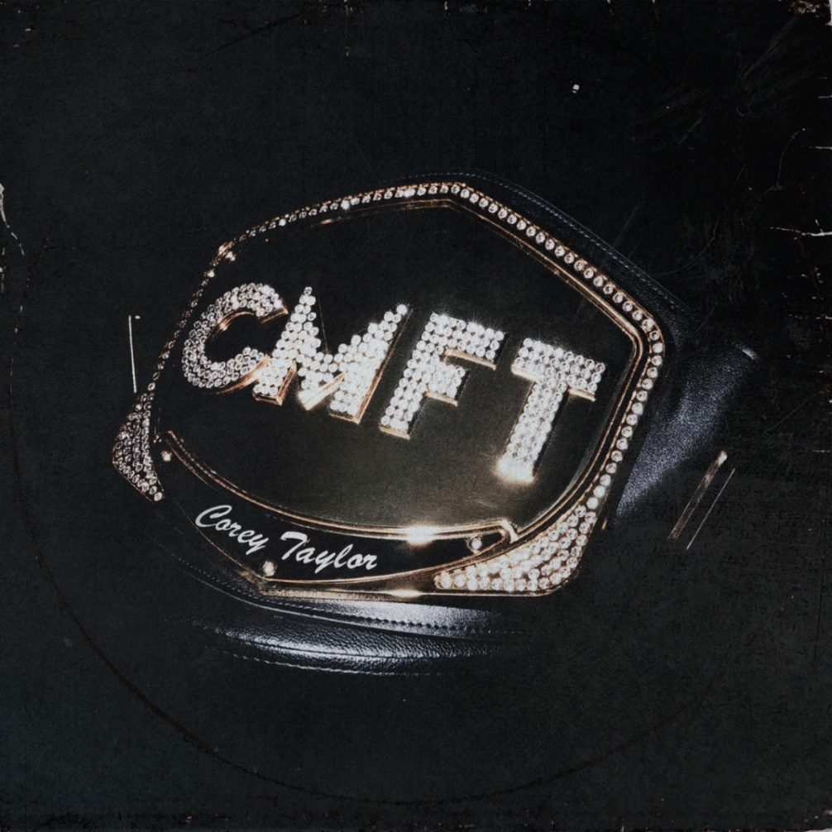
- HWY 666
- Black Eyes Blue
- Samantha’s Gone
- Meine Lux
- Halfway Down
- Silverfish
- Kansas
- Culture Head
- Everybody Dies On My Birthday
- The Maria Fire
- Home
- CMFT Must Be Stopped [Feat. Tech N9ne & Kid Bookie]
- European Tour Bus Bathroom Song
ABOUT COREY TAYLOR:
Uncompromising, unfiltered, and undeniable in any arena, Corey Taylor continues to impact culture as the frontman for both GRAMMY® Award-winning multi-platinum juggernaut Slipknot and platinum rock force Stone Sour. Taylor is a New York Times Best-Selling author as well as an actor with a myriad film and television credits. Impacting generations of fans and peers alike, his voice roars across six Slipknot albums which have rallied millions of fans across the globe. Globally Slipknot boast 13 Platinum and 44 Gold albums, three of which debuted at #1 on the Billboard 200 (All Hope is Gone, .5 the Gray Chapter and We Are Not Your Kind). 2019’s We Are Not Your Kind represented a critical and creative high watermark for Slipknot affirmed by praise from The Ringer, The FADER, and GQ, as well as the honor of Rolling Stone’s #1 “Best Metal Album of 2019.” With two gold-certified albums and a platinum single, Stone Sour have notched five Top 10 debuts on the “Billboard 200” and garnered Loudwire’s “Rock Album of the Decade” for House of Gold & Bones — Part 1, which also spawned its own Dark Horse Comics graphic novel of the same name by Taylor. 2017’s Hydrograd yielded one of the band’s biggest singles in the form of “Song #3,” which put up 100 million streams and clinched #1 on the “Billboard Mainstream Rock Songs” chart for five consecutive weeks. Taylor first crashed the New York Times Best Seller List with Seven Deadly Sins in 2011, occupying the chart for four weeks. He followed it up with three popular tomes: A Funny Thing Happened On The Way To Heaven [2013], You’re Making Me Hate You [2015], and America 51 [2017]. Meanwhile, his filmography encompasses Fear Clinic, Doctor Who, Officer Downe, and Sharknado 4. The rare renaissance man who can give a symposium at Oxford University and headline heavy music festivals around the globe, Taylor forever challenges culture to think, dream, and scream along with him. For more information visit www.thecoreytaylor.com.
FOR MORE INFORMATION ON COREY TAYLOR, CONTACT:
Ross Anderson / Rossanderson@elektra.com

# # #

