COREY TAYLOR
MAKES IMPRESSIVE CHART IMPACT WITH DEBUT SOLO ALBUM CMFT

#1 “CURRENT HARD ROCK ALBUMS” CHART
#2 “CURRENT ROCK ALBUMS” CHART
#6 “VINYL ALBUMS” CHART
#9 “TOP ALBUMS” CHART

CMFT AVAILABLE NOW ON ALL STREAMING PLATFORMS

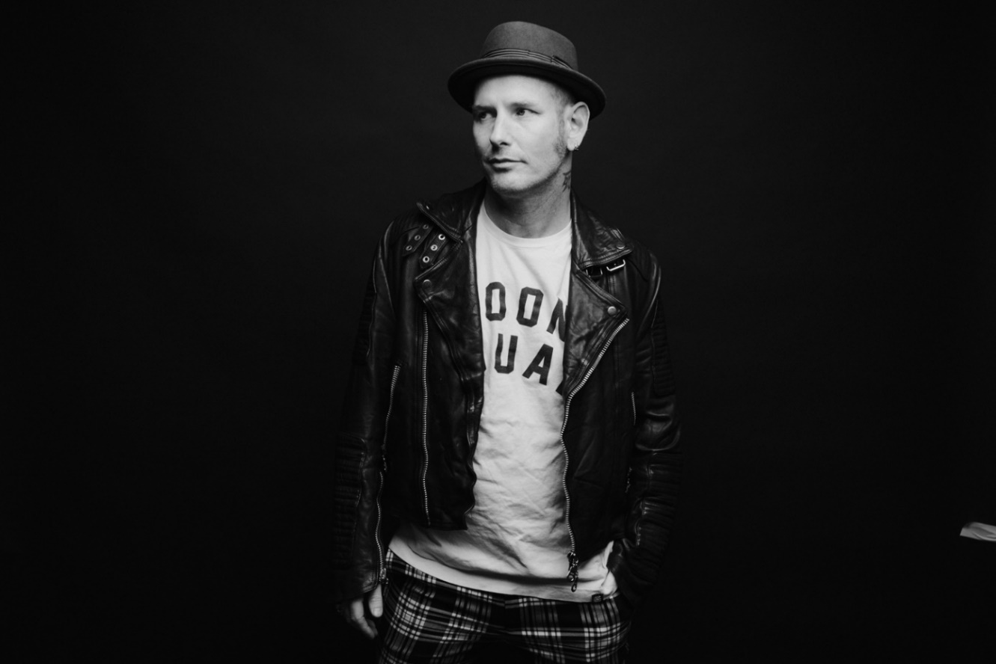

OCTOBER 13, 2020 – GRAMMY® Award-winning singer / songwriter, actor, and New York Times Best-Selling Author, Corey Taylor has made an impressive chart impact with his acclaimed first-ever solo album, CMFT. The Slipknot and Stone Sour vocalist’s debut solo release entered at #1 on Billboard’s “Current Hard Rock Albums” chart this week, while claiming #2 on “Current Rock Albums,” #6 on “Vinyl Albums,” and #9 on the “Top Albums” charts. Furthermore, CMFT has made remarkable debuts around the globe with Top 10 entries on the official album charts in Australia and Germany, as well as Top 20 debuts in the United Kingdom and Japan (international chart). CMFT is available now all streaming platforms with limited-edition vinyl and merch bundles available at www.thecoreytaylor.com.

Featured in Rolling Stone’s “Fall Album Preview 2020,” CMFT has been garnering widespread critical applause with FORBES affirming, “Corey Taylor’s singing is undeniably the best it’s ever been. From Slipknot’s last album to his new solo material, Taylor is easily among the best sounding rock singers alive.” Kerrang! raved, “Corey Taylor certainly couldn’t have predicted how important a sense of uninhibited joy would be on his debut solo effort, it’s just what 2020 needs – and, even more importantly, exactly what he delivers.” The Daily Beast attested, “CMFT finds the singer broadening his horizons and showing off his considerable versatility,” while Stereogum noted, “Corey Taylor’s lived several lives in the span that it takes most of us to push through just one, and it’s clear that he cherishes every experience he’s had so far.”

Taylor celebrated the release of his debut solo album in spectacular style, when he and his band took to the stage of iconic Los Angeles venue, The Forum to put on an epic, globally streamed rock n roll show for the ages. Originally broadcasted on October 2nd, Forum Or Against ‘Em, saw Taylor and crew blaze through a 23 song setlist including every song on his debut solo album CMFT, songs from the Slipknot and Stone Sour catalogues, several covers, and a jaw-dropping finale featuring a high octane, high flying performance from girl gang dance squad The Cherry Bombs. Fans can watch a full performance of "Halfway Down" from the evening on Taylor’s official YouTube channel.

CMFT is highlighted by the singles “Culture Head,” “HWY 666,” “CMFT Must Be Stopped” [feat. Tech N9ne & Kid Bookie],” and the Active Rock radio hit “Black Eyes Blue,” which is currently surging towards the top spot on the chart. Taylor also hit #1 on Billboard’s “Hard Rock Songwriters” chart following the unprecedented debut of “Black Eyes Blue” and “CMFT Must Be Stopped” [feat. Tech N9ne & Kid Bookie],” the latter of which has racked up over 3 million YouTube views for its star-studded music video. Just last week Taylor debuted the pummeling “Culture Head” during WWE’s NXT broadcast on the USA Network, illuminating yet another facet of CMFT and showcasing the broad spectrum of this fiery and fearless rock ‘n’ roll opus, as Taylor touches on lifelong influences ranging from hard rock to classic rock, punk rock to hip-hop. Furthermore, 14-Time World Champion and EVP of Global Talent Strategy & Development at WWE, Triple H, recently shared a WWE exclusive performance of Taylor and his band tearing through the Motorhead classic “Ace of Spades” – Watch it HERE.

CMFT has been a long time coming for Taylor, with newly written tracks alongside some dating back to his teens. Recorded at Hideout Studio in Las Vegas, with producer Jay Ruston and his band—Christian Martucci [guitar], Zach Throne [guitar], Jason Christopher [bass], and Dustin Robert [drums]— the album traces a wild and exhilarating roadmap through Taylor’s musical psyche.

[ALBUM ART / TRACKLIST / BOILERPLATE BELOW]

COREY TAYLOR
CMFT
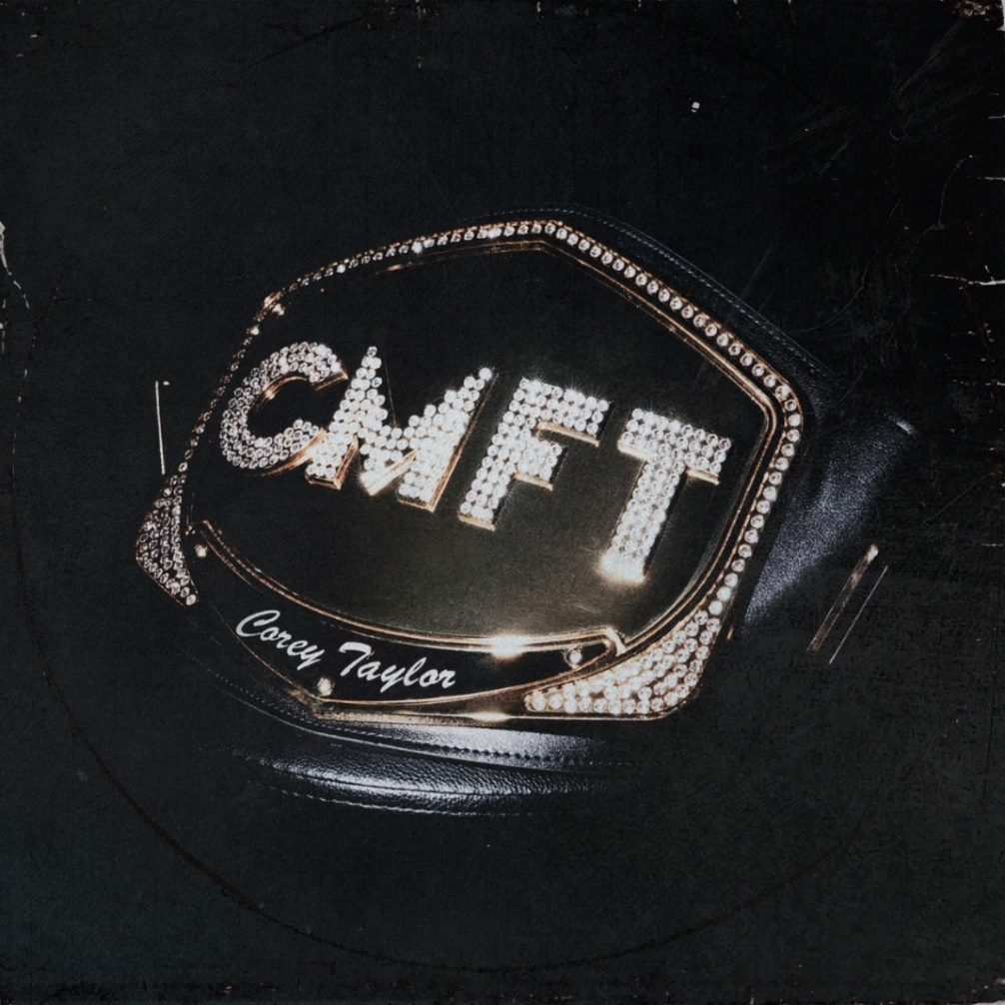
- HWY 666
- Black Eyes Blue
- Samantha’s Gone
- Meine Lux
- Halfway Down
- Silverfish
- Kansas
- Culture Head
- Everybody Dies On My Birthday
- The Maria Fire
- Home
- CMFT Must Be Stopped [Feat. Tech N9ne & Kid Bookie]
- European Tour Bus Bathroom Song
ABOUT COREY TAYLOR:
Uncompromising, unfiltered, and undeniable in any arena, Corey Taylor continues to impact culture as the frontman for both GRAMMY® Award-winning multi-platinum juggernaut Slipknot and platinum rock force Stone Sour. Taylor is a New York Times Best-Selling author as well as an actor with a myriad film and television credits. Impacting generations of fans and peers alike, his voice roars across six Slipknot albums which have rallied millions of fans across the globe. Globally Slipknot boast 13 Platinum and 44 Gold albums, three of which debuted at #1 on the Billboard 200 (All Hope is Gone, .5 the Gray Chapter and We Are Not Your Kind). 2019’s We Are Not Your Kind represented a critical and creative high watermark for Slipknot affirmed by praise from The Ringer, The FADER, and GQ, as well as the honor of Rolling Stone’s #1 “Best Metal Album of 2019.” With two gold-certified albums and a platinum single, Stone Sour have notched five Top 10 debuts on the “Billboard 200” and garnered Loudwire’s “Rock Album of the Decade” for House of Gold & Bones — Part 1, which also spawned its own Dark Horse Comics graphic novel of the same name by Taylor. 2017’s Hydrograd yielded one of the band’s biggest singles in the form of “Song #3,” which put up 100 million streams and clinched #1 on the “Billboard Mainstream Rock Songs” chart for five consecutive weeks. Taylor first crashed the New York Times Best Seller List with Seven Deadly Sins in 2011, occupying the chart for four weeks. He followed it up with three popular tomes: A Funny Thing Happened On The Way To Heaven [2013], You’re Making Me Hate You [2015], and America 51 [2017]. Meanwhile, his filmography encompasses Fear Clinic, Doctor Who, Officer Downe, and Sharknado 4. The rare renaissance man who can give a symposium at Oxford University and headline heavy music festivals around the globe, Taylor forever challenges culture to think, dream, and scream along with him. For more information visit www.thecoreytaylor.com.
FOR MORE INFORMATION ON COREY TAYLOR, CONTACT:
Ross Anderson / Rossanderson@elektra.com

# # #

