COREY TAYLOR
RELEASES DEBUT SOLO ALBUM CMFT

AVAILABLE TODAY ON ALL STREAMING PLATFORMS

GLOBAL STREAM PPV FORUM OR AGAINST ‘EM
AIRS TONIGHT AT 5:00PM ET / 2:00PM PT

TICKETS AVAILABLE AT WATCH.THECOREYTAYLOR.COM

OCTOBER 2, 2020 – GRAMMY® Award-winning singer / songwriter, actor, and New York Times Best-Selling Author, Corey Taylor has released his widely anticipated debut solo album, CMFT. Available now all streaming platforms, fans can also find limited-edition vinyl and merch bundles for CMFT available at www.thecoreytaylor.com.

Later today, Taylor will celebrate the release of CMFT with his global streaming event Forum Or Against ‘Em, which will broadcast at 5:00PM ET / 2:00PM PT. Set at the iconic Los Angeles venue, The Forum, the global streaming event will see Taylor performing a stacked set list featuring CMFT in its entirety, select fan-favorite cuts from Taylor’s Slipknot and Stone Sour catalogues, as well as a handful of covers. A collaboration between 5B Artists + Media and Danny Wimmer Presents, Forum Or Against ‘Em will be a full arena production complete with pyrotechnics and feature a guest performance from rock n’ roll girl-gang dance squad, The Cherry Bombs. Kicking off the event’s festivities will be a special pre-show event hosted by presenter/journalist, Beez that will feature exclusive interviews and behind-the-scenes footage. Tickets for this historic pay-per-view streaming event are available at watch.thecoreytaylor.com

Featured in Rolling Stone’s “Fall Album Preview 2020,” CMFT has been garnering widespread critical applause with FORBES affirming, “Corey Taylor’s singing is undeniably the best it’s ever been. From Slipknot’s last album to his new solo material, Taylor is easily among the best sounding rock singers alive.” Kerrang! raved, “Corey Taylor certainly couldn’t have predicted how important a sense of uninhibited joy would be on his debut solo effort, it’s just what 2020 needs – and, even more importantly, exactly what he delivers.” The Daily Beast attested, “CMFT finds the singer broadening his horizons and showing off his considerable versatility,” while Stereogum noted, “Corey Taylor’s lived several lives in the span that it takes most of us to push through just one, and it’s clear that he cherishes every experience he’s had so far.”

CMFT is highlighted by the singles “Culture Head,” “HWY 666,” “CMFT Must Be Stopped” [feat. Tech N9ne & Kid Bookie],” and the Top 5 Active Rock radio hit “Black Eyes Blue.” Taylor hit #1 on Billboard’s “Hard Rock Songwriters” chart following the unprecedented debut of “Black Eyes Blue” and “CMFT Must Be Stopped” [feat. Tech N9ne & Kid Bookie],” the latter of which has racked up over 3 million YouTube views for its star-studded music video. Just last week Taylor debuted the pummeling “Culture Head” during WWE’s NXT broadcast on the USA Network, illuminating yet another facet of CMFT and showcasing the broad spectrum of this fiery and fearless rock ‘n’ roll opus, as Taylor touches on lifelong influences ranging from hard rock to classic rock, punk rock to hip-hop. Furthermore, 14-Time World Champion and EVP of Global Talent Strategy & Development at WWE, Triple H, recently shared a WWE exclusive performance of Taylor and his band tearing through the Motorhead classic “Ace of Spades” – Watch it HERE.

CMFT has been a long time coming for Taylor, with newly written tracks alongside some dating back to his teens. Recorded at Hideout Studio in Las Vegas, with producer Jay Ruston and his band—Christian Martucci [guitar], Zach Throne [guitar], Jason Christopher [bass], and Dustin Robert [drums]— the album traces a wild and exhilarating roadmap through Taylor’s musical psyche.

[ALBUM ART / TRACKLIST / BOILERPLATE BELOW]

COREY TAYLOR
CMFT
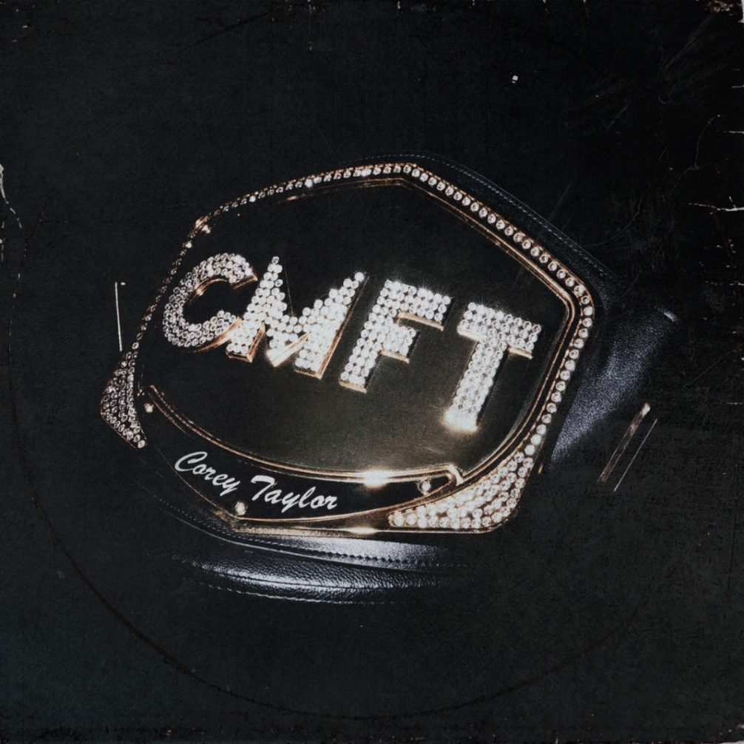
- HWY 666
- Black Eyes Blue
- Samantha’s Gone
- Meine Lux
- Halfway Down
- Silverfish
- Kansas
- Culture Head
- Everybody Dies On My Birthday
- The Maria Fire
- Home
- CMFT Must Be Stopped [Feat. Tech N9ne & Kid Bookie]
- European Tour Bus Bathroom Song
ABOUT COREY TAYLOR:
Uncompromising, unfiltered, and undeniable in any arena, Corey Taylor continues to impact culture as the frontman for both GRAMMY® Award-winning multi-platinum juggernaut Slipknot and platinum rock force Stone Sour. Taylor is a New York Times Best-Selling author as well as an actor with a myriad film and television credits. Impacting generations of fans and peers alike, his voice roars across six Slipknot albums which have rallied millions of fans across the globe. Globally Slipknot boast 13 Platinum and 44 Gold albums, three of which debuted at #1 on the Billboard 200 (All Hope is Gone, .5 the Gray Chapter and We Are Not Your Kind). 2019’s We Are Not Your Kind represented a critical and creative high watermark for Slipknot affirmed by praise from The Ringer, The FADER, and GQ, as well as the honor of Rolling Stone’s #1 “Best Metal Album of 2019.” With two gold-certified albums and a platinum single, Stone Sour have notched five Top 10 debuts on the “Billboard 200” and garnered Loudwire’s “Rock Album of the Decade” for House of Gold & Bones — Part 1, which also spawned its own Dark Horse Comics graphic novel of the same name by Taylor. 2017’s Hydrograd yielded one of the band’s biggest singles in the form of “Song #3,” which put up 100 million streams and clinched #1 on the “Billboard Mainstream Rock Songs” chart for five consecutive weeks. Taylor first crashed the New York Times Best Seller List with Seven Deadly Sins in 2011, occupying the chart for four weeks. He followed it up with three popular tomes: A Funny Thing Happened On The Way To Heaven [2013], You’re Making Me Hate You [2015], and America 51 [2017]. Meanwhile, his filmography encompasses Fear Clinic, Doctor Who, Officer Downe, and Sharknado 4. The rare renaissance man who can give a symposium at Oxford University and headline heavy music festivals around the globe, Taylor forever challenges culture to think, dream, and scream along with him. For more information visit www.thecoreytaylor.com.
FOR MORE INFORMATION ON COREY TAYLOR, CONTACT:
Ross Anderson / Rossanderson@elektra.com

# # #

