COREY TAYLOR
ANNOUNCES SOCIALLY DISTANCED & COVID-19 SAFE 2021 TOUR

‘CMFTour’ GETS UNDERWAY MAY 18TH IN TEMPE, AZ

ALL DATES FEATURING SPECIAL GUESTS THE CHERRY BOMBS

PRE-SALE TICKETS AVAILABLE TODAY
TICKETS ON SALE FRIDAY, MARCH 19TH

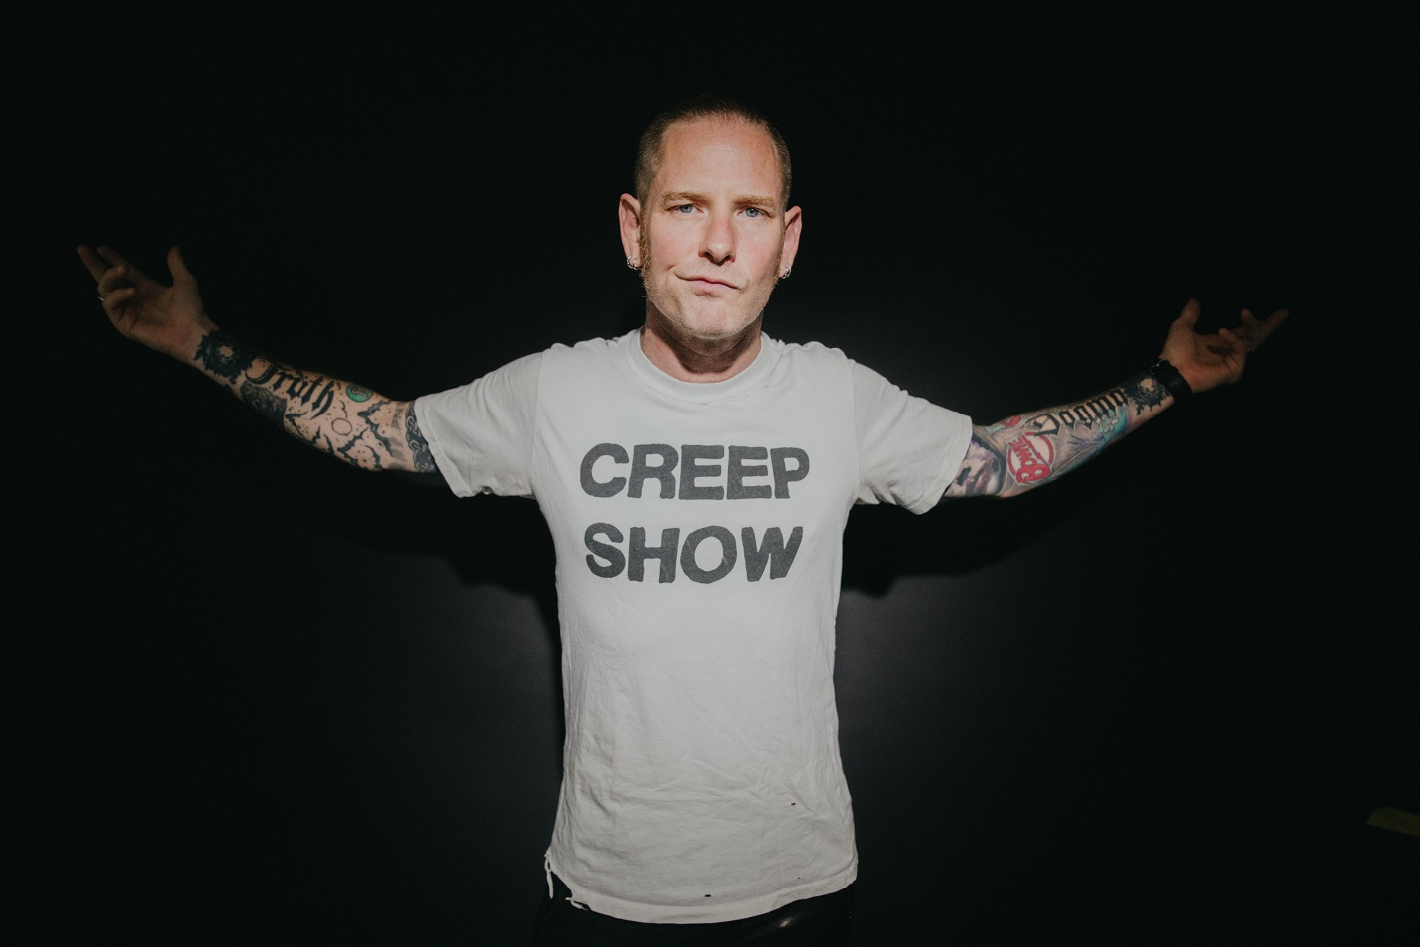

MARCH 17, 2021 – Returning to the road in the safest possible socially distanced fashion, GRAMMY® Award-winning singer / songwriter, actor, and New York Times Best-Selling Author, Corey Taylor has announced details of his ‘CMFTour’ upcoming Spring tour. The 19-date run will kick-off off on May 18th at The Marquee Backyard in Tempe, AZ and see Taylor and his band performing for fans socially distanced and following state recommended health guidelines [see admat / itinerary below]. Pre-sale tickets are available today, Wednesday March 17th, with all remaining tickets going on sale to the general public on Friday, March 19th. Support on all dates comes from special guests The Cherry Bombs. For tickets, safety guidelines and more information on the upcoming concerts, please visit www.thecoreytaylor.com.

Taylor decided to launch this tour for a few significant and personal reasons. As always, he endeavors to deliver an unforgettable show for fans, but just as importantly, he recognizes the massive impact that the ongoing global pandemic has had on live music venues and touring crews alike. It upholds his staunch commitment to supporting live music and the industry surrounding it as illustrated last year through his popular eBay guitar auction, which raised $150,000 for COVID-19 relief, and his COVID-19 safe secret L.A. show benefiting Sweet Relief Musicians Fund—a 501(c)(3) non-profit healing musicians and music industry workers in need.

As for the show itself, Taylor and his band will run through anthems from his critically acclaimed solo debut CMFT, choice cuts from his Slipknot and Stone Sour catalogs, and various covers and surprises. Additionally, girl gang dance squad The Cherry Bombs will kick off each night of the tour with a high octane, high flying performance.

2021 has been as busy as ever for Taylor. He recently dropped the music video for his single “Samantha’s Gone” - which is currently Top 15 at Active Rock Radio - featuring Tom Sandoval of Bravo’s Vanderpump Rules, actor Dean Cameron [Summer School, Ski School, Straight Outta Compton], Steel Panther, plus actor Greg Grunberg, Ace Von Johnson, Travis Miguel and Jonah Nimoy. Additionally, he recently fronted Ground Control a supergroup also comprised of Taylor Hawkins [Foo Fighters], Dave Navarro [Jane’s Addiction], and Chris Chaney [Jane’s Addiction] performing at The Bowie Celebration: Just for One Day in tribute to the late David Bowie.

CMFT remains another milestone for Taylor. Making history, he reached #1 at Active Rock Radio with his powerful single “Black Eyes Blue.” The achievement put Taylor in a class all his own, cementing him as the first artist in the history of the format to reach #1 with three separate projects, following chart-topping efforts from his band’s Slipknot and Stone Sour. CMFT made impressive debuts on charts around the world this month entering at #1 on Billboard’s “Current Hard Rock Albums” chart, while claiming #2 on “Current Rock Albums,” #6 on “Vinyl Albums,” and #9 on the “Top Albums” charts. Furthermore, CMFT landed Top 10 on the official album charts in Australia, Germany, Switzerland and Austria, with Top 20 debuts in the United Kingdom, Finland and Japan (international chart).

Named one of Loudwire’s “Best Rock +Metal Albums of 2020,” CMFT garnered widespread critical applause with FORBES affirming, “Corey Taylor’s singing is undeniably the best it’s ever been. From Slipknot’s last album to his new solo material, Taylor is easily among the best sounding rock singers alive.” Kerrang! raved, “Corey Taylor certainly couldn’t have predicted how important a sense of uninhibited joy would be on his debut solo effort, it’s just what 2020 needs – and, even more importantly, exactly what he delivers.” The Daily Beast attested, “CMFT finds the singer broadening his horizons and showing off his considerable versatility,” while Stereogum noted, “Corey Taylor’s lived several lives in the span that it takes most of us to push through just one, and it’s clear that he cherishes every experience he’s had so far.” New York Magazine added that CMFT “bridges his vast tastes and influences, dabbling in punk rock, metal, reflective acoustic tunes, plaintive piano ballads, and hip-hop, with Taylor’s power-house vocals and introspective lyrics acting as a guide.”

CMFT is highlighted by the singles “Culture Head,” “HWY 666,” “CMFT Must Be Stopped” [feat. Tech N9ne & Kid Bookie],” and the Active Rock radio hit “Black Eyes Blue.” Taylor hit #1 on Billboard’s “Hard Rock Songwriters” chart following the unprecedented debut of “Black Eyes Blue” and “CMFT Must Be Stopped” [feat. Tech N9ne & Kid Bookie],” the latter of which has racked up over 4.5 million YouTube views for its star-studded music video. Furthermore, Taylor debuted the pummeling “Culture Head” during WWE’s NXT broadcast on the USA Network, illuminating yet another facet of CMFT and showcasing the broad spectrum of this fiery and fearless rock ‘n’ roll opus, as Taylor touches on lifelong influences ranging from hard rock to classic rock, punk rock to hip-hop. 14-Time World Champion and EVP of Global Talent Strategy & Development at WWE, Triple H, also shared a WWE exclusive performance of Taylor and his band tearing through the Motorhead classic “Ace of Spades” – Watch it HERE – while “HWY 666” was selected as the theme song for WWE’s Tables, Ladders & Chairs pay-per-view event.

CMFT has been a long time coming for Taylor, with newly written tracks alongside some dating back to his teens. Recorded at Hideout Studio in Las Vegas, with producer Jay Ruston and his band—Christian Martucci [guitar], Zach Throne [guitar], Jason Christopher [bass], and Dustin Robert [drums]— the album traces a wild and exhilarating roadmap through Taylor’s musical psyche.

[TOUR ADMAT / ITINERARY BELOW]

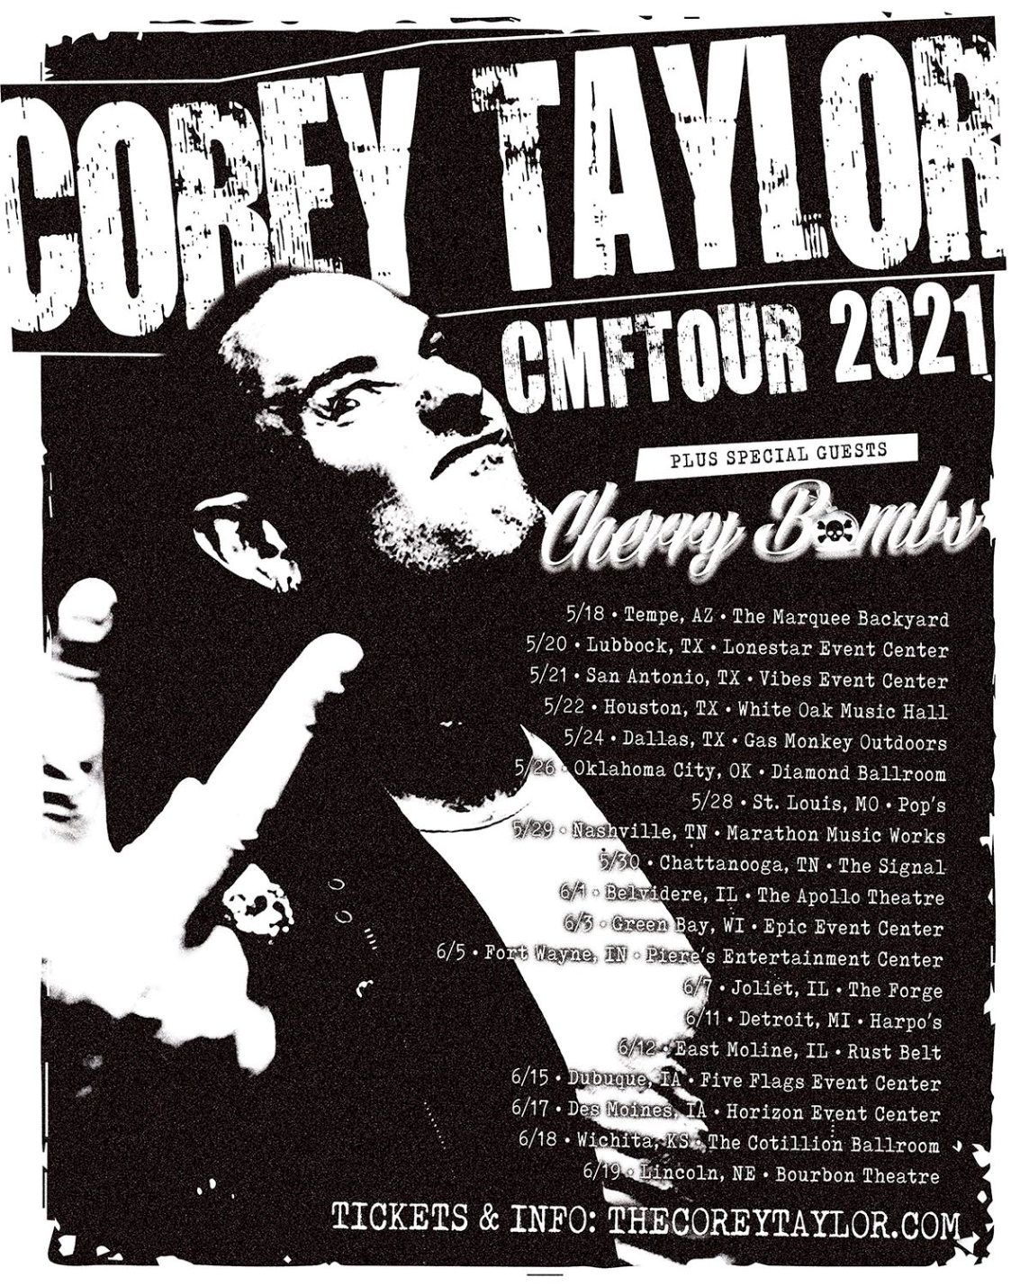

5/18 Tempe, AZ The Marquee Backyard
5/20 Lubbock, TX Lonestar Event Center
5/21 San Antonio, TX Vibes Event Center
5/22 Houston, TX White Oak Music Hall
5/24 Dallas, TX Gas Monkey Outdoors
5/26 Oklahoma City, OK Diamond Ballroom
5/28 St. Louis, MO Pop’s
5/29 Nashville, TN Marathon Music Works
5/30 Chattanooga, TN The Signal
6/1 Belvidere, IL The Apollo Theatre
6/3 Green Bay, WI Epic Event Center
6/5 Fort Wayne, IN Piere’s Entertainment Center
6/7 Joliet, IL The Forge
6/11 Detroit, MI Harpo’s
6/12 East Moline, IL Rust Belt
6/15 Dubuque, IA Five Flags Event Center
6/17 Des Moines, IA Horizon Event Center
6/18 Wichita, KS The Cotillion Ballroom
6/19 Lincoln, NE Bourbon Theatre

ABOUT COREY TAYLOR:
Uncompromising, unfiltered, and undeniable in any arena, Corey Taylor continues to impact culture as the frontman for both GRAMMY® Award-winning multi-platinum juggernaut Slipknot and platinum rock force Stone Sour. Taylor is a New York Times Best-Selling author as well as an actor with a myriad film and television credits. Impacting generations of fans and peers alike, his voice roars across six Slipknot albums which have rallied millions of fans across the globe. With two gold-certified albums and a platinum single, Stone Sour have notched five Top 10 debuts on the “Billboard 200” and garnered Loudwire’s “Rock Album of the Decade” for House of Gold & Bones — Part 1, which also spawned its own Dark Horse Comics graphic novel of the same name by Taylor. His debut solo effort, CMFT, made history with the powerful single “Black Eyes Blue” reaching #1 at Active Rock Radio making Taylor the first artist in the history of the format to reach #1 with three separate projects, following chart-topping efforts from Slipknot and Stone Sour. Taylor first crashed the New York Times Best Seller List with Seven Deadly Sins in 2011, occupying the chart for four weeks. He followed it up with three popular tomes: A Funny Thing Happened On The Way To Heaven [2013], You’re Making Me Hate You [2015], and America 51 [2017]. Meanwhile, his filmography encompasses Fear Clinic, Doctor Who, Officer Downe, and Sharknado 4. The rare renaissance man who can give a symposium at Oxford University and headline heavy music festivals around the globe, Taylor forever challenges culture to think, dream, and scream along with him. For more information visit www.thecoreytaylor.com.

FOR MORE INFORMATION ON COREY TAYLOR, CONTACT:
Ross Anderson / Rossanderson@elektra.com

# # #

