FOR IMMEDIATE RELEASE
FEBRUARY 12, 2021

DANA DENTATA SHARES “DO U LIKE ME NOW?” OFFICIAL VIDEO

WATCH IT HERE

DEBUT ALBUM PANTYCHRIST DUE OUT LATER THIS YEAR

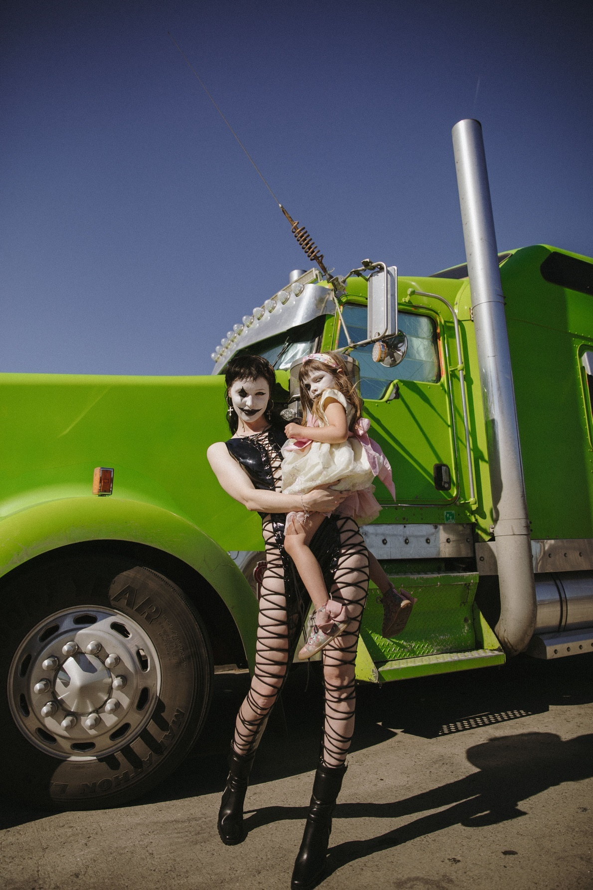

“An instant release from patriarchal bullshit.” - PAPER

“Weaving together metal, performance art and horrorcore à la Three 6 Mafia, Dana Dentata transcends the confines of genre and the laziness of stereotypes.” - HYPEBAE

“Dentata has found her groove with sex-positive, femme-centered hip-hop.” - NYLON

“Strip club-ready rap songs that are all about empowering women.” – THE FADER

“Her sex-positive hip-hop, whether it's being bumped in your headphones or at the strip club,
will definitely empower you.” - OFFICE

FEBRUARY 12, 2021 – Canadian-born musician / model Dana Dentata has shared an official music video for her new single, “Do U Like Me Now?” which premiered today via PAPER. Directed by Carlie C., the video features an appearance from Adult Film Star Eliza Ibarra who Dana Dentata drew inspiration from for the song. Ibarra experienced a viral moment back in 2011 when she posted a video titled “Do You Like Me Now?” to Tumblr, a reaction to unrealistic expectations placed on women by men, which she endured at a young age as she struggled with low self-esteem. The viral video left a lasting impact on Dana Dentata who sampled it for “Do U Like Me Now?” - seizing the reins on the narrative of being a woman in a patriarchal society, transmuting her trauma and weaponizing it.

Dana Dentata expanded on the genesis of the song and video concept telling PAPER, “I saw the ‘Do You Like Me Now?’ video by 12-year-old Eliza one day at the studio and I thought it was bad ass. It instantly inspired me to talk about all the other bullshit things that are expected of us and projected at us. I related to it because I was actually in a relationship where I had to drastically change my hair, clothes, nails, my personality, everything for someone, I was really screaming a form of ‘do you like me now, bitch?’ inside. Being able to recreate this experience but take his ass out and free my inner child was my redemption. I feel like the song and video have the same energy as Eliza's original video and whether you are a 12-year-old girl or a porn star we can all relate to feeling pressured by society to change ourselves. To have Eliza in it made the video so meaningful and literal.”

“Do U Like Me Now?” previews Dana Dentata’s forthcoming debut album, Pantychrist. Expected to arrive this year, Dana Dentata has been finalizing work on Pantychrist, collaborating in the studio with artists / producers: Dylan Brady of 100 Gecs, Kris Esfandiari of King Woman / Miserable, Robokid, Yawns and Fish Narc of GothBoiClique, The Heavy and more.

Dana Dentata announced her signing with Roadrunner Records last fall, becoming the first female solo artist signed to the label. Alongside the announcement, Dana Dentata shared the 20-minute performance art film, ‘The Resurrection of Dana Dentata,’ which sees her carving through performances of tracks from her 2019 EP Daddy Loves You, as well as brand-new material with an unapologetically raw expression of sexual power.

With her brazen rhymes and authoritative flows, Dana Dentata has gained distinction for being equal parts empowering and provocative. By pairing her unapologetically sexual lyrics with production that is just as menacing, Dentata creates liberating, femme-centric hip-hop. A native of Toronto, Canada, she grew up inspired by artists ranging from Britney Spears and Hole, to the Plasmatics and Eminem. At the end of 2019, Dentata performed at Los Angeles’ Rolling Loud Festival and released Daddy Loves You, an EP inspired by fragile masculinity, big dick energy, misogyny and shame.

CONNECT WITH DANA DENTATA:
WEBSITE / INSTAGRAM / TWITTER / FACEBOOK / YOUTUBE

