DANA DENTATA
ANNOUNCES DEBUT ALBUM PANTYCHRIST

SHARES NEW SINGLE + MUSIC VIDEO “APOLOGY”

PANTYCHRIST ARRIVES SEPTEMBER 3RD

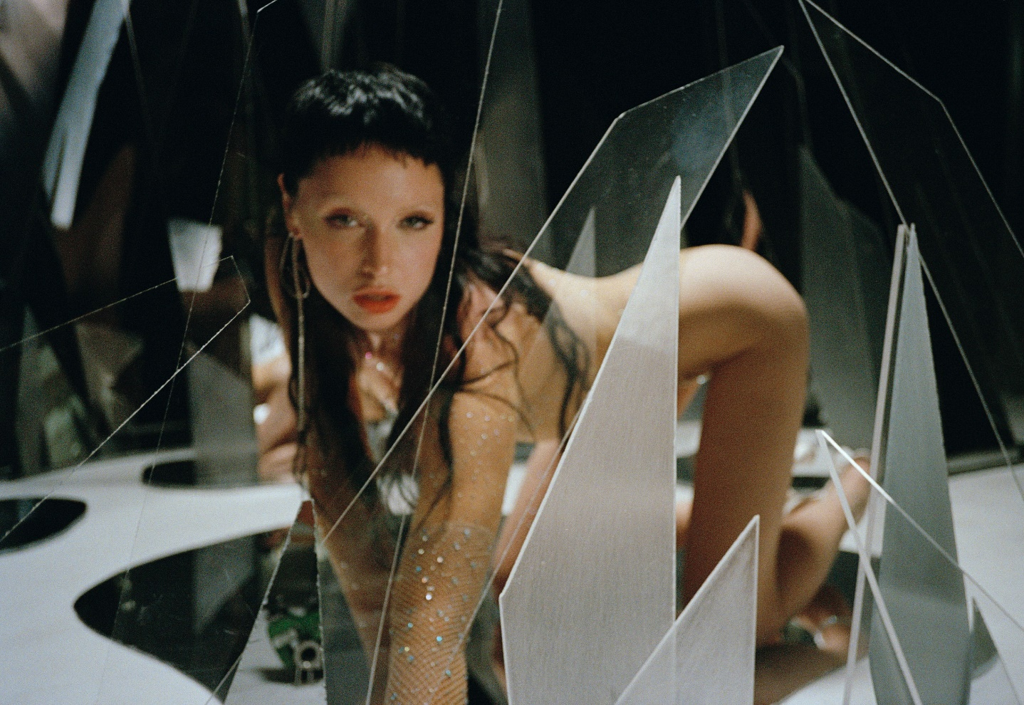
PHOTO CREDIT: AMINA GOLD

“An instant release from patriarchal bullshit.” - PAPER

“Weaving together metal, performance art and horrorcore à la Three 6 Mafia, Dana Dentata transcends the confines of genre and the laziness of stereotypes.” - HYPEBAE

“Dentata has found her groove with sex-positive, femme-centered hip-hop.” - NYLON

“Strip club-ready rap songs that are all about empowering women.” – THE FADER

“Her sex-positive hip-hop, whether it's being bumped in your headphones or at the strip club,
will definitely empower you.” - OFFICE

AUGUST 11, 2021 – Canadian-born musician Dana Dentata has announced details of her debut album Pantychrist, which will be released September 3rd on Roadrunner Records and is available for pre-order today [album art / track listing below]. Dana Dentata also shared the new single, “Apology” which is produced by Dylan Brady of 100 gecs and streaming today on all platforms. “Apology” is joined by an official music video directed by Kathleen Dycaico – watch it HERE.

The first female signee to Roadrunner Records, Pantychrist is the sound of a new beginning for Dana Dentata. Recorded over lockdown with an array of producers including Travis Barker, Dylan Brady, Arthur Rizk, NOLIFE, Yawns & Fish Narc, Italian Leather and others, Pantychrist represents the culmination of Dana Dentata’s spiritual and artistic breakthrough; her evolution from darkness into light. A collection of songs resulting from a period healing and positive manifestations, Pantychrist is the sound of her coming to life.

Earlier this summer Dana Dentata shared the album’s title track “pantychrist,” which arrived with an official music video written / conceived by her and directed by Kathleen Dycaico. Produced by Dylan Brady of 100 gecs, the track’s maximalism production lays a menacing foundation for Dana Dentata as she ushers in a new era of self-empowerment and continues her artistic journey into the light. The track made NPR’s New Music Friday playlist upon launch and was included in HYPEBAE’s Best New Music of July round-up. Recommended Listen declared “Brady’s hand maximalizes a buzzsaw beat behind Dentata’s trauma exorcism, and in turn, pierces her bars deeper into your skin.”

“pantychrist” follows Dana Dentata’s 2020 single “Do U Like Me Now?” which is joined by a Charlie C. directed music video featuring Adult Film Star Eliza Ibarra. Dana Dentata drew inspiration from Ibarra for the song, referencing a viral moment from 2011 when Ibarra posted a video titled “Do You Like Me Now?” to Tumblr. A reaction to the unrealistic expectations placed on women by men, which Ibarra endured at a young age as she struggled with low self-esteem, the clip left a lasting impact on Dana Dentata who sampled it for “Do U Like Me Now?” - seizing the reins on the narrative of being a woman in a patriarchal society, transmuting her trauma and weaponizing it.

Dana Dentata announced her signing with Roadrunner Records last year and shared the 20-minute performance art film, ‘The Resurrection of Dana Dentata,’ which sees her carving through performances of tracks from her 2019 EP Daddy Loves You, as well as new material with an unapologetically raw expression of sexual power.

Dana Dentata has gained distinction for being equal parts empowering and provocative. By pairing her unapologetically sexual lyrics with genre blurring production, Dentata creates liberating and aggressive femme-centric hip-hop. A native of Toronto, Canada, she grew up inspired by artists ranging from Britney Spears and Hole, to the Plasmatics and Eminem. At the end of 2019, Dentata performed at Los Angeles’ Rolling Loud Festival and released Daddy Loves You, an EP inspired by fragile masculinity, big dick energy, misogyny and shame.

[album art / track listing below]

DANA DENTATA
PANTYCHRIST



1. Birth
2. pantychrist
3. Church Hooker
4. Spit (feat. Travis Barker)
5. I Know What You Did Last Summer
6. Flesh Prison
7. Happy Family
8. Manic Monday
9. Free
10. Like A Preyer
11. I.U.D
12. Apology
13. Woodstock 99

CONNECT WITH DANA DENTATA:
WEBSITE / INSTAGRAM / TWITTER / FACEBOOK / YOUTUBE

