DANA DENTATA RELEASES DEBUT ALBUM PANTYCHRIST

STREAM IT HERE

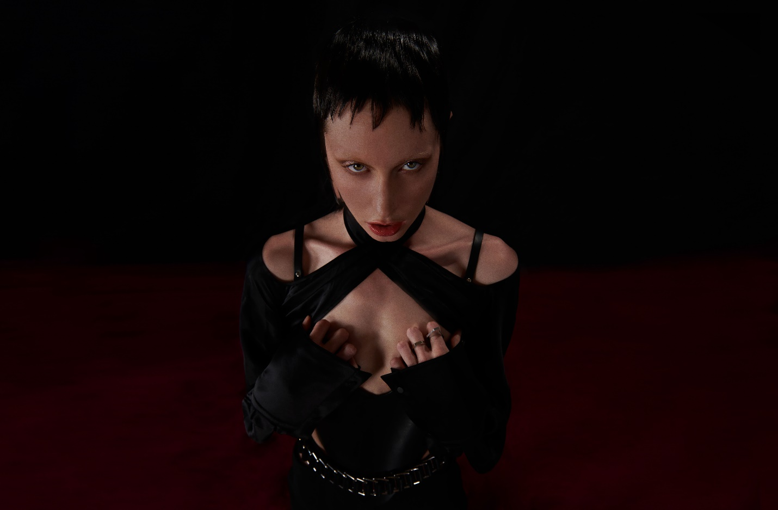
PHOTO CREDIT: 91 RULES

“An instant release from patriarchal bullshit.” - PAPER

“Weaving together metal, performance art and horrorcore à la Three 6 Mafia, Dana Dentata transcends the confines of genre and the laziness of stereotypes.” - HYPEBAE

“Dentata has found her groove with sex-positive, femme-centered hip-hop.” - NYLON

“Strip club-ready rap songs that are all about empowering women.” – THE FADER

“Her sex-positive hip-hop, whether it's being bumped in your headphones or at the strip club,
will definitely empower you.” - OFFICE

SEPTEMBER 3, 2021 – Canadian-born musician Dana Dentata has released her widely anticipated debut album Pantychrist – stream it HERE.

The first female signee to Roadrunner Records, Pantychrist is the sound of a new beginning for Dana Dentata. Recorded over lockdown with an array of producers including Travis Barker, Dylan Brady, Arthur Rizk, NOLIFE, Yawns & Fish Narc, Italian Leather and others, Pantychrist represents the culmination of Dana Dentata’s spiritual and artistic breakthrough; her evolution from darkness into light. A collection of songs resulting from a period healing and positive manifestations, Pantychrist is the sound of her coming to life.

Following breakout festival performances at Reading & Leeds and ALT LDN last week, Pantychrist arrives today highlighted by the lead singles “Apology” and “pantychrist” – both of which are produced by Dylan Brady of 100 gecs and joined by official music videos directed by Kathleen Dycaico. Both songs made NPR’s New Music Friday playlist upon launch, with HYPEBAE including “pantychrist” in their Best New Music of July round-up. Recommended Listen declared “Brady’s hand maximalizes a buzzsaw beat behind Dentata’s trauma exorcism, and in turn, pierces her bars deeper into your skin.” REVOLVER attested “(Apology) builds from slow-burning R&B to a cathartic screamed climax,” and Alternative Press praised “Apology” noting, “you can feel the artist’s frustrations oozing from every pore.”

“pantychrist” follows Dana Dentata’s 2020 single “Do U Like Me Now?” which is joined by a Charlie C. directed music video featuring Adult Film Star Eliza Ibarra. Dana Dentata drew inspiration from Ibarra for the song, referencing a viral moment from 2011 when Ibarra posted a video titled “Do You Like Me Now?” to Tumblr. A reaction to the unrealistic expectations placed on women by men, which Ibarra endured at a young age as she struggled with low self-esteem, the clip left a lasting impact on Dana Dentata who sampled it for “Do U Like Me Now?” - seizing the reins on the narrative of being a woman in a patriarchal society, transmuting her trauma and weaponizing it.

Dana Dentata announced her signing with Roadrunner Records last year and shared the 20-minute performance art film, ‘The Resurrection of Dana Dentata,’ which sees her carving through performances of tracks from her 2019 EP Daddy Loves You, as well as new material with an unapologetically raw expression of sexual power.

Dana Dentata has gained distinction for being equal parts empowering and provocative. By pairing her unapologetically sexual lyrics with genre blurring production, Dentata creates liberating and aggressive femme-centric hip-hop. A native of Toronto, Canada, she grew up inspired by artists ranging from Britney Spears and Hole, to the Plasmatics and Eminem. At the end of 2019, Dentata performed at Los Angeles’ Rolling Loud Festival and released Daddy Loves You, an EP inspired by fragile masculinity, big dick energy, misogyny and shame.

DANA DENTATA
PANTYCHRIST

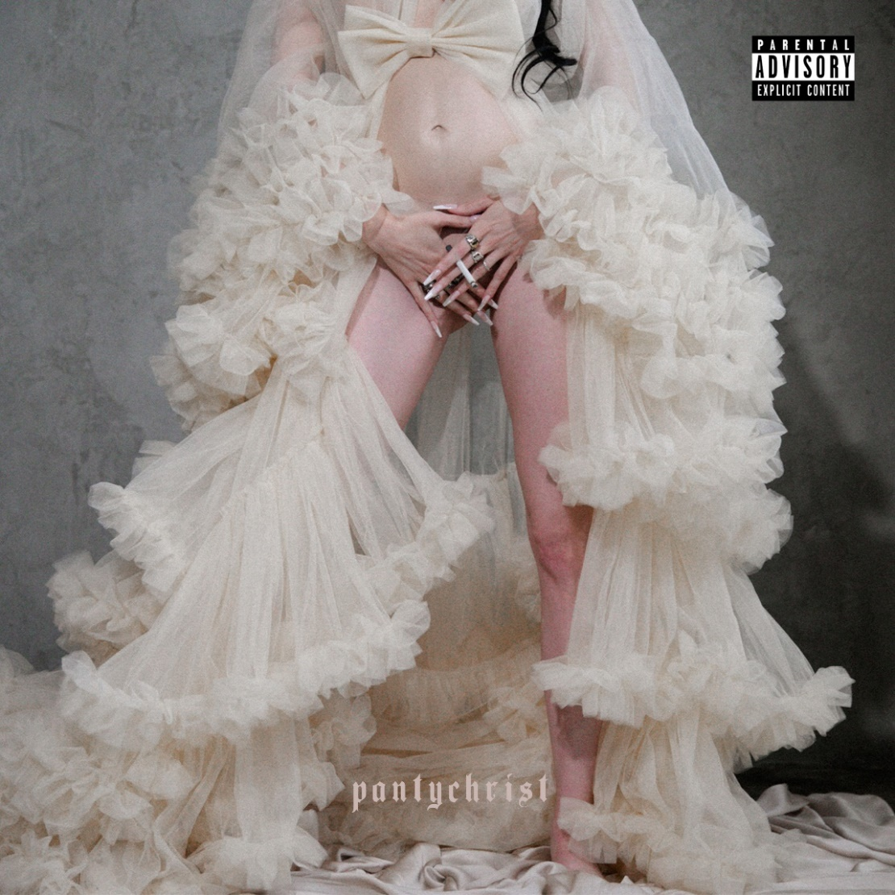

01. Birth
02. pantychrist
03. Church Hooker
04. Spit (feat. Travis Barker)
05. I Know What You Did Last Summer
06. Flesh Prison
07. Happy Family
08. Manic Monday
09. Free
10. Like A Preyer
11. I.U.D
12. Apology
13. Dstock ’99

CONNECT WITH DANA DENTATA:
WEBSITE / INSTAGRAM / TWITTER / FACEBOOK / YOUTUBE

