DANA DENTATA
SHARES NEW SINGLE “PANTYCHRIST”

OFFICIAL MUSIC VIDEO STREAMING NOW

DEBUT ALBUM PANTYCHRIST DUE OUT LATER THIS YEAR

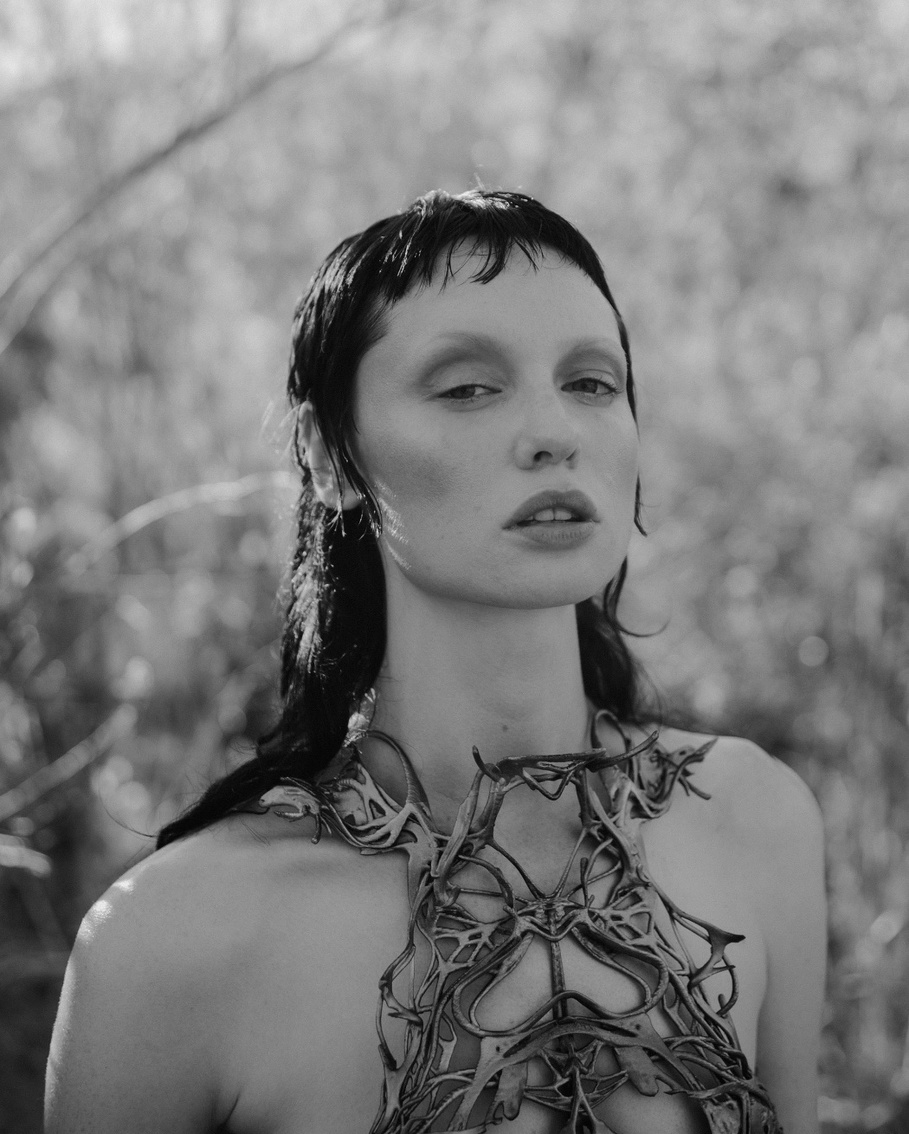

“An instant release from patriarchal bullshit.” - PAPER

“Weaving together metal, performance art and horrorcore à la Three 6 Mafia, Dana Dentata transcends the confines of genre and the laziness of stereotypes.” - HYPEBAE

“Dentata has found her groove with sex-positive, femme-centered hip-hop.” - NYLON

“Strip club-ready rap songs that are all about empowering women.” – THE FADER

“Her sex-positive hip-hop, whether it's being bumped in your headphones or at the strip club,
will definitely empower you.” - OFFICE

JULY 15, 2021 – Canadian-born musician / model Dana Dentata has shared “pantychrist,” a brand-new single which also serves as the title track off her forthcoming debut album expected to arrive this year. Produced by Dylan Brady of 100 gecs, “pantychrist” is available today on all streaming platforms and is joined by an official music video written / conceived by Dana Dentata and directed by Kathleen Dycaico. On “pantychrist,” Brady’s signature maximalism production lays a menacing foundation for Dana Dentata as she ushers in a new era of self-empowerment and continues her artistic journey into the light.

“Healing a lifetime of trauma can feel uncomfortable, vulnerable and painful, similar to a pregnancy,” remarked Dana Dentata. “Your former self may die in the process but what comes next is a new creation of life that is beautiful and pure. In many ways the abuse I’ve endured around my womb has held me down and kept me in purgatory. Ripping out the nail from my womb means setting myself free, bringing my new self back to life to experience happiness, purity and bliss. The ‘pantychrist’ state of mind I have been manifesting is finally coming to fruition.”

“pantychrist” follows Dana Dentata’s recent single “Do U Like Me Now?” which is joined by a Charlie C. directed music video featuring Adult Film Star Eliza Ibarra. Dana Dentata drew inspiration from Ibarra for the song, referencing a viral moment from 2011 when Ibarra posted a video titled “Do You Like Me Now?” to Tumblr. A reaction to the unrealistic expectations placed on women by men, which Ibarra endured at a young age as she struggled with low self-esteem, the clip left a lasting impact on Dana Dentata who sampled it for “Do U Like Me Now?” - seizing the reins on the narrative of being a woman in a patriarchal society, transmuting her trauma and weaponizing it.

Both “pantychrist” and “Do U Like Me Now?” preview Dana Dentata’s forthcoming debut album, pantychrist. In recent months Dana Dentata has been finalizing work on pantychrist, collaborating in the studio with artists / producers Robokid, Yawns and Fish Narc of GothBoiClique, The Heavy and more.

Dana Dentata announced her signing with Roadrunner Records last year, becoming the first female solo artist signed to the label. Alongside the announcement, Dana Dentata shared the 20-minute performance art film, ‘The Resurrection of Dana Dentata,’ which sees her carving through performances of tracks from her 2019 EP Daddy Loves You, as well as brand-new material with an unapologetically raw expression of sexual power.

Dana Dentata has gained distinction for being equal parts empowering and provocative. By pairing her unapologetically sexual lyrics with genre blurring production, Dentata creates liberating and aggressive femme-centric hip-hop. A native of Toronto, Canada, she grew up inspired by artists ranging from Britney Spears and Hole, to the Plasmatics and Eminem. At the end of 2019, Dentata performed at Los Angeles’ Rolling Loud Festival and released Daddy Loves You, an EP inspired by fragile masculinity, big dick energy, misogyny and shame.

DANA DENTATA
“PANTYCHRIST” SINGLE ART

CONNECT WITH DANA DENTATA:
WEBSITE / INSTAGRAM / TWITTER / FACEBOOK / YOUTUBE

