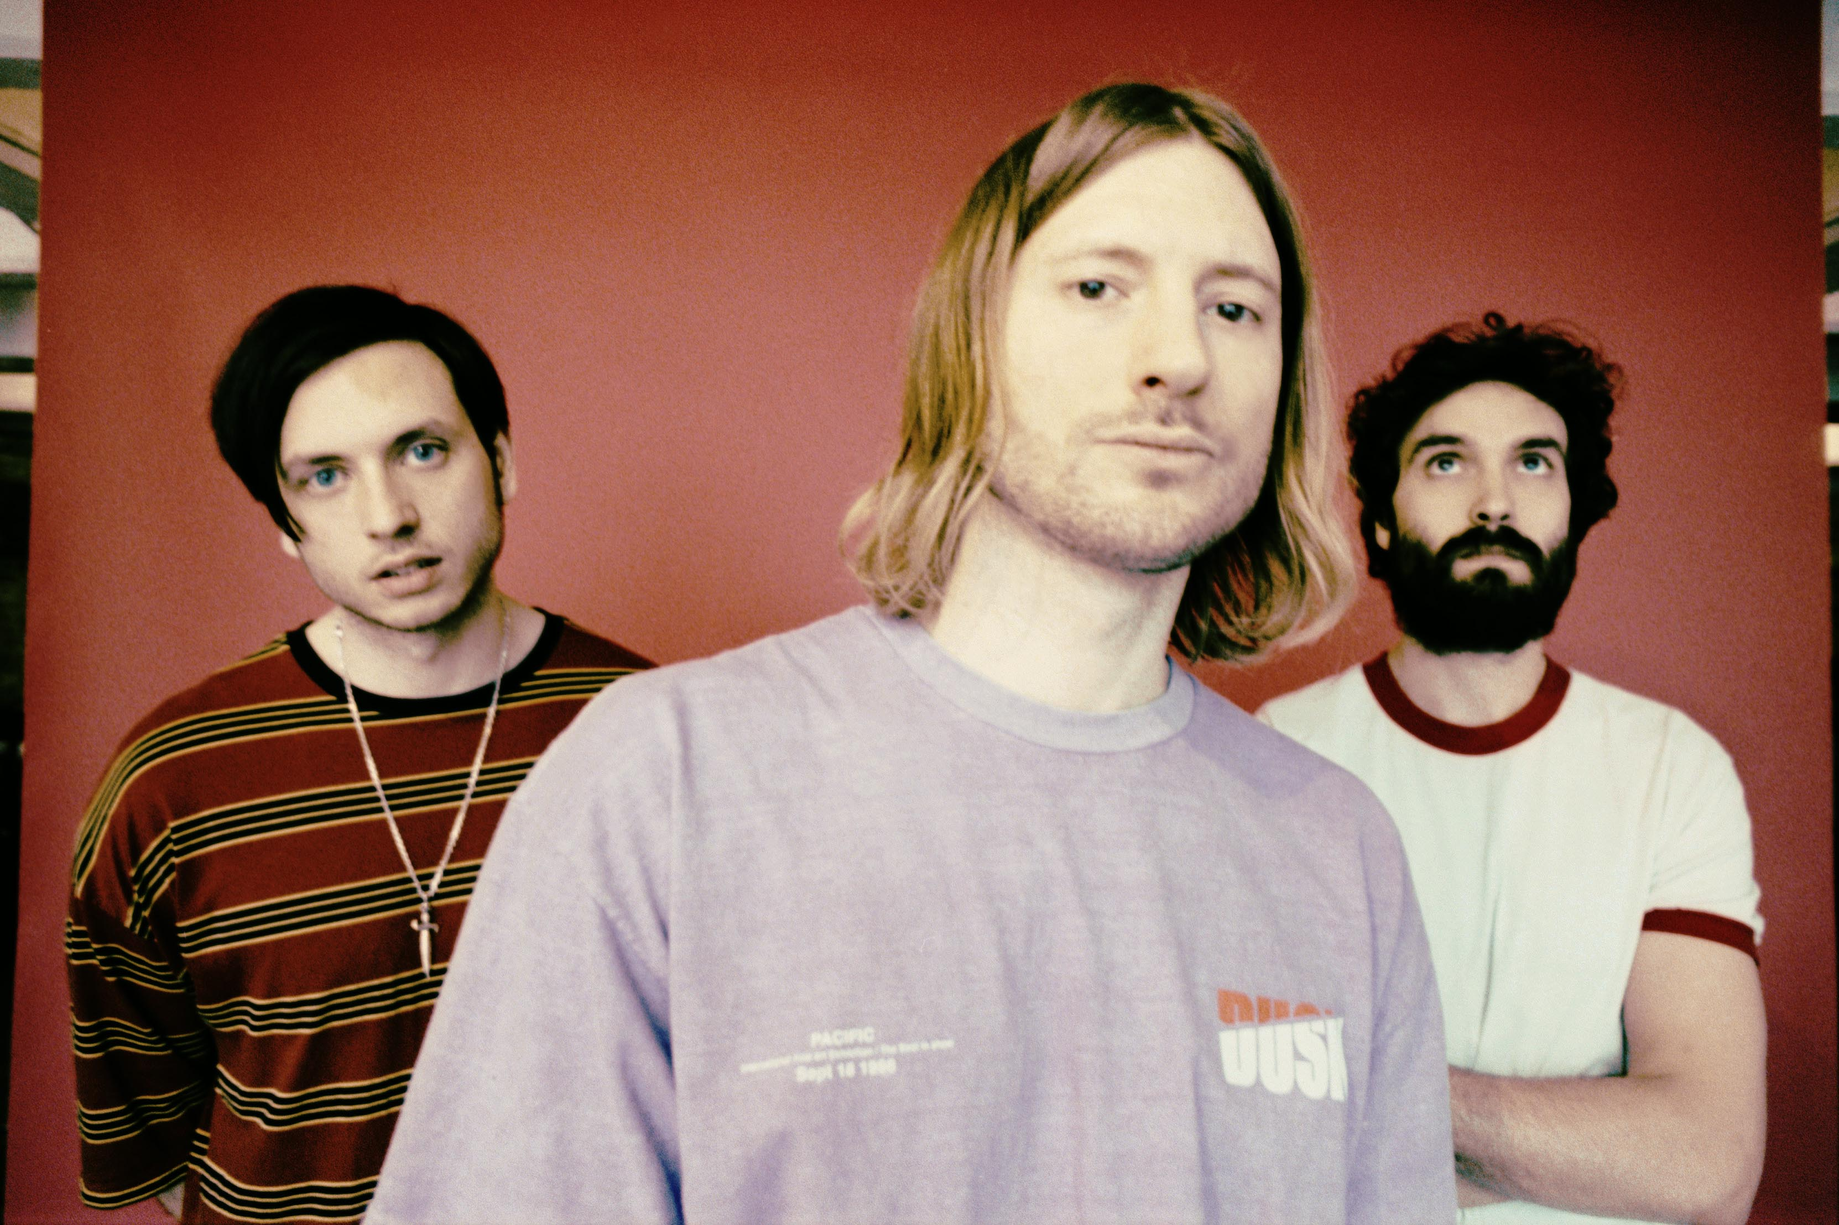

SHARE OFFICIAL MUSIC VIDEO FOR “ROUND THE BEND”

ANNOUNCE U.S. HEADLINE TOUR
DATES KICK OFF APRIL 16TH IN CAPE CORAL, FL

CELEBRITY MANSIONS AVAILABLE NOW
VIA PARLOPHONE RECORDS / ROADRUNNER RECORDS

FEBRUARY 18, 2020 – Dinosaur Pile-Up have shared the official music video for “Round The Bend” off their acclaimed album, Celebrity Mansions. Created by Toon53 Productions, the animated video is streaming now on the band’s official YouTube channel and depicts a heart-wrenching story of lost lovers and a car-ride gone wrong.

Frontman Matt Bigland commented on the clip, stating, “’Round The Bend’ is about being at the very edge of your emotional strength. I wrote it when I was at a breaking point of sorts, where I felt like what I'd been trying to make happen with the band for twelve years wasn't in fact going to happen. When I wrote the song and whenever I listened to the demo, I'd imagine this short film playing out in my head – the story was extremely vivid in my mind and really heart-breaking. Seeing yourself immortalized as a cartoon is always a trip, but the end result had us all bouncing off the walls!”

The video is shared alongside the announcement a U.S. headline tour, which kicks off April 16th in Cape Coral, Florida. In addition to the headline dates, DPU will make festival appearances at Shaky Knees, Epicenter, Welcome To Rockville, and more this spring (see attached tour itinerary). Presale tickets are available beginning Wednesday, February 19th at 10am local time, with general onsale beginning Friday, February 21st at 10am local time. For up-to-date ticketing information, please visit www.dinosaurpileup.com.

Celebrity Mansions – a collection of songs that sizzle with big melodies, skewered through with raw, intoxicating emotion – was recently featured as one of Loudwire’s “Best Rock Records of 2019.” The album is highlighted by lead single ‘Back Foot,‘ which hit Top 5 at Rock Radio and is accompanied by an official music video.

The group were also featured on the cover Upset Magazine, whose four-star review touted the record as “one of the most attention-grabbing albums of 2019.” NME raved, “Dinosaur Pile-Up might have become the most tuneful group the UK rock scene has to offer right now. Their new album, Celebrity Mansions, should be renamed Welcome To Hitsville. Seriously. It’s stunning,” while Kerrang exclaimed, “10 absolutely killer bangers, with the promise of 100 more.”

DINOSAUR PILE-UP
2020 U.S. HEADLINE TOUR DATES
* - festival performance
^ - supporting Starset

APRIL
16 Cape Coral, FL Dixie Roadhouse
17 Tampa, FL Amalie Arena*
18 Orlando, FL Central Florida Fairgrounds*
20 Baltimore, MD Metro Gallery
21 Philadelphia, PA The Foundry
23 Syracuse, NY Lost Horizon
24 Newark, NJ Prudential Center*
25 Worcester, MA DCU Center*
26 Atlantic City, NJ Anchor Rock Club
28 Brooklyn, NY Baby's All Right
29 Harrisburg, PA HMAC

MAY
1 Norfolk, VA Lunatic Luau*
2 Charlotte, NC Epicenter*
3 Atlanta, GA Shaky Knees*
5 Johnson City, TN Capone's
6 Hunstville, AL Sidetracks Music Hall
8 Jacksonville, FL Welcome to Rockville*
9 St. Louis, MO Point Fest*
11 Nashville, TN Mercy Lounge
13 Toronto, ON Hard Luck
15 Lansing, MI Overdrive
16 Columbus, OH Sonic Temple*
18 Kansas City, MO The Truman ^
19 Wichita, KS Cotillion Ballroom ^
20 Colorado Springs, CO The Black Sheep
21 Denver, CO The Marquis Theater
22-23 Pryor, OK Rocklahoma*
24 Dallas, TX Dos Equis Pavilion*

DINOSAUR PILE-UP
CELEBRITY MANSIONS
AVAILABLE NOW
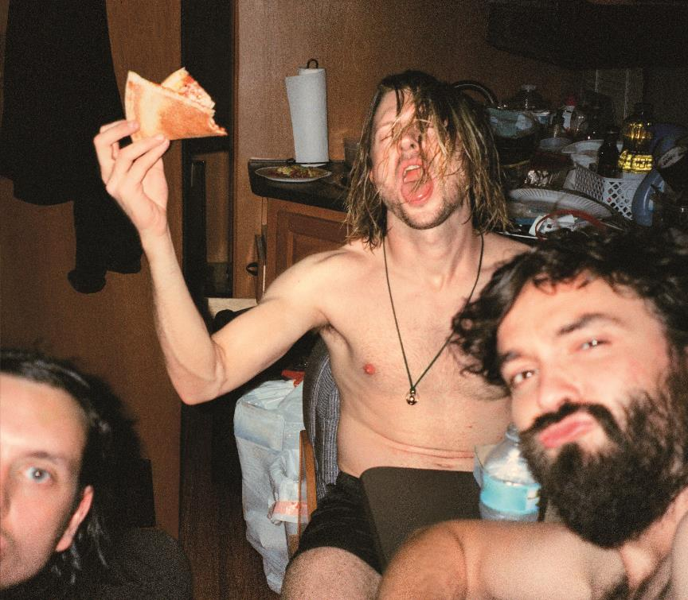

- Thrash Metal Cassette
- Back Foot
- Stupid Heavy Metal Broken Hearted Loser Punk
- Celebrity Mansions
- Round The Bend
- Pouring Gasoline
- Black Limousine
- K West
- Professional Freak
- Long Way Down

www.dinosaurpileup.com

For US press inquiries contact Sarah Goldstein
Sarah.goldstein@elektra.com

