FOR IMMEDIATE RELEASE
APRIL 11, 2022

FITZ AND THE TANTRUMS ANNOUNCE CO-HEADLINE TOUR
WITH ANDY GRAMMER

DATES KICK OFF JULY 29 IN KEY WEST, FL

TICKET PRE-SALES BEGIN WEDNESDAY, APRIL 13
GENERAL ON-SALE STARTS FRIDAY, APRIL 15

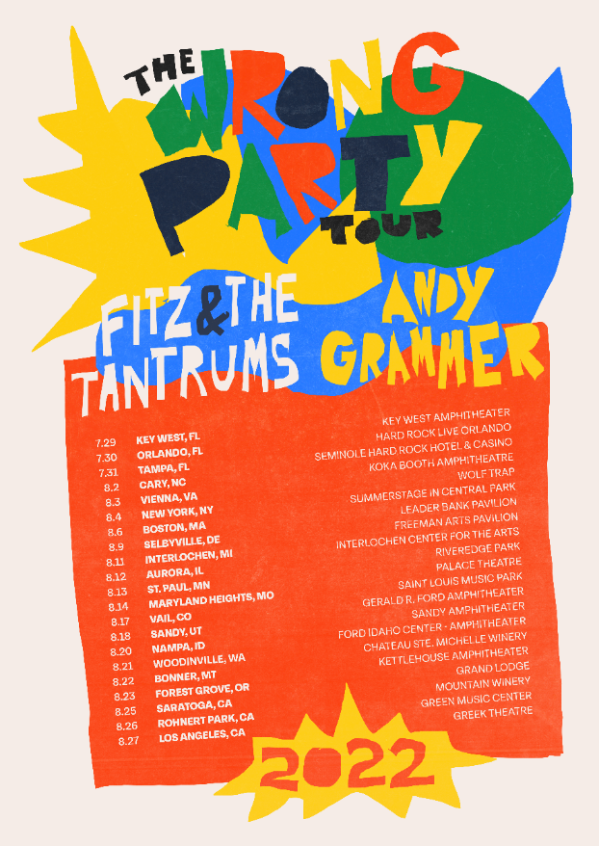

MULTIPLATINUM BAND ALSO SET TO EMBARK ON CO-HEADLINING RUN ALONGSIDE ST. PAUL AND THE BROKEN BONES ON JUNE 1

PRESS ASSETS HERE

Multiplatinum band Fitz and the Tantrums have announced additional touring plans for summer 2022. The run of dates – co-headlined with Andy Grammer – are set to kick off in Key West, FL on July 29th (full itinerary below). Ticket pre-sales will begin this Wednesday, April 13, at 10am local time, with general on-sale starting this Friday, April 15, at 10am local time. For more information, please visit www.fitzandthetantrums.com.

Fitz and the Tantrums frontman Michael “Fitz” Fitzpatrick said: “We cannot wait to get our fans together with Andy’s fans this summer and get everybody dancing. The wrong party tour is gonna go down in history as one hot sweaty mess not to be missed. Were you there?”

Fitz and the Tantrums are also set to embark on a co-headlining run alongside St. Paul and the Broken Bones this summer. The run of dates are set to kick off in Asheville, NC, on June 1 (full itinerary below). Support on the first leg comes from Seratones; the second leg will feature Devon Gilfilian.

The LA-based band has been busy working on new material to follow up 2019’s “ALL THE FEELS,” which featured the top 10 hit “I Just Wanna Shine” and was supported by national television appearances on “Jimmy Kimmel LIVE!,” “Good Morning America,” and “Live with Kelly and Ryan.” In 2021, Fitz and the Tantrums’ frontman released his first-ever solo album “HEAD UP HIGH” under the moniker FITZ. FITZ performed the album’s infectious title track on the “The Ellen DeGeneres Show,” “The Late Late Show with James Corden,” and “Good Morning America.”

Stay tuned for more from Fitz and the Tantrums very soon.

TOUR DATES
Co-headlining with St. Paul and the Broken Bones
Support from Seratones (June 1st – 12th) and Devon Gilfilian (June 14th – 25th)

June 1 Asheville, NC Rabbit Rabbit
June 3 Nashville, TN Ascend Amphitheater
June 4 Wilmington, NC Live Oak Bank Pavilion at Riverfront Park
June 5 Doswell, VA After Hours Concerts at The Meadow Event Park
June 7 Shelburne, VT Shelburne Museum – The Green
June 8 Portland, ME State Theatre Summer Concert Series at Thompson’s Point
June 10 New Haven, CT Westville Music Bowl
June 11 Asbury Park, NJ The Stone Pony Summer Stage
June 12 Bethlehem, PA Levitt Pavilion SteelStacks
June 14 Canandaigua, NY Constellation Brands Marvin Sands Performing Arts Center
(CMAC)
June 15 Cleveland, OH Jacobs Pavilion at Nautica
June 17 Kettering, OH Fraze Pavilion
June 18 Indianapolis, IN TCU Amphitheater at White River State Park
June 21 Kansas City, MO GrindersKC
June 23 Rogers, AR Walmart Arkansas Music Pavilion
June 24 Des Moines, IA The Lauridsen Amphitheater at Water Works Park
June 25 Council Bluffs, IA Harrah’s Council Bluffs – Stir Concert Cove

Co-headlining with Andy Grammar
*Support from Breland

July 29 Key West, FL Key West Ampitheater
July 30 Orlando, FL Hard Rock Live Orlando
July 31 Tampa, FL Seminole Hard Rock Hotel & Casino Tampa
August 2 Cary, NC Koka Booth Amphitheatre*
August 3 Vienna, VA Wolf Trap*
August 4 New York, NY Summerstage in Central Park*
August 6 Boston, MA Leader Bank Pavilion*
August 9 Selbyville, DE The Freeman Arts Pavilion
August 11 Interlochen, MI Interlochen Center for the Arts (On Sale May 13)
August 12 Aurora, IL Riveredge Park
August 13 Saint Paul, MN Palace Theatre
August 14 St. Louis, MO Saint Louis Music Park
August 17 Vail, CO Gerald R. Ford Amphiteater
August 18 Sandy, UT Sandy Amphiteater
August 20 Nampa, ID Ford Idaho Center - Amphitheater
August 21 Woodinville, WA Chateau Ste. Michelle
August 22 Bonner, MT KettleHouse Ampitheater
August 23 Forest Grove, OR Grand Lodge
August 25 Saratoga, CA The Mountain Winery*
August 26 Rohnert Park, CA Green Music Center* (On Sale April 28)
August 27 Los Angeles, CA Greek Theatre*

ABOUT FITZ AND THE TANTRUMS:

Over the course of four, full length albums, multi-platinum artists Fitz and the Tantrums have grown from independent upstarts to bonafide hitmakers. Beginning with their 2010 debut album “PICKIN’ UP THE PIECES” and it’s gold-certified single “Moneygrabber,” the LA-based sextet built a rabid fanbase with their infectious music and energetic live shows, which landed them a coveted spot on the Coachella Music and Arts Festival lineup. The band’s major label debut “MORE THAN JUST A DREAM” arrived in 2013 and spawned back-to-back platinum certified singles in “Out Of My League” and “The Walker.” Following that breakout success, Fitz and the Tantrums returned with their 2016 release “FITZ AND THE TANTRUMS,” which featured their biggest hit to date, the double-platinum certified “HandClap.” Continuing their streak of hits, 2019’s “ALL THE FEELS” was highlighted by the top 10 smash “I Just Wanna Shine.” Amassing billions of streams and attracting praise from Rolling Stone, Billboard, and more, the group has morphed into an arena-ready force, performing countless, sold out headlining shows and marque music festivals around the world.

Fitz and the Tantrums are: Michael “Fitz” Fitzpatrick (vocals), Noelle Scaggs (vocals), James King (saxophone, flute), Jeremy Ruzumna (keyboards), Joseph Karnes (bass), and John Wicks (drums, percussion).

# # #

PRESS CONTACT:

Glenn Fukushima (National)
818.238.6833
GlennFukushima@elektra.com

Collin Citron (National)
818.238.6314
CollinCitron@elektra.com

Sydney Worden (Tour/Online)
818.238.6834
SydneyWorden@elektra.com

