FOR IMMEDIATE RELEASE

MAY 6, 2022

**FLOR RELEASE EAGERLY ANTICIPATED NEW ALBUM *FUTURE SHINE***

**AVAILABLE NOW VIA FUELED BY RAMEN - LISTEN**[**HERE**](https://nam04.safelinks.protection.outlook.com/?url=https%3A%2F%2Fflor.lnk.to%2Ffutureshine&data=05%7C01%7CDestinyDominguez%40elektra.com%7C3e296da4ca8f47b206f808da2f64d0ce%7C8367939002ec4ba1ad3d69da3fdd637e%7C0%7C0%7C637874407307647498%7CUnknown%7CTWFpbGZsb3d8eyJWIjoiMC4wLjAwMDAiLCJQIjoiV2luMzIiLCJBTiI6Ik1haWwiLCJXVCI6Mn0%3D%7C3000%7C%7C%7C&sdata=C3Up%2F64jjHVybRQpYxTUrgy2TCYINVik8iTvqnFbijw%3D&reserved=0)

**BAND SHARES OFFICIAL  MUSIC VIDEO FOR NEW SINGLE “GOTTA DO SOMETHING”**

**WATCH**[**HERE**](https://nam04.safelinks.protection.outlook.com/?url=https%3A%2F%2Fyoutu.be%2FK8RpFOcmxJ4&data=05%7C01%7CDestinyDominguez%40elektra.com%7C3e296da4ca8f47b206f808da2f64d0ce%7C8367939002ec4ba1ad3d69da3fdd637e%7C0%7C0%7C637874407307647498%7CUnknown%7CTWFpbGZsb3d8eyJWIjoiMC4wLjAwMDAiLCJQIjoiV2luMzIiLCJBTiI6Ik1haWwiLCJXVCI6Mn0%3D%7C3000%7C%7C%7C&sdata=D%2FxiXuq03hbIFFZ9l8BceR4OHQcQ3DPfGegYDyJYIB8%3D&reserved=0)

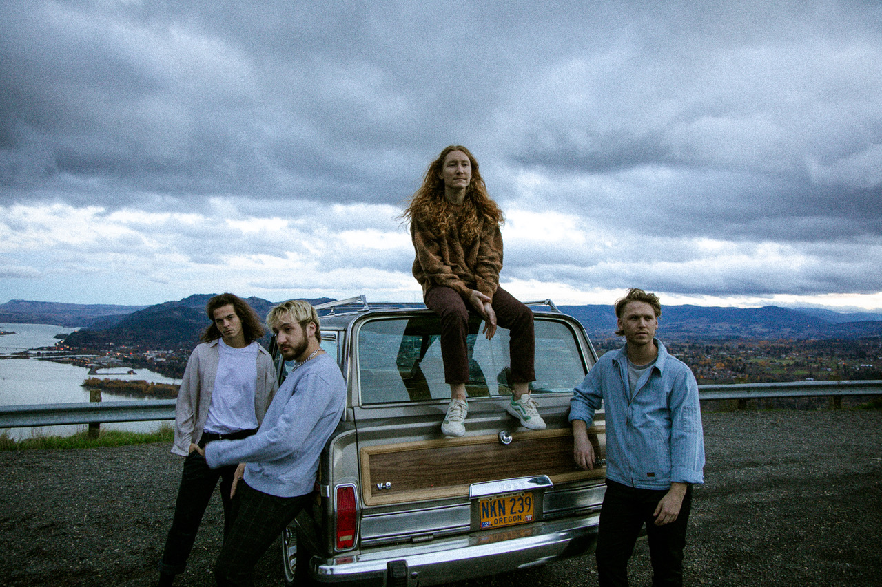

*(Photo credit: Ashley Osborn)*

Hood River, OR alt-pop band **flor** have released their eagerly anticipated new album ***Future Shine*** via Fueled By Ramen. The album is available to stream and download beginning today [HERE](https://nam04.safelinks.protection.outlook.com/?url=https%3A%2F%2Fflor.lnk.to%2Ffutureshine&data=05%7C01%7CDestinyDominguez%40elektra.com%7C3e296da4ca8f47b206f808da2f64d0ce%7C8367939002ec4ba1ad3d69da3fdd637e%7C0%7C0%7C637874407307647498%7CUnknown%7CTWFpbGZsb3d8eyJWIjoiMC4wLjAwMDAiLCJQIjoiV2luMzIiLCJBTiI6Ik1haWwiLCJXVCI6Mn0%3D%7C3000%7C%7C%7C&sdata=C3Up%2F64jjHVybRQpYxTUrgy2TCYINVik8iTvqnFbijw%3D&reserved=0). CDs, cassettes, and limited edition merch bundles are available now exclusively through flor’s online store [HERE](https://nam04.safelinks.protection.outlook.com/?url=https%3A%2F%2Fwww.florsounds.com%2F&data=05%7C01%7CDestinyDominguez%40elektra.com%7C3e296da4ca8f47b206f808da2f64d0ce%7C8367939002ec4ba1ad3d69da3fdd637e%7C0%7C0%7C637874407307647498%7CUnknown%7CTWFpbGZsb3d8eyJWIjoiMC4wLjAwMDAiLCJQIjoiV2luMzIiLCJBTiI6Ik1haWwiLCJXVCI6Mn0%3D%7C3000%7C%7C%7C&sdata=Swj0IjqvgVvqqFiM8dhobjtymnThE9wECvxtklAWd2o%3D&reserved=0).

To celebrate the record’s arrival, the quartet have also shared an official music video for their new single **“Gotta Do Something**.**”**Watch the Caleb Mallery-directed visual on the band’s YouTube channel [HERE](https://nam04.safelinks.protection.outlook.com/?url=https%3A%2F%2Fyoutu.be%2FK8RpFOcmxJ4&data=05%7C01%7CDestinyDominguez%40elektra.com%7C3e296da4ca8f47b206f808da2f64d0ce%7C8367939002ec4ba1ad3d69da3fdd637e%7C0%7C0%7C637874407307647498%7CUnknown%7CTWFpbGZsb3d8eyJWIjoiMC4wLjAwMDAiLCJQIjoiV2luMzIiLCJBTiI6Ik1haWwiLCJXVCI6Mn0%3D%7C3000%7C%7C%7C&sdata=D%2FxiXuq03hbIFFZ9l8BceR4OHQcQ3DPfGegYDyJYIB8%3D&reserved=0).The track’s chorus stares down adulthood as the lyrics urge, *“Well, ya gotta do something. Won’t be young forever. Gotta get yourself together*.*”*The visual translates this sentiment to the screen, as the band performs on stage at Hood River Middle School. Audience members cycle in and out, looking onward and absorbing the song’s exploration of millennial malaise in the face of growing up.

“On this album, we were on a creative level we’ve never reached before,” shares flor vocalist/guitarist Zach Grace. “I would credit it to collaboration at its finest. We were true to the music we wanted to make, the music that makes us excited, and the music we think will absolutely destroy live. That’s *Future Shine*.”

*Future Shine* represents flor’s most collaborative body of work to date. Feeling uninspired to write while alone during quarantine, Grace gathered his bandmates - Dylan Bauld [bass], McKinley Kitts [guitar], and Kyle Hill [drums] - at Bauld’s Los Angeles studio for a series of writing sessions as soon as it became safe to do so. This time around, they built the bulk of the songs face-to-face, inspired by favorite records from the likes of MGMT, Phoenix, The Killers, and M83. “There was immediate magic. Imagine if we went back in time to my garage, but we had all of this experience writing songs and touring together? That’s what it was like. All of these years culminated in feeling like kids again,” adds Kitts.

Across the album’s 11 tracks, flor excavate unshakable melodies from jubilant synths, buoyant beats, and lush guitars as they relay a coming-of-age story all their own. flor previewed *Future Shine*with the February release of lead single “[Play Along](https://nam04.safelinks.protection.outlook.com/?url=https%3A%2F%2Fyoutu.be%2Fl1_2oEcEXeI&data=05%7C01%7CDestinyDominguez%40elektra.com%7C3e296da4ca8f47b206f808da2f64d0ce%7C8367939002ec4ba1ad3d69da3fdd637e%7C0%7C0%7C637874407307647498%7CUnknown%7CTWFpbGZsb3d8eyJWIjoiMC4wLjAwMDAiLCJQIjoiV2luMzIiLCJBTiI6Ik1haWwiLCJXVCI6Mn0%3D%7C3000%7C%7C%7C&sdata=a7qOqy9YoRdRlRgydpIWrsG1%2FTtlwK8wxD3i5Sr8qXo%3D&reserved=0)”, which *Variance Magazine*praised as *“the perfect introduction to their next chapter as a band.”* In March, the band returned with “[Skate](https://nam04.safelinks.protection.outlook.com/?url=https%3A%2F%2Fyoutu.be%2F3Qx52YKKSIs&data=05%7C01%7CDestinyDominguez%40elektra.com%7C3e296da4ca8f47b206f808da2f64d0ce%7C8367939002ec4ba1ad3d69da3fdd637e%7C0%7C0%7C637874407307647498%7CUnknown%7CTWFpbGZsb3d8eyJWIjoiMC4wLjAwMDAiLCJQIjoiV2luMzIiLCJBTiI6Ik1haWwiLCJXVCI6Mn0%3D%7C3000%7C%7C%7C&sdata=OelyATuyKKWLuDX0m1h0%2Bj%2FD81RPMc9ut%2FGQ%2FZ5IJQI%3D&reserved=0)” and “[Big Shot](https://nam04.safelinks.protection.outlook.com/?url=https%3A%2F%2Fyoutu.be%2FGAIKF7xUawE&data=05%7C01%7CDestinyDominguez%40elektra.com%7C3e296da4ca8f47b206f808da2f64d0ce%7C8367939002ec4ba1ad3d69da3fdd637e%7C0%7C0%7C637874407307647498%7CUnknown%7CTWFpbGZsb3d8eyJWIjoiMC4wLjAwMDAiLCJQIjoiV2luMzIiLCJBTiI6Ik1haWwiLCJXVCI6Mn0%3D%7C3000%7C%7C%7C&sdata=wqR%2FdIy5k8cjOsJ3AV8z4dpHRf6ZVUghs2MIZvTeU%2Bo%3D&reserved=0)”.  *The Honey Pop*raved, *“From the three singles that have been released, it’s clear that this album highlights flor’s musical range and their amazing ability to cover various genres. We are playing all three of these singles on repeat*.*”*Additional praise came for flor’s 2018 track “Heart”, which was recently featured prominently in the Netflix series *Heartstopper.*

Last week, flor concluded a successful North American tour supporting The Band CAMINO in sold out venues coast-to-coast. This evening, flor will ring in *Future Shine* with their first-ever *“flor in Twenty Four*.*”* The band will perform a marathon three sold out shows in Brooklyn, NY, Los Angeles, CA, and Hood River, OR over the course of just 24 hours. Stay tuned for additional flor headline touring plans in the coming weeks.

**flor in Twenty Four Tour Dates**

May 06, 2022 - Brooklyn, NY - The Sultan Room - **SOLD OUT**

May 07, 2022 - Los Angeles, CA - The Moroccan Lounge - **SOLD OUT**

May 07, 2022 - Hood River, OR - River City Saloon - **SOLD OUT**

**FLOR - *FUTURE SHINE***

**LISTEN**[**HERE**](https://nam04.safelinks.protection.outlook.com/?url=https%3A%2F%2Fflor.lnk.to%2Ffutureshine&data=05%7C01%7CDestinyDominguez%40elektra.com%7C3e296da4ca8f47b206f808da2f64d0ce%7C8367939002ec4ba1ad3d69da3fdd637e%7C0%7C0%7C637874407307647498%7CUnknown%7CTWFpbGZsb3d8eyJWIjoiMC4wLjAwMDAiLCJQIjoiV2luMzIiLCJBTiI6Ik1haWwiLCJXVCI6Mn0%3D%7C3000%7C%7C%7C&sdata=C3Up%2F64jjHVybRQpYxTUrgy2TCYINVik8iTvqnFbijw%3D&reserved=0)

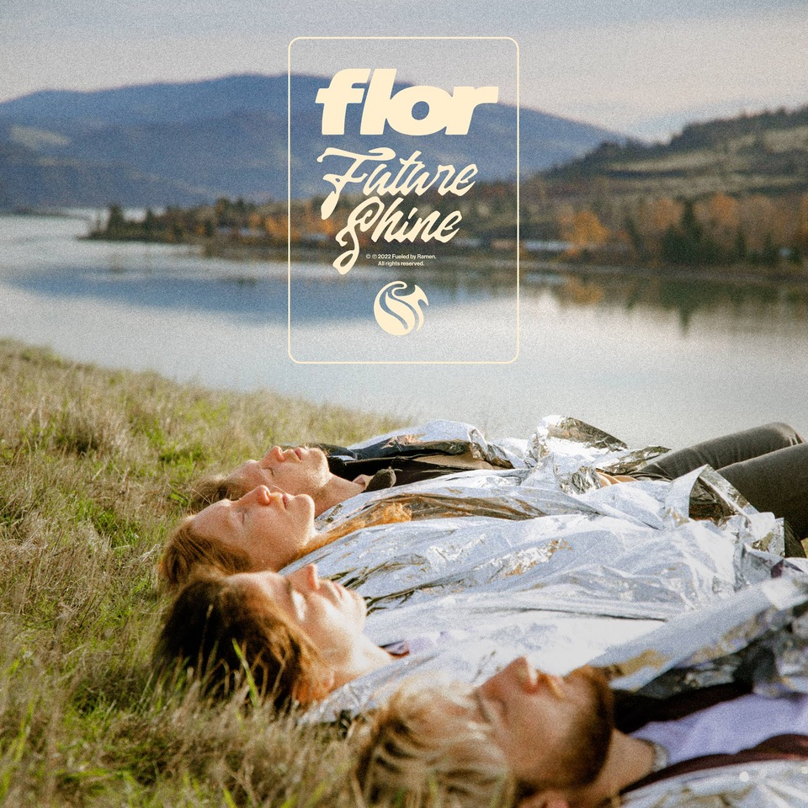

***Future Shine* Tracklisting**

1. 24

2. Big Shot

3. Clouds

4. Come Over Now

5. Conditional

6. Gotta Do Something

7. Play Along

8. Skate

9. Take it Back Home

10. Future Shine

11. The Way We Talk About a Song

**About flor**

flor finds light in the promise of a new day. The Hood River, OR quartet—Zach Grace [vocals, guitar], Dylan Bauld [bass], McKinley Kitts [guitar], and Kyle Hill [drums]—excavate unshakable melodies from jubilant synths, buoyant beats, and lush guitars as they relay a coming-of-age story all their own. The story began as high school kids in McKinley’s garage. The band quietly generated hundreds of millions of streams in the wake of their 2016 debut *come out. you*’*re hiding*. In 2019, *ley lines* only accelerated their momentum buoyed by tracks including “white noise,” “slow motion,” and “dancing around”. Critical acclaim followed from *Nylon*, *Billboard*, *Paste,* and *Ones To Watch* who hailed the album as “*an exhilarating balancing act*.*”*They concluded a successful headline tour at the top of 2020 only to face the harsh reality of the Global Pandemic with the rest of us. Once it became safe enough to do so, the musicians congregated back in Los Angeles at Dylan’s studio for a series of writing sessions. This time around, they built the bulk of the songs face-to-face together inspired by favorite records from the likes of MGMT, Phoenix, The Killers, and M83. Now, flor shines brighter than ever on their third full-length album, *Future Shine*[Fueled By Ramen].

[https://www.florsounds.com/](https://nam04.safelinks.protection.outlook.com/?url=https%3A%2F%2Fwww.florsounds.com%2F&data=05%7C01%7CDestinyDominguez%40elektra.com%7C3e296da4ca8f47b206f808da2f64d0ce%7C8367939002ec4ba1ad3d69da3fdd637e%7C0%7C0%7C637874407307647498%7CUnknown%7CTWFpbGZsb3d8eyJWIjoiMC4wLjAwMDAiLCJQIjoiV2luMzIiLCJBTiI6Ik1haWwiLCJXVCI6Mn0%3D%7C3000%7C%7C%7C&sdata=Swj0IjqvgVvqqFiM8dhobjtymnThE9wECvxtklAWd2o%3D&reserved=0)

[Facebook](https://nam04.safelinks.protection.outlook.com/?url=https%3A%2F%2Fwww.facebook.com%2Fflorsounds&data=05%7C01%7CDestinyDominguez%40elektra.com%7C3e296da4ca8f47b206f808da2f64d0ce%7C8367939002ec4ba1ad3d69da3fdd637e%7C0%7C0%7C637874407307803731%7CUnknown%7CTWFpbGZsb3d8eyJWIjoiMC4wLjAwMDAiLCJQIjoiV2luMzIiLCJBTiI6Ik1haWwiLCJXVCI6Mn0%3D%7C3000%7C%7C%7C&sdata=nL%2FqQzP87WR4vk70VvdChcBavjJVTiThGGhUgLOca74%3D&reserved=0) |[Twitter](https://nam04.safelinks.protection.outlook.com/?url=https%3A%2F%2Ftwitter.com%2Fflor&data=05%7C01%7CDestinyDominguez%40elektra.com%7C3e296da4ca8f47b206f808da2f64d0ce%7C8367939002ec4ba1ad3d69da3fdd637e%7C0%7C0%7C637874407307803731%7CUnknown%7CTWFpbGZsb3d8eyJWIjoiMC4wLjAwMDAiLCJQIjoiV2luMzIiLCJBTiI6Ik1haWwiLCJXVCI6Mn0%3D%7C3000%7C%7C%7C&sdata=ih1N4bNdSufuqSI7Xz5IKwddE%2FW%2FIhBiS4B4D5ZcD8w%3D&reserved=0) |[Instagram](https://nam04.safelinks.protection.outlook.com/?url=https%3A%2F%2Fwww.instagram.com%2Fflor%2F&data=05%7C01%7CDestinyDominguez%40elektra.com%7C3e296da4ca8f47b206f808da2f64d0ce%7C8367939002ec4ba1ad3d69da3fdd637e%7C0%7C0%7C637874407307803731%7CUnknown%7CTWFpbGZsb3d8eyJWIjoiMC4wLjAwMDAiLCJQIjoiV2luMzIiLCJBTiI6Ik1haWwiLCJXVCI6Mn0%3D%7C3000%7C%7C%7C&sdata=qsBRJMdRVYcL9LuLaQ100g4iKmILqdpGg7s9s0D%2BVOQ%3D&reserved=0) |[YouTube](https://nam04.safelinks.protection.outlook.com/?url=https%3A%2F%2Fwww.youtube.com%2Fflorsounds&data=05%7C01%7CDestinyDominguez%40elektra.com%7C3e296da4ca8f47b206f808da2f64d0ce%7C8367939002ec4ba1ad3d69da3fdd637e%7C0%7C0%7C637874407307803731%7CUnknown%7CTWFpbGZsb3d8eyJWIjoiMC4wLjAwMDAiLCJQIjoiV2luMzIiLCJBTiI6Ik1haWwiLCJXVCI6Mn0%3D%7C3000%7C%7C%7C&sdata=9I5KupQwBo%2B%2B%2FLylpznxB3y5Ch2mI%2F2Xre8rsgjwbsk%3D&reserved=0)

**Press contact:**

Collin Citron / [collincitron@elektra.com](mailto:collincitron@elektra.com)