FOR IMMEDIATE RELEASE

AUGUST 19, 2020

**FLOR RELEASES NEW SINGLE “LMHO”**

**WATCH A LYRIC VIDEO FOR THE TRACK**[**HERE**](https://nam04.safelinks.protection.outlook.com/?url=https%3A%2F%2Fwww.youtube.com%2Fwatch%3Fv%3DbyguIw36t8M%26feature%3Dyoutu.be&data=02%7C01%7CSydneyWorden%40elektra.com%7Cc62fa229c0af4ee863cb08d84448689f%7C8367939002ec4ba1ad3d69da3fdd637e%7C0%7C0%7C637334425114046564&sdata=EvCjJQ8oEqRC612akALFNCBdZvFGWyvIw%2Bdhk4GQDSk%3D&reserved=0)

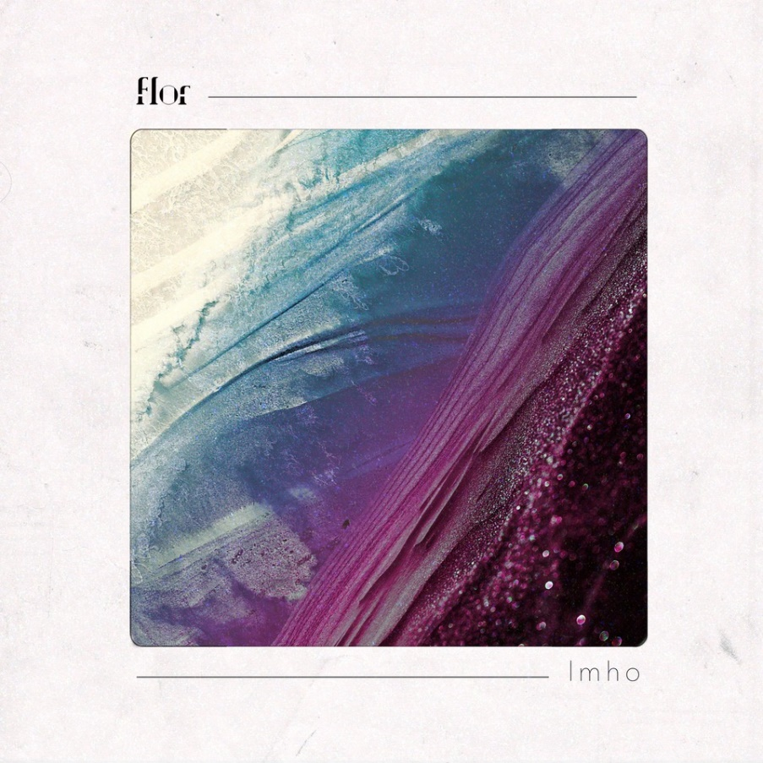

**August 19, 2020** **-** Los Angeles, CA alt-pop band **flor** has released a new standalone single entitled [“lmho”](https://nam04.safelinks.protection.outlook.com/?url=https%3A%2F%2Fflor.lnk.to%2Flmho&data=02%7C01%7CSydneyWorden%40elektra.com%7Cc62fa229c0af4ee863cb08d84448689f%7C8367939002ec4ba1ad3d69da3fdd637e%7C0%7C0%7C637334425114056564&sdata=dEgex%2F9a5n65T46CFM117kVSRtfL3WshTBNC%2FlumQwE%3D&reserved=0) The track marks the first new original music from the critically acclaimed quartet since their 2019 sophomore album, *ley lines*. “lmho” is available to stream and download starting today [HERE](https://nam04.safelinks.protection.outlook.com/?url=https%3A%2F%2Fflor.lnk.to%2Flmho&data=02%7C01%7CSydneyWorden%40elektra.com%7Cc62fa229c0af4ee863cb08d84448689f%7C8367939002ec4ba1ad3d69da3fdd637e%7C0%7C0%7C637334425114066557&sdata=knGBJlUrRo1YbPtRkSG50GE4U9Ipsm2R0i%2Fa5bAb%2F7k%3D&reserved=0) via Fueled By Ramen. Watch a lyric video for the song [HERE](https://nam04.safelinks.protection.outlook.com/?url=https%3A%2F%2Fwww.youtube.com%2Fwatch%3Fv%3DbyguIw36t8M%26feature%3Dyoutu.be&data=02%7C01%7CSydneyWorden%40elektra.com%7Cc62fa229c0af4ee863cb08d84448689f%7C8367939002ec4ba1ad3d69da3fdd637e%7C0%7C0%7C637334425114066557&sdata=LOasjfHt%2FMBPcRY%2Fnf1dEkE80o08Jf3J7sihxymAeP0%3D&reserved=0).

*“‘lmho’*was written around the time *come out. you’re hiding was completed. Most of my lyrics try to look at the bright side, but this song had no barriers. I was simply spilling my sadness, confusion, and heartache into our music,”*shared flor frontman Zach Grace.*“There are points in our lives where we feel completely out-of-control and stuck, and I did my best to be honest with myself and write exactly how I was feeling. Four years later, and our world is at a halt—some of these feelings have a way of coming back again.”*



[**flor “lmho” (official lyric video)**](https://nam04.safelinks.protection.outlook.com/?url=https%3A%2F%2Fwww.youtube.com%2Fwatch%3Fv%3DbyguIw36t8M%26feature%3Dyoutu.be&data=02%7C01%7CSydneyWorden%40elektra.com%7Cc62fa229c0af4ee863cb08d84448689f%7C8367939002ec4ba1ad3d69da3fdd637e%7C0%7C0%7C637334425114066557&sdata=LOasjfHt%2FMBPcRY%2Fnf1dEkE80o08Jf3J7sihxymAeP0%3D&reserved=0)

Earlier this year, flor released their *reimagined*EP, which features stripped-down recordings of fan-favorite tracks including “unsaid”, “white noise”, “warm blood”, and “slow motion”. Additionally, the EP includes a cover of Coldplay’s “yellow” featuring labelmates MisterWives. Watch the track’s official music video, which premiered on [Billboard](https://nam04.safelinks.protection.outlook.com/?url=https%3A%2F%2Fwww.billboard.com%2Farticles%2Fcolumns%2Fpop%2F8550405%2Fflor-misterwives-cover-coldplay-yellow-video&data=02%7C01%7CSydneyWorden%40elektra.com%7Cc62fa229c0af4ee863cb08d84448689f%7C8367939002ec4ba1ad3d69da3fdd637e%7C0%7C0%7C637334425114076549&sdata=LFj5X1dbXaDFgpNrggDyIwVRDdHWNRokDL8iHL%2BfgcA%3D&reserved=0), [HERE](https://nam04.safelinks.protection.outlook.com/?url=https%3A%2F%2Fwww.youtube.com%2Fwatch%3Fv%3DhGnrYtEVR7A&data=02%7C01%7CSydneyWorden%40elektra.com%7Cc62fa229c0af4ee863cb08d84448689f%7C8367939002ec4ba1ad3d69da3fdd637e%7C0%7C0%7C637334425114076549&sdata=nKIQ3TLJl%2B38kCnSf8gvuxbuwXFAVojO1TFI78UAD2s%3D&reserved=0).

flor’s sophomore full-length *ley lines*was released in September, 2019, andis available physically and digitally[HERE](https://nam04.safelinks.protection.outlook.com/?url=https%3A%2F%2Flnk.to%2Fflorleylines&data=02%7C01%7CSydneyWorden%40elektra.com%7Cc62fa229c0af4ee863cb08d84448689f%7C8367939002ec4ba1ad3d69da3fdd637e%7C0%7C0%7C637334425114086541&sdata=%2FAaTZ47tWZl7Ta6QKhN%2BGDxZdaTOtyopvxgGUsTDVJw%3D&reserved=0) via Fueled By Ramen. Singles including “[slow motion](https://nam04.safelinks.protection.outlook.com/?url=https%3A%2F%2Flnk.to%2Fslowmotionflor&data=02%7C01%7CSydneyWorden%40elektra.com%7Cc62fa229c0af4ee863cb08d84448689f%7C8367939002ec4ba1ad3d69da3fdd637e%7C0%7C0%7C637334425114086541&sdata=E5pZf%2FZ7NsfRtvyRg2bVhU%2BIqerW4%2FOGHdwH1oBSxQo%3D&reserved=0)” and “[dancing around](https://nam04.safelinks.protection.outlook.com/?url=https%3A%2F%2Flnk.to%2Fflordancingaround&data=02%7C01%7CSydneyWorden%40elektra.com%7Cc62fa229c0af4ee863cb08d84448689f%7C8367939002ec4ba1ad3d69da3fdd637e%7C0%7C0%7C637334425114086541&sdata=DghaKT20m9NzdHLO9mE2uCo8IWko13Ie4A9WvjZcZLI%3D&reserved=0)” received praise from Nylon, Ones to Watch, and Earmilk, and were prominently featured on playlists including Today In Music on Apple Music, Brand New Music on Amazon Music, and New Music Friday on Spotify. *ley lines*was co-produced by singer/guitarist Zach Grace and bassist  Dylan Bauld in Bauld’s home studio in Los Angeles, over several writing sessions with guitarist McKinley Kitts and drummer Kyle Hill.

In March, flor wrapped their second US headline tour in support of *ley lines*. The trek followed the band’s massive Ones To Watch Presents: flor North American tour, which saw them perform their largest sold-out headline shows to date. flor has previously supported Paramore, Hayley Kiyoko, Walk The Moon, and Andrew McMahon in the Wilderness on the road.

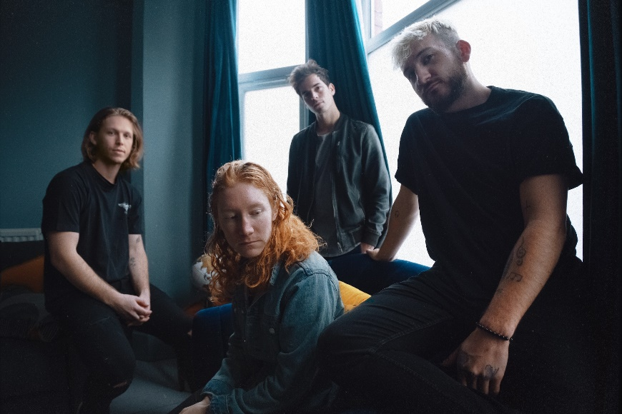

*Photo Credit: Jade Ehlers*

**About flor**

With their nuanced songwriting and inventive sensibilities, flor use their songs to explore feelings of longing and heartache, anxiety and self-doubt. Singer/guitarist Zach Grace, bassist Dylan Bauld, guitarist McKinley Kitts, and drummer Kyle Hill alternately magnify and brighten those feelings by dreaming up an intensely cinematic take on synth-driven alt-pop. Growing up in the tiny town of Hood River, Oregon, the band pushed forward in their career by relocating to L.A. and taking on the name flor—a word that translates to *flower* in Portuguese. flor soon landed a deal with Fueled By Ramen, who released their debut EP *Sounds* in February 2016 and debut LP *come out. you’re hiding* in May 2017. flor released their much anticipated sophomore album *ley lines*on September 6, 2019 on Fueled By Ramen.

[https://florsounds.com/](https://nam04.safelinks.protection.outlook.com/?url=https%3A%2F%2Fflorsounds.com%2F&data=02%7C01%7CSydneyWorden%40elektra.com%7Cc62fa229c0af4ee863cb08d84448689f%7C8367939002ec4ba1ad3d69da3fdd637e%7C0%7C0%7C637334425114096535&sdata=zvQNEmV8L2Lgu1ix7VUdNX2ZwMFqnpNGDlHDOTJ8ego%3D&reserved=0)

[https://www.facebook.com/florsounds](https://nam04.safelinks.protection.outlook.com/?url=https%3A%2F%2Fwww.facebook.com%2Fflorsounds&data=02%7C01%7CSydneyWorden%40elektra.com%7Cc62fa229c0af4ee863cb08d84448689f%7C8367939002ec4ba1ad3d69da3fdd637e%7C0%7C0%7C637334425114096535&sdata=KC%2Fj1Vct6JlU5xZICwO9Ln1ngUJY79jKkJ9b7Ohneeg%3D&reserved=0)

[https://www.instagram.com/flor/](https://nam04.safelinks.protection.outlook.com/?url=https%3A%2F%2Fwww.instagram.com%2Fflor%2F&data=02%7C01%7CSydneyWorden%40elektra.com%7Cc62fa229c0af4ee863cb08d84448689f%7C8367939002ec4ba1ad3d69da3fdd637e%7C0%7C0%7C637334425114106531&sdata=P1OPTDRn%2FXpeF3ErF%2By3HSuIcEhk3ChTtwb2LBRGQn8%3D&reserved=0)

[https://twitter.com/flor](https://nam04.safelinks.protection.outlook.com/?url=https%3A%2F%2Ftwitter.com%2Fflor&data=02%7C01%7CSydneyWorden%40elektra.com%7Cc62fa229c0af4ee863cb08d84448689f%7C8367939002ec4ba1ad3d69da3fdd637e%7C0%7C0%7C637334425114106531&sdata=THgCho%2FMMVnFebAU3kSNwG97KXLXzXFbfkAJF0vPOj0%3D&reserved=0)

[https://www.youtube.com/florsounds](https://nam04.safelinks.protection.outlook.com/?url=https%3A%2F%2Fwww.youtube.com%2Fflorsounds&data=02%7C01%7CSydneyWorden%40elektra.com%7Cc62fa229c0af4ee863cb08d84448689f%7C8367939002ec4ba1ad3d69da3fdd637e%7C0%7C0%7C637334425114106531&sdata=nv2GwOo9pzq6bSMXtyFim5rwwJHJ%2BOw4aZuEV8SIkxw%3D&reserved=0)

**Press Contact:**Collin Citron

[collincitron@elektra.com](mailto:collincitron@elektra.com) / 818-238-6314