**FLOR UNVEILS *LIVE AT HOME***

**WATCH THE SEVEN-TRACK PERFORMANCE**[**HERE**](https://nam04.safelinks.protection.outlook.com/?url=https%3A%2F%2Fflor.lnk.to%2Fliveathome&data=04%7C01%7CSydneyWorden%40elektra.com%7C1b0553230d7048432fbe08d8a1ecd798%7C8367939002ec4ba1ad3d69da3fdd637e%7C0%7C0%7C637437385956653458%7CUnknown%7CTWFpbGZsb3d8eyJWIjoiMC4wLjAwMDAiLCJQIjoiV2luMzIiLCJBTiI6Ik1haWwiLCJXVCI6Mn0%3D%7C1000&sdata=QbLqFohGTrk8AWQZnqdKv6aIgFiDG8Tfo%2BvygtLhlZI%3D&reserved=0)



**December 16, 2020 -**Los Angeles, CA alt-pop band **flor** has unveiled [***live at home***](https://nam04.safelinks.protection.outlook.com/?url=https%3A%2F%2Fflor.lnk.to%2Fliveathome&data=04%7C01%7CSydneyWorden%40elektra.com%7C1b0553230d7048432fbe08d8a1ecd798%7C8367939002ec4ba1ad3d69da3fdd637e%7C0%7C0%7C637437385956663455%7CUnknown%7CTWFpbGZsb3d8eyJWIjoiMC4wLjAwMDAiLCJQIjoiV2luMzIiLCJBTiI6Ik1haWwiLCJXVCI6Mn0%3D%7C1000&sdata=C0MYHmcRr1QepgIlRAT8MCLhjs%2BOe0nRMgzjtoaswpw%3D&reserved=0)**,**a seven-track performance of their latest single “lmho”, and songs off their albums *ley lines* and *come out. you're hiding. live at home*was produced and mixed by flor bassist Dylan Bauld, and directed by longtime collaborator Jade Ehlers at Bauld’s home studio. The performance is available to stream now exclusively on the band’s YouTube channel. Watch it [HERE](https://nam04.safelinks.protection.outlook.com/?url=https%3A%2F%2Fflor.lnk.to%2Fliveathome&data=04%7C01%7CSydneyWorden%40elektra.com%7C1b0553230d7048432fbe08d8a1ecd798%7C8367939002ec4ba1ad3d69da3fdd637e%7C0%7C0%7C637437385956663455%7CUnknown%7CTWFpbGZsb3d8eyJWIjoiMC4wLjAwMDAiLCJQIjoiV2luMzIiLCJBTiI6Ik1haWwiLCJXVCI6Mn0%3D%7C1000&sdata=C0MYHmcRr1QepgIlRAT8MCLhjs%2BOe0nRMgzjtoaswpw%3D&reserved=0).

“We wanted to spend 2020 on the road playing music and meeting all of you, but this wasn’t the year any of us were hoping for. We can’t wait to see you when it’s safe to tour again, but in the meantime, we got together at Dylan’s house to play some songs for you. We hope you enjoy,” shared flor singer/guitarist Zach Grace.

flor released their latest standalone single “[LMHO](https://nam04.safelinks.protection.outlook.com/?url=https%3A%2F%2Fflor.lnk.to%2Flmho&data=04%7C01%7CSydneyWorden%40elektra.com%7C1b0553230d7048432fbe08d8a1ecd798%7C8367939002ec4ba1ad3d69da3fdd637e%7C0%7C0%7C637437385956663455%7CUnknown%7CTWFpbGZsb3d8eyJWIjoiMC4wLjAwMDAiLCJQIjoiV2luMzIiLCJBTiI6Ik1haWwiLCJXVCI6Mn0%3D%7C1000&sdata=18%2BlAV6ey%2BdnGXJn59KW%2FV9oSf1FlEIONSmbzh5B714%3D&reserved=0)” alongside an [official music video](https://nam04.safelinks.protection.outlook.com/?url=https%3A%2F%2Fyoutu.be%2F-lhOgBPcKf8&data=04%7C01%7CSydneyWorden%40elektra.com%7C1b0553230d7048432fbe08d8a1ecd798%7C8367939002ec4ba1ad3d69da3fdd637e%7C0%7C0%7C637437385956673448%7CUnknown%7CTWFpbGZsb3d8eyJWIjoiMC4wLjAwMDAiLCJQIjoiV2luMzIiLCJBTiI6Ik1haWwiLCJXVCI6Mn0%3D%7C1000&sdata=MDvQTmlugx3QAkYyNaBQJljeaD9Q5zsMUszePMSgeNg%3D&reserved=0) in August. The song followed the release of their [*reimagined*EP](https://nam04.safelinks.protection.outlook.com/?url=https%3A%2F%2Flnk.to%2Freimagined&data=04%7C01%7CSydneyWorden%40elektra.com%7C1b0553230d7048432fbe08d8a1ecd798%7C8367939002ec4ba1ad3d69da3fdd637e%7C0%7C0%7C637437385956673448%7CUnknown%7CTWFpbGZsb3d8eyJWIjoiMC4wLjAwMDAiLCJQIjoiV2luMzIiLCJBTiI6Ik1haWwiLCJXVCI6Mn0%3D%7C1000&sdata=0pjM7gahT1mhQ5kcAWuvuhT53ibpkM%2BWR9tKnG6ZqVE%3D&reserved=0), which features stripped-down recordings of fan-favorite tracks including “unsaid”, “white noise”, “warm blood”, and “slow motion”. Additionally, the EP includes a cover of Coldplay’s “yellow” featuring labelmates MisterWives. Watch the track’s official music video, which premiered on [Billboard](https://nam04.safelinks.protection.outlook.com/?url=https%3A%2F%2Fwww.billboard.com%2Farticles%2Fcolumns%2Fpop%2F8550405%2Fflor-misterwives-cover-coldplay-yellow-video&data=04%7C01%7CSydneyWorden%40elektra.com%7C1b0553230d7048432fbe08d8a1ecd798%7C8367939002ec4ba1ad3d69da3fdd637e%7C0%7C0%7C637437385956683442%7CUnknown%7CTWFpbGZsb3d8eyJWIjoiMC4wLjAwMDAiLCJQIjoiV2luMzIiLCJBTiI6Ik1haWwiLCJXVCI6Mn0%3D%7C1000&sdata=bjQPm%2B%2F5ugG9b%2Bd0YUGLUIOIiO2O9ItwOPTyZJrDuAQ%3D&reserved=0), [HERE](https://nam04.safelinks.protection.outlook.com/?url=https%3A%2F%2Fwww.youtube.com%2Fwatch%3Fv%3DhGnrYtEVR7A&data=04%7C01%7CSydneyWorden%40elektra.com%7C1b0553230d7048432fbe08d8a1ecd798%7C8367939002ec4ba1ad3d69da3fdd637e%7C0%7C0%7C637437385956683442%7CUnknown%7CTWFpbGZsb3d8eyJWIjoiMC4wLjAwMDAiLCJQIjoiV2luMzIiLCJBTiI6Ik1haWwiLCJXVCI6Mn0%3D%7C1000&sdata=XNgpqNCyC3sdXn007JssUuaOngzhkFwadii4WpTCEFU%3D&reserved=0).

flor’s sophomore full-length *ley lines*was released in September, 2019, andis available physically and digitally[HERE](https://nam04.safelinks.protection.outlook.com/?url=https%3A%2F%2Flnk.to%2Fflorleylines&data=04%7C01%7CSydneyWorden%40elektra.com%7C1b0553230d7048432fbe08d8a1ecd798%7C8367939002ec4ba1ad3d69da3fdd637e%7C0%7C0%7C637437385956693436%7CUnknown%7CTWFpbGZsb3d8eyJWIjoiMC4wLjAwMDAiLCJQIjoiV2luMzIiLCJBTiI6Ik1haWwiLCJXVCI6Mn0%3D%7C1000&sdata=6QUjg%2FHzvlF4U1xmObg1XgS%2F0aq0ruE53bpZAfWvB%2B8%3D&reserved=0) via Fueled By Ramen. Singles including “[slow motion](https://nam04.safelinks.protection.outlook.com/?url=https%3A%2F%2Flnk.to%2Fslowmotionflor&data=04%7C01%7CSydneyWorden%40elektra.com%7C1b0553230d7048432fbe08d8a1ecd798%7C8367939002ec4ba1ad3d69da3fdd637e%7C0%7C0%7C637437385956693436%7CUnknown%7CTWFpbGZsb3d8eyJWIjoiMC4wLjAwMDAiLCJQIjoiV2luMzIiLCJBTiI6Ik1haWwiLCJXVCI6Mn0%3D%7C1000&sdata=qzKSandJhU00e6G8exk%2Byn8Ee0MAzhfrc53HkFXtlg0%3D&reserved=0)” and “[dancing around](https://nam04.safelinks.protection.outlook.com/?url=https%3A%2F%2Flnk.to%2Fflordancingaround&data=04%7C01%7CSydneyWorden%40elektra.com%7C1b0553230d7048432fbe08d8a1ecd798%7C8367939002ec4ba1ad3d69da3fdd637e%7C0%7C0%7C637437385956703431%7CUnknown%7CTWFpbGZsb3d8eyJWIjoiMC4wLjAwMDAiLCJQIjoiV2luMzIiLCJBTiI6Ik1haWwiLCJXVCI6Mn0%3D%7C1000&sdata=j%2BJbz2XMzz%2FJW4x2k9NWogWg0srx0WUkaozRipvH0XM%3D&reserved=0)” received praise from Nylon, Ones to Watch, and Earmilk, and were prominently featured on playlists including Today In Music on Apple Music, Brand New Music on Amazon Music, and New Music Friday on Spotify. *ley lines*was co-produced by singer/guitarist Zach Grace and bassist  Dylan Bauld in Bauld’s home studio in Los Angeles, over several writing sessions with guitarist McKinley Kitts and drummer Kyle Hill.

In March, flor wrapped their second US headline tour in support of *ley lines*. The trek followed the band’s massive Ones To Watch Presents: flor North American tour, which saw them perform their largest sold-out headline shows to date. flor has previously supported Paramore, Hayley Kiyoko, Walk The Moon, and Andrew McMahon in the Wilderness on the road.

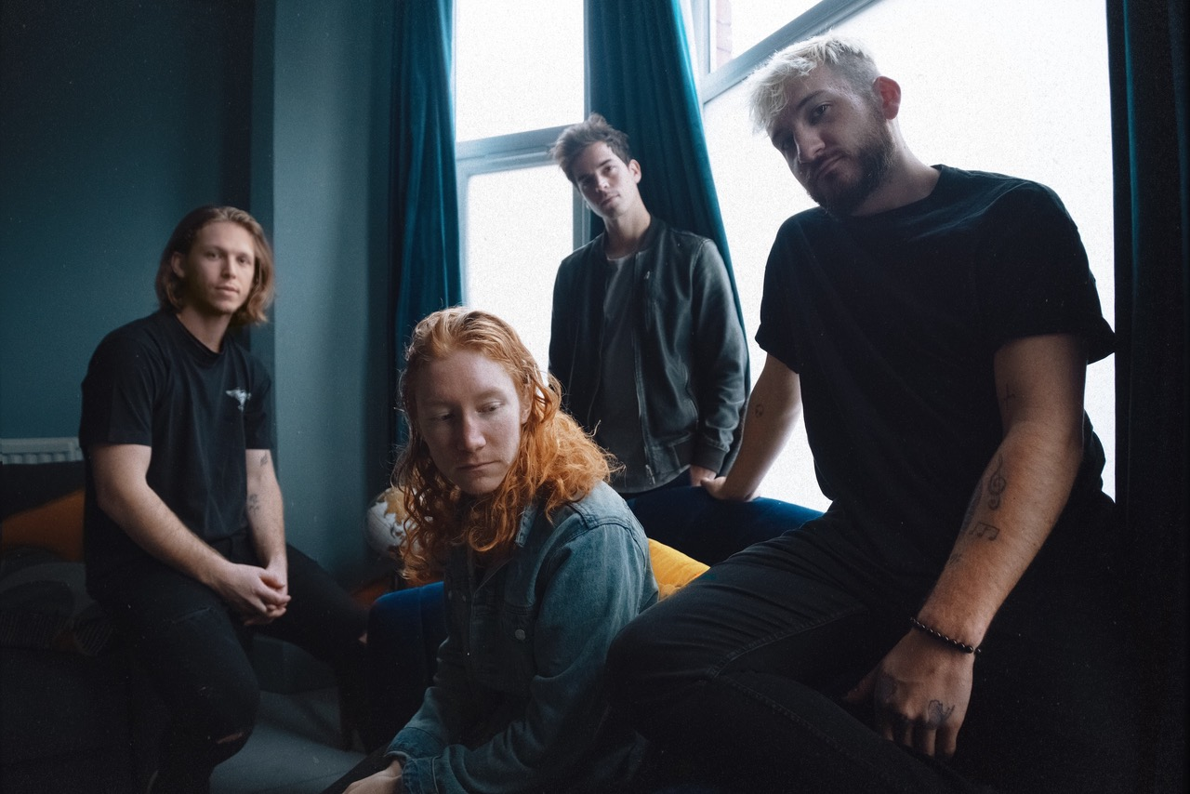

*Photo Credit: Jade Ehlers*

**About flor**

With their nuanced songwriting and inventive sensibilities, flor use their songs to explore feelings of longing and heartache, anxiety and self-doubt. Singer/guitarist Zach Grace, bassist Dylan Bauld, guitarist McKinley Kitts, and drummer Kyle Hill alternately magnify and brighten those feelings by dreaming up an intensely cinematic take on synth-driven alt-pop. Growing up in the tiny town of Hood River, Oregon, the band pushed forward in their career by relocating to L.A. and taking on the name flor—a word that translates to *flower* in Portuguese. flor soon landed a deal with Fueled By Ramen, who released their debut EP *Sounds* in February 2016 and debut LP *come out. you’re hiding* in May 2017. flor released their much anticipated sophomore album *ley lines*on September 6, 2019 on Fueled By Ramen.

[https://florsounds.com/](https://nam04.safelinks.protection.outlook.com/?url=https%3A%2F%2Fflorsounds.com%2F&data=04%7C01%7CSydneyWorden%40elektra.com%7C1b0553230d7048432fbe08d8a1ecd798%7C8367939002ec4ba1ad3d69da3fdd637e%7C0%7C0%7C637437385956703431%7CUnknown%7CTWFpbGZsb3d8eyJWIjoiMC4wLjAwMDAiLCJQIjoiV2luMzIiLCJBTiI6Ik1haWwiLCJXVCI6Mn0%3D%7C1000&sdata=zVswCHmQzQtkpQ920LjupFtirT3TNuEbtLjldQ2UCQg%3D&reserved=0)

[https://www.facebook.com/florsounds](https://nam04.safelinks.protection.outlook.com/?url=https%3A%2F%2Fwww.facebook.com%2Fflorsounds&data=04%7C01%7CSydneyWorden%40elektra.com%7C1b0553230d7048432fbe08d8a1ecd798%7C8367939002ec4ba1ad3d69da3fdd637e%7C0%7C0%7C637437385956713425%7CUnknown%7CTWFpbGZsb3d8eyJWIjoiMC4wLjAwMDAiLCJQIjoiV2luMzIiLCJBTiI6Ik1haWwiLCJXVCI6Mn0%3D%7C1000&sdata=%2BeTVUP15YKdIOcXRrYMPYkcIeRr2wZ7FMjC4ZdhdSDw%3D&reserved=0)

[https://www.instagram.com/flor/](https://nam04.safelinks.protection.outlook.com/?url=https%3A%2F%2Fwww.instagram.com%2Fflor%2F&data=04%7C01%7CSydneyWorden%40elektra.com%7C1b0553230d7048432fbe08d8a1ecd798%7C8367939002ec4ba1ad3d69da3fdd637e%7C0%7C0%7C637437385956713425%7CUnknown%7CTWFpbGZsb3d8eyJWIjoiMC4wLjAwMDAiLCJQIjoiV2luMzIiLCJBTiI6Ik1haWwiLCJXVCI6Mn0%3D%7C1000&sdata=3fu494RDav8KzCU1fdRcjNyNuL6BwCB2eY1O9r1hTbc%3D&reserved=0)

[https://twitter.com/flor](https://nam04.safelinks.protection.outlook.com/?url=https%3A%2F%2Ftwitter.com%2Fflor&data=04%7C01%7CSydneyWorden%40elektra.com%7C1b0553230d7048432fbe08d8a1ecd798%7C8367939002ec4ba1ad3d69da3fdd637e%7C0%7C0%7C637437385956723420%7CUnknown%7CTWFpbGZsb3d8eyJWIjoiMC4wLjAwMDAiLCJQIjoiV2luMzIiLCJBTiI6Ik1haWwiLCJXVCI6Mn0%3D%7C1000&sdata=K591J1xL7FetZj6CUpDfDLSWo6PIO2BxzFlLgHWl4fc%3D&reserved=0)

[https://www.youtube.com/florsounds](https://nam04.safelinks.protection.outlook.com/?url=https%3A%2F%2Fwww.youtube.com%2Fflorsounds&data=04%7C01%7CSydneyWorden%40elektra.com%7C1b0553230d7048432fbe08d8a1ecd798%7C8367939002ec4ba1ad3d69da3fdd637e%7C0%7C0%7C637437385956723420%7CUnknown%7CTWFpbGZsb3d8eyJWIjoiMC4wLjAwMDAiLCJQIjoiV2luMzIiLCJBTiI6Ik1haWwiLCJXVCI6Mn0%3D%7C1000&sdata=qxDCo31RfqRY9%2BEmKuF9MM%2Bnewh2xhfX%2Btbkjp3z8%2F0%3D&reserved=0)

**Press Contact:**Collin Citron

[collincitron@elektra.com](mailto:collincitron@elektra.com) / 818-238-6314