FOR IMMEDIATE RELEASE

JUNE 17, 2021

**FOY VANCE ANNOUNCES NEW ALBUM *SIGNS OF LIFE* AND SHARES NEW SINGLE “TIME STAND STILL”**

***SIGNS OF LIFE* WILL BE RELEASED SEPTEMBER 10, 2021 ON ED SHEERAN’S GINGERBREAD MAN RECORDS/ELEKTRA RECORDS**

**PRE-ORDER THE ALBUM** [**HERE**](https://nam04.safelinks.protection.outlook.com/?url=https%3A%2F%2Flnk.to%2FSigns-of-Life&data=04%7C01%7CSydneyWorden%40elektra.com%7Cced232289e954ad0fd3008d9319871b6%7C8367939002ec4ba1ad3d69da3fdd637e%7C0%7C0%7C637595353141666230%7CUnknown%7CTWFpbGZsb3d8eyJWIjoiMC4wLjAwMDAiLCJQIjoiV2luMzIiLCJBTiI6Ik1haWwiLCJXVCI6Mn0%3D%7C1000&sdata=5lpuqsD7%2BYsmxTEK6NGPrd88wle86fVMjDUlDAG4tec%3D&reserved=0)

*“He harks back to Van Morrison’s better days,*

*grainy and impassioned.”* ***The New York Times***

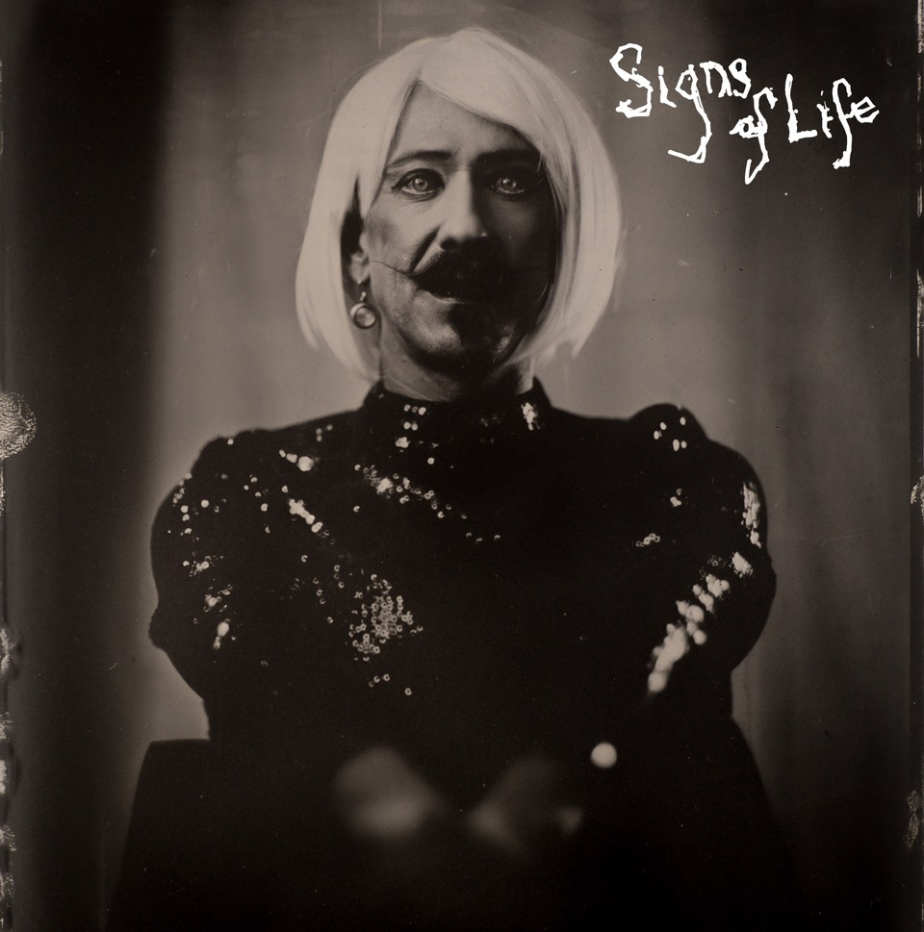

Award-winning Northern Irish singer/songwriter **Foy Vance** has announced he will release his fourth studio album ***Signs Of Life***on September 10, 2021. The album is available for pre-order starting today [HERE](https://nam04.safelinks.protection.outlook.com/?url=https%3A%2F%2Flnk.to%2FSigns-of-Life&data=04%7C01%7CSydneyWorden%40elektra.com%7Cced232289e954ad0fd3008d9319871b6%7C8367939002ec4ba1ad3d69da3fdd637e%7C0%7C0%7C637595353141676233%7CUnknown%7CTWFpbGZsb3d8eyJWIjoiMC4wLjAwMDAiLCJQIjoiV2luMzIiLCJBTiI6Ik1haWwiLCJXVCI6Mn0%3D%7C1000&sdata=9ODzBxnrcrz7qvqDo6E5chnZFRdl4VYm5QG77wjrLO0%3D&reserved=0). *Sings of Life* marks Vance’s second studio album on Ed Sheeran’s Gingerbread Man Records/Elektra Records and follows 2016’s critically acclaimed *The Wild Swan*.

Vance will celebrate the album’s arrival with *An Evening With Foy Vance*, an intimate tour of the UK and US, including stops in Los Angeles, New York, and Nashville’s famed Ryman Auditorium. Pre-sale tickets will be available beginning June 28, and general on sale begins on July 2 at 12:00pm local time [HERE](https://nam04.safelinks.protection.outlook.com/?url=https%3A%2F%2Fwww.foyvance.com%2Ftour%2F&data=04%7C01%7CSydneyWorden%40elektra.com%7Cced232289e954ad0fd3008d9319871b6%7C8367939002ec4ba1ad3d69da3fdd637e%7C0%7C0%7C637595353141686216%7CUnknown%7CTWFpbGZsb3d8eyJWIjoiMC4wLjAwMDAiLCJQIjoiV2luMzIiLCJBTiI6Ik1haWwiLCJXVCI6Mn0%3D%7C1000&sdata=51ScjYpgtdseXtYCd2n0W%2B2T0UzmGLub3JeYlAVynKc%3D&reserved=0).

Vance has also released the album’s latest single [“](https://nam04.safelinks.protection.outlook.com/?url=https%3A%2F%2Flnk.to%2FTime-Stand-Still&data=04%7C01%7CSydneyWorden%40elektra.com%7Cced232289e954ad0fd3008d9319871b6%7C8367939002ec4ba1ad3d69da3fdd637e%7C0%7C0%7C637595353141686216%7CUnknown%7CTWFpbGZsb3d8eyJWIjoiMC4wLjAwMDAiLCJQIjoiV2luMzIiLCJBTiI6Ik1haWwiLCJXVCI6Mn0%3D%7C1000&sdata=buXsfSUuJdq5vJq7rGlV%2F%2FHpmqhsFGC3PpjEMF3xmjs%3D&reserved=0)[Time Stand Still](https://nam04.safelinks.protection.outlook.com/?url=https%3A%2F%2Flnk.to%2FTime-Stand-Still&data=04%7C01%7CSydneyWorden%40elektra.com%7Cced232289e954ad0fd3008d9319871b6%7C8367939002ec4ba1ad3d69da3fdd637e%7C0%7C0%7C637595353141696217%7CUnknown%7CTWFpbGZsb3d8eyJWIjoiMC4wLjAwMDAiLCJQIjoiV2luMzIiLCJBTiI6Ik1haWwiLCJXVCI6Mn0%3D%7C1000&sdata=qaH1enCahGsPF4zzCVHWiAo%2F%2FfwcbkxKxzY3l70XhDo%3D&reserved=0)”. The song is available to stream and download now [HERE](https://nam04.safelinks.protection.outlook.com/?url=https%3A%2F%2Flnk.to%2FTime-Stand-Still&data=04%7C01%7CSydneyWorden%40elektra.com%7Cced232289e954ad0fd3008d9319871b6%7C8367939002ec4ba1ad3d69da3fdd637e%7C0%7C0%7C637595353141696217%7CUnknown%7CTWFpbGZsb3d8eyJWIjoiMC4wLjAwMDAiLCJQIjoiV2luMzIiLCJBTiI6Ik1haWwiLCJXVCI6Mn0%3D%7C1000&sdata=qaH1enCahGsPF4zzCVHWiAo%2F%2FfwcbkxKxzY3l70XhDo%3D&reserved=0). “Time Stand Still” is the third track Vance has shared from *Signs Of Life* and follows the May release of [“Sapling”](https://nam04.safelinks.protection.outlook.com/?url=https%3A%2F%2Fyoutu.be%2Fz18IKb3bcRs&data=04%7C01%7CSydneyWorden%40elektra.com%7Cced232289e954ad0fd3008d9319871b6%7C8367939002ec4ba1ad3d69da3fdd637e%7C0%7C0%7C637595353141706213%7CUnknown%7CTWFpbGZsb3d8eyJWIjoiMC4wLjAwMDAiLCJQIjoiV2luMzIiLCJBTiI6Ik1haWwiLCJXVCI6Mn0%3D%7C1000&sdata=94PhtEn%2F4p63TomGtearbra26lFuzS9Kd9SsEbjuP48%3D&reserved=0) and [“Signs Of Life”](https://nam04.safelinks.protection.outlook.com/?url=https%3A%2F%2Fyoutu.be%2FAF9gdUsGefk&data=04%7C01%7CSydneyWorden%40elektra.com%7Cced232289e954ad0fd3008d9319871b6%7C8367939002ec4ba1ad3d69da3fdd637e%7C0%7C0%7C637595353141706213%7CUnknown%7CTWFpbGZsb3d8eyJWIjoiMC4wLjAwMDAiLCJQIjoiV2luMzIiLCJBTiI6Ik1haWwiLCJXVCI6Mn0%3D%7C1000&sdata=DiRKX8uLqzJ6vNBRHam3cGWyAvomYag%2Fjf%2FQVYjmYSQ%3D&reserved=0). Upon its release, *The New York Times* featured “Sapling” in *The Playlist* and *Clash Music* applauded the song as “An instant fan favorite… a song about renewal and survival.”

*Signs Of Life* is the sound of a beloved singer-songwriter at the peak of his powers. It’s also the sound of a man – a husband, a father, a sinner, a drinker – belatedly coming to terms with his demons. Driven by powerful percussion, “Time Stand Still” features a soaring, emotive vocal from Vance, who was struggling with an addiction to alcohol and painkillers at the time of writing.

“I had my first extended period off the road after twenty years of constant touring,” says Vance. “And I realised: wow, I drink two bottles of wine and at least a half bottle of vodka a day. I’d start the day with codeine to get myself sorted, and I’d smoke joints throughout the day. So I realised: I have so many incredibly bad habits here. I’m showing all the signs of death, getting ashen, grey, smoking more, drinking more, smoking more…I hit a wall. It was my manager that made me get help. And in those moments, you do wish time would stand still. Can’t I just stop here and sit in this moment before I have to take up that mantle?”

*Signs Of Life* was recorded in three locations: Vance’s Pilgrim studio at home on the shores of Loch Tay in Highland Perthshire, another recording set-up in a nearby Dunvarlich House, and at Plan B’s Kings X studio in London. The album was written and played more or less entirely by Vance, with assistance from young Northern Irish producer Gareth Dunlop. Serendipitously, Dunlop had been inspired on his career path by a chance encounter with Vance many years before.

“When I was around 14 years-old I wandered into a coffee shop in Belfast and saw Foy playing in the corner,” Dunlop explains. “I was completely spellbound by what I heard. It was a lightbulb moment that sent me on the road of wanting to discover my own voice and musicality. I would never have imagined that I would be co-producing a record with him 18 years later, and that I would be just as inspired and spellbound by what he does.”

Created out of the grimness of 2020, *Signs of Life* is an album of dawn after darkness, hope after despair, engagement after isolation, uplift after lockdown. The album’s bold artwork reflects Vance's desire to embrace all sides of everything, all humanity's textures. Shot on a 160-year-old camera, the back image is of Vance as a bare-chested, bare-knuckle boxer. On the front, he's in a dress, blonde wig and theatrical make-up. “They’re just mad, striking images, and I loved the fact that it was male and female. You know, life’s extreme, life’s volatile, life explodes into reality sometimes, and stops just as quick. So to be struck by images on the cover made sense.”

Commenting on the album’s timely subject matter, Vance shared, “*Signs of Life* is about re-emergence – me in my own soft revolution, the world re-emerging in what we’re about to see as we hopefully go back to some semblance of normality. But just life in general – flowers growing through the cracks in Chernobyl. Life finds a way, doesn’t it?”

***Signs of Life* Tracklisting**

01. Sapling

02. We Can't Be Tamed

03. Signs Of Life

04. Roman Attack

05. People Are Pills

06. Time Stand Still

07. If Christopher Calls

08. System

09. Hair of The Dog

10. Resplendence

11. Republic Of Eden

12. It Ain't Over

13. Percolate

***An Evening With Foy Vance Tour* 2021**

September 6 Glasgow, King Tuts

September 7 Leeds, Brudenell Social Club

September 9 London, Oslo

September 10 London, St. Pancras Church

September 12 Belfast, Empire

September 13 Dublin, Whelans

October 11 Los Angeles, Masonic Lodge at Hollywood Forever Cemetery

October 12 Nashville, Ryman Auditorium* - SOLD OUT

October 13 Nashville, Ryman Auditorium* - Second Night

October 16 New York, Rockwood Music Hall – Stage 2

* supporting Anderson East

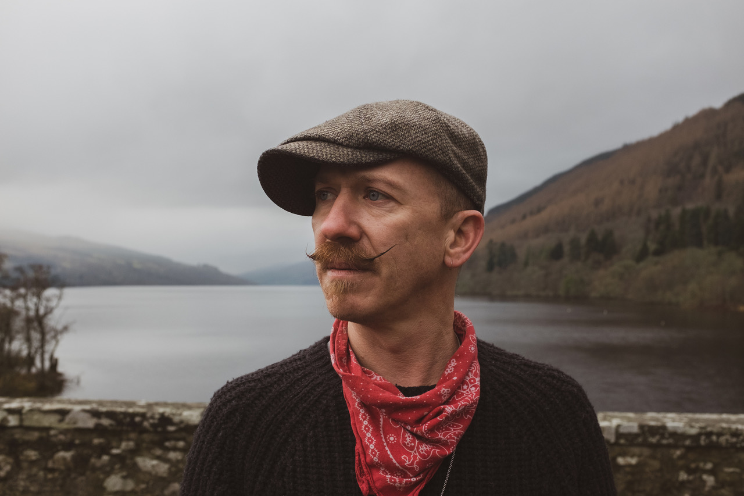

*Photo Credit: Babysweet*

**About Foy Vance**

Hailing from Bangor in Northern Ireland, Vance independently released his debut album *Hope* in 2007, quickly garnering acclaim from fans and fellow musicians alike. His second full-length album, *Joy of Nothing*, released in 2013 on Glassnote Records, won the inaugural Northern Ireland Music Prize and saw Vance tour the globe with Ed Sheeran, Bonnie Raitt, Marcus Foster, Snow Patrol and Sir Elton John, as well as his own solo headline tours.

In 2015 Vance was became the second signing to Gingerbread Man Records, Ed Sheeran’s label division within Atlantic Records. His debut recording for the label, *The Wild Swan -* Executive Produced by Sir Elton John - contained the BBC Radio 2 playlisted singles “Coco”, “Upbeat Feelgood”, and “Noam Chomsky Is A Soft Revolution”, and saw Vance perform on NBC’s Today and CBS’s The Late Late Show with James Corden.

As a songwriter, Vance’s collaborations include co-writing four cuts including “Galway Girl” on Ed Sheeran’s 2017 album *Divide*. He has also worked with Alicia Keys, Rag N Bone Man, Keith Urban, Kacey Musgraves, Miranda Lambert, Plan B and Rudimental among many others, effortlessly switching between genres.

Last year, Vance launched the podcast series *The Vinyl Supper* in which he talks music, food and life stories with special guests and friends from the world of music, poetry and film. Recorded remotely during the global pandemic, series one featured Anderson East, Atticus, Benny Blanco, Blake Mills, Bruce Cockburn, Chrissy Metz, Courteney Cox, Devin Dawson, Josh Groban, Keith Urban and Passenger.

Foy Vance has headlined globally to sell-out crowds and splits his time between London and the Scottish Highlands with his family.

[FoyVance.com](https://nam04.safelinks.protection.outlook.com/?url=https%3A%2F%2Ffoyvance.com%2F&data=04%7C01%7CSydneyWorden%40elektra.com%7Cced232289e954ad0fd3008d9319871b6%7C8367939002ec4ba1ad3d69da3fdd637e%7C0%7C0%7C637595353141716206%7CUnknown%7CTWFpbGZsb3d8eyJWIjoiMC4wLjAwMDAiLCJQIjoiV2luMzIiLCJBTiI6Ik1haWwiLCJXVCI6Mn0%3D%7C1000&sdata=CoSBlfWtUtSkGWhUAfOQ1J7F6zX0XA0OKwj9sBGKlyo%3D&reserved=0)

[Facebook](https://nam04.safelinks.protection.outlook.com/?url=https%3A%2F%2Fwww.facebook.com%2Ffoyvancemusic&data=04%7C01%7CSydneyWorden%40elektra.com%7Cced232289e954ad0fd3008d9319871b6%7C8367939002ec4ba1ad3d69da3fdd637e%7C0%7C0%7C637595353141716206%7CUnknown%7CTWFpbGZsb3d8eyJWIjoiMC4wLjAwMDAiLCJQIjoiV2luMzIiLCJBTiI6Ik1haWwiLCJXVCI6Mn0%3D%7C1000&sdata=D5nR5xSaKHIP340w2fomuqyfVBaFQnNEIaj8mmQg1l0%3D&reserved=0) | [Twitter](https://nam04.safelinks.protection.outlook.com/?url=https%3A%2F%2Ftwitter.com%2Ffoyvance&data=04%7C01%7CSydneyWorden%40elektra.com%7Cced232289e954ad0fd3008d9319871b6%7C8367939002ec4ba1ad3d69da3fdd637e%7C0%7C0%7C637595353141726199%7CUnknown%7CTWFpbGZsb3d8eyJWIjoiMC4wLjAwMDAiLCJQIjoiV2luMzIiLCJBTiI6Ik1haWwiLCJXVCI6Mn0%3D%7C1000&sdata=g%2BQX%2FD800MK1tH7FmHuMhBHBIXmxN89LCgVnC6qTzGc%3D&reserved=0) | [Instagram](https://nam04.safelinks.protection.outlook.com/?url=https%3A%2F%2Fwww.instagram.com%2Ffoyvance%2F&data=04%7C01%7CSydneyWorden%40elektra.com%7Cced232289e954ad0fd3008d9319871b6%7C8367939002ec4ba1ad3d69da3fdd637e%7C0%7C0%7C637595353141726199%7CUnknown%7CTWFpbGZsb3d8eyJWIjoiMC4wLjAwMDAiLCJQIjoiV2luMzIiLCJBTiI6Ik1haWwiLCJXVCI6Mn0%3D%7C1000&sdata=ZngbefGOPHLVKy%2FRSjWxUKyuQvOo9jXHkAZEEU%2FmJEk%3D&reserved=0) | [YouTube](https://nam04.safelinks.protection.outlook.com/?url=https%3A%2F%2Fwww.youtube.com%2Fuser%2Ffoyvancemusic%2Ffeatured&data=04%7C01%7CSydneyWorden%40elektra.com%7Cced232289e954ad0fd3008d9319871b6%7C8367939002ec4ba1ad3d69da3fdd637e%7C0%7C0%7C637595353141736198%7CUnknown%7CTWFpbGZsb3d8eyJWIjoiMC4wLjAwMDAiLCJQIjoiV2luMzIiLCJBTiI6Ik1haWwiLCJXVCI6Mn0%3D%7C1000&sdata=URwKNR0CjNwyaK7LuJ1Vg3IH8I71sbkIREW9IiDk%2Fv4%3D&reserved=0)

**Press contact:**

Collin Citron | [CollinCitron@elektra.com](mailto:CollinCitron@elektra.com)