FOR IMMEDIATE RELEASE

JULY 15, 2021

**FOY VANCE RELEASES NEW TRACK “IF CHRISTOPHER CALLS”**

**LISTEN**[**HERE**](https://nam04.safelinks.protection.outlook.com/?url=https%3A%2F%2Fyoutu.be%2Fv0p1bFMZ7Fs&data=04%7C01%7CSydneyWorden%40elektra.com%7C6cff571caf2e4945461808d947978bda%7C8367939002ec4ba1ad3d69da3fdd637e%7C0%7C0%7C637619538553290622%7CUnknown%7CTWFpbGZsb3d8eyJWIjoiMC4wLjAwMDAiLCJQIjoiV2luMzIiLCJBTiI6Ik1haWwiLCJXVCI6Mn0%3D%7C1000&sdata=tKgCL0Tg%2BU5mH1JBk0SV9NydVpe2FDUHM93JAg0vZV0%3D&reserved=0)

**NEW ALBUM *SIGNS OF LIFE* TO BE RELEASED SEPTEMBER 10, 2021 ON ED SHEERAN’S GINGERBREAD MAN RECORDS/ELEKTRA RECORDS**

**PRE-ORDER THE ALBUM** [**HERE**](https://nam04.safelinks.protection.outlook.com/?url=https%3A%2F%2Flnk.to%2FSigns-of-Life&data=04%7C01%7CSydneyWorden%40elektra.com%7C6cff571caf2e4945461808d947978bda%7C8367939002ec4ba1ad3d69da3fdd637e%7C0%7C0%7C637619538553300616%7CUnknown%7CTWFpbGZsb3d8eyJWIjoiMC4wLjAwMDAiLCJQIjoiV2luMzIiLCJBTiI6Ik1haWwiLCJXVCI6Mn0%3D%7C1000&sdata=O2oxrOi9962vKKxqvHGP%2Fev5IYxK3%2Ba3rISVJ%2FGe0L8%3D&reserved=0)

**REMAINING TICKETS FOR LARGELY SOLD-OUT *AN EVENING WITH FOY VANCE* TOUR AVAILABLE** [**HERE**](https://nam04.safelinks.protection.outlook.com/?url=https%3A%2F%2Fwww.foyvance.com%2Ftour%2F&data=04%7C01%7CSydneyWorden%40elektra.com%7C6cff571caf2e4945461808d947978bda%7C8367939002ec4ba1ad3d69da3fdd637e%7C0%7C0%7C637619538553300616%7CUnknown%7CTWFpbGZsb3d8eyJWIjoiMC4wLjAwMDAiLCJQIjoiV2luMzIiLCJBTiI6Ik1haWwiLCJXVCI6Mn0%3D%7C1000&sdata=jkrsivlepGpMNHz2wUgWPabCo3Vh63ZbXKVNWMNCTsc%3D&reserved=0)

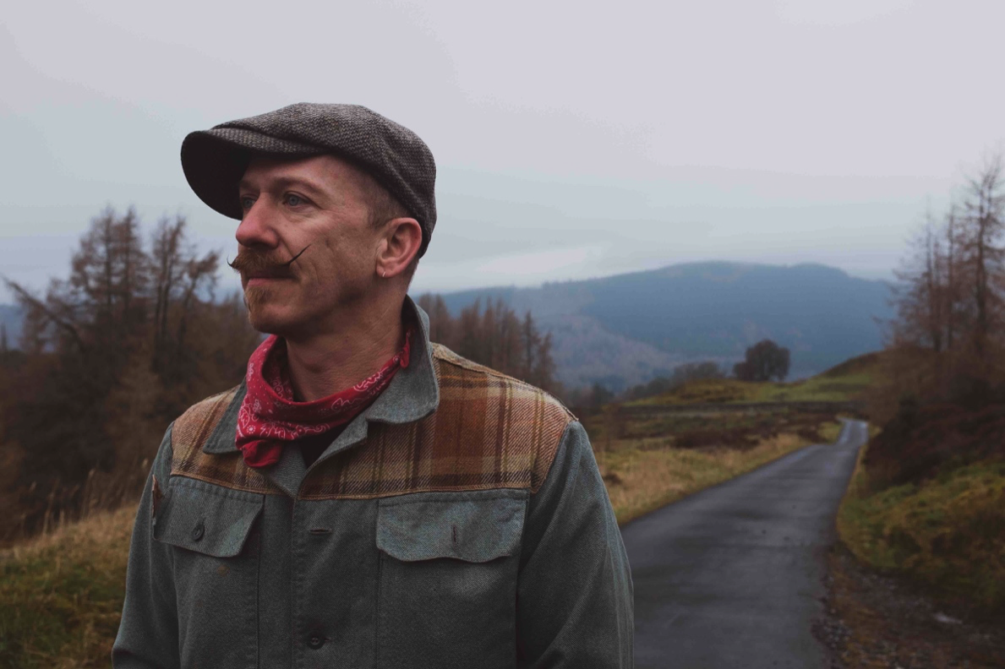

*Photo Credit: Babysweet*

*“He harks back to Van Morrison’s better days, grainy and impassioned.”* **The New York Times**

“…*simply beautiful, all about (Vance’s) wonderfully characterful voice*

*and the gorgeous melody it enfolds.”***Americana UK**

Award-winning Northern Irish singer/songwriter **Foy Vance** has released [**“If Christopher Calls”**](https://nam04.safelinks.protection.outlook.com/?url=https%3A%2F%2Fyoutu.be%2Fv0p1bFMZ7Fs&data=04%7C01%7CSydneyWorden%40elektra.com%7C6cff571caf2e4945461808d947978bda%7C8367939002ec4ba1ad3d69da3fdd637e%7C0%7C0%7C637619538553310611%7CUnknown%7CTWFpbGZsb3d8eyJWIjoiMC4wLjAwMDAiLCJQIjoiV2luMzIiLCJBTiI6Ik1haWwiLCJXVCI6Mn0%3D%7C1000&sdata=tBhvpoJ0A6RBGRbdb79q2o0ZUilRWKEKEYoqgNfE4Ag%3D&reserved=0), the fourth track off his forthcoming album *Signs Of Life*. The song is available to stream and download starting today [HERE](https://nam04.safelinks.protection.outlook.com/?url=https%3A%2F%2Flnk.to%2FSigns-of-Life&data=04%7C01%7CSydneyWorden%40elektra.com%7C6cff571caf2e4945461808d947978bda%7C8367939002ec4ba1ad3d69da3fdd637e%7C0%7C0%7C637619538553310611%7CUnknown%7CTWFpbGZsb3d8eyJWIjoiMC4wLjAwMDAiLCJQIjoiV2luMzIiLCJBTiI6Ik1haWwiLCJXVCI6Mn0%3D%7C1000&sdata=1tdL6PEMxsLiD5%2B3fxKRC7oWq55wVvmezrPBgJeVNG8%3D&reserved=0). *Signs Of Life* is due for release on September 10, and is available for pre-order now [HERE](https://nam04.safelinks.protection.outlook.com/?url=https%3A%2F%2Flnk.to%2FSigns-of-Life&data=04%7C01%7CSydneyWorden%40elektra.com%7C6cff571caf2e4945461808d947978bda%7C8367939002ec4ba1ad3d69da3fdd637e%7C0%7C0%7C637619538553320604%7CUnknown%7CTWFpbGZsb3d8eyJWIjoiMC4wLjAwMDAiLCJQIjoiV2luMzIiLCJBTiI6Ik1haWwiLCJXVCI6Mn0%3D%7C1000&sdata=qq1fE2bpOxWZ%2FqtpNprWoAxZZ8pdWrYbHf9WQ3eAruY%3D&reserved=0). The album marks Vance’s second LP on Ed Sheeran’s Gingerbread Man Records/Elektra Records and follows 2016’s critically acclaimed *The Wild Swan*.

Vance will celebrate *Signs Of Life’s* arrival with *An Evening With Foy Vance*, an intimate tour of the UK and US, including stops in Los Angeles, New York, and Nashville’s famed Ryman Auditorium. Remaining tickets for the largely sold-out run of shows are available now [HERE](https://nam04.safelinks.protection.outlook.com/?url=https%3A%2F%2Fwww.foyvance.com%2Ftour%2F&data=04%7C01%7CSydneyWorden%40elektra.com%7C6cff571caf2e4945461808d947978bda%7C8367939002ec4ba1ad3d69da3fdd637e%7C0%7C0%7C637619538553330599%7CUnknown%7CTWFpbGZsb3d8eyJWIjoiMC4wLjAwMDAiLCJQIjoiV2luMzIiLCJBTiI6Ik1haWwiLCJXVCI6Mn0%3D%7C1000&sdata=QUqTWfjNbASVyV0y8jLLL14J9k%2Fp%2BUDWS3p%2FZdXH5dY%3D&reserved=0).

Written for his wife about her late father, “If Christopher Calls” is at once beautiful yet quietly devastating. Over a gorgeous, swelling melody Vance delivers a restrained yet palpably emotional vocal. “Christopher was Marie, my wife’s father, who passed away suddenly a few years back,” Vance explains. “When it happened, Marie was in London and I was in Scotland. Her mum had phoned her to say Christopher had dropped in the kitchen but they weren’t sure if he was dead. Marie wasn’t there, she was a few miles away and just talking to her mum on the phone, trying to tell her what to do.”

“Marie then called me and when she explained the situation it was clear to me that he was already dead. But she was still holding out hope that he would be alive when she got there, and I let her think that, rather than tell her what I was certain to be true. And it was. He died immediately. Her hope of hearing his voice again was heartbreaking,” Vance recalls. “She then came to Nashville with me while I was recording an album, and every day we would wake in the morning then go and sit out the back with a coffee, and that is where I would leave her - and that is where I would find her when I got home.”

“If Christopher Calls” follows *Signs of Life’s* previously released tracks [“Time Stand Still”](https://nam04.safelinks.protection.outlook.com/?url=https%3A%2F%2Flnk.to%2FTime-Stand-Still&data=04%7C01%7CSydneyWorden%40elektra.com%7C6cff571caf2e4945461808d947978bda%7C8367939002ec4ba1ad3d69da3fdd637e%7C0%7C0%7C637619538553330599%7CUnknown%7CTWFpbGZsb3d8eyJWIjoiMC4wLjAwMDAiLCJQIjoiV2luMzIiLCJBTiI6Ik1haWwiLCJXVCI6Mn0%3D%7C1000&sdata=QF04w6NK74Jxrsy8M4LmkK4Yts%2FR%2B4oKc661fa9uFBI%3D&reserved=0), [“Signs Of Life”](https://nam04.safelinks.protection.outlook.com/?url=https%3A%2F%2Fyoutu.be%2FAF9gdUsGefk&data=04%7C01%7CSydneyWorden%40elektra.com%7C6cff571caf2e4945461808d947978bda%7C8367939002ec4ba1ad3d69da3fdd637e%7C0%7C0%7C637619538553340592%7CUnknown%7CTWFpbGZsb3d8eyJWIjoiMC4wLjAwMDAiLCJQIjoiV2luMzIiLCJBTiI6Ik1haWwiLCJXVCI6Mn0%3D%7C1000&sdata=wQcP7KaPRdudQqawg8lwgAeI1x979ZDzCSOfhYIK6%2Bk%3D&reserved=0), and [“Sapling”](https://nam04.safelinks.protection.outlook.com/?url=https%3A%2F%2Fyoutu.be%2Fz18IKb3bcRs&data=04%7C01%7CSydneyWorden%40elektra.com%7C6cff571caf2e4945461808d947978bda%7C8367939002ec4ba1ad3d69da3fdd637e%7C0%7C0%7C637619538553340592%7CUnknown%7CTWFpbGZsb3d8eyJWIjoiMC4wLjAwMDAiLCJQIjoiV2luMzIiLCJBTiI6Ik1haWwiLCJXVCI6Mn0%3D%7C1000&sdata=jB%2F3uBojdl%2FBeUchDF%2BLR0CGu67sb3oz3Zjc6gVBFlA%3D&reserved=0)*.* Upon its release, *The New York Times* featured “Sapling” in *The Playlist* and *Clash Music* applauded the song as “An instant fan favorite… a song about renewal and survival.”  The album’s early tracks have received additional praise from *Entertainment Tonight*, *Americana UK*, and more.

*Signs Of Life* was recorded in three locations: Vance’s Pilgrim studio at home on the shores of Loch Tay in Highland Perthshire, another recording set-up in a nearby Dunvarlich House, and at Plan B’s Kings X studio in London. The album was written and played more or less entirely by Vance, with assistance from young Northern Irish producer Gareth Dunlop. Serendipitously, Dunlop had been inspired on his career path by a chance encounter with Vance in a coffee shop 18 years ago.

Created out of the grimness of 2020, *Signs of Life* is an album of dawn after darkness, hope after despair, engagement after isolation, uplift after lockdown. The album’s bold artwork reflects Vance's desire to embrace all sides of everything, all humanity's textures. Shot on a 160-year-old camera, the back image is of Vance as a bare-chested, bare-knuckle boxer. On the front, he's in a dress, blonde wig and theatrical make-up. “They’re just mad, striking images, and I loved the fact that it was male and female. You know, life’s extreme, life’s volatile, life explodes into reality sometimes, and stops just as quick. So to be struck by images on the cover made sense.”

Commenting on the album’s timely subject matter, Vance shared, “*Signs of Life* is about re-emergence – me in my own soft revolution, the world re-emerging in what we’re about to see as we hopefully go back to some semblance of normality. But just life in general – flowers growing through the cracks in Chernobyl. Life finds a way, doesn’t it?”

**An Evening With Foy Vance Tour 2021**

September 06, 2021 -  Glasgow, UK - King Tuts -  **SOLD OUT**

September 07, 2021 - Leeds, UK -  Brudenell Social Club

September 09, 2021 - London, UK - Oslo - **SOLD OUT**

September 10, 2021 - London, UK - St. Pancras Church - **SOLD OUT**

September 12, 2021 - Belfast, UK - Empire - **SOLD OUT**

September 13, 2021 - Dublin, IE - Whelans

November 10, 2021 - Los Angeles, CA - Masonic Lodge at Hollywood Forever - **SOLD OUT**

November 12, 2021 - Nashville, TN - Ryman Auditorium **\*** - **SOLD OUT**

November 13, 2021 - Nashville, TN - Ryman Auditorium **\***

November 16, 2021 - New York, NY - Rockwood Music Hall Stage 2 - **SOLD OUT**

**\*** supporting Anderson East

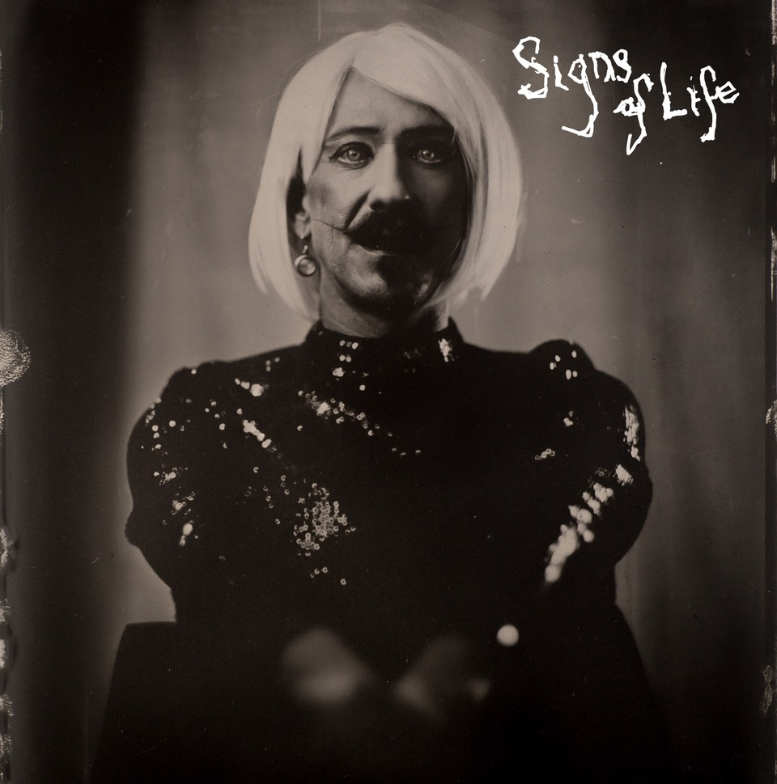

**About Foy Vance**

Hailing from Bangor in Northern Ireland, Vance independently released his debut album *Hope* in 2007, quickly garnering acclaim from fans and fellow musicians alike. His second full-length album, *Joy of Nothing*, released in 2013 on Glassnote Records, won the inaugural Northern Ireland Music Prize and saw Vance tour the globe with Ed Sheeran, Bonnie Raitt, Marcus Foster, Snow Patrol and Sir Elton John, as well as his own solo headline tours.

In 2015 Vance was became the second signing to Gingerbread Man Records, Ed Sheeran’s label division within Atlantic Records. His debut recording for the label, *The Wild Swan -* Executive Produced by Sir Elton John - contained the BBC Radio 2 playlisted singles “Coco”, “Upbeat Feelgood”, and “Noam Chomsky Is A Soft Revolution”, and saw Vance perform on NBC’s Today and CBS’s The Late Late Show with James Corden.

As a songwriter, Vance’s collaborations include co-writing four cuts including “Galway Girl” on Ed Sheeran’s 2017 album *Divide*. He has also worked with Alicia Keys, Rag N Bone Man, Keith Urban, Kacey Musgraves, Miranda Lambert, Plan B and Rudimental among many others, effortlessly switching between genres.

Last year, Vance launched the podcast series *The Vinyl Supper* in which he talks music, food and life stories with special guests and friends from the world of music, poetry and film. Recorded remotely during the global pandemic, series one featured Anderson East, Atticus, Benny Blanco, Blake Mills, Bruce Cockburn, Chrissy Metz, Courteney Cox, Devin Dawson, Josh Groban, Keith Urban and Passenger.

Foy Vance has headlined globally to sell-out crowds and splits his time between London and the Scottish Highlands with his family.

[FoyVance.com](https://nam04.safelinks.protection.outlook.com/?url=https%3A%2F%2Ffoyvance.com%2F&data=04%7C01%7CSydneyWorden%40elektra.com%7C6cff571caf2e4945461808d947978bda%7C8367939002ec4ba1ad3d69da3fdd637e%7C0%7C0%7C637619538553350587%7CUnknown%7CTWFpbGZsb3d8eyJWIjoiMC4wLjAwMDAiLCJQIjoiV2luMzIiLCJBTiI6Ik1haWwiLCJXVCI6Mn0%3D%7C1000&sdata=0jgZt2I9LZL1AdF0cC4tFA0p9M%2Ba%2FSqvGZusEHJRW80%3D&reserved=0)

[Facebook](https://nam04.safelinks.protection.outlook.com/?url=https%3A%2F%2Fwww.facebook.com%2Ffoyvancemusic&data=04%7C01%7CSydneyWorden%40elektra.com%7C6cff571caf2e4945461808d947978bda%7C8367939002ec4ba1ad3d69da3fdd637e%7C0%7C0%7C637619538553350587%7CUnknown%7CTWFpbGZsb3d8eyJWIjoiMC4wLjAwMDAiLCJQIjoiV2luMzIiLCJBTiI6Ik1haWwiLCJXVCI6Mn0%3D%7C1000&sdata=Tcogd8LU3Iob4MWLo%2FM%2BZadK5uwOdDFnxv1mZmvRLk8%3D&reserved=0) | [Twitter](https://nam04.safelinks.protection.outlook.com/?url=https%3A%2F%2Ftwitter.com%2Ffoyvance&data=04%7C01%7CSydneyWorden%40elektra.com%7C6cff571caf2e4945461808d947978bda%7C8367939002ec4ba1ad3d69da3fdd637e%7C0%7C0%7C637619538553360583%7CUnknown%7CTWFpbGZsb3d8eyJWIjoiMC4wLjAwMDAiLCJQIjoiV2luMzIiLCJBTiI6Ik1haWwiLCJXVCI6Mn0%3D%7C1000&sdata=vi0TOWODYy00hi1KZAsNuO%2Fy9baw37AG55ks55YdGkM%3D&reserved=0) | [Instagram](https://nam04.safelinks.protection.outlook.com/?url=https%3A%2F%2Fwww.instagram.com%2Ffoyvance%2F&data=04%7C01%7CSydneyWorden%40elektra.com%7C6cff571caf2e4945461808d947978bda%7C8367939002ec4ba1ad3d69da3fdd637e%7C0%7C0%7C637619538553360583%7CUnknown%7CTWFpbGZsb3d8eyJWIjoiMC4wLjAwMDAiLCJQIjoiV2luMzIiLCJBTiI6Ik1haWwiLCJXVCI6Mn0%3D%7C1000&sdata=o%2FR%2BHU5GPlesLj74%2BP9g70n6yQirXyB0s0QoU4ihxic%3D&reserved=0) | [YouTube](https://nam04.safelinks.protection.outlook.com/?url=https%3A%2F%2Fwww.youtube.com%2Fuser%2Ffoyvancemusic%2Ffeatured&data=04%7C01%7CSydneyWorden%40elektra.com%7C6cff571caf2e4945461808d947978bda%7C8367939002ec4ba1ad3d69da3fdd637e%7C0%7C0%7C637619538553370574%7CUnknown%7CTWFpbGZsb3d8eyJWIjoiMC4wLjAwMDAiLCJQIjoiV2luMzIiLCJBTiI6Ik1haWwiLCJXVCI6Mn0%3D%7C1000&sdata=AL%2BKzG2qhA1ycJA0Q2iIspa1XFyySNWeTKdkibh9HRo%3D&reserved=0)

**Press contact:**

Collin Citron | [CollinCitron@elektra.com](mailto:CollinCitron@elektra.com)