FOR IMMEDIATE RELEASE

AUGUST 25, 2021

**FOY VANCE RELEASES NEW TRACK “ROMAN ATTACK”**

**LISTEN**[**HERE**](https://nam04.safelinks.protection.outlook.com/?url=https%3A%2F%2Flnk.to%2FRoman-Attack&data=04%7C01%7CSydneyWorden%40elektra.com%7C7165907099064b8c043408d96899d91b%7C8367939002ec4ba1ad3d69da3fdd637e%7C0%7C0%7C637655832256134760%7CUnknown%7CTWFpbGZsb3d8eyJWIjoiMC4wLjAwMDAiLCJQIjoiV2luMzIiLCJBTiI6Ik1haWwiLCJXVCI6Mn0%3D%7C1000&sdata=YRNZ3Vk0Swrjmy74VX2vSGTZ%2BLSbvF2gLcIXpdqnF7M%3D&reserved=0)

**NEW ALBUM *SIGNS OF LIFE* OUT SEPTEMBER 10, 2021 ON ED SHEERAN’S GINGERBREAD MAN RECORDS/ELEKTRA RECORDS - PRE-ORDER** [**HERE**](https://nam04.safelinks.protection.outlook.com/?url=https%3A%2F%2Flnk.to%2FSigns-of-Life&data=04%7C01%7CSydneyWorden%40elektra.com%7C7165907099064b8c043408d96899d91b%7C8367939002ec4ba1ad3d69da3fdd637e%7C0%7C0%7C637655832256144753%7CUnknown%7CTWFpbGZsb3d8eyJWIjoiMC4wLjAwMDAiLCJQIjoiV2luMzIiLCJBTiI6Ik1haWwiLCJXVCI6Mn0%3D%7C1000&sdata=1BWaIZAKLtMlHk0WyXq%2Bq5LaMBZJGcyYUz%2BMLqTYc10%3D&reserved=0)

**SOLD-OUT *AN EVENING WITH FOY VANCE* *TOUR* KICKS OFF SEPTEMBER 6**

**TICKETS FOR SEPTEMBER 10 CONCERT LIVESTREAM AVAILABLE** [**HERE**](https://nam04.safelinks.protection.outlook.com/?url=https%3A%2F%2Fwww.google.com%2Furl%3Fq%3Dhttps%3A%2F%2Flink.dice.fm%2Ffoyvance%26sa%3DD%26source%3Deditors%26ust%3D1629939041340000%26usg%3DAOvVaw2i8B0ECoMS97Xdg7_vnzqn&data=04%7C01%7CSydneyWorden%40elektra.com%7C7165907099064b8c043408d96899d91b%7C8367939002ec4ba1ad3d69da3fdd637e%7C0%7C0%7C637655832256144753%7CUnknown%7CTWFpbGZsb3d8eyJWIjoiMC4wLjAwMDAiLCJQIjoiV2luMzIiLCJBTiI6Ik1haWwiLCJXVCI6Mn0%3D%7C1000&sdata=5CUxOFaMfWeszQeduFxqw4Xi6DKDvcCeIH7nlDp2Z2A%3D&reserved=0)

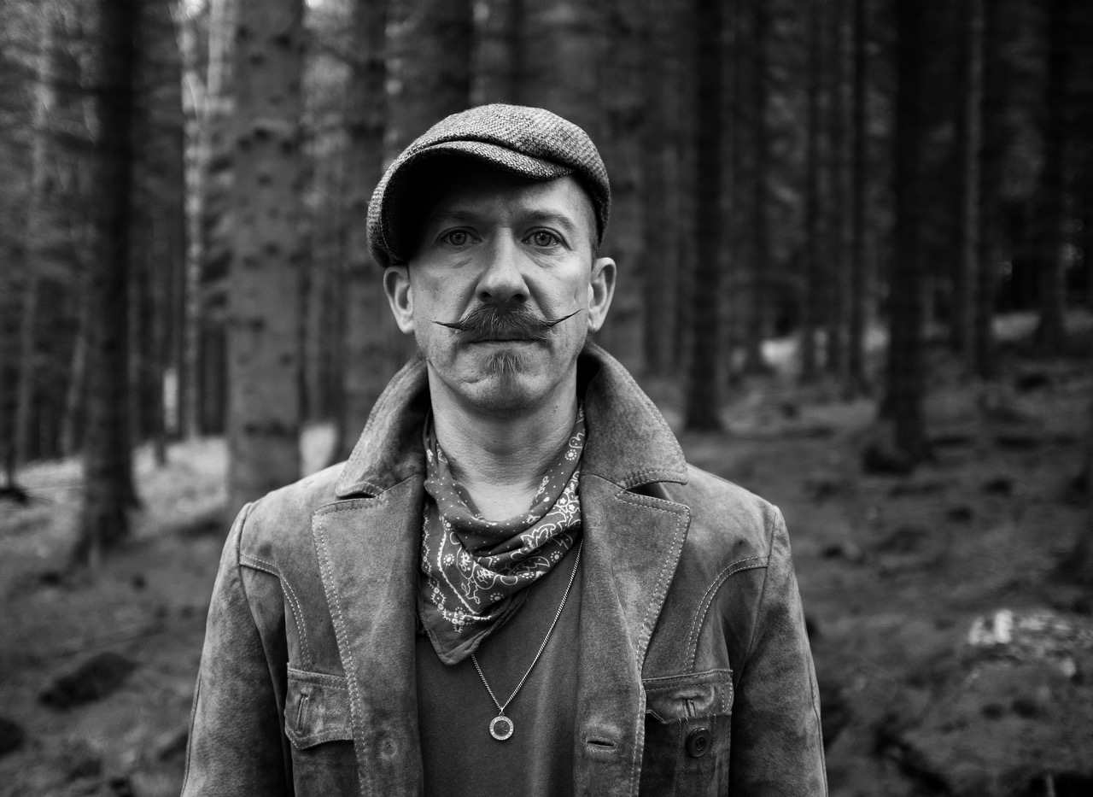

*Photo credit: Babysweet*

*“As always Foy has knocked it out of the park”* **Ed Sheeran**

*“(Sapling) harks back to Van Morrison’s better days, grainy and impassioned”* **The New York Times**

“…*simply beautiful, all about (Vance’s) wonderfully characterful voice*

*and the gorgeous melody it enfolds.”* **Americana UK**

Award-winning Northern Irish singer/songwriter **Foy Vance** has released [**"Roman Attack"**](https://nam04.safelinks.protection.outlook.com/?url=https%3A%2F%2Flnk.to%2FRoman-Attack&data=04%7C01%7CSydneyWorden%40elektra.com%7C7165907099064b8c043408d96899d91b%7C8367939002ec4ba1ad3d69da3fdd637e%7C0%7C0%7C637655832256154746%7CUnknown%7CTWFpbGZsb3d8eyJWIjoiMC4wLjAwMDAiLCJQIjoiV2luMzIiLCJBTiI6Ik1haWwiLCJXVCI6Mn0%3D%7C1000&sdata=36J6j7M7PaYuaSvBFyHz9zYoxZbj1UaXpajEXSXVyno%3D&reserved=0), the latest track off his forthcoming album ***Signs Of Life***. The song is available to stream and download starting today [HERE](https://nam04.safelinks.protection.outlook.com/?url=https%3A%2F%2Flnk.to%2FRoman-Attack&data=04%7C01%7CSydneyWorden%40elektra.com%7C7165907099064b8c043408d96899d91b%7C8367939002ec4ba1ad3d69da3fdd637e%7C0%7C0%7C637655832256154746%7CUnknown%7CTWFpbGZsb3d8eyJWIjoiMC4wLjAwMDAiLCJQIjoiV2luMzIiLCJBTiI6Ik1haWwiLCJXVCI6Mn0%3D%7C1000&sdata=36J6j7M7PaYuaSvBFyHz9zYoxZbj1UaXpajEXSXVyno%3D&reserved=0). *Signs Of Life* is due for release on September 10 via Ed Sheeran’s Gingerbread Man Records/Elektra Records. The album is available for pre-order now [HERE](https://nam04.safelinks.protection.outlook.com/?url=https%3A%2F%2Flnk.to%2FSigns-of-Life&data=04%7C01%7CSydneyWorden%40elektra.com%7C7165907099064b8c043408d96899d91b%7C8367939002ec4ba1ad3d69da3fdd637e%7C0%7C0%7C637655832256154746%7CUnknown%7CTWFpbGZsb3d8eyJWIjoiMC4wLjAwMDAiLCJQIjoiV2luMzIiLCJBTiI6Ik1haWwiLCJXVCI6Mn0%3D%7C1000&sdata=NQWs9PhozVB%2BlfhWY74j9cd9ibVmOWUR%2BrKQdZn1o8E%3D&reserved=0).

“As always Foy has knocked it out of the park,” comments Ed Sheeran on *Signs Of Life*. “I love giving him the creative freedom to do what he wants as I’m at the end of the day just a huge fan of his work. It’s such a joy to be able to put out such great bodies of work from him, I hope everyone enjoys it as much as me.”

"I feel like I’ve got a confidante in Ed, a real ally,” adds Vance. “In many ways he has found a way to afford me the ability to keep on making art the way I want to make it. It’s comforting to know that no matter what I wanted to do, he would fight for it.”

Vance will celebrate the album’s release with *An Evening With Foy Vance*, an intimate, sold-out UK & US tour in September and November. Vance’s sold-out show at London’s St Pancras Old Church on September 10 will be streaming live via Dice at 9:00pm BST, and will be available to US audiences at 9:00pm EST/PST with multiple broadcasts to follow. Tickets are available now from [Dice](https://nam04.safelinks.protection.outlook.com/?url=https%3A%2F%2Flink.dice.fm%2Ffoyvance&data=04%7C01%7CSydneyWorden%40elektra.com%7C7165907099064b8c043408d96899d91b%7C8367939002ec4ba1ad3d69da3fdd637e%7C0%7C0%7C637655832256164738%7CUnknown%7CTWFpbGZsb3d8eyJWIjoiMC4wLjAwMDAiLCJQIjoiV2luMzIiLCJBTiI6Ik1haWwiLCJXVCI6Mn0%3D%7C1000&sdata=bVmXjczvMjWbivvKjdaZsaK9QttSdAeWfx23pqnfxrc%3D&reserved=0) for $13.20.

The powerful, widescreen “Roman Attack” was “written after an argument that I started at the most inappropriate moment,” says Vance. “I went in hard just like a roman attack, a ‘send in the horses’ type thing. I feel like it’s also a nod to a time when we were more gracious with each other."

*Signs Of Life* is the sound of a beloved singer-songwriter at the peak of his powers. It’s also the sound of a man – a husband, a father, a sinner, a drinker – belatedly coming to terms with his demons. Namely, after years and years of almost constant touring, an addiction to alcohol and painkillers. In [“Hair Of The Dog”](https://nam04.safelinks.protection.outlook.com/?url=https%3A%2F%2Fyoutu.be%2FT1gqFwYhyss&data=04%7C01%7CSydneyWorden%40elektra.com%7C7165907099064b8c043408d96899d91b%7C8367939002ec4ba1ad3d69da3fdd637e%7C0%7C0%7C637655832256164738%7CUnknown%7CTWFpbGZsb3d8eyJWIjoiMC4wLjAwMDAiLCJQIjoiV2luMzIiLCJBTiI6Ik1haWwiLCJXVCI6Mn0%3D%7C1000&sdata=HgzB%2BSp%2BtUS3XwqlDy2PRIo7dSKx%2F4D8saZ1EB0i644%3D&reserved=0) Vance tackles the subject head on, listing his self-medicating crutches while confessing “*You no longer make me happy / You no longer make me smile / You take everything that’s good within me*.”

“I had my first extended period off the road for twenty years, and I realised: wow, I drink two bottles of wine and at least a half bottle of vodka a day,” Vance explains. “I’d start the day with codeine to get myself sorted, and I’d smoke joints throughout the day. I’m showing all the signs of death, getting ashen, grey, smoking more, drinking more, smoking more… I hit a wall.”

Album opener and lead track [“Sapling”](https://nam04.safelinks.protection.outlook.com/?url=https%3A%2F%2Fyoutu.be%2Fz18IKb3bcRs&data=04%7C01%7CSydneyWorden%40elektra.com%7C7165907099064b8c043408d96899d91b%7C8367939002ec4ba1ad3d69da3fdd637e%7C0%7C0%7C637655832256174735%7CUnknown%7CTWFpbGZsb3d8eyJWIjoiMC4wLjAwMDAiLCJQIjoiV2luMzIiLCJBTiI6Ik1haWwiLCJXVCI6Mn0%3D%7C1000&sdata=blqGtKk8bBCB0mXY%2BsI8hJY7IVRQ47Dg%2FBL7dM%2FHnik%3D&reserved=0) was one of the first tracks Vance wrote for *Signs Of Life*, and it showed him the path forward. The song, as earwormy a mea culpa as you’ll ever hear, begins with a lovely piano figure, like the stage curtains opening. Vance sings: *“I once built a bower, I could build you a home.”* It was promising his new wife - who’d recently moved from London to join the Bangor native in his adopted home in the Scottish Highlands - that he’d do more than simply offer a new domestic setting. Or, as he puts it in his inimitable style: “Let me go further and do the actual right thing instead of being a drunken ballbag.”

*Signs Of Life* was recorded in three locations: Vance’s Pilgrim studio at home on the shores of Loch Tay in Highland Perthshire, another recording set-up in a nearby Dunvarlich House, and at Plan B’s Kings X studio in London. The album was written and played more or less entirely by Vance, with assistance from young Northern Irish producer Gareth Dunlop.

Commenting on the album’s timely subject matter, Vance shared, “*Signs of Life* is about re-emergence – me in my own soft revolution, the world re-emerging in what we’re about to see as we hopefully go back to some semblance of normality. But just life in general – flowers growing through the cracks in Chernobyl. Life finds a way, doesn’t it?”

**An Evening With Foy Vance Tour 2021**

September 06, 2021 -  Glasgow, UK - King Tuts -  **SOLD OUT**

September 07, 2021 - Leeds, UK -  Brudenell Social Club - **SOLD OUT**

September 09, 2021 - London, UK - Oslo - **SOLD OUT**

September 10, 2021 - London, UK - St. Pancras Church - **SOLD OUT**

September 12, 2021 - Belfast, UK - Empire - **SOLD OUT**

September 13, 2021 - Dublin, IE - Whelans - **SOLD OUT**

November 10, 2021 - Los Angeles, CA - Masonic Lodge at Hollywood Forever - **SOLD OUT**

November 12, 2021 - Nashville, TN - Ryman Auditorium **\*** - **SOLD OUT**

November 13, 2021 - Nashville, TN - Ryman Auditorium **\***

November 16, 2021 - New York, NY - Rockwood Music Hall Stage 2 - **SOLD OUT**

**\*** supporting Anderson East

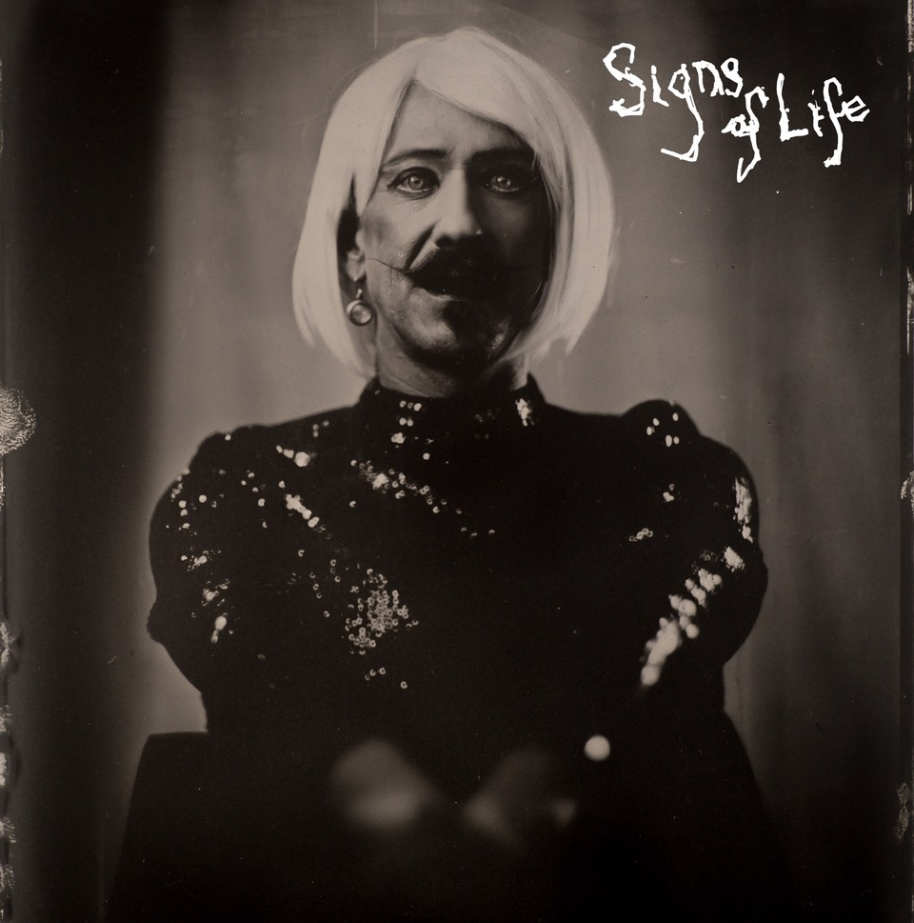

**About Foy Vance**

Hailing from Bangor in Northern Ireland, Vance independently released his debut album *Hope* in 2007, quickly garnering acclaim from fans and fellow musicians alike. His second full-length album, *Joy of Nothing*, released in 2013 on Glassnote Records, won the inaugural Northern Ireland Music Prize and saw Vance tour the globe with Ed Sheeran, Bonnie Raitt, Marcus Foster, Snow Patrol and Sir Elton John, as well as his own solo headline tours.

In 2015 Vance was became the second signing to Gingerbread Man Records, Ed Sheeran’s label division within Atlantic Records. His debut recording for the label, *The Wild Swan -* Executive Produced by Sir Elton John - contained the BBC Radio 2 playlisted singles “Coco”, “Upbeat Feelgood”, and “Noam Chomsky Is A Soft Revolution”, and saw Vance perform on NBC’s Today and CBS’s The Late Late Show with James Corden.

As a songwriter, Vance’s collaborations include co-writing four cuts including “Galway Girl” on Ed Sheeran’s 2017 album *Divide*. He has also worked with Alicia Keys, Rag N Bone Man, Keith Urban, Kacey Musgraves, Miranda Lambert, Plan B and Rudimental among many others, effortlessly switching between genres.

Last year, Vance launched the podcast series *The Vinyl Supper* in which he talks music, food and life stories with special guests and friends from the world of music, poetry and film. Recorded remotely during the global pandemic, series one featured Anderson East, Atticus, Benny Blanco, Blake Mills, Bruce Cockburn, Chrissy Metz, Courteney Cox, Devin Dawson, Josh Groban, Keith Urban and Passenger.

Foy Vance has headlined globally to sell-out crowds and splits his time between London and the Scottish Highlands with his family.

[FoyVance.com](https://nam04.safelinks.protection.outlook.com/?url=https%3A%2F%2Ffoyvance.com%2F&data=04%7C01%7CSydneyWorden%40elektra.com%7C7165907099064b8c043408d96899d91b%7C8367939002ec4ba1ad3d69da3fdd637e%7C0%7C0%7C637655832256174735%7CUnknown%7CTWFpbGZsb3d8eyJWIjoiMC4wLjAwMDAiLCJQIjoiV2luMzIiLCJBTiI6Ik1haWwiLCJXVCI6Mn0%3D%7C1000&sdata=WJ80p98OUbaDto%2F6QlBSajoDmKM11qEE2sBsYJu9Q7w%3D&reserved=0)

[Facebook](https://nam04.safelinks.protection.outlook.com/?url=https%3A%2F%2Fwww.facebook.com%2Ffoyvancemusic&data=04%7C01%7CSydneyWorden%40elektra.com%7C7165907099064b8c043408d96899d91b%7C8367939002ec4ba1ad3d69da3fdd637e%7C0%7C0%7C637655832256184730%7CUnknown%7CTWFpbGZsb3d8eyJWIjoiMC4wLjAwMDAiLCJQIjoiV2luMzIiLCJBTiI6Ik1haWwiLCJXVCI6Mn0%3D%7C1000&sdata=%2Fo%2B9P0rYFkc5yFLGBaJ%2FUGfQrWa83KJypfKopH6LmE8%3D&reserved=0) | [Twitter](https://nam04.safelinks.protection.outlook.com/?url=https%3A%2F%2Ftwitter.com%2Ffoyvance&data=04%7C01%7CSydneyWorden%40elektra.com%7C7165907099064b8c043408d96899d91b%7C8367939002ec4ba1ad3d69da3fdd637e%7C0%7C0%7C637655832256184730%7CUnknown%7CTWFpbGZsb3d8eyJWIjoiMC4wLjAwMDAiLCJQIjoiV2luMzIiLCJBTiI6Ik1haWwiLCJXVCI6Mn0%3D%7C1000&sdata=tD4xHbREg89yj5fzMtv%2B4hhY44tVdWb8lK0P0NG%2FxKI%3D&reserved=0) | [Instagram](https://nam04.safelinks.protection.outlook.com/?url=https%3A%2F%2Fwww.instagram.com%2Ffoyvance%2F&data=04%7C01%7CSydneyWorden%40elektra.com%7C7165907099064b8c043408d96899d91b%7C8367939002ec4ba1ad3d69da3fdd637e%7C0%7C0%7C637655832256194725%7CUnknown%7CTWFpbGZsb3d8eyJWIjoiMC4wLjAwMDAiLCJQIjoiV2luMzIiLCJBTiI6Ik1haWwiLCJXVCI6Mn0%3D%7C1000&sdata=VjOkw0gxn6qtw11Ys%2BId994%2FhH1zRJTnlanPAyjzGKM%3D&reserved=0) | [YouTube](https://nam04.safelinks.protection.outlook.com/?url=https%3A%2F%2Fwww.youtube.com%2Fuser%2Ffoyvancemusic%2Ffeatured&data=04%7C01%7CSydneyWorden%40elektra.com%7C7165907099064b8c043408d96899d91b%7C8367939002ec4ba1ad3d69da3fdd637e%7C0%7C0%7C637655832256194725%7CUnknown%7CTWFpbGZsb3d8eyJWIjoiMC4wLjAwMDAiLCJQIjoiV2luMzIiLCJBTiI6Ik1haWwiLCJXVCI6Mn0%3D%7C1000&sdata=Il%2BrH%2BbiUt9CY4SNWUQTrFpqjM6ryI2%2FPbeTFGTWR4U%3D&reserved=0)

**Press contact:**

Collin Citron | [CollinCitron@elektra.com](mailto:CollinCitron@elektra.com)