FOR IMMEDIATE RELEASE

SEPTEMBER 17, 2021

**FOY VANCE PRESENTS *SIGNS OF LIFE* TOUR 2022**

**TICKETS ON SALE NOW** [**HERE**](https://nam04.safelinks.protection.outlook.com/?url=https%3A%2F%2Fwww.foyvance.com%2Ftour%2F&data=04%7C01%7CSydneyWorden%40elektra.com%7Cff8f8cbd870b4c62e88e08d979fcaac0%7C8367939002ec4ba1ad3d69da3fdd637e%7C0%7C0%7C637674948375442375%7CUnknown%7CTWFpbGZsb3d8eyJWIjoiMC4wLjAwMDAiLCJQIjoiV2luMzIiLCJBTiI6Ik1haWwiLCJXVCI6Mn0%3D%7C1000&sdata=wdJuwNBWoqQVgPu8K2oZKUYglmSLMx%2BCHk3mpqNmHs4%3D&reserved=0)

**NEW ALBUM**[***SIGNS OF LIFE***](https://nam04.safelinks.protection.outlook.com/?url=https%3A%2F%2Flnk.to%2FSigns-of-Life&data=04%7C01%7CSydneyWorden%40elektra.com%7Cff8f8cbd870b4c62e88e08d979fcaac0%7C8367939002ec4ba1ad3d69da3fdd637e%7C0%7C0%7C637674948375442375%7CUnknown%7CTWFpbGZsb3d8eyJWIjoiMC4wLjAwMDAiLCJQIjoiV2luMzIiLCJBTiI6Ik1haWwiLCJXVCI6Mn0%3D%7C1000&sdata=T15Y5QaqUS98d6KLiwpQjn3Ny%2BGcY4LpLySrw1RYOy8%3D&reserved=0) **AVAILABLE NOW**

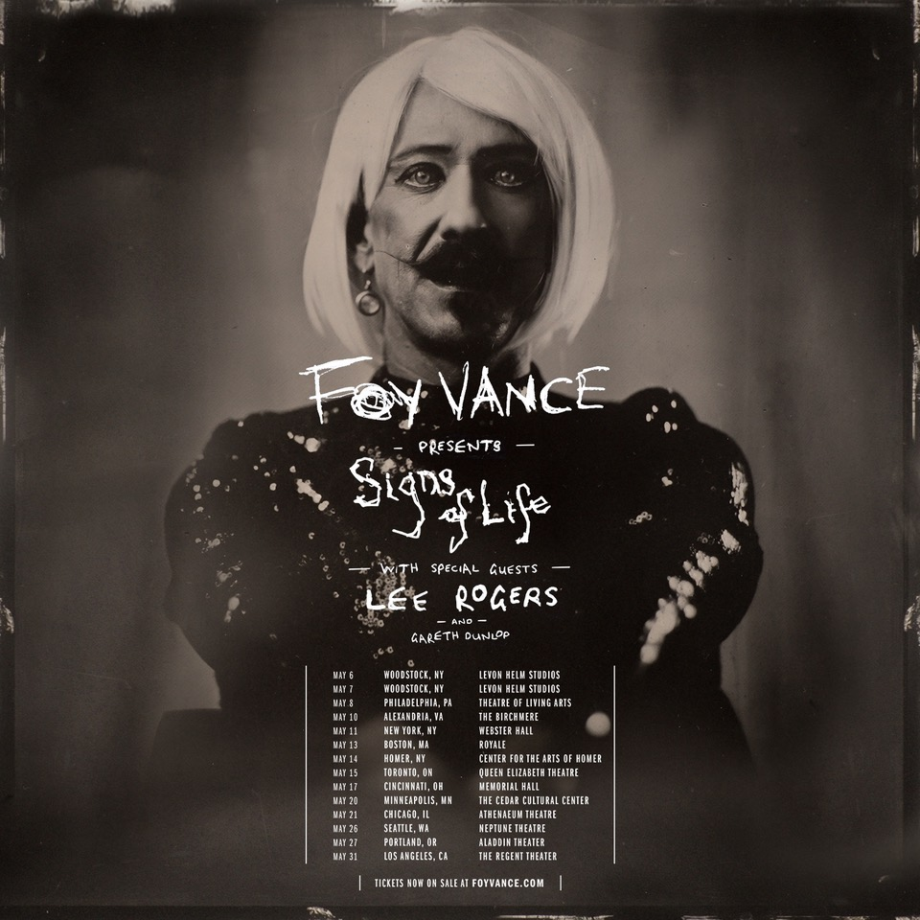

*“As always Foy has knocked it out of the park”*

**Ed Sheeran**

*“…harks back to Van Morrison’s better days, grainy and impassioned”*

**The New York Times**

*“Signs Of Life captures a spiritual awakening and the revival of a soul that nearly departed”*

**American Songwriter**

Tickets have gone on sale for ***Foy Vance Presents Signs Of Life****.* The Award-winning Northern Irish singer/songwriter’s 2022 North American tour will kick off on May 6 in Woodstock, NY and wrap on May 31 in Los Angeles, CA. Special guests Lee Rogers and Garth Dunlop will provide support. Tickets for all dates are available now [HERE](https://nam04.safelinks.protection.outlook.com/?url=https%3A%2F%2Fwww.foyvance.com%2Ftour%2F&data=04%7C01%7CSydneyWorden%40elektra.com%7Cff8f8cbd870b4c62e88e08d979fcaac0%7C8367939002ec4ba1ad3d69da3fdd637e%7C0%7C0%7C637674948375452369%7CUnknown%7CTWFpbGZsb3d8eyJWIjoiMC4wLjAwMDAiLCJQIjoiV2luMzIiLCJBTiI6Ik1haWwiLCJXVCI6Mn0%3D%7C1000&sdata=0sp8l1wIimvRS8i%2BA3Amzk%2Boqe5MFqpPOFPNwhk23MI%3D&reserved=0).

Foy Vance’s brand new studio album [*Signs of Life*](https://nam04.safelinks.protection.outlook.com/?url=https%3A%2F%2Flnk.to%2FSigns-of-Life&data=04%7C01%7CSydneyWorden%40elektra.com%7Cff8f8cbd870b4c62e88e08d979fcaac0%7C8367939002ec4ba1ad3d69da3fdd637e%7C0%7C0%7C637674948375452369%7CUnknown%7CTWFpbGZsb3d8eyJWIjoiMC4wLjAwMDAiLCJQIjoiV2luMzIiLCJBTiI6Ik1haWwiLCJXVCI6Mn0%3D%7C1000&sdata=6dpzjjWCCwzdlWmPIaks2QlWpoIQnqPG4eVPUCaVMWQ%3D&reserved=0) was released last week. The critically acclaimed collection is available physically and digitally now via Ed Sheeran’s Gingerbread Man Records/Elektra Records [HERE](https://nam04.safelinks.protection.outlook.com/?url=https%3A%2F%2Flnk.to%2FSigns-of-Life&data=04%7C01%7CSydneyWorden%40elektra.com%7Cff8f8cbd870b4c62e88e08d979fcaac0%7C8367939002ec4ba1ad3d69da3fdd637e%7C0%7C0%7C637674948375462369%7CUnknown%7CTWFpbGZsb3d8eyJWIjoiMC4wLjAwMDAiLCJQIjoiV2luMzIiLCJBTiI6Ik1haWwiLCJXVCI6Mn0%3D%7C1000&sdata=AAuuxInDB0mkbdqm5JBDcNsQd7alWIswXkiJAPgV0WY%3D&reserved=0). *Sings Of Life* is Vance’s fourth studio album and follows 2016’s critically acclaimed *The Wild Swan*.

**FOY VANCE PRESENTS SIGNS OF LIFE TOUR 2022**

**North American Dates - Tickets available now** [**HERE**](https://nam04.safelinks.protection.outlook.com/?url=https%3A%2F%2Fwww.foyvance.com%2Ftour%2F&data=04%7C01%7CSydneyWorden%40elektra.com%7Cff8f8cbd870b4c62e88e08d979fcaac0%7C8367939002ec4ba1ad3d69da3fdd637e%7C0%7C0%7C637674948375462369%7CUnknown%7CTWFpbGZsb3d8eyJWIjoiMC4wLjAwMDAiLCJQIjoiV2luMzIiLCJBTiI6Ik1haWwiLCJXVCI6Mn0%3D%7C1000&sdata=Md4rd3yqn7pqLMuoTZ9zKns2Sa6Mk5MstG%2FhpwFU6Q0%3D&reserved=0)

May 06, 2022 - Woodstock, NY - Levon Helm Studios

May 07, 2022 - Woodstock, NY - Levon Helm Studios

May 08, 2022 - Philadelphia, PA - Theatre of Living Arts

May 10, 2022 - Alexandria, VA - The Birchmere

May 11, 2022 - New York, NY - Webster Hall

May 13, 2022 - Boston, MA - Royale

May 14, 2022 - Homer, NY - Center for the Arts of Homer

May 15, 2022 - Toronto, ON - Queen Elizabeth Theatre

May 17, 2022 - Cincinnati, OH - Memorial Hall

May 20, 2022 - Minneapolis, MN - The Cedar Cultural Center

May 21, 2022 - Chicago, IL - Athenaeum Theatre

May 26, 2022 - Seattle, WA - Neptune Theatre

May 27, 2022 - Portland, OR - Aladdin Theater

May 31, 2022 - Los Angeles, CA - The Regent Theater

*With special guests Lee Rogers and Gareth Dunlop*

Next year’s tour follows *An Evening With Foy Vance*, Vance’s current sold-out UK & US run which started earlier this month and includes performances in Los Angeles, Nashville, and New York.

**AN EVENING WITH FOY VANCE TOUR 2021 (REMAINING DATES)**

November 10, 2021 - Los Angeles, CA - Masonic Lodge at Hollywood Forever - **SOLD OUT**

November 12, 2021 - Nashville, TN - Ryman Auditorium **\*** - **SOLD OUT**

November 13, 2021 - Nashville, TN - Ryman Auditorium **\***

November 16, 2021 - New York, NY - Rockwood Music Hall Stage 2 - **SOLD OUT**

**\*** *Supporting Anderson East*

Created out of the grimness of 2020, *Signs Of Life* is an album of dawn after darkness, hope after despair, engagement after isolation, uplift after lockdown.  “As always Foy has knocked it out of the park,” comments Sheeran, who made his long-time friend and sometime touring partner Vance one of the first signings to his label. “I love giving him the creative freedom to do what he wants as I’m at the end of the day just a huge fan of his work. It’s such a joy to be able to put out such great bodies of work from him, I hope everyone enjoys it as much as me.”

*Signs Of Life* was recorded in three locations: Vance’s Pilgrim studio at home on the shores of Loch Tay in Highland Perthshire, another recording set-up in a nearby Dunvarlich House, and at Plan B’s Kings X studio in London. The album was written and played more or less entirely by Vance, with assistance from young Northern Irish producer Gareth Dunlop.

*Signs Of Life*’s bold artwork reflects Vance's desire to embrace all sides of everything, all humanity's textures. Shot on a 160-year-old camera which does arresting things with colours and shading, the back image is of Vance as a bare-chested, bare-knuckle boxer. On the front, he's in a dress, blonde wig and theatrical make-up. “They’re just mad, striking images, and I loved the fact that it was male and female,” explains Vance. “You know, life’s extreme, life’s volatile, life explodes into reality sometimes, and stops just as quick. So to be struck by images on the cover made sense.”

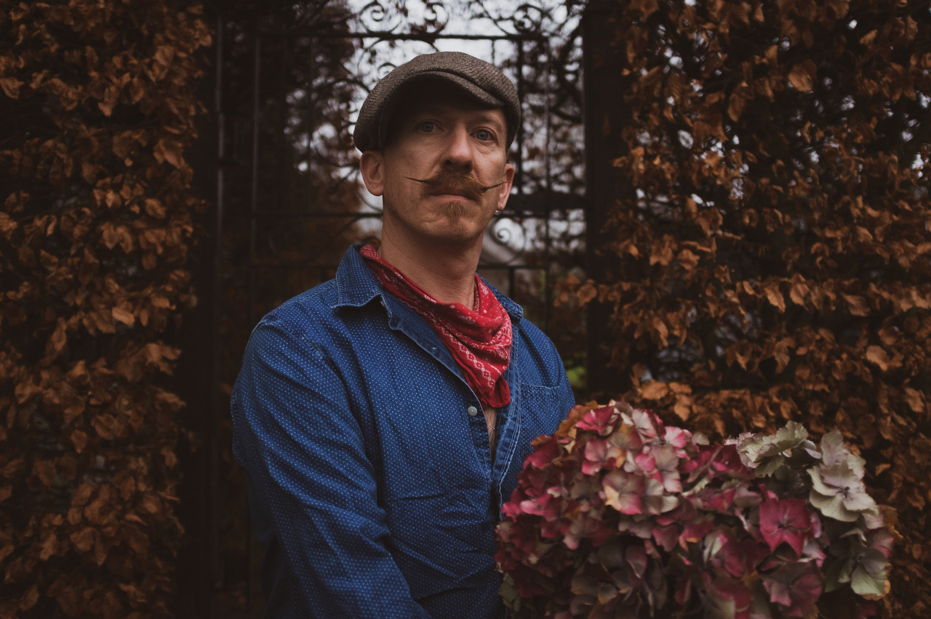

*Photo credit: Babysweet*

**About Foy Vance**

Hailing from Bangor in Northern Ireland, Vance independently released his debut album *Hope* in 2007, quickly garnering acclaim from fans and fellow musicians alike. His second full-length album, *Joy of Nothing*, released in 2013 on Glassnote Records, won the inaugural Northern Ireland Music Prize and saw Vance tour the globe with Ed Sheeran, Bonnie Raitt, Marcus Foster, Snow Patrol and Sir Elton John, as well as his own solo headline tours.

In 2015 Vance was became the second signing to Gingerbread Man Records, Ed Sheeran’s label division within Atlantic Records. His debut recording for the label, *The Wild Swan -* Executive Produced by Sir Elton John - contained the BBC Radio 2 playlisted singles “Coco”, “Upbeat Feelgood”, and “Noam Chomsky Is A Soft Revolution”, and saw Vance perform on NBC’s Today and CBS’s The Late Late Show with James Corden.

As a songwriter, Vance’s collaborations include co-writing four cuts including “Galway Girl” on Ed Sheeran’s 2017 album *Divide*. He has also worked with Alicia Keys, Rag N Bone Man, Keith Urban, Kacey Musgraves, Miranda Lambert, Plan B and Rudimental among many others, effortlessly switching between genres.

Last year, Vance launched the podcast series *The Vinyl Supper* in which he talks music, food and life stories with special guests and friends from the world of music, poetry and film. Recorded remotely during the global pandemic, series one featured Anderson East, Atticus, Benny Blanco, Blake Mills, Bruce Cockburn, Chrissy Metz, Courteney Cox, Devin Dawson, Josh Groban, Keith Urban and Passenger.

Foy Vance has headlined globally to sell-out crowds and splits his time between London and the Scottish Highlands with his family.

[FoyVance.com](https://nam04.safelinks.protection.outlook.com/?url=https%3A%2F%2Ffoyvance.com%2F&data=04%7C01%7CSydneyWorden%40elektra.com%7Cff8f8cbd870b4c62e88e08d979fcaac0%7C8367939002ec4ba1ad3d69da3fdd637e%7C0%7C0%7C637674948375472364%7CUnknown%7CTWFpbGZsb3d8eyJWIjoiMC4wLjAwMDAiLCJQIjoiV2luMzIiLCJBTiI6Ik1haWwiLCJXVCI6Mn0%3D%7C1000&sdata=wffTNpvMsRNr2V3CMghkOFxIy5ZYVOhNVzhGJAs89fM%3D&reserved=0)

[Facebook](https://nam04.safelinks.protection.outlook.com/?url=https%3A%2F%2Fwww.facebook.com%2Ffoyvancemusic&data=04%7C01%7CSydneyWorden%40elektra.com%7Cff8f8cbd870b4c62e88e08d979fcaac0%7C8367939002ec4ba1ad3d69da3fdd637e%7C0%7C0%7C637674948375472364%7CUnknown%7CTWFpbGZsb3d8eyJWIjoiMC4wLjAwMDAiLCJQIjoiV2luMzIiLCJBTiI6Ik1haWwiLCJXVCI6Mn0%3D%7C1000&sdata=%2Fc1XTbg0qu8j5lxUeqWAAa4%2Be1QcChGf98QFXBtlofE%3D&reserved=0) | [Twitter](https://nam04.safelinks.protection.outlook.com/?url=https%3A%2F%2Ftwitter.com%2Ffoyvance&data=04%7C01%7CSydneyWorden%40elektra.com%7Cff8f8cbd870b4c62e88e08d979fcaac0%7C8367939002ec4ba1ad3d69da3fdd637e%7C0%7C0%7C637674948375482358%7CUnknown%7CTWFpbGZsb3d8eyJWIjoiMC4wLjAwMDAiLCJQIjoiV2luMzIiLCJBTiI6Ik1haWwiLCJXVCI6Mn0%3D%7C1000&sdata=fPYUZV35Ek%2Biy7YQjQsKu8ZmGTcW%2F8IWbGZU9HMpxtE%3D&reserved=0) | [Instagram](https://nam04.safelinks.protection.outlook.com/?url=https%3A%2F%2Fwww.instagram.com%2Ffoyvance%2F&data=04%7C01%7CSydneyWorden%40elektra.com%7Cff8f8cbd870b4c62e88e08d979fcaac0%7C8367939002ec4ba1ad3d69da3fdd637e%7C0%7C0%7C637674948375492361%7CUnknown%7CTWFpbGZsb3d8eyJWIjoiMC4wLjAwMDAiLCJQIjoiV2luMzIiLCJBTiI6Ik1haWwiLCJXVCI6Mn0%3D%7C1000&sdata=PJp3cu0klRRUcwJD%2FJq4%2FGqyE54QyynRYSX6k4Alqp4%3D&reserved=0) | [YouTube](https://nam04.safelinks.protection.outlook.com/?url=https%3A%2F%2Fwww.youtube.com%2Fuser%2Ffoyvancemusic%2Ffeatured&data=04%7C01%7CSydneyWorden%40elektra.com%7Cff8f8cbd870b4c62e88e08d979fcaac0%7C8367939002ec4ba1ad3d69da3fdd637e%7C0%7C0%7C637674948375492361%7CUnknown%7CTWFpbGZsb3d8eyJWIjoiMC4wLjAwMDAiLCJQIjoiV2luMzIiLCJBTiI6Ik1haWwiLCJXVCI6Mn0%3D%7C1000&sdata=dhmNmBE8Uk%2FYoGc5%2BlcP6xtEYBL%2FETPKXpa0ZnfI%2F%2FE%3D&reserved=0)

**Press contact:**

Collin Citron | [CollinCitron@elektra.com](mailto:CollinCitron@elektra.com)