**FOY VANCE UNVEILS NEW SINGLE “SAPLING” (FEAT. ANDERSON EAST)**

**LISTEN**[**HERE**](https://nam04.safelinks.protection.outlook.com/?url=https%3A%2F%2Flnk.to%2FSapling&data=04%7C01%7CDestinyDominguez%40elektra.com%7Cd82108ac011342a9ff1a08d9dceeb5a5%7C8367939002ec4ba1ad3d69da3fdd637e%7C0%7C0%7C637783740096544140%7CUnknown%7CTWFpbGZsb3d8eyJWIjoiMC4wLjAwMDAiLCJQIjoiV2luMzIiLCJBTiI6Ik1haWwiLCJXVCI6Mn0%3D%7C3000&sdata=PtsvWGuN1iEtnq0CX6Sz1WtL0lRW4Htgdc7buKvoWN4%3D&reserved=0)

**NEW ALBUM**[***SIGNS OF LIFE***](https://nam04.safelinks.protection.outlook.com/?url=https%3A%2F%2Flnk.to%2FSigns-of-Life&data=04%7C01%7CDestinyDominguez%40elektra.com%7Cd82108ac011342a9ff1a08d9dceeb5a5%7C8367939002ec4ba1ad3d69da3fdd637e%7C0%7C0%7C637783740096544140%7CUnknown%7CTWFpbGZsb3d8eyJWIjoiMC4wLjAwMDAiLCJQIjoiV2luMzIiLCJBTiI6Ik1haWwiLCJXVCI6Mn0%3D%7C3000&sdata=foPyGWeZtQ%2BywKDBRxaH2R%2FO3MaqAovrdod8HFAPbYg%3D&reserved=0)**AVAILABLE NOW**

**TICKETS FOR *SIGNS OF LIFE*TOUR 2022 AVAILABLE**[**HERE**](https://nam04.safelinks.protection.outlook.com/?url=https%3A%2F%2Fwww.foyvance.com%2Ftour%2F&data=04%7C01%7CDestinyDominguez%40elektra.com%7Cd82108ac011342a9ff1a08d9dceeb5a5%7C8367939002ec4ba1ad3d69da3fdd637e%7C0%7C0%7C637783740096544140%7CUnknown%7CTWFpbGZsb3d8eyJWIjoiMC4wLjAwMDAiLCJQIjoiV2luMzIiLCJBTiI6Ik1haWwiLCJXVCI6Mn0%3D%7C3000&sdata=UnamZLD4wXybhGyN0mceraLjqQJlmMazC90I6HufMcE%3D&reserved=0)

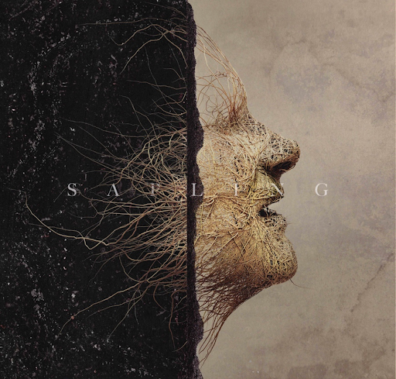

Award-winning Northern Irish singer/songwriter **Foy Vance**has released his new single “Sapling” (feat. Anderson East). The song is available to stream and download starting today [HERE](https://nam04.safelinks.protection.outlook.com/?url=https%3A%2F%2Flnk.to%2FSapling&data=04%7C01%7CDestinyDominguez%40elektra.com%7Cd82108ac011342a9ff1a08d9dceeb5a5%7C8367939002ec4ba1ad3d69da3fdd637e%7C0%7C0%7C637783740096544140%7CUnknown%7CTWFpbGZsb3d8eyJWIjoiMC4wLjAwMDAiLCJQIjoiV2luMzIiLCJBTiI6Ik1haWwiLCJXVCI6Mn0%3D%7C3000&sdata=PtsvWGuN1iEtnq0CX6Sz1WtL0lRW4Htgdc7buKvoWN4%3D&reserved=0) via Ed Sheeran’s Gingerbread Man Records/Elektra Records. Watch the track’s visualizer [HERE](https://nam04.safelinks.protection.outlook.com/?url=https%3A%2F%2Fyoutu.be%2FEb_0e13g3L8&data=04%7C01%7CDestinyDominguez%40elektra.com%7Cd82108ac011342a9ff1a08d9dceeb5a5%7C8367939002ec4ba1ad3d69da3fdd637e%7C0%7C0%7C637783740096544140%7CUnknown%7CTWFpbGZsb3d8eyJWIjoiMC4wLjAwMDAiLCJQIjoiV2luMzIiLCJBTiI6Ik1haWwiLCJXVCI6Mn0%3D%7C3000&sdata=uHj6LefYrmC2weHdTOsqRLkZRvsJyaM0ULsrYt3IQlE%3D&reserved=0). A re-imagined version of the lead single off Vance’s new album [*Signs Of Life*](https://nam04.safelinks.protection.outlook.com/?url=https%3A%2F%2Flnk.to%2FSigns-of-Life&data=04%7C01%7CDestinyDominguez%40elektra.com%7Cd82108ac011342a9ff1a08d9dceeb5a5%7C8367939002ec4ba1ad3d69da3fdd637e%7C0%7C0%7C637783740096544140%7CUnknown%7CTWFpbGZsb3d8eyJWIjoiMC4wLjAwMDAiLCJQIjoiV2luMzIiLCJBTiI6Ik1haWwiLCJXVCI6Mn0%3D%7C3000&sdata=foPyGWeZtQ%2BywKDBRxaH2R%2FO3MaqAovrdod8HFAPbYg%3D&reserved=0), “Sapling” features additional vocals from longtime friend, GRAMMY-nominated singer, songwriter, and performer **Anderson East**.

A beautiful song written for Vance’s partner, who moved from London to join the Bangor native in his adopted home in the Scottish Highlands, “Sapling” has already struck a chord with both fans and critics. The album version of the track has amassed millions of streams and received praise from *The New York Times*, *Taste of Country, American Songwriter*, and more.

“This is the waking up to a harsh reality that my addictions were putting at risk everything I had worked hard for,” shares Vance. “A home, a family and a career. It’s about being honest. There was a time in my life that I felt like an oak, but there was no oak there when I looked, just a fragile sapling, but a sign of life nonetheless.”

“I’ve never been eager to duet, but when this opportunity came up it made complete sense to me to have Anderson on ‘Sapling’ having pulled me through a hard spot himself,” he adds of the new version.

“Foy and his music have always been a massive inspiration to me and on my music,” shares East.  “I’m beyond honored to be asked to be a part of this beautiful song. He has a way of draining every last drop of emotion out of every note and I’m humbled he’d ask to add my voice to such a powerful and moving song. If the world was full of more Foys, we’d be doing alright.”

“Sapling” (feat. Anderson East) arrives ahead of Vance’s upcoming *Signs of Life* Tour 2022, which kicks off in Woodstock, NY on May 6, and wraps in Los Angeles, CA on May 31. Special guests Lee Rogers and Gareth Dunlap will provide support.  Tickets for all dates on the tour are available now [HERE](https://nam04.safelinks.protection.outlook.com/?url=https%3A%2F%2Fwww.foyvance.com%2Ftour%2F&data=04%7C01%7CDestinyDominguez%40elektra.com%7Cd82108ac011342a9ff1a08d9dceeb5a5%7C8367939002ec4ba1ad3d69da3fdd637e%7C0%7C0%7C637783740096544140%7CUnknown%7CTWFpbGZsb3d8eyJWIjoiMC4wLjAwMDAiLCJQIjoiV2luMzIiLCJBTiI6Ik1haWwiLCJXVCI6Mn0%3D%7C3000&sdata=UnamZLD4wXybhGyN0mceraLjqQJlmMazC90I6HufMcE%3D&reserved=0).

*Signs Of Life* was recorded in three locations: Vance’s Pilgrim studio at home on the shores of Loch Tay in Highland Perthshire, another recording set-up in a nearby Dunvarlich House, and at Plan B’s Kings X studio in London. The album was written and played more or less entirely by Vance, with assistance from young Northern Irish producer Gareth Dunlop.

“As always Foy has knocked it out of the park,” comments Ed Sheeran of the album, who made his long-time friend Vance one of the first signings to his label Gingerbread Man Records. “I love giving him the creative freedom to do what he wants as I’m at the end of the day just a huge fan of his work. It’s such a joy to be able to put out such great bodies of work from him, I hope everyone enjoys it as much as me.”

**FOY VANCE PRESENTS SIGNS OF LIFE TOUR 2022**

**North American Dates - Tickets available now**[**HERE**](https://nam04.safelinks.protection.outlook.com/?url=https%3A%2F%2Fwww.foyvance.com%2Ftour%2F&data=04%7C01%7CDestinyDominguez%40elektra.com%7Cd82108ac011342a9ff1a08d9dceeb5a5%7C8367939002ec4ba1ad3d69da3fdd637e%7C0%7C0%7C637783740096700390%7CUnknown%7CTWFpbGZsb3d8eyJWIjoiMC4wLjAwMDAiLCJQIjoiV2luMzIiLCJBTiI6Ik1haWwiLCJXVCI6Mn0%3D%7C3000&sdata=Twd2Sb%2BwOwd4%2FV0eFa2Kpet0YO6gvXUWTt7LOiZSHoQ%3D&reserved=0)

May 06, 2022 - Woodstock, NY - Levon Helm Studios

May 07, 2022 - Woodstock, NY - Levon Helm Studios

May 08, 2022 - Philadelphia, PA - Theatre of Living Arts

May 10, 2022 - Alexandria, VA - The Birchmere

May 11, 2022 - New York, NY - Webster Hall

May 13, 2022 - Boston, MA - Royale

May 14, 2022 - Homer, NY - Center for the Arts of Homer

May 15, 2022 - Toronto, ON - Queen Elizabeth Theatre

May 17, 2022 - Cincinnati, OH - Memorial Hall

May 18, 2022 - Nashville, TN - James K. Polk Theater

May 20, 2022 - Minneapolis, MN - The Cedar Cultural Center

May 21, 2022 - Chicago, IL - Athenaeum Theatre

May 26, 2022 - Seattle, WA - Neptune Theatre

May 27, 2022 - Portland, OR - Aladdin Theater

May 31, 2022 - Los Angeles, CA - The Regent Theater

*With special guests Lee Rogers and Gareth Dunlop*

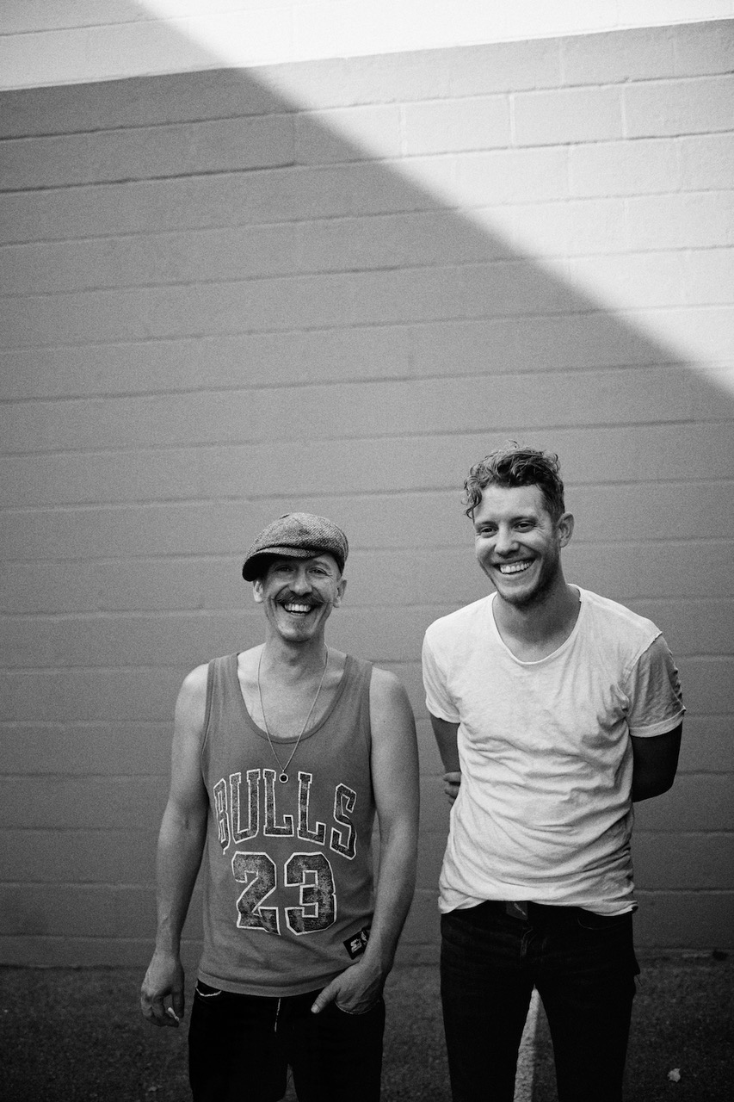

**About Foy Vance**

Hailing from Bangor in Northern Ireland, Vance independently released his debut album *Hope*in 2007, quickly garnering acclaim from fans and fellow musicians alike. His second full-length album, *Joy of Nothing*, released in 2013 on Glassnote Records, won the inaugural Northern Ireland Music Prize and saw Vance tour the globe with Ed Sheeran, Bonnie Raitt, Marcus Foster, Snow Patrol and Sir Elton John, as well as his own solo headline tours.

In 2015 Vance was became the second signing to Gingerbread Man Records, Ed Sheeran’s label division within Atlantic Records. His debut recording for the label, *The Wild Swan -* Executive Produced by Sir Elton John - contained the BBC Radio 2 playlisted singles “Coco”, “Upbeat Feelgood”, and “Noam Chomsky Is A Soft Revolution”, and saw Vance perform on NBC’s Today and CBS’s The Late Late Show with James Corden.

As a songwriter, Vance’s collaborations include co-writing four cuts including “Galway Girl” on Ed Sheeran’s 2017 album *Divide*. He has also worked with Alicia Keys, Rag N Bone Man, Keith Urban, Kacey Musgraves, Miranda Lambert, Plan B and Rudimental among many others, effortlessly switching between genres.

Last year, Vance launched the podcast series *The Vinyl Supper* in which he talks music, food and life stories with special guests and friends from the world of music, poetry and film. Recorded remotely during the global pandemic, series one featured Anderson East, Atticus, Benny Blanco, Blake Mills, Bruce Cockburn, Chrissy Metz, Courteney Cox, Devin Dawson, Josh Groban, Keith Urban and Passenger.

Foy Vance has headlined globally to sell-out crowds and splits his time between London and the Scottish Highlands with his family.

[FoyVance.com](https://nam04.safelinks.protection.outlook.com/?url=https%3A%2F%2Ffoyvance.com%2F&data=04%7C01%7CDestinyDominguez%40elektra.com%7Cd82108ac011342a9ff1a08d9dceeb5a5%7C8367939002ec4ba1ad3d69da3fdd637e%7C0%7C0%7C637783740096700390%7CUnknown%7CTWFpbGZsb3d8eyJWIjoiMC4wLjAwMDAiLCJQIjoiV2luMzIiLCJBTiI6Ik1haWwiLCJXVCI6Mn0%3D%7C3000&sdata=2KiZSCM6Eq4dZDqT4%2FTmRUEOWZ78B%2BwAIDpSjV6YSXk%3D&reserved=0)

[Facebook](https://nam04.safelinks.protection.outlook.com/?url=https%3A%2F%2Fwww.facebook.com%2Ffoyvancemusic&data=04%7C01%7CDestinyDominguez%40elektra.com%7Cd82108ac011342a9ff1a08d9dceeb5a5%7C8367939002ec4ba1ad3d69da3fdd637e%7C0%7C0%7C637783740096700390%7CUnknown%7CTWFpbGZsb3d8eyJWIjoiMC4wLjAwMDAiLCJQIjoiV2luMzIiLCJBTiI6Ik1haWwiLCJXVCI6Mn0%3D%7C3000&sdata=sIdwMlIVUNU7D0z6NdLfo7fjk8CPjEknBL%2FCenz1cyA%3D&reserved=0) | [Twitter](https://nam04.safelinks.protection.outlook.com/?url=https%3A%2F%2Ftwitter.com%2Ffoyvance&data=04%7C01%7CDestinyDominguez%40elektra.com%7Cd82108ac011342a9ff1a08d9dceeb5a5%7C8367939002ec4ba1ad3d69da3fdd637e%7C0%7C0%7C637783740096700390%7CUnknown%7CTWFpbGZsb3d8eyJWIjoiMC4wLjAwMDAiLCJQIjoiV2luMzIiLCJBTiI6Ik1haWwiLCJXVCI6Mn0%3D%7C3000&sdata=oH40NK0al5sSgGMOcVoPQeC74kC22uZTB0aaRlcPlDQ%3D&reserved=0) | [Instagram](https://nam04.safelinks.protection.outlook.com/?url=https%3A%2F%2Fwww.instagram.com%2Ffoyvance%2F&data=04%7C01%7CDestinyDominguez%40elektra.com%7Cd82108ac011342a9ff1a08d9dceeb5a5%7C8367939002ec4ba1ad3d69da3fdd637e%7C0%7C0%7C637783740096700390%7CUnknown%7CTWFpbGZsb3d8eyJWIjoiMC4wLjAwMDAiLCJQIjoiV2luMzIiLCJBTiI6Ik1haWwiLCJXVCI6Mn0%3D%7C3000&sdata=7SlyrHb28kktKM%2B2O7iW%2BpLm9U8yEFmgiytGva%2BAtuE%3D&reserved=0) | [YouTube](https://nam04.safelinks.protection.outlook.com/?url=https%3A%2F%2Fwww.youtube.com%2Fuser%2Ffoyvancemusic%2Ffeatured&data=04%7C01%7CDestinyDominguez%40elektra.com%7Cd82108ac011342a9ff1a08d9dceeb5a5%7C8367939002ec4ba1ad3d69da3fdd637e%7C0%7C0%7C637783740096700390%7CUnknown%7CTWFpbGZsb3d8eyJWIjoiMC4wLjAwMDAiLCJQIjoiV2luMzIiLCJBTiI6Ik1haWwiLCJXVCI6Mn0%3D%7C3000&sdata=n%2FmvdlMY4%2BInzIXO%2Bzst5FStRgAGOvFDHgnvimBhbaM%3D&reserved=0)

**About Anderson East**

*Maybe We Never Die*, Anderson East's third release for Elektra/Low Country Sound takes the Alabama born, Nashville-based singer-songwriter’s seductively vintage voice in a decidedly fresh direction. The 12 tracks flow together with an overarching sense of ambience but maintain distinct musical boundaries. The energy toggles between a hunger for vulnerability in togetherness and a clinging to solitude as a romantic self-defense. There is consternation with the speed and volume at which the world operates and solace to be found in the simple act of getting up and going. And the beguiling title track, with its woozy strings swirling around East’s celestial falsetto as it curls towards the ceiling like smoke is, as they say, a whole mood; a sense of a single night’s dusk-to-sunrise contemplation. Collaborating once again with Dave Cobb along with longtime bandleader and now co-producer Philip Towns, East has found an enticing new avenue, one that maintains a connection to his past but keeps his eyes on the road ahead.

*Maybe We Never Die*is East's first new music since 2018's breakthrough album, *Encore*, which featured the Grammy-nominated #1 AAA radio single, "All On My Mind." Heralded by critics, *The New York Times* praised *Encore* as, “…an often lustrous revisiting of raucous Southern soul, rousingly delivered and pinpoint precise. He has a voice full of extremely careful scrape and crunch, but his howls never feel unhinged," while *Rolling Stone* declared, “On *Encore*, East’s influences meld seamlessly, stacking the album with Stax-worthy R&B grooves, gospel-blues ooohs and aaahs, surging keys and blasting brass.” Known for his magnetic live performances, East and his band have performed sold-out shows worldwide and have been featured on ABC's "Jimmy Kimmel Live!," CBS' "The Late Show with Stephen Colbert" and "CBS This Morning Saturday," NBC's "TODAY" and "Late Night with Seth Meyers," PBS' "Austin City Limits" and more.

[AndersonEast.com](https://nam04.safelinks.protection.outlook.com/?url=https%3A%2F%2Fwww.andersoneast.com%2F&data=04%7C01%7CDestinyDominguez%40elektra.com%7Cd82108ac011342a9ff1a08d9dceeb5a5%7C8367939002ec4ba1ad3d69da3fdd637e%7C0%7C0%7C637783740096700390%7CUnknown%7CTWFpbGZsb3d8eyJWIjoiMC4wLjAwMDAiLCJQIjoiV2luMzIiLCJBTiI6Ik1haWwiLCJXVCI6Mn0%3D%7C3000&sdata=lRmFhfa7mYjw4SFRoXiLyFEiNCyt6O6zkhSurIpFv8c%3D&reserved=0)

[Facebook](https://nam04.safelinks.protection.outlook.com/?url=https%3A%2F%2Fwww.facebook.com%2Fandersoneast&data=04%7C01%7CDestinyDominguez%40elektra.com%7Cd82108ac011342a9ff1a08d9dceeb5a5%7C8367939002ec4ba1ad3d69da3fdd637e%7C0%7C0%7C637783740096700390%7CUnknown%7CTWFpbGZsb3d8eyJWIjoiMC4wLjAwMDAiLCJQIjoiV2luMzIiLCJBTiI6Ik1haWwiLCJXVCI6Mn0%3D%7C3000&sdata=wf5xZ8Bc6nIC7mYPWJmwQA5MyNG8w%2FjtNqXYwHgCVxE%3D&reserved=0) | [Twitter](https://nam04.safelinks.protection.outlook.com/?url=https%3A%2F%2Ftwitter.com%2FAndersoneast&data=04%7C01%7CDestinyDominguez%40elektra.com%7Cd82108ac011342a9ff1a08d9dceeb5a5%7C8367939002ec4ba1ad3d69da3fdd637e%7C0%7C0%7C637783740096700390%7CUnknown%7CTWFpbGZsb3d8eyJWIjoiMC4wLjAwMDAiLCJQIjoiV2luMzIiLCJBTiI6Ik1haWwiLCJXVCI6Mn0%3D%7C3000&sdata=cmTIXMKe3RhSiYMqFcsVwNAJlyV2d2FQOfa3O16avIE%3D&reserved=0) | [Instagram](https://nam04.safelinks.protection.outlook.com/?url=https%3A%2F%2Fwww.instagram.com%2Fandersoneast%2F&data=04%7C01%7CDestinyDominguez%40elektra.com%7Cd82108ac011342a9ff1a08d9dceeb5a5%7C8367939002ec4ba1ad3d69da3fdd637e%7C0%7C0%7C637783740096700390%7CUnknown%7CTWFpbGZsb3d8eyJWIjoiMC4wLjAwMDAiLCJQIjoiV2luMzIiLCJBTiI6Ik1haWwiLCJXVCI6Mn0%3D%7C3000&sdata=ABss9MklV0bn968rDtgC7QgCcKAdQvzXjtKOVI9MGHg%3D&reserved=0) | [YouTube](https://nam04.safelinks.protection.outlook.com/?url=https%3A%2F%2Fwww.youtube.com%2Fuser%2Fandersoneast&data=04%7C01%7CDestinyDominguez%40elektra.com%7Cd82108ac011342a9ff1a08d9dceeb5a5%7C8367939002ec4ba1ad3d69da3fdd637e%7C0%7C0%7C637783740096700390%7CUnknown%7CTWFpbGZsb3d8eyJWIjoiMC4wLjAwMDAiLCJQIjoiV2luMzIiLCJBTiI6Ik1haWwiLCJXVCI6Mn0%3D%7C3000&sdata=ZVDiO4hH7Ki%2Bk0OFgNaWMs8m5nt2x%2F91HLx6G5Opg1o%3D&reserved=0)

**Press contact:**

Collin Citron | [CollinCitron@elektra.com](mailto:CollinCitron@elektra.com)