FOR IMMEDIATE RELEASE

MAY 9, 2022

**FLOR TO EMBARK ON *FUTURE SHINE TOUR* OF NORTH AMERICA THIS FALL**

**TICKETS AVAILABLE TO THE PUBLIC THIS FRIDAY MAY 13** [**HERE**](https://nam04.safelinks.protection.outlook.com/?url=https%3A%2F%2Fwww.florsounds.com%2F&data=05%7C01%7CDestinyDominguez%40elektra.com%7C5460c7887dbd42672b3d08da31c469af%7C8367939002ec4ba1ad3d69da3fdd637e%7C0%7C0%7C637877016908192174%7CUnknown%7CTWFpbGZsb3d8eyJWIjoiMC4wLjAwMDAiLCJQIjoiV2luMzIiLCJBTiI6Ik1haWwiLCJXVCI6Mn0%3D%7C3000%7C%7C%7C&sdata=q6VLfjgo9yyJQ7DcVE8Aw%2FzsufOaFyV%2FT6PyjPI7xRA%3D&reserved=0)

**NEW ALBUM *FUTURE SHINE* AVAILABLE NOW VIA FUELED BY RAMEN**

**LISTEN** [**HERE**](https://nam04.safelinks.protection.outlook.com/?url=https%3A%2F%2Fflor.lnk.to%2Ffutureshine&data=05%7C01%7CDestinyDominguez%40elektra.com%7C5460c7887dbd42672b3d08da31c469af%7C8367939002ec4ba1ad3d69da3fdd637e%7C0%7C0%7C637877016908192174%7CUnknown%7CTWFpbGZsb3d8eyJWIjoiMC4wLjAwMDAiLCJQIjoiV2luMzIiLCJBTiI6Ik1haWwiLCJXVCI6Mn0%3D%7C3000%7C%7C%7C&sdata=my4pBrZh1Ub9%2BCypRWi3woYEpGke1M2fiCyzpksCvcM%3D&reserved=0)

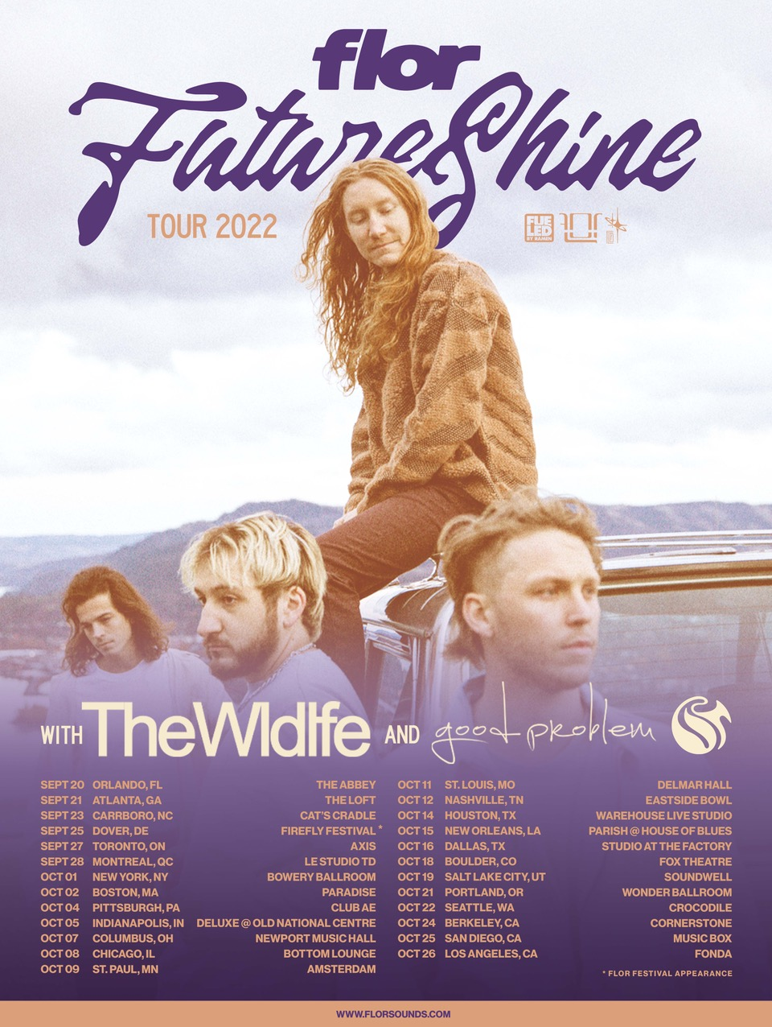

Hood River, OR alt-pop band **flor** have announced the ***Future Shine Tour***of North America in support of their brand new album [***Future Shine***](https://nam04.safelinks.protection.outlook.com/?url=https%3A%2F%2Fflor.lnk.to%2Ffutureshine&data=05%7C01%7CDestinyDominguez%40elektra.com%7C5460c7887dbd42672b3d08da31c469af%7C8367939002ec4ba1ad3d69da3fdd637e%7C0%7C0%7C637877016908192174%7CUnknown%7CTWFpbGZsb3d8eyJWIjoiMC4wLjAwMDAiLCJQIjoiV2luMzIiLCJBTiI6Ik1haWwiLCJXVCI6Mn0%3D%7C3000%7C%7C%7C&sdata=my4pBrZh1Ub9%2BCypRWi3woYEpGke1M2fiCyzpksCvcM%3D&reserved=0). The 25-city trek will kick off on September 20 in Orlando, FL, visit major markets coast-to-coast, and wrap on October 26 in Los Angeles, CA. The Wldlfe and good problem will provide support. Pre-sale tickets will be available beginning tomorrow, May 10 at 10:00am local time. General on-sale will kick off this Friday, May 13 at 10:00am local time [HERE](https://nam04.safelinks.protection.outlook.com/?url=https%3A%2F%2Fwww.florsounds.com%2F&data=05%7C01%7CDestinyDominguez%40elektra.com%7C5460c7887dbd42672b3d08da31c469af%7C8367939002ec4ba1ad3d69da3fdd637e%7C0%7C0%7C637877016908192174%7CUnknown%7CTWFpbGZsb3d8eyJWIjoiMC4wLjAwMDAiLCJQIjoiV2luMzIiLCJBTiI6Ik1haWwiLCJXVCI6Mn0%3D%7C3000%7C%7C%7C&sdata=q6VLfjgo9yyJQ7DcVE8Aw%2FzsufOaFyV%2FT6PyjPI7xRA%3D&reserved=0). A complete list of upcoming tour dates can be found below.

*Future Shine* was released last Friday, and is available to stream and download [HERE](https://nam04.safelinks.protection.outlook.com/?url=https%3A%2F%2Fflor.lnk.to%2Ffutureshine&data=05%7C01%7CDestinyDominguez%40elektra.com%7C5460c7887dbd42672b3d08da31c469af%7C8367939002ec4ba1ad3d69da3fdd637e%7C0%7C0%7C637877016908192174%7CUnknown%7CTWFpbGZsb3d8eyJWIjoiMC4wLjAwMDAiLCJQIjoiV2luMzIiLCJBTiI6Ik1haWwiLCJXVCI6Mn0%3D%7C3000%7C%7C%7C&sdata=my4pBrZh1Ub9%2BCypRWi3woYEpGke1M2fiCyzpksCvcM%3D&reserved=0) via Fueled By Ramen. CDs, cassettes, and limited edition merch bundles are available now exclusively through flor’s online store [HERE](https://nam04.safelinks.protection.outlook.com/?url=https%3A%2F%2Fwww.florsounds.com%2F&data=05%7C01%7CDestinyDominguez%40elektra.com%7C5460c7887dbd42672b3d08da31c469af%7C8367939002ec4ba1ad3d69da3fdd637e%7C0%7C0%7C637877016908192174%7CUnknown%7CTWFpbGZsb3d8eyJWIjoiMC4wLjAwMDAiLCJQIjoiV2luMzIiLCJBTiI6Ik1haWwiLCJXVCI6Mn0%3D%7C3000%7C%7C%7C&sdata=q6VLfjgo9yyJQ7DcVE8Aw%2FzsufOaFyV%2FT6PyjPI7xRA%3D&reserved=0). Last week, the band spoke at length about their new album in features in [*Rolling Stone*](https://nam04.safelinks.protection.outlook.com/?url=https%3A%2F%2Fwww.rollingstone.com%2Fmusic%2Fmusic-features%2Fflor-interview-future-shine-1347158%2F&data=05%7C01%7CDestinyDominguez%40elektra.com%7C5460c7887dbd42672b3d08da31c469af%7C8367939002ec4ba1ad3d69da3fdd637e%7C0%7C0%7C637877016908192174%7CUnknown%7CTWFpbGZsb3d8eyJWIjoiMC4wLjAwMDAiLCJQIjoiV2luMzIiLCJBTiI6Ik1haWwiLCJXVCI6Mn0%3D%7C3000%7C%7C%7C&sdata=UHpUTLVYx9ag8JOE37uZEG8prkbxuOky0E8P6f%2F7Hik%3D&reserved=0)and [*Atwood Magazine*](https://nam04.safelinks.protection.outlook.com/?url=https%3A%2F%2Fatwoodmagazine.com%2Fflor-future-shine-album-interview-music-feature%2F&data=05%7C01%7CDestinyDominguez%40elektra.com%7C5460c7887dbd42672b3d08da31c469af%7C8367939002ec4ba1ad3d69da3fdd637e%7C0%7C0%7C637877016908192174%7CUnknown%7CTWFpbGZsb3d8eyJWIjoiMC4wLjAwMDAiLCJQIjoiV2luMzIiLCJBTiI6Ik1haWwiLCJXVCI6Mn0%3D%7C3000%7C%7C%7C&sdata=H9%2BHkwefZom26ENwGI8dsuRYcDpYLh4Ew1sgjPFFjGA%3D&reserved=0). Additionally, flor unveiled an official music video for the album’s new single “Gotta Do Something”. Watch it on the band’s YouTube channel [HERE](https://nam04.safelinks.protection.outlook.com/?url=https%3A%2F%2Fyoutu.be%2FK8RpFOcmxJ4&data=05%7C01%7CDestinyDominguez%40elektra.com%7C5460c7887dbd42672b3d08da31c469af%7C8367939002ec4ba1ad3d69da3fdd637e%7C0%7C0%7C637877016908192174%7CUnknown%7CTWFpbGZsb3d8eyJWIjoiMC4wLjAwMDAiLCJQIjoiV2luMzIiLCJBTiI6Ik1haWwiLCJXVCI6Mn0%3D%7C3000%7C%7C%7C&sdata=5U%2FdsMHczsI9XuuZUGkHJvPaL6pf7djII%2FFwXkyrvlQ%3D&reserved=0).

flor celebrated the release of *Future Shine* with their first-ever “flor in Twenty Four”, which saw them perform a marathon three sold out shows in Brooklyn, NY, Los Angeles, CA, and Hood River, OR in just 24 hours. Last month, the band wrapped a tour supporting The Band CAMINO in sold out venues across North America.

*Future Shine* represents flor’s most collaborative body of work to date. Feeling uninspired to write while alone during quarantine, Grace gathered his bandmates - Dylan Bauld [bass], McKinley Kitts [guitar], and Kyle Hill [drums] - at Bauld’s Los Angeles studio for a series of writing sessions as soon as it became safe to do so. This time around, they built the bulk of the songs face-to-face, inspired by favorite records from the likes of MGMT, Phoenix, The Killers, and M83.

Across the album’s 11 tracks, flor excavate unshakable melodies from jubilant synths, buoyant beats, and lush guitars as they relay a coming-of-age story all their own. flor previewed *Future Shine* with the February release of lead single “[Play Along](https://nam04.safelinks.protection.outlook.com/?url=https%3A%2F%2Fyoutu.be%2Fl1_2oEcEXeI&data=05%7C01%7CDestinyDominguez%40elektra.com%7C5460c7887dbd42672b3d08da31c469af%7C8367939002ec4ba1ad3d69da3fdd637e%7C0%7C0%7C637877016908192174%7CUnknown%7CTWFpbGZsb3d8eyJWIjoiMC4wLjAwMDAiLCJQIjoiV2luMzIiLCJBTiI6Ik1haWwiLCJXVCI6Mn0%3D%7C3000%7C%7C%7C&sdata=1JGFU5IkymjNeky7kF%2B%2BuvPxbKoEvZ9jWr3AyIeXB%2Bc%3D&reserved=0)”, which *Variance Magazine* praised as *“the perfect introduction to their next chapter as a band.”* In March, the band returned with “[Skate](https://nam04.safelinks.protection.outlook.com/?url=https%3A%2F%2Fyoutu.be%2F3Qx52YKKSIs&data=05%7C01%7CDestinyDominguez%40elektra.com%7C5460c7887dbd42672b3d08da31c469af%7C8367939002ec4ba1ad3d69da3fdd637e%7C0%7C0%7C637877016908192174%7CUnknown%7CTWFpbGZsb3d8eyJWIjoiMC4wLjAwMDAiLCJQIjoiV2luMzIiLCJBTiI6Ik1haWwiLCJXVCI6Mn0%3D%7C3000%7C%7C%7C&sdata=0D3nYLxsYAVs9zJH7U9jyiO%2FprZqs8QtOIZZO0qXbFo%3D&reserved=0)” and “[Big Shot](https://nam04.safelinks.protection.outlook.com/?url=https%3A%2F%2Fyoutu.be%2FGAIKF7xUawE&data=05%7C01%7CDestinyDominguez%40elektra.com%7C5460c7887dbd42672b3d08da31c469af%7C8367939002ec4ba1ad3d69da3fdd637e%7C0%7C0%7C637877016908192174%7CUnknown%7CTWFpbGZsb3d8eyJWIjoiMC4wLjAwMDAiLCJQIjoiV2luMzIiLCJBTiI6Ik1haWwiLCJXVCI6Mn0%3D%7C3000%7C%7C%7C&sdata=CmQ0LlEKCQSVc8T%2FmWUhSOKGFtcxZKtekprfQNaIVd0%3D&reserved=0)”.  *The Honey Pop* raved, *“From the three singles that have been released, it’s clear that this album highlights flor’s musical range and their amazing ability to cover various genres. We are playing all three of these singles on repeat*.*”* Additional praise came for flor’s 2018 track “Heart”, which was recently featured prominently in the Netflix series *Heartstopper.*

**FLOR TOUR DATES**

September 20, 2022 - Orlando, FL - The Abbey

September 21, 2022 - Atlanta, GA - The Loft

September 23, 2022 - Carrboro, NC - Cat’s Cradle

September 25, 2022 - Dover, DE - Firefly Music Festival*

September 27, 2022 - Toronto, ON - Axis

September 28, 2022 - Montreal, QC - Le Studio TD

October 01, 2022 - New York, NY - Bowery Ballroom

October 02, 2022 - Boston, MA - Paradise

October 04, 2022 - Pittsburgh, PA - Club AE

October 05, 2022 - Indianapolis, IN - Deluxe @ Old National Centre

October 07, 2022 - Columbus, OH - Newport Music Hall

October 08, 2022 - Chicago, IL - Bottom Lounge

October 09, 2022 - St Paul, MN - Amsterdam

October 11, 2022 - St. Louis, MO - Delmar Hall

October 12, 2022 - Nashville, TN - Eastside Bowl

October 14, 2022 - Houston, TX - Warehouse Live Studio

October 15, 2022 - New Orleans, LA - Parish @ House of Blues

October 16, 2022 - Dallas, TX - Studio at The Factory

October 18, 2022 - Boulder, CO - Fox

October 19, 2022 - Salt Lake City, UT - Soundwell

October 21, 2022 - Portland, OR - Wonder Ballroom

October 22, 2022 - Seattle, WA - Crocodile

October 24, 2022 - Berkeley, CA - Cornerstone

October 25, 2022 - San Diego, CA - Music Box

October 26, 2022 - Los Angeles, CA - The Fonda Theater

*Festival appearance

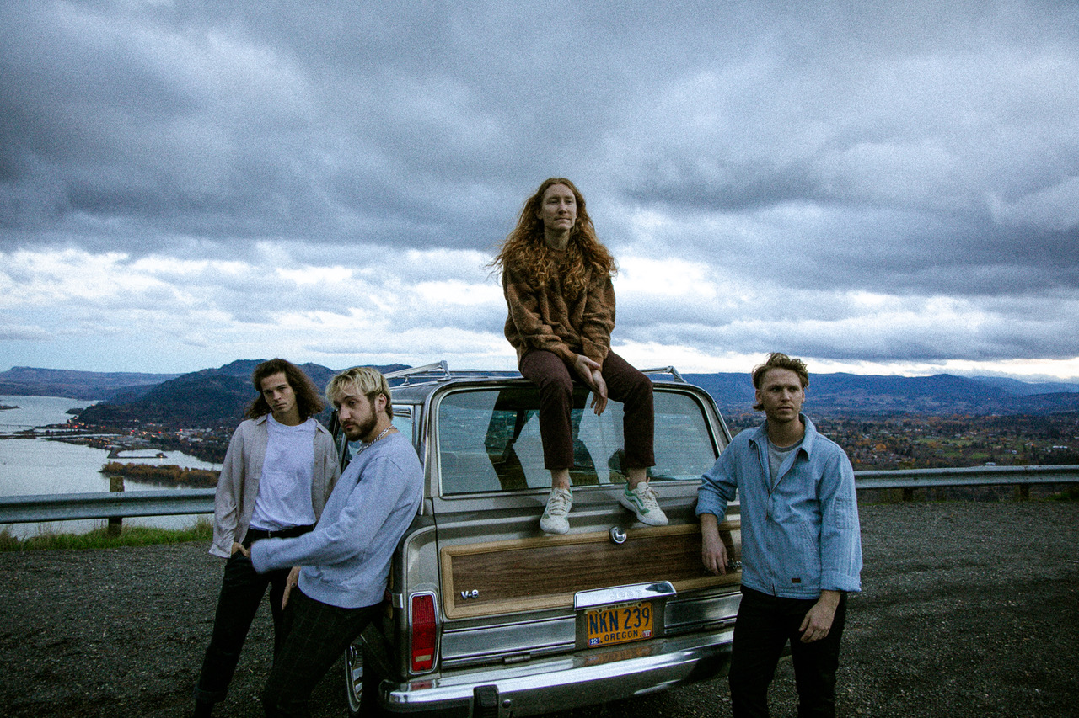

*(Photo credit: Ashley Osborn)*

**About flor**

flor finds light in the promise of a new day. The Hood River, OR quartet—Zach Grace [vocals, guitar], Dylan Bauld [bass], McKinley Kitts [guitar], and Kyle Hill [drums]—excavate unshakable melodies from jubilant synths, buoyant beats, and lush guitars as they relay a coming-of-age story all their own. The story began as high school kids in McKinley’s garage. The band quietly generated hundreds of millions of streams in the wake of their 2016 debut *come out. you*’*re hiding*. In 2019, *ley lines* only accelerated their momentum buoyed by tracks including “white noise,” “slow motion,” and “dancing around”. Critical acclaim followed from *Nylon*, *Billboard*, *Paste,* and *Ones To Watch* who hailed the album as “*an exhilarating balancing act*.*”* They concluded a successful headline tour at the top of 2020 only to face the harsh reality of the Global Pandemic with the rest of us. Once it became safe enough to do so, the musicians congregated back in Los Angeles at Dylan’s studio for a series of writing sessions. This time around, they built the bulk of the songs face-to-face together inspired by favorite records from the likes of MGMT, Phoenix, The Killers, and M83. Now, flor shines brighter than ever on their third full-length album, *Future Shine* [Fueled By Ramen].

[https://www.florsounds.com/](https://nam04.safelinks.protection.outlook.com/?url=https%3A%2F%2Fwww.florsounds.com%2F&data=05%7C01%7CDestinyDominguez%40elektra.com%7C5460c7887dbd42672b3d08da31c469af%7C8367939002ec4ba1ad3d69da3fdd637e%7C0%7C0%7C637877016908192174%7CUnknown%7CTWFpbGZsb3d8eyJWIjoiMC4wLjAwMDAiLCJQIjoiV2luMzIiLCJBTiI6Ik1haWwiLCJXVCI6Mn0%3D%7C3000%7C%7C%7C&sdata=q6VLfjgo9yyJQ7DcVE8Aw%2FzsufOaFyV%2FT6PyjPI7xRA%3D&reserved=0)

[Facebook](https://nam04.safelinks.protection.outlook.com/?url=https%3A%2F%2Fwww.facebook.com%2Fflorsounds&data=05%7C01%7CDestinyDominguez%40elektra.com%7C5460c7887dbd42672b3d08da31c469af%7C8367939002ec4ba1ad3d69da3fdd637e%7C0%7C0%7C637877016908192174%7CUnknown%7CTWFpbGZsb3d8eyJWIjoiMC4wLjAwMDAiLCJQIjoiV2luMzIiLCJBTiI6Ik1haWwiLCJXVCI6Mn0%3D%7C3000%7C%7C%7C&sdata=87keuqRz6elizg8IAq%2ByzrAjoVX3WUpLzMp2ThHV9NA%3D&reserved=0) | [Twitter](https://nam04.safelinks.protection.outlook.com/?url=https%3A%2F%2Ftwitter.com%2Fflor&data=05%7C01%7CDestinyDominguez%40elektra.com%7C5460c7887dbd42672b3d08da31c469af%7C8367939002ec4ba1ad3d69da3fdd637e%7C0%7C0%7C637877016908192174%7CUnknown%7CTWFpbGZsb3d8eyJWIjoiMC4wLjAwMDAiLCJQIjoiV2luMzIiLCJBTiI6Ik1haWwiLCJXVCI6Mn0%3D%7C3000%7C%7C%7C&sdata=j4MuZxZqzJKnBFIy%2BRx5D%2FCYDin%2FbliiFTS%2FBH6Qpac%3D&reserved=0) | [Instagram](https://nam04.safelinks.protection.outlook.com/?url=https%3A%2F%2Fwww.instagram.com%2Fflor%2F&data=05%7C01%7CDestinyDominguez%40elektra.com%7C5460c7887dbd42672b3d08da31c469af%7C8367939002ec4ba1ad3d69da3fdd637e%7C0%7C0%7C637877016908192174%7CUnknown%7CTWFpbGZsb3d8eyJWIjoiMC4wLjAwMDAiLCJQIjoiV2luMzIiLCJBTiI6Ik1haWwiLCJXVCI6Mn0%3D%7C3000%7C%7C%7C&sdata=Xu%2F7Opez0%2By%2BVyHoydygSxiZSo0Bb1BXYZ2tkJlHTS4%3D&reserved=0) | [YouTube](https://nam04.safelinks.protection.outlook.com/?url=https%3A%2F%2Fwww.youtube.com%2Fflorsounds&data=05%7C01%7CDestinyDominguez%40elektra.com%7C5460c7887dbd42672b3d08da31c469af%7C8367939002ec4ba1ad3d69da3fdd637e%7C0%7C0%7C637877016908192174%7CUnknown%7CTWFpbGZsb3d8eyJWIjoiMC4wLjAwMDAiLCJQIjoiV2luMzIiLCJBTiI6Ik1haWwiLCJXVCI6Mn0%3D%7C3000%7C%7C%7C&sdata=lIPQLVUX2Hkow6M5vMgCRxIvoHCs5TwqygZlx7gaDUY%3D&reserved=0)

**Press contacts:**

Collin Citron / [collincitron@elektra.com](mailto:collincitron@elektra.com)

Sydney Worden / [sydneyworden@elektra.com](mailto:sydneyworden@elektra.com)